Girls with High functioning Autism/ Asperger’s Group.

Come along to meet other girls age 12-16.

A safe space to talk, connect and make new friends.

Take Part in different activities each week that you can be part of choosing.

WHEN: Starting Wednesday 18th May 2016
3.30pm-5pm

Where: The Edge- Behind Fairweather Hall
Barrhead Road
Newton Mearns, G776BB
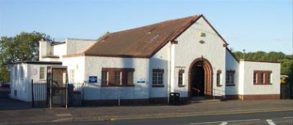

* we have limited spaces for this Group*

To register your interest in attending please contact:
Alison Burton, Young Persons services
Alison.Burton@eastrenfrewshire.gov.uk
Text or call 07738753650

