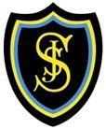
PFFA in St Joseph’s Primary

Here at St Joseph's, we wish to create a bulletin to help you share in our learning experience during the Pope Francis Faith Award 2020; we hope to inspire your journey of faith by demonstrating how we have used the gifts of the Holy Spirit in our daily lives.
Virtue of the Month
Justice - Justice means that we deal fairly with others, recognising the equality and dignity of all. At St. Joseph’s, we are always taught how to include others and treat each other with respect. To understand injustice more clearly, we have explored situations where we see injustice in our world and discuss how we can avoid being unjust. We are learning how not to judge each other on how we act or what we say but who we are as a person, made by God. So this month we challenge you to try extra hard to be kind and loving to each other. We also pray for the people who want peace and who are kind to each other. Blessed are the peacemakers: for they shall be called the children of God (Matthew 5:9)
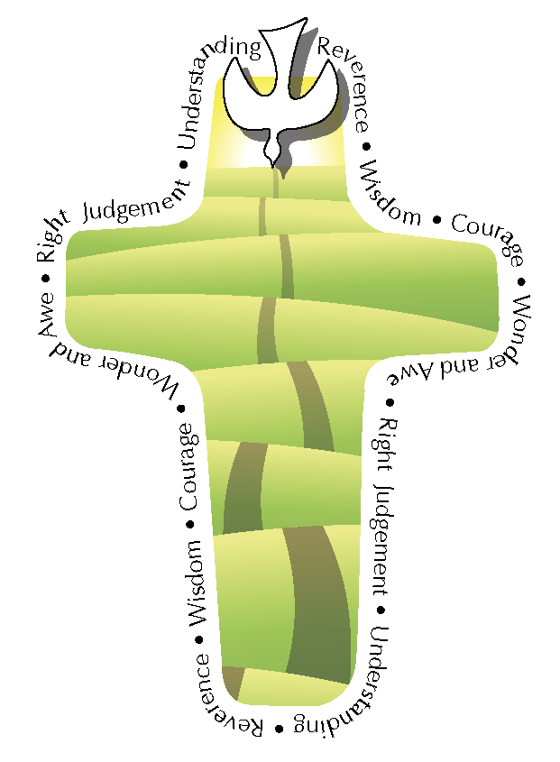
Gift of the Month

P6​ P7
This month, in P7, we have been embarking on a new chapter in our faith journey by completing our our Parish Commendation Sheet. This is when we reflect on what we have been doing in our community to share our faith in real life ways. Fr. Stephen then came in to look at them and signed them for us. Normally we would mention the things we are doing to help our parish but due to the pandemic, we have been unable to attend our weekly church service, so instead,this year we have been focusing on what we have been doing in our homes and communities, from walking neighbour’s dogs, to organising charity fundraisers and praying for those who may be lonely during this time.This month in PFFA, we have been working on the gift of Fortitude, which is the Gift of the Holy Spirit that helps us to be confident to say ‘we are disciples of Jesus!’ A person with Fortitude has the courage to stand up for what they think is right in the sight of God, even if it means being unpopular. An example of Fortitude would be to stand up for someone who is being mistreated, even if that feels like a difficult thing to do, another thing would be to always try your best at whatever you do, no matter how difficult it may seem.
In P6 we have been learning about the Gift of Knowledge. Knowledge is the gift that helps us to know ourselves, others and the world around us. We need to know ourselves in order to identify the gifts and talents God gave us. Knowledge is also a map, showing us where our faith is leading us.
When we were initially asked what the Gift of Knowledge is we all thought it was when you know things, but it is about more than just facts. When it is a gift from the Holy Spirit it is where you know yourself. Knowledge can be shown in multiple ways, for example, we might show others what we know or what we have learned. We also use our Knowledge to know how amazing God’s creations can be and how we can act with the knowledge He has given us.
We have been writing our first entries into our PFFA journals about how we use knowledge in our school, home and parishes.
The GIft of Knowledge brings us closer to God because we are thinking less about ourselves and more about others and the world around us.

Saint of the Month​
St Andrew is the Patron Saint of Scotland (he is also recognised as the Patron Saint of Greece, Russia, Italy’s Amalfi and Barbados). His feast day is celebrated on the 30th November. He was born in Bethsaida, a town in Galilee. Andrew was Jesus’ first disciple. He was a fisherman before he and his brother Simon Peter became two of the 12 disciples of Jesus. He was baptised by John the Baptist. Andrew was with Jesus throughout his journey of faith and his name appears in many stories, including the story of the feeding of the five thousand. He also travelled to Greece to preach Christianity. Little else is known about his life, but legend has it that he was crucified on an X shaped cross, because he believed that he wasn’t worthy enough to be crucified on the same type of cross as Jesus.
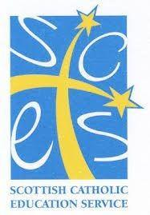

PFFA in St Joseph’s Primary ​

Faith and Fruits in In the Hot Seat With...
our Daily Lives​
Bishop John Keenan

Favourite thing about being a priest (Catholic): Being called ‘Father’, because I love being father in the family of the Church and keeping everyone together, happy in love.
Favourite Sacrament: Confession because it reminds me God loves me not for being perfect but for just keeping trying.
Favourite Prayer: The Rosary because I feel Our Lady and Jesus very close when I am praying it.
Favourite Hymn: Lord, You Have Come To The Seashore, because it reminds me I am a priest because Jesus called me and that is all that matters.
Hardest thing to do since C19: Trying to keep the family of our Church together when we cannot be together for Sunday Mass.
Favourite Church: My home parish of St. Gregory’s in Maryhill, Glasgow, where I grew up as a child and got to know Jesus.
Favourite Saint: I have lots but I would say Saint Joseph because he just quietly did what God asked him to do without seeking the limelight.
Anything to say to the readers: I was so lucky because my school, parish and family all worked together to help me grow in my Faith. I know it is the same in St. Joseph’s and I hope everyone builds on this and goes from strength to strength.

The Fruits of the Holy Spirit are what we
receive/see when we put the Gifts of the Holy
Spirit into practice. Here are some examples that
we have witnessed this month:
Joy- Getting a new fresh Christmas tree delivered
Joy- Smiling at someone could make others do the same and it could brighten their day. Smiles are infectious (Spike Milligan).
Joy - Making the most of the new restrictions and making the Christmas Story into an animation to share with others
Faithfulness - asking God for his forgiveness in confession and asking God to guide us.
Patience - you could wait on your friends finishing their work before going to start a new game
Patience -Wait on your your family getting ready and help everyone to get organised.
Patience - We are waiting for the current restrictions to lift and trying not to get frustrated.
Generosity - We have been thinking about giving presents to others at Christmas. These don’t need to be material things.
Generosity - This month we raised money by doing a sponsored ‘Walk to the Vatican’ in aid of Glasgow's Spirit of Christmas.

