St Joseph’s Primary School
Learning at Home (Remote Learning)
Accessing Google Classroom
Dear Pupil,
Below are some things you need to remember to be able to access Google Classroom at home.
You can log in using any of the following devices:
- Phones
- Tablets
- Laptops
- Desktops
- Chromebooks.

- If you are logging in using a laptop, desktop or chromebook click this link: www.glow.rmunify.com
- Log in using your glow username and password.
- If you have any problems logging in try glowusername@glow or glowusername@glow.sch.uk

- If you are using a phone or tablet, download the following apps :
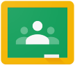
- Google classroom
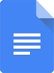
- Google docs
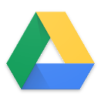
- Google drive

- To log into these use glowusername@er.glow.scot

To find tasks on a laptop, Chromebook or desktop:
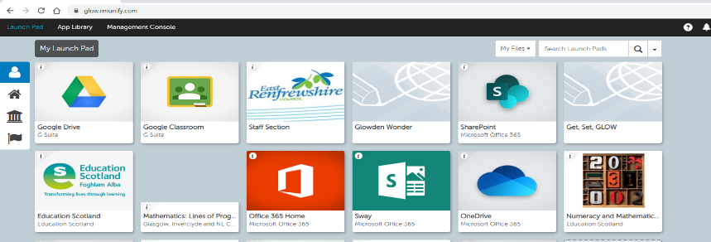
- Log into Glow and open Google classroom via your launch pad

To find tasks on a phone or tablet:
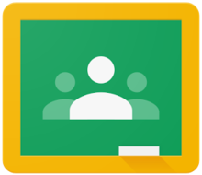
- Open the Google Classroom App on your phone or tablet.

Logging out when using a laptop, desktop or chromebook
Remember to log out fully when finished by clicking your initial on the right hand side and pressing sign out.

You also then need to log out of your Glow Launchpad

If sharing a phone or tablet to access Google Classroom
To add another account to the App, click the initial on the top right and press ‘add another account’. Pupils can then remain logged in and switch between their accounts if sharing.

