

**Parent Reading**

**Support Pack**

**Content**

**Jolly Phonics Sounds**

**Long Vowel Sounds**

**Blends**

**Vowels**

**Learn syllables with** 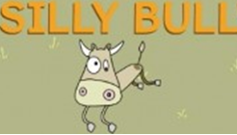

**Syllable Division (Part 1)**

**Syllable Division (Part 2)**

**Word Endings**

**Word Ending -le**

**Word Endings -ed**

**Magic **

** **

**When to use -tch and –ch**

* **and k**

**The Doubling Rule**

**Homophones**

**Mnemonic**

**Common Words – Set 1**

**Common Words – Set 2**

**Common Words – Set 3**

**Jolly Phonics Sounds**

|  |  |  |  |  |  |  |
| --- | --- | --- | --- | --- | --- | --- |
| **s** | **a** | **t** | **i** | **p** | **n** | **c** |
| **k** | **e** | **h** | **r** | **m** | **d** | **g** |
| **o** | **u** | **l** | **f** | **b** | **z** | **w** |
| **ng** | **v** | **oo** | **y** | **x** | **ch** | **sh** |
| **th** | **ai** | **j** | **oa** | **ie** | **ee** | **or** |
| **qu** | **ou** | **oi** | **ue** | **er** | **ar** |  |

**https://www.youtube.com/watch?v=-ksblMiliA8 (hear the sounds)**

**Long Vowel Sounds**

|  |  |  |  |  |
| --- | --- | --- | --- | --- |
| **Long vowel**  **a** | **Long Vowel**  **e** | **Long Vowel**  **i** | **Long Vowel**  **o** | **Long vowel**  **u** |
| **a-e** | **e-e** | **i-e** | **o-e** | **u-e** |
| **ay** | **ea** | **ie** | **oe** | **ui** |
| **ai** | **ee** | **y** | **oa** | **ue** |
|  |  | **igh** | **ow** | **ew** |

**A weak vowel says the letter sound**

**A strong vowel says the letter name**

**Blends**

|  |  |  |  |  |  |  |  |
| --- | --- | --- | --- | --- | --- | --- | --- |
| **Initial Consonant Blends** | | | **Double Consonant Blends** | **Final Consonant Blends** | | | |
| **br** | **st** | **sch** | **dd** | **nd** | **nk** | **mp** | **ft** |
| **cr** | **sn** | **scr** | **ff** | **rd** | **rk** | **rp** | **rt** |
| **dr** | **sm** | **spl** | **gg** | **ld** | **lk** | **lp** | **lt** |
| **fr** | **sp** | **str** | **ll** |  | **sk** | **sp** | **st** |
| **gr** | **sk** | **squ** | **ss** |  |  |  | **nt** |
| **pr** | **sw** | **thr** | **ck** |  |  |  | **pt** |
| **tr** |  | **shr** |  |  |  |  | **ct** |
|  |  | **chr** |  |  |  |  |  |

**Vowels**

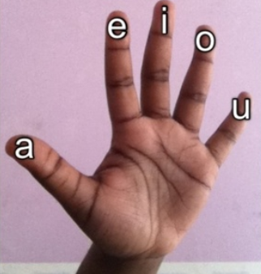

**These are the names of the vowels.**

**There is a vowel in every word.**

**This makes them very important.**

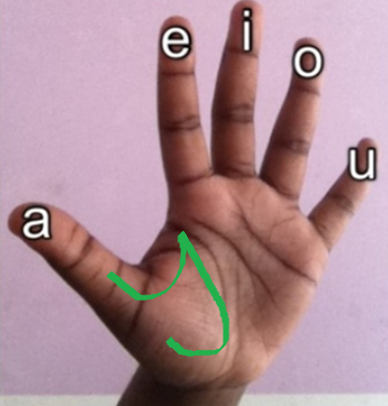

**Sometimes Y makes a vowel sound. Y is half a vowel.**

**Remembering Vowels**

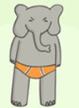

**an elephant in orange underpants**

**Learn syllables with** 

**beat!**

**beat!**

‘**Silly Bull’ beats the ground.**

**A syllable is the beat of a word.**

**Every syllable has a vowel sound.**

**It is the vowel sound that makes you open your mouth.**

**The vowels are a e i o u and y is our special vowel.**

**Right ‘Silly Bull’**  **how may beats are there in**

**beat!**

**beat!**

**Cobweb cob web - 2**

**Important im por tant - 3**

**Syllable Division (Part 1)**

**Using this strategy will help you read and spell longer words.**

**To split a word into syllables, first underline the vowels.**

**Kitten**

**Now find the middle point between the two vowels and split the word.**

**Kit ten**

**Now you can split a word into syllables.**

**The advantage of doing this is that you have smaller chunks to read or spell.**

**Syllable Division (Part 2)**

**Using this strategy will help you read and spell longer words.**

**To split a word into syllables, underline the vowels**

**hotel**

**and divide the word between them, but this word cannot be split in the middle.**

**hotel**

**You have to choose one side. Most words split on the side of the first vowel.**

**ho tel**

**Remember, most words split on the side of the first vowel, so always try this one first.**

**Here is another word to split. Underline the vowels and split the word.**

**le mon lee mon!**

**What is a leemon? This word does not sound right. So we will try splitting it on the other side.**

**lem on**

**Remember, if a word does not sound right you will need to try splitting it on the other side.**

**Word Endings**

**Head - Body - Tail**

**prefix root suffix**

**Every word has a body. Splitting words into head, body and tails makes smaller chunks that are easier to read and spell.**

**A body may have a tail.**

**This body has 2 tails.**

**A body may have a head.**

**re**

**The same body can have a different head.**

**im**

**This body has a head and a tail.**

**im**

**This body has 2 heads and 2 tails!**

**in**

**de**

**Word Ending -le**

**-le is a word ending that does not sound the way you would expect.**

**-le stands for –ul,**

**ul**

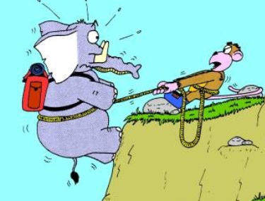

**pulling elephants**

**To read a word that ends in -le, count back three and split**

tr**e**m ble

1 2 3

ble

**Notice that the vowel is closed in trem / ble making it sound weak (sound)**

C**a** ble

1 2 3

**The vowel is open. It says its strong name**.

**Word Endings -ed**

**The word ending –ed can sound differently. Look below.**

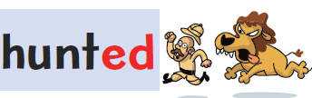

**id**

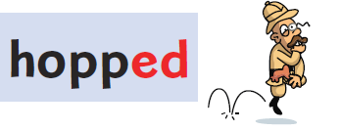

**t**



**d**

**Magic **

**Magic  gives power to vowels.**

**A weak vowel can only make a weak sound** 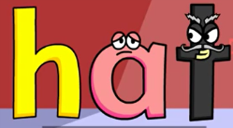

**T is closing in the vowel making it weak.**

**The weak vowel needs power, this is a job for Magic **

**The Magic  goes at the end of the word and sends all its power to the vowel.**

**Now the strong vowel says its name **

**But  has no power left to make a sound all its power has gone to make the weak vowel strong.**

[**https://www.youtube.com/watch?v=c3oA4wfUBak**](https://www.youtube.com/watch?v=c3oA4wfUBak)

**video about Magic **

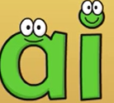 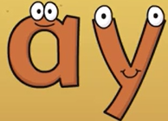

** and  both make the same sound a**

**trners  pl **

** goes in the middle of words **

 **at the end of words** 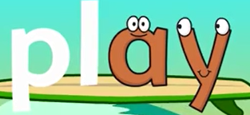

**Just watch out for words with a tail. Tails join the end of the body. So use  at the end of the body before you put on the tail.** 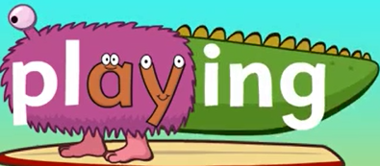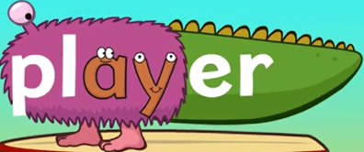

[**https://www.youtube.com/watch?v=BGrIyCT7nK0**](https://www.youtube.com/watch?v=BGrIyCT7nK0)

**video about  **

**When to use -tch and –ch**

**Some words are spelt with a -tch at the end and some words with just a -ch but they make the same sound.**

**-tch protects a lonely weak sound. When you see a vowel on its own, it is lonely. It makes a weak sound. To protect the vowel use –tch**

**pitch**

**All these words have lonely weak vowels.**

**hutch**

**catch**

**fetch**

**so use -tch to protect them.**

**Where the vowel has a friend use –ch.**

**pinch**

**bench**

**torch**

**march**

 **and k**

**Some words are spelled with**  **at the end**

**…..and some have just ‘k’, but they make the same sound.**

**When a vowel is on its own and makes a weak vowel sound it needs protecting with** **.**

**li ck**

**All these words have lonely, weak vowels, so I have to protect them with** 

**sack lick duck rock neck**

**Remember when you have a vowel on its own that makes a weak sound use the protector** **.**

**Where the vowel has a friend, use just a ‘k’.**

**lin k**

**The vowel has a letter friend and doesn’t need protecting.**

**All these words have vowels with letter friends!**

**tank week park bunk**

**Remember where a vowel has a friends use just a ‘k’.**

**The Doubling Rule**

**Words**

**How do you know when a word has a double or a single consonant in the middle?**

** you are so weak. Instead of 2 ears it has 2 consonants. The  word is weak it has a weak vowel sound, so we can make it into a rabbit word.**

**A rabbit can hop. Hop has a weak vowel sound so we can make it into a  word. Hopping is a  word.**

**Other  words are eat and jump.**

**eating – oh dear this word cannot become a  word because the vowel is strong. It says its name. Rabbits are weak.**

**jumper – this word has 2 consonants already it cannot change into a  word, it would have three ears!**

**Remember**

**To make a  word you double the consonant, but make sure it has a weak vowel sound in the body of the word and an ending as a tail.**

**Homophones**

|  |  |
| --- | --- |
| **their** | **there** |
| **were** | **where** |
| **which** | **witch** |
| **here** | **hear** |
| **road** | **rode** |
| **red** | **read** |
| **pair** | **pare** |
| **see** | **sea** |
| **piece** | **peace** |
| **whether** | **weather** |
| **no** | **know** |
| **to/too** | **two** |
| **pale** | **pail** |
| **hair** | **hare** |
| **knit** | **nit** |
| **leak** | **leek** |
| **knight** | **night** |
| **sure** | **shore** |
| **sun** | **son** |
| **mail** | **male** |
| **pray** | **prey** |
| **sleigh** | **slay** |
| **nay** | **neigh** |
| **bread** | **bred** |
| **allowed** | **aloud** |
| **tea** | **tee** |
| **flea** | **flee** |
| **stake** | **steak** |
| **flower** | **flour** |
| **warn** | **wore** |
| **dear** | **deer** |
| **bear** | **bare** |
| **peak** | **peek** |
| **week** | **weak** |
| **nun** | **none** |
| **key** | **quay** |

**Mnemonic**

|  |  |
| --- | --- |
| because | **b**ig **e**lephants **c**an **a**lways **u**nderstand **s**mall **e**lephants |
| beautiful | **b**ig **e**ars **a**nd **u**gly **t**eeth **I** **f**ind **u**tterly **l**ovely |
| any | **a**nts **n**ip **y**ou |
| come | **c**ome **o**n **m**y **e**lephant |
| could | **C**ould **O**liver **u**nderstand **l**ittle **d**ogs? |
| every | **e**very **v**ampire **e**ats **r**ed **y**ogurt |
| many | **m**any **a**nts **n**ip **y**ou |
| said | **S**am **a**nd **I** **d**ance |
| their | **t**heir **h**appy **e**lephant **i**s **r**ed |
| was | **w**as **a** **s**ausage |
| which | **w**hich **h**orse **i**s **C**harlie **h**aving? |
| what | **W**hat **hat**? |
| with | **w**ith **i**t **t**ickle **h**er |
| you | **y**ou **o**pen **u**mbrella |
| all | **a**nts **l**ook **l**ittle |
| does | **D**oes **O**liver **e**at **s**weets? |

**Common Words – Set 1**

|  |  |  |  |
| --- | --- | --- | --- |
| the  of  and  a  to  in  is  you  that  it | he  was  for  on  are  as  with  his  they  I | at  be  this  have  from  or  one  had  by  word | many  not  what  all  were  we  when  your  can  said |

**Common Words – Set 2**

|  |  |  |  |
| --- | --- | --- | --- |
| there  use  an  each  which  she  do  how  their  if  will  up  other  about  out | many  then  them  these  so  some  her  would  make  like  him  into  time  has  look | two  more  write  go  see  number  no  way  could  people  my  than  first  water  been | call  who  oil  now  find  long  down  day  did  get  come  made  may  part  over |

**Common Words – Set 3**

|  |  |  |  |
| --- | --- | --- | --- |
| new  sound  take  only  little  work  know  place  year  live  me  back  give  most  very  after  thing  our  just  name  good  sentence  man  think  say | help  where  great  through  much  before  line  right  too  mean  old  any  same  tell  boy  follow  came  want  show  also  around  form  three  small  set | put  end  does  another  well  must  large  big  even  such  because  turn  here  why  ask  went  men  read  need  land  different  home  us  move  try | picture  hand  large  again  change  off  play  spell  air  away  animal  house  page  point  letter  mother  answer  found  study  still  learn  should  America  world  high |