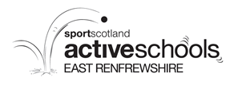

End of Term Ski Race
In celebration of the success of the Active Schools Ski Programme, Glasgow Ski & Snowboard Centre are hosting a fun ski race for all children who can ski at intermediate level or above (no race skiers please). Please note this is event is now open to all intermediate level or above skiers regardless if they have taken part in the schools programme.
Dates: Wednesday 20th & Thursday 21st June 2018
Time: 4:30pm (with an anticipated finish by 6:30pm)
Costs: £8 (covers race entry & equipment hire)
Tubing is provided for siblings or friends not racing. 45 minutes sessions are available at the cost of £5 when booking a child onto the race event.
Call the office before Friday 15th June on 0141 427 4991 to book your place.

