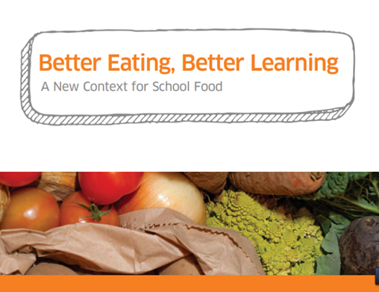
We are delighted to share the news that St Joseph’s have won the National Better Eating, Better Learning award for primary.
The BEBL award is a competition open to schools across Scotland who can demonstrate innovative ways to improve school and food education.
For the second year in a row, we have reached the finals of this prestigious award.
This year the 2 Judges were treated to a tour of the school garden, where some P6 children were cooking a paella on the fire pit, a visit to the school kitchen to see the P6 Kitchen Work Experience children making a vegetable curry and enjoyed looking at a photo gallery and a wide variety of work carried out from P1 through to P7.
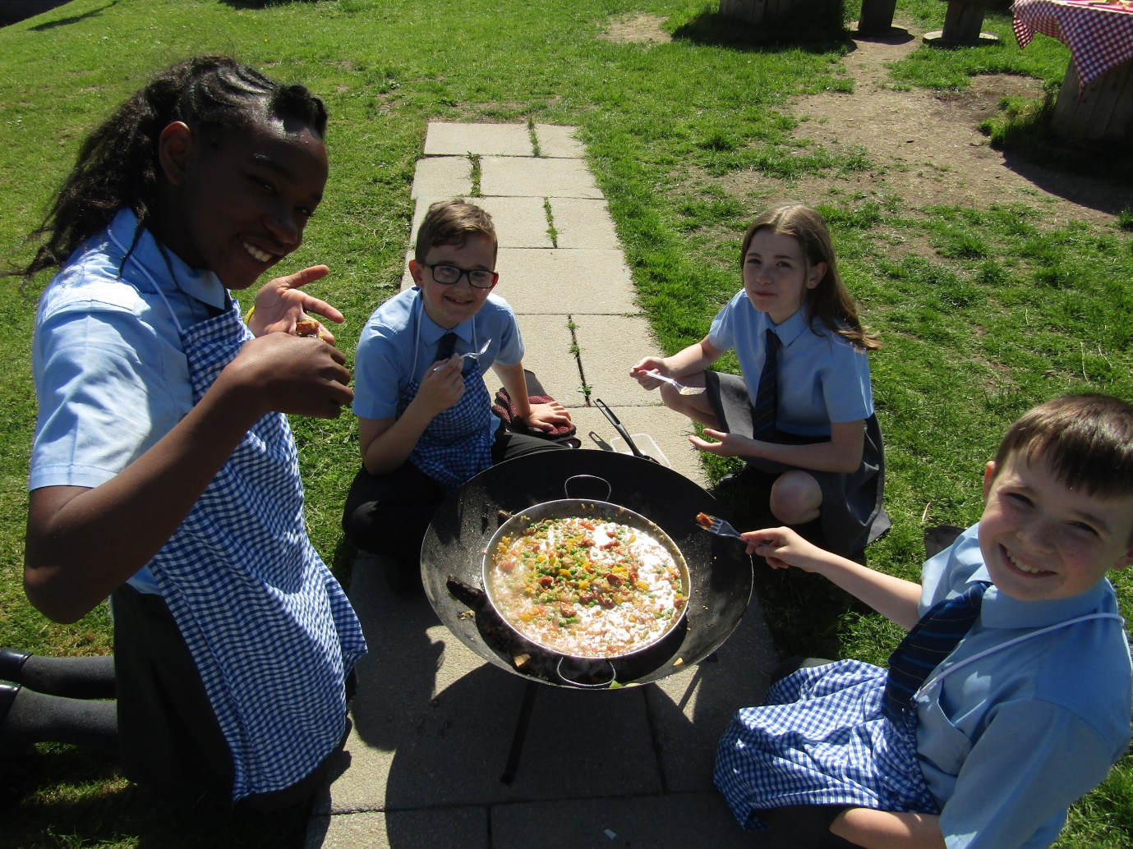
“We were highly impressed with the pupils leading the visit and articulating their knowledge so confidently – it is clear to see that using food as a context for learning throughout the school is sparking the enthusiasm of the pupils and it was lovely to see the pupils continue to work with school catering staff on that particular work experience project.” The Judges.

St Joseph’s aim is to educate, excite and inspire children to grow, cook and enjoy food through our Food and Health curriculum.
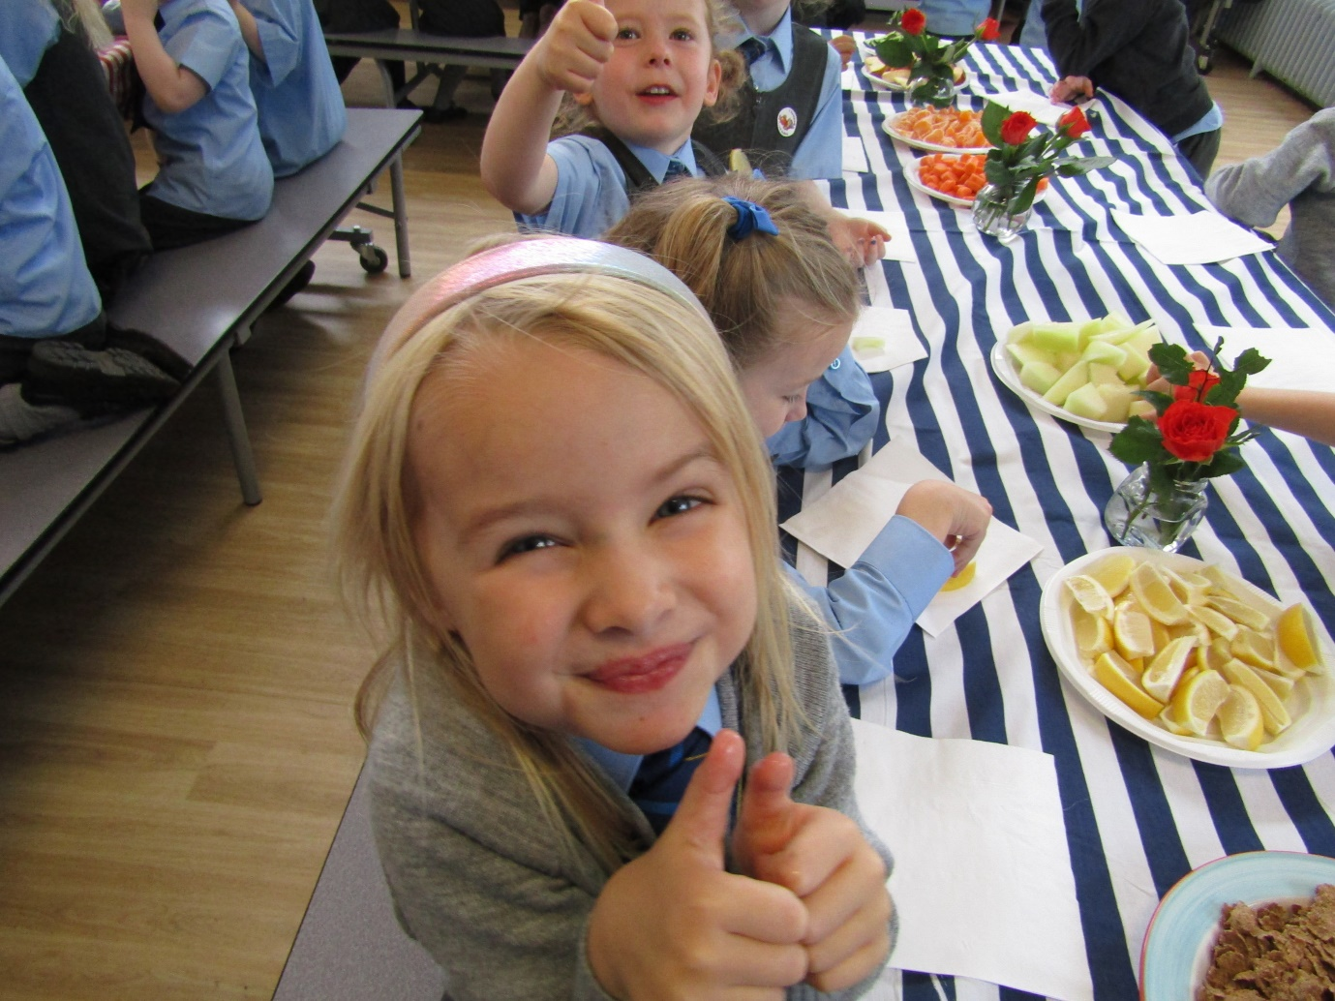
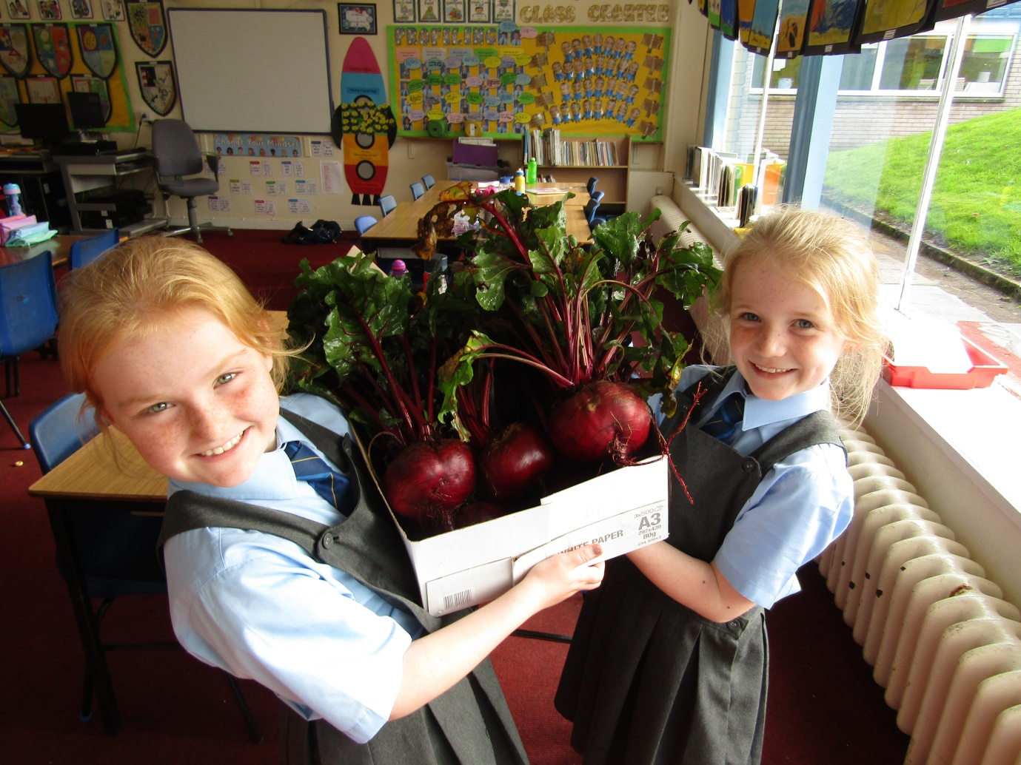
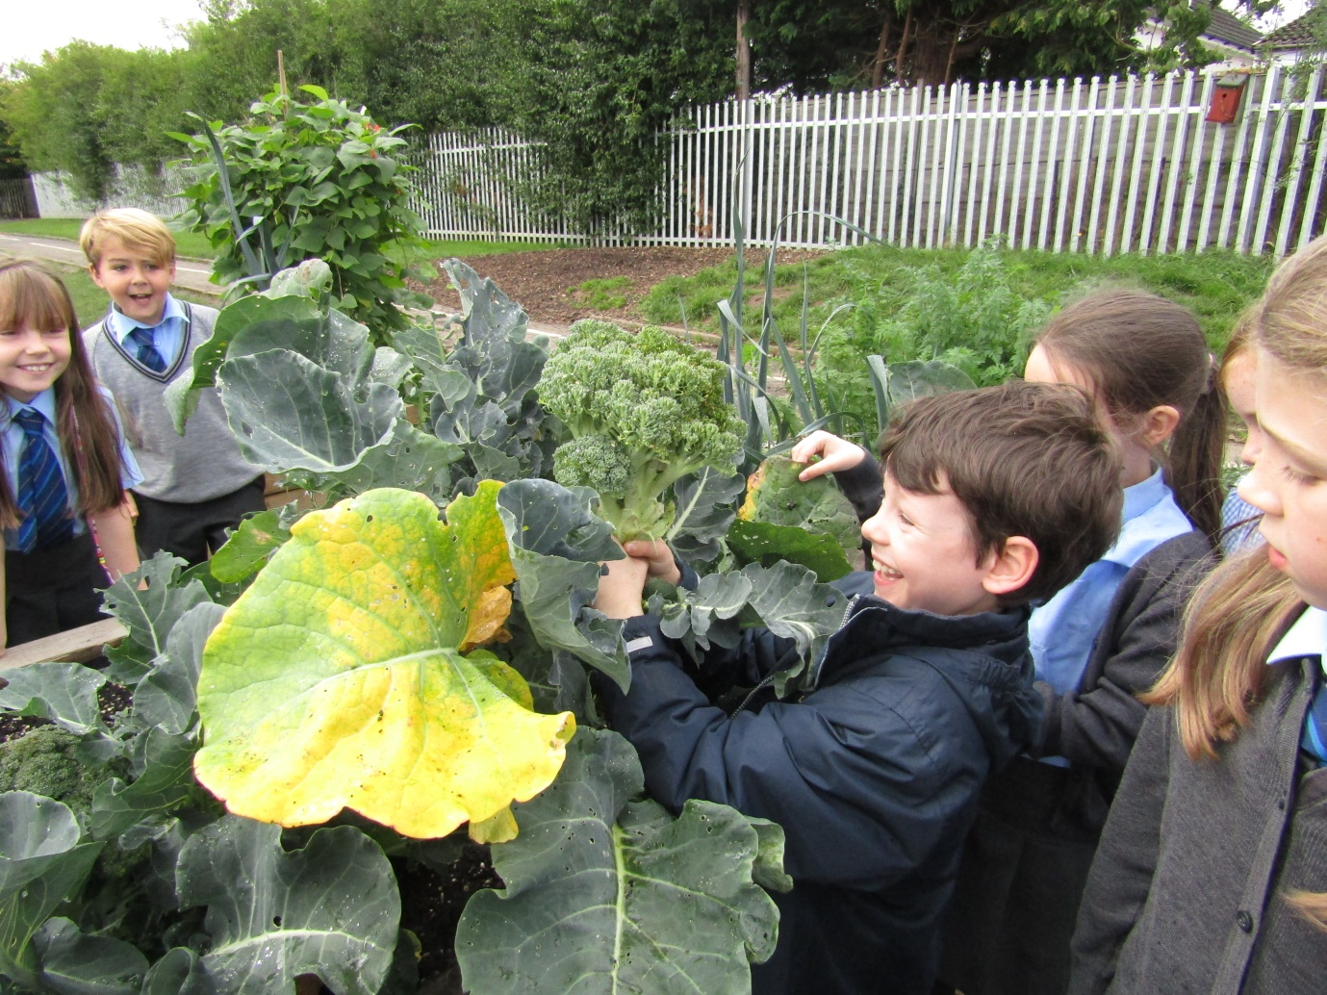
This is a huge achievement which would have not been possible without the help and support of our School Community. We would like to extend a sincere thank you to everyone who has contributed to the creation of the school garden and the opportunities it has presented to teach children about enjoying a healthy lifestyle now and in the future.
Thank you especially to our catering team who work so closely with us to enhance our children’s food experiences.
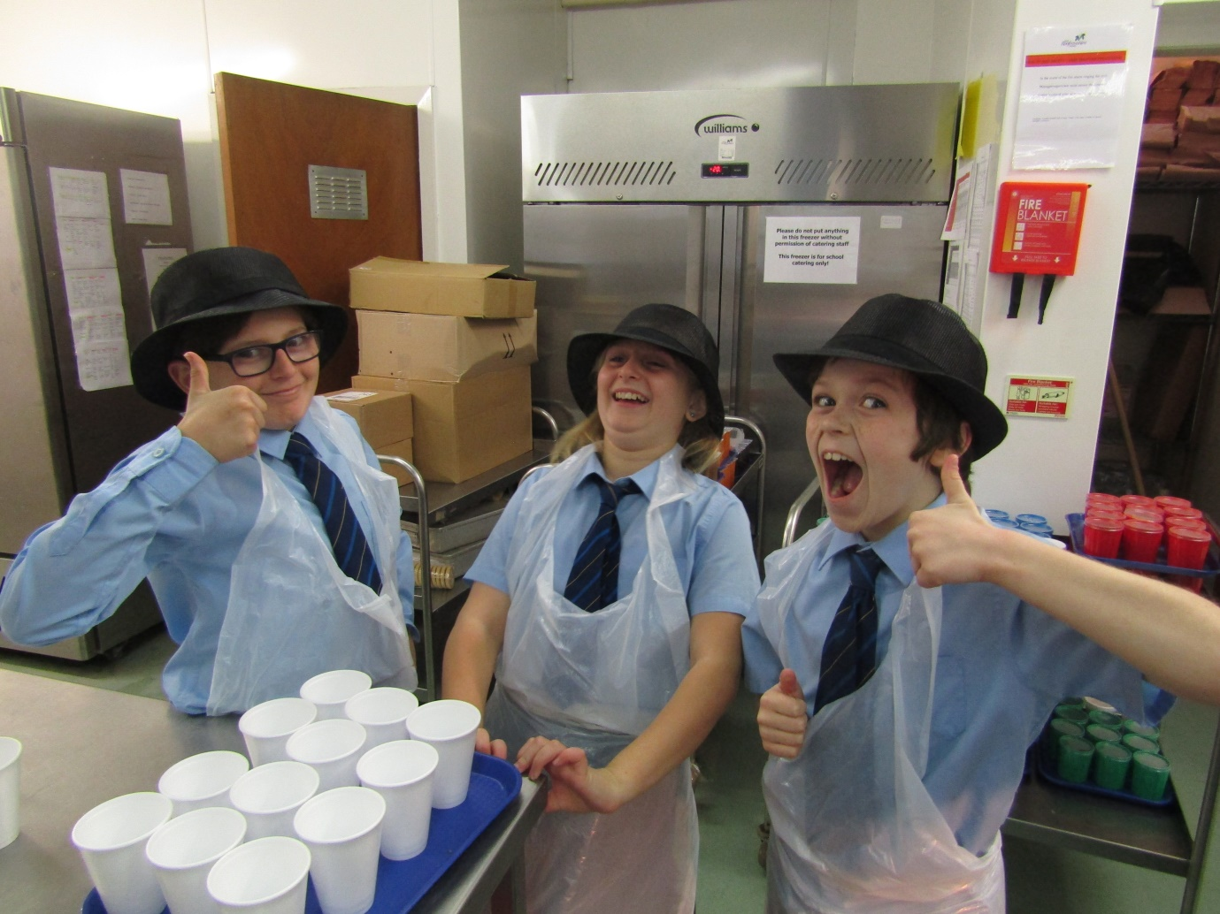
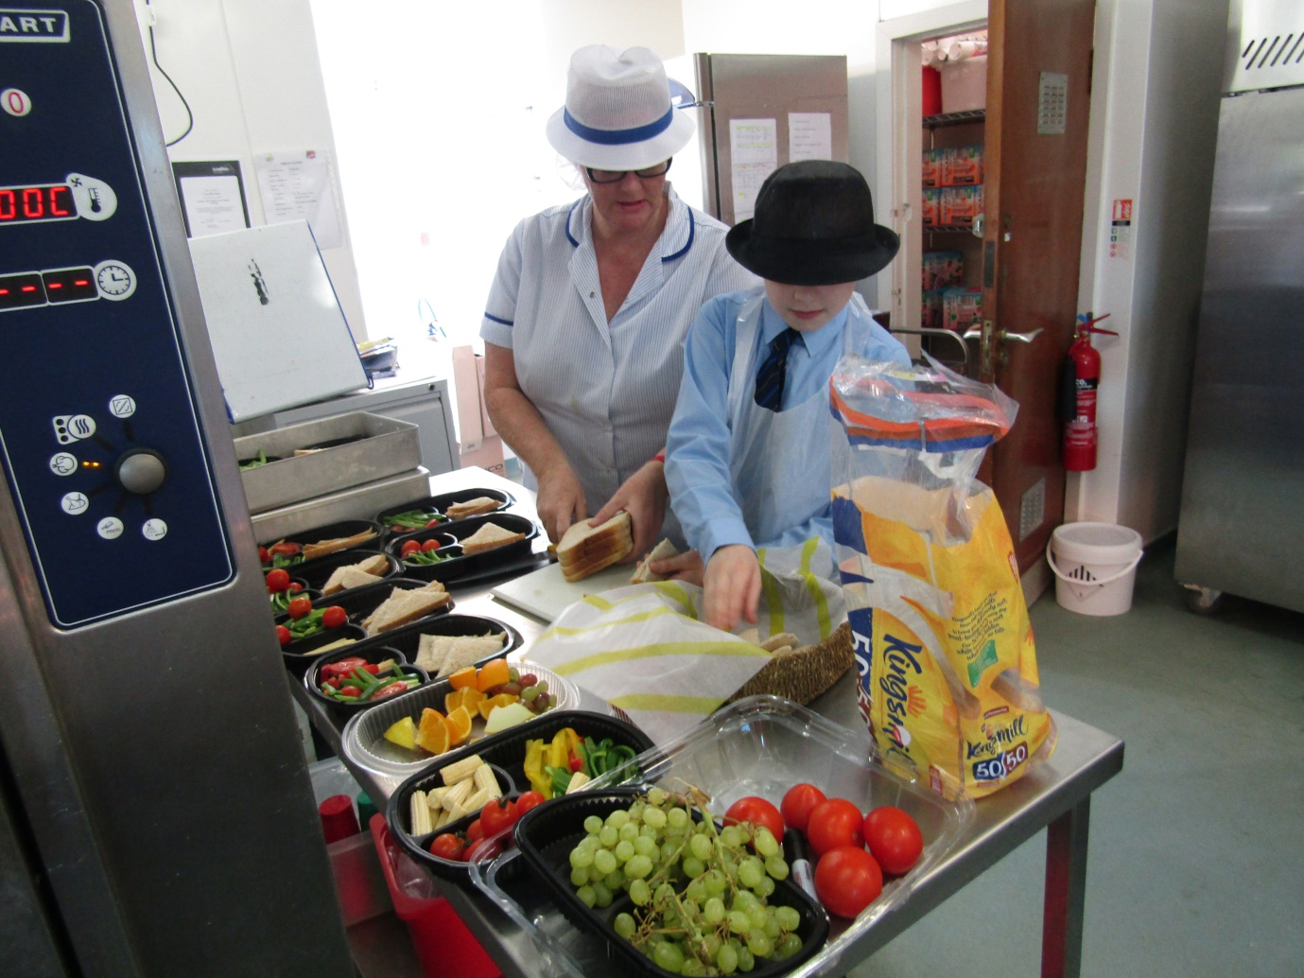
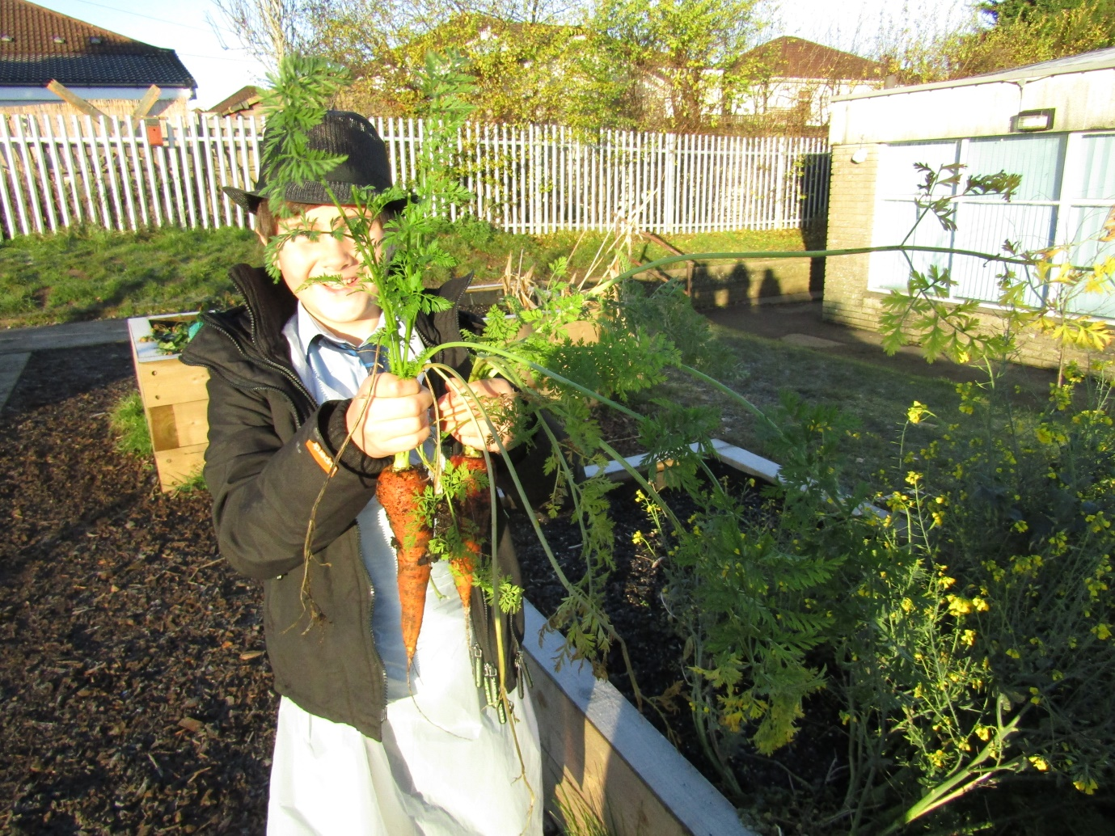
We are looking forward to sharing our food journey at the ASSIST FM conference in August.

