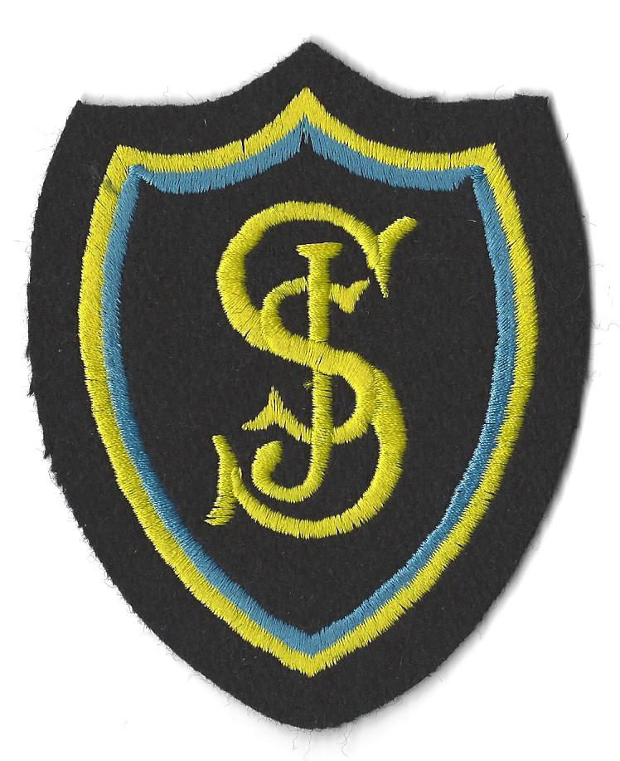
St Joseph’s Primary School

CALENDAR 2016 - 2017

Week Commencing | Monday | Tuesday | Wednesday | Thursday | Friday
08.08.16 |  |  |  | In-Service day | In-Service day
15.08.16 | Pupils return  9.30 Mass P3 – P7  1.30 Mass P1 & P2 |  | 3.15 – 4.00  Come and Meet My Teacher
22.08.16 |  | 7pm: Social Committee Meeting |  | P7 Class Mass
29.08.16 |  | 6.15pm P1 and P7 Curricular workshop |  |  | P7 Safety in the Park  P1 Welcome Night
05.09.16 |  | 6.15pm P2 and P6 Curricular workshop
12.09.16 |  | 6.15pm P3 and P5 Curricular workshop
19.09.16 |  | 6.15pm P4 Curricular workshop |  | P6 Class Mass | Holiday
26.09.16 | Holiday | Parent Council meeting and AGM
03.10.16 |  |  |  | P5 Class Mass
10.10.16 | 7pm: P4 Sacramental Preparation Meeting | Social Committee Meeting |  |  | In-Service day
17.10.16 | Holiday | Holiday | Holiday | Holiday | Holiday
24.10.16 |  |  |  | P2 – P5 Halloween Disco
31.10.16 |  | 9.30: Mass  All Saints Day  Social Committee Meeting
07.11.16 | 7pm: P7 Sacramental Preparation Meeting |  | Parents Nights | Parents Nights
14.11.16
21.11.16 |  |  |  |  | Advent Assembly
28.11.16 |  | Parent Council Meeting | 9.30 Mass  St Andrew’s Day |  | Advent Assembly
05.12.16 |  | 2pm: P3 Nativity | 10am: P3 Nativity  2pm: P2 Nativity |  | Advent Assembly
12.12.16 | 10am: P2 Nativity | 10am: P1 Nativity | 2pm: P1 Nativity  P6/7 Disco (Parent Council) | 7pm: P4 Advent Service
19.12.16 |  |  | Aladdin whole school pantomime. School Closes 2.30pm | Holiday | Holiday
26.12.16 | Holiday | Holiday | Holiday | Holiday | Holiday
02.01.17 | Holiday | Holiday | Holiday | School Re-opens
09.01.17 |  | Social Committee Meeting
16.01.17
23.01.17
30.01.17 |  |  |  |  | Ceilidh Night  (Parent Council)
06.02.17 |  | Parent Council Meeting |  |  | In-Service day
13.02.17 | Holiday | Holiday | Holiday
20.02.17 |  |  | Sponsored Bounce  (Parent Council)
27.02.17 |  |  | Ash Wednesday
06.03.17
13.03.17 |  |  |  | P3 Class Mass | Feast of St Joseph’s
20.03.17 |  |  | Parents Nights | P2 Class Mass  Parents Nights
27.03.17
03.04.17 | Holiday | Holiday | Holiday | Holiday | Holiday
10.04.17 | Holiday | Holiday | Holiday | Holiday | Good Friday Holiday
17.04.17 | Easter Monday Holiday
24.04.17 |  | Parent Council Meeting |  | P1 Class Mass
01.05.17 | May Day Holiday
08.05.17 |  | Social Committee Meeting
15.05.17
22.05.17 |  | 7pm: P4 and P7 Thanksgiving Mass (TBC) |  | Ascension Day | Holiday
29.05.17 | Holiday | In-Service day
05.06.17 |  | Parent Council Meeting |  | P4 Class Mass | Quiz Night  (Parent Council)
12.06.17 | P7 Lockerbie Manor | P7 Lockerbie Manor | P7 Lockerbie Manor | P7 Lockerbie Manor | P7 Lockerbie Manor
19.06.17 |  | Leavers Disco  (Parent Council) |  | P7 Leavers Mass
26.06.17 |  | 1pm  School Closes

Christmas Fayre (Parent Council) Saturday 26th November

FIRST COMMUNION
Saturday 13th May - St Joseph’s Church – P4a 10.00am, P4b 12.30pm
Sunday 14th May – St Bridget’s Church – 11.00am

Sunday 14th May – St Joseph’s Church - Communion Breakfast (Parent Council)

Please note that there may be occasions when some dates will require to be changed and other activities and events added.

