St Cadoc's Primary




Mathematics 1st and 2nd Level
Parent and Carer Leaflet

Article 29: Children’s education should develop each child’s personality, talents and abilities to the fullest. It should encourage children to respect others, human rights and their own and other cultures.

In St. Cadoc’s, we recognise that Mathematics is fundamental to all areas of learning, as it unlocks access to the wider curriculum.

What can learning in mathematics enable children and young people to achieve?

Mathematics is important in our everyday life, allowing us to make sense of the world around us and to manage our lives. Using mathematics enables us to model real-life situations and make connections and informed predictions. It equips us with the skills we need to interpret and analyse information, simplify and solve problems, assess risk and make informed decisions.

Because mathematics is rich and stimulating, it engages and fascinates learners of all ages, interests and abilities. Learning mathematics develops logical reasoning, analysis, problem-solving skills, creativity and the ability to think in abstract ways. It uses a universal language of numbers and symbols which allows us to communicate ideas in a concise, unambiguous and rigorous way.
Mathematics Principles and Practice Paper

Mathematics Framework
The mathematics experiences and outcomes are structured within three main organisers, each of which contains a number of subdivisions:

Number, Money and Measure | Shape, position and movement | Information handling
Number and number processes  Multiples, factors and primes  Powers and roots  Fractions, decimal fractions and percentages  Money  Time  Measurement  Mathematics – its impact on the world, past, present and future  Patterns and relationships  Expressions and equations. | Properties of 2D shapes and 3D objects  Angle, symmetry and transformation. | Data and analysis  Ideas of chance and uncertainty.

We aim to enable all our children to:

- Develop a secure understanding of the concepts, principles and processes of mathematics and apply these in different contexts, including the world of work

- Understand the application of mathematics, its impact on our society past and present, and its potential for the future

- Develop essential numeracy skills which will allow them to participate fully in society

- Understand that successful independent living requires financial awareness, effective money management, using schedules and other related skills

- interpret numerical information appropriately and use it to draw conclusions, assess risk, and make reasoned evaluations and informed decisions

- apply skills and understanding creatively and logically to solve problems, within a variety of contexts

- Provide a consistent and whole school methodology in line with reciprocal reading approaches and Curriculum for Excellence

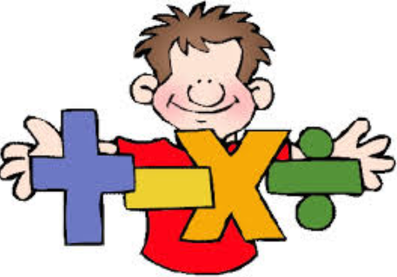

Supporting learning at home. How can you help?

- Practise the number facts regularly with your child
- Support them in the use of homework diary and class notes
- Support their organisation - pencil/rubber/ruler/jotters
- Encourage their best presentation
- Ensure they attempt all questions
- Step-by-step, vertical working where possible

Some practical tips:
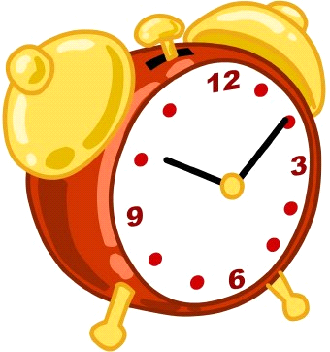
- Time: Encourage your child to use a watch or clock to tell the time, provide timed activities and read timetables

- Calendars: Plan family birthdays on a calendar & do a birthday countdown.

- Measure: Take advantage of measure opportunities in the kitchen; weighing, timing and temperature
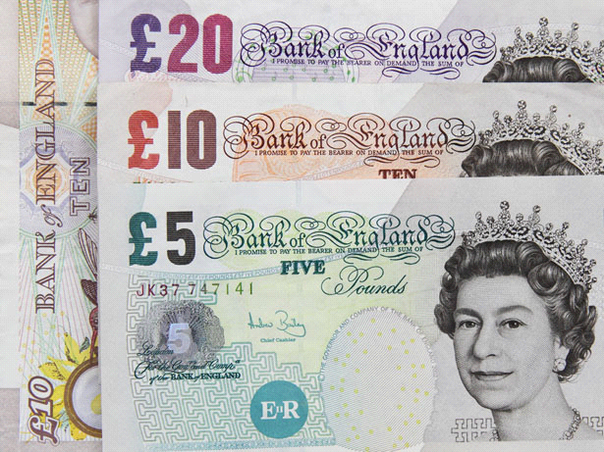
- Money: Talk about best deals with your child, budgeting pocket money or wages.

- Estimating: plan for activities in advance like calculating the number of rolls of paper or paint required to decorate a room, the length of time activities may take.


- Logical thinking: Ask your child to explain their thinking and consider consequences of actions. e.g. using the information gathered from reading newspapers, using the internet and watching TV to draw conclusions and make choices that involve numeracy.

LANGUAGE OF ARITHMETIC

Avoid the use of the word ‘sum’ to mean a maths question.
Use the word ‘calculation’
Addition (+)
• sum of
• more than
• add
• total
• and
• plus
• increase

Subtraction (-)
• less than
• take away
• minus
• subtract
• difference between

Equals (=)
• is equal to
• same as
• makes
• will be

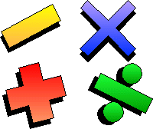

Multiplication (×)
• multiply
• times
• product of

Division (÷)
• divide
• share equally
• split equally
• groups of
• per
quotient

Written Calculations

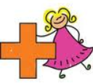
Before doing a calculation, pupils should be encouraged to make an estimate of the answer by rounding the numbers. They should also be encouraged to check if their answers are sensible in the context of the question.
Addition

Example: 3456 + 975
We add the numbers in each column from right to left
Line up the numbers according to place value
3 456 + 975

Estimate
3 500 + 1 000 = 4 500

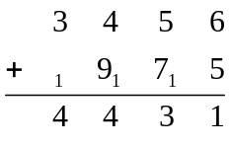

Carried numbers are written above the line

Mental Calculations
Children should be able to carry out the following processes mentally, although some will need further thinking time
* recall addition and subtraction facts up to 20
* recall multiplication and division facts for multiplication tables up to 10
Children should also be encouraged to carry out other calculations mentally using a variety of strategies.
e.g. 34 + 28 = 34 + 30 - 2 68 + 4 = (68 +2) + 2
163 - 47 = 163 - 50 + 3
Children will be encouraged to discuss how they might do mental calculations such as these.
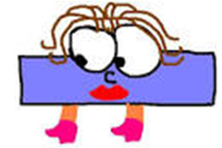
Subtraction

Subtraction with Exchanging
It is important that you are familiar with the words and methods your child’s teacher will be using in the classroom. One potential change from your school days may be that the term “EXCHANGE” is used instead of “borrow” and “pay back” or “equal addition”.

Step 1:
Begin at the units column. 2 is less than 8, therefore I cannot subtract.
H T U
3 5 2
- 1 6 8
_______

Step 2:
Go to the tens column.
You must EXCHANGE one of the five tens for ten units. Score out the 5 and write a small 4.
Put the figure 1 (representing one ten – 10 units) in front of the 2 units.
12 subtract 8 is 4. Put a figure 4 in the units column
H T U
3 ⁴5 ¹2
- 1 6 8
4

Step 3:
Go to the tens column. We can’t subtract 6 tens from 4 tens.
Go to the hundreds column. You have 3 hundreds here.
EXCHANGE 1 hundred for 10 tens. Do this by scoring out the 3 and
writing a small 2. Put the figure 1 in front of the 4 tens.
14 subtract 6 is 8. Write the figure 8 in the tens column
H T U
² 3 ¹⁴5 ¹2
- 1 6 8
8 4

Step 4:
Go to the hundreds column. 2 hundreds subtract 1 hundred equals
1 hundred. Write a 1 in the hundreds column. The answer is 184.
H T U
² 3 ¹⁴5 ¹2
- 1 6 8
1 8 4


Multiplication
Multiplying Tens and Units
First multiply the units.
2 x 6 = 12
Put the 2 in the units column and carry the 1 to the tens column.
Next multiply the tens column
2 x 5 = 10 …
Adding the 1 makes
11 tens. Put 1 in the tens column and 1 in the hundreds column

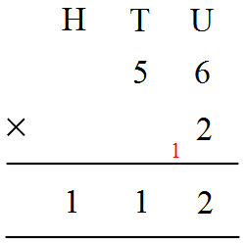

Next, multiply the tens
4 x 6 = 24…
and add the 2 makes
26 tens. Put 6 in the tens column and carry the 2 to the hundreds column
First multiply the units.
4 x 5 = 20
Put the 0 in the units column and carry the 2 to the tens column

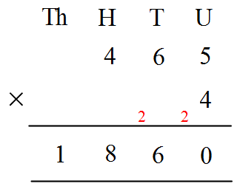

v
Finally, multiply the hundreds 4 x 4 =16…
and add the 2 makes
18 hundreds. Put 8 in the hundreds column and the 1 in the thousands column

Division

Unlike other written methods for addition, subtraction and multiplication, the standard layout for division works from left to right and is displayed in a different way.
810 ÷ 6

We start at the left hand column and work to the right.

Start with 8 divided by 6 (8 ÷ 6 = 1 remainder 2). The 1 is written above the line in the same column as the 8.
(Pupils can be supported if necessary by saying “how many 6s in 8?”
Any remainders are carried over to the next digit. Here, the remainder 2 is carried over beside to the 1 and the next calculation is 21 divided by 6
(21 ÷ 6 = 3 remainder 3). The remainder is again carried over to the next digit. The next calculation is 30 divided by 6 (30 ÷ 6 = 5).

Division of decimals

When dividing a decimal number by a whole number, the calculation is the same as a division without decimal points, with the decimal point in the answer being inserted above the decimal point in the question.

0 8 1 . 9
4 3 ³2 7 . ³6

A decimal division is calculated in the same way as Example 3.
Each calculation is performed in turn and remainders carry over to the next digit. The decimal point does not change the method – the answer should contain a decimal point in the same place as the decimal you are dividing.

Useful websites

www.topmarks.co.uk

http://www.topmarks.co.uk/Flash.aspx?f=SpeedChallenge

www.primaryresources.co.uk/maths/maths.htm
www.taw.org.uk/lic/itp/index.html
http://www.kidzone.ws/math/index.htm

http://mathworksheetwizard.com/

http://themathworksheetsite.com/

http://www.mathfactcafe.com/worksheet/wordproblem/

http://www.sheffieldmaths.co.uk/

http://www.visnos.com/demos/clock

http://www.timestables.me.uk/printable-pdf-quiz-generator.htm

