**2015**

**Waves and Particles**

**Standard Model, Forces on Charged Particles, Nuclear Reactions, Wave Particle Duality, Interference and Diffraction, Refraction of Light, Spectra.**

Contents

Section 1: The standard model 2

Orders of magnitude 2

The standard model of fundamental particles and interactions 3

Section 2: Forces on charged particles 5

electric fields 5

Charged particles in a magnetic field 7

Particle accelerators 9

Section 3: Nuclear reactions 14

Fission and fusion 14

Section 4: Wave particle duality 17

Photoelectric effect 17

Section 5: Interference and diffraction 21

Section 6: Refraction of light 25

Section 7: Spectra 29

Irradiance and inverse square law 29

Line and continuous spectra 30

# Section 1: The standard model

## Orders of magnitude

1. The diagram shows a simple model of the atom.

+

+

−

+

+

+

−

−

−

−

−

B

C

D

A

Match each of the letters A, B, C and D with the correct word from the list below.

electron neutron nucleus proton

2. In the following table the numbers or words represented by the letters A, B, C, D, E, F and G are missing.

|  |  |
| --- | --- |
| *Order of magnitude/m* | *Object* |
| 10−15 | A |
| 10−14 | B |
| 10−10 | Diameter of hydrogen atom |
| 10−4 | C |
| 100 | D |
| 103 | E |
| 107 | Diameter of Earth |
| 109 | F |
| 1013 | Diameter of solar system |
| 1021 | G |

Match each letter with the correct words from the list below.

diameter of nucleus diameter of proton diameter of Sun

distance to nearest galaxy height of Ben Nevis

size of dust particle your height

## The standard model of fundamental particles and interactions

1. Name the particles represented by the following symbols.

(a) p (b) $\overline{p}$ (c) e (d) 

$\overline{e}$

(e) n (f)  (g) *v* (h) 

2. A particle can be represented by a symbol where M represents the mass number, A the atomic number and X identifies the type of particle, for example a proton can be represented by . Give the symbols, in this form, for the following particles.

(a) $\overline{p}$ (b) e (c) (d) n (e)

3. Copy and complete the table by placing the fermions in the list below in the correct column of the table.

bottom charm down electron electron neutrino

muon muon neutrino strange tau

tau neutrino top up

|  |  |
| --- | --- |
| *Quarks* | *Leptons* |
|  |  |
|  |  |
|  |  |
|  |  |
|  |  |
|  |  |

4. (a) State the difference between a hadron and a lepton in terms of the type of force experienced by each particle.

(b) Give one example of a hadron and one example of a lepton.

5. Information on the sign and charge relative to proton charge of six types of quarks (and their corresponding antiquarks) is shown in the table.

|  |  |  |  |
| --- | --- | --- | --- |
| *Quark name* | *Charge relative to size of proton charge* | *Antiquark name* | *Charge relative to size of proton charge* |
| up | +2/3 | antiup | –2/3 |
| charm | +2/3 | anticharm | –2/3 |
| top | +2/3 | antitop | –2/3 |
| down | –1/3 | antidown | +1/3 |
| strange | –1/3 | antistrange | +1/3 |
| bottom | –1/3 | antibottom | +1/3 |

Calculate the charge of the following combinations of quarks:

1. two up quarks and one down quark
2. one up quark and two down quarks
3. two antiup quarks and one antidown quark
4. one antiup quark and two antidown quarks.

6. Neutrons and protons are considered to be composed of quarks.

(a) How many quarks are in each neutron and in each proton?

(b) Comment briefly on the different composition of the neutron and proton.

7. (a) Briefly state any differences between the ‘strong’ and ‘weak’ nuclear forces.

(b) Give an example of a particle decay associated with the weak nuclear force.

(c) Which of the two forces, strong and weak, acts over the greater distance?

# Section 2: Forces on charged particles

## electric fields

1. Draw the electric field pattern for the following point charges and pair of charges:

(a) plus (b) minus (c) plus minus

2. Describe the motion of the small positive test charges in each of the following fields.



(a) (b)

(c) (d)



3. An electron volt (eV) is a unit of energy. It represents the change in potential energy of an electron that moves through a potential difference of 1 V (the size of the charge on an electron is 1·6 x 10−19 C).

What is the equivalent energy of 1 eV in joules?

4. An electron has energy of 5 MeV. Calculate its energy in joules.

5. The diagram shows an electron accelerates between two parallel conducting plates A and B.



The p.d. between the plates is 500 V.

(mass of electron = 9·1 x 10−31 kg

charge on electron = 1·6 x 10−19 C)

(a) Calculate the electrical work done in moving the electron from plate A to plate B.

(b) How much kinetic energy has the electron gained in moving from A to B?

(c) What is the speed of the electron just before it reaches plate B?

6. Electrons are ‘fired’ from an electron gun at a screen.

108

The p.d. across the electron gun is 2000 V.

The electron gun and screen are in a vacuum.

After leaving the positive plate the electrons travel at a constant speed to the screen.

Calculate the speed of the electrons just before they hit the screen.

7. A proton is accelerated from rest across a p.d. of 400 V.

Calculate the increase in speed of the proton.

8. In an X-ray tube electrons forming a beam are accelerated from rest and strike a metal target.

The metal then emits X-rays.

The electrons are accelerated across a p.d. of 25 kV. The beam of electrons forms a current of 3·0 mA.

(a) (i) Calculate the kinetic energy of each electron just before it hits the target.

(ii) Calculate the speed of an electron just before it hits the target.

(iii) Find the number of electrons hitting the target each second.

(mass of electron = 9·1 × 10−31 kg

charge on electron = 1·6 × 10−19 C)

(b) What happens to the kinetic energy of the electrons?

9. Sketch the paths which

1. an alpha-particle
2. a beta-particle
3. a neutron

would follow if each particle, with the same velocity, enters the electric fields shown in the diagrams.

109

## Charged particles in a magnetic field

1. An electron travelling with a constant velocity enters a region where there is a uniform magnetic field. There is no change in the velocity of the electron. What information does this give about the magnetic field?

2. The diagram shows a beam of electrons as it enters the magnetic field between two magnets.

beam of  
electrons

**N**

**S**

**S**

**N**

The electrons will:

A be deflected to the left (towards the N pole)

B be deflected to the right (towards the S pole)

C be deflected upwards

D be deflected downwards

E have their speed increased without any change in direction.

3. The diagrams show particles entering a region where there is a uniform magnetic field.

Use the terms: *up, down, into the paper, out of the paper, left, right, no change in direction* to describe the deflection of the particles in the magnetic field.

(a)

electron

magnetic field

(b)

magnetic field

alpha particle

(c)

neutron

magnetic field

(d)

proton

magnetic field

electron

magnetic field

(e)

proton

magnetic field

(f)

electron

x

x

x

x

x

x

x

x

x

x

x

x

x

x

x

x

x

x

x

x

x

x

x

x

x

magnetic field

(g)

proton

x

x

x

x

x

x

x

x

x

x

x

x

x

x

x

x

x

x

x

x

x

x

x

x

x

magnetic field

(h)

4. An electron enters a region of space where there is a uniform magnetic field. As it enters the field the velocity of the electron is at right angles to the magnetic field lines.

The energy of the electron does not change although it accelerates in the field.

Use your knowledge of physics to explain this effect.

## Particle accelerators

In the following questions, when required, use the following data:

Charge on electron = –1·60 × 10−19 C Mass of electron = 9·11 × 10−31 kg

Charge on proton = 1·60 × 10−19 C Mass of proton = 1·67 × 10−27 kg

1. In an evacuated tube, an electron initially at rest is accelerated through a p.d. of 500 V.

(a) Calculate, in joules, the amount of work done in accelerating the electron.

(b) How much kinetic energy has the electron gained?

(c) Calculate the final speed of the electron.

2. In an electron gun, electrons in an evacuated tube are accelerated from rest through a potential difference of 250 V.

(a) Calculate the energy gained by an electron.

(b) Calculate the final speed of the electron.

3. Electrons in an evacuated tube are ‘fired’ from an electron gun at a screen. The p.d. between the cathode and the anode of the gun is 2000 V. After leaving the anode, the electrons travel at a constant speed to the screen. Calculate the maximum speed at which the electrons will hit the screen.

4. A proton, initially at rest, in an evacuated tube is accelerated between two charged plates A and B. It moves from A, where the potential is 10 kV, to B, where the potential is zero.

Calculate the speed of the proton at B.

5. A linear accelerator is used to accelerate a beam of electrons, initially at rest, to high speed in an evacuated container. The high- speed electrons then collide with a stationary target. The accelerator operates at 2·5 kV and the electron beam current is 3 mA.

(a) Calculate the gain in kinetic energy of each electron.

(b) Calculate the speed of impact of each electron as it hits the target.

(c) Calculate the number of electrons arriving at the target each second.

(d) Give a reason for accelerating particles to high speed and allowing them to collide with a target.

6. The power output of an oscilloscope (cathode-ray tube) is estimated to be 30 W. The potential difference between the cathode and the anode in the evacuated tube is 15 kV.

(a) Estimate the number of electrons striking the screen per second.

(b) Calculate the speed of an electron just before it strikes the screen, assuming that it starts from rest and that its mass remains constant.

7. In an oscilloscope electrons are accelerated between a cathode and an anode and then travel at constant speed towards a screen. A p.d. of 1000 V is maintained between the cathode and anode. The distance between the cathode and anode is 5·0 × 10−2 cm. The electrons are at rest at the cathode and attain a speed of 1·87 × 107 m s−1 on reaching the anode. The tube is evacuated.

(a) (i) Calculate the work done in accelerating an electron from the cathode to the anode.

(ii) Show that the average force on the electron in the electric field is 3·20 × 10−15 N.

(iii) Calculate the average acceleration of an electron while travelling from the cathode to the anode.

(iv) Calculate the time taken for an electron to travel from cathode to anode.

(v) Beyond the anode the electric field is zero. The anode to screen distance is 0·12 cm. Calculate the time taken for an electron to travel from the anode to the screen.

(b) Another oscilloscope has the same voltage but a greater distance between cathode and anode.

(i) Would the speed of the electrons be higher, lower or remain at 1·87 × 107 m s−1? Explain your answer.

(ii) Would the time taken for an electron to travel from cathode to anode be increased, decreased or stay the same as in (a) (iv)? Explain your answer.

8. In an X-ray tube a beam of electrons, initially at rest, is accelerated through a potential difference of 25 kV. The electron beam then collides with a stationary target. The electron beam current is 5 mA.

(a) Calculate the kinetic energy of each electron as it hits the target.

(b) Calculate the speed of the electrons at the moment of impact with the target assuming that the electron mass remains constant.

(c) Calculate the number of electrons hitting the target each second.

(d) What happens to the kinetic energy of the electrons?

9. On the same diagram shown below sketch the paths that (a) an electron, (b) a proton and (c) a neutron would follow if each particle entered the given electric fields with the same velocity.

Path of particles

+ + + + + + + + + + +

− − − − − − − − − − −

10. In the following examples identify the charge of particle (positive or negative) which is rotating in a uniform magnetic field. (X denotes magnetic field into page and • denotes magnetic field out of page.)

(a)

X

X

X

X

X

X

X

X

X

X

X

X

X

X

X

X

(a)

(b)

(c)

(d)

X

X

X

X

X

X

X

X

X

X

X

X

X

X

X

X

11. In the following descriptions of particle accelerators, some words and phrases have been replaced by the letters A to R.

In a linear accelerator bunches of charged particles are accelerated by a series of ____**A**____. The final energy of the particles is limited by the length of the accelerator.

This type of accelerator is used in ____**B**____ experiments.

In a cyclotron the charged particles are accelerated by ____**C**____. The particles travel in a ____**D**____ as a result of a ____**E**____, which is ____**F**____ to the spiral. The radius of the spiral increases as the energy of the particles ____**G**____. The diameter of the cyclotron is limited by the ____**H**____ of the magnet. The resultant energy of the particles is limited by the diameter of the cyclotron and by ____**I**____.

This type of accelerator is used in ____**J**____ experiments.

In a synchrotron bunches of charged particles travel in a ____**K**____ as a result of C shaped magnets whose strength ____**L**____. The particles are accelerated by ____**M**____. As the energy of the particles increases the strength of the magnetic field is ____**N**____ to maintain the radius of the path of the particles. In synchrotron accelerators the particles can have, in theory, an unlimited series of accelerations as the particles can transit indefinitely around the ring. There will be a limit caused by ____**O**____.

In this type of accelerator particles with ____P____ mass and ____**Q**____ charge can circulate in opposite directions at the same time before colliding. This increases the energy of impact. This type of accelerator is used in ____**R**____ experiments.

From the table below choose the correct words or phrases to replace the letters.

|  |  |
| --- | --- |
| *Letter* | *List of replacement word or phrase* |
| A, C, E, M | constant magnetic field, alternating magnetic fields, alternating electric fields, constant electric fields |
| B, J,R | colliding-beam, fixed-target |
| D*,* K | spiral of decreasing radius, spiral of increasing radius, circular path of fixed radius |
| F | perpendicular, parallel |
| G | decreases, increases |
| H | physical size, strength |
| I, O | gravitational effects, relativistic effects |
| L | can be varied, is constant |
| N | decreased, increased |
| P, Q | the same, different |

# Section 3: Nuclear reactions

## Fission and fusion

1. The following is a list of atomic numbers:

(a) 6

(b) 25

(c) 47

(d) 80

(e) 86

(f) 92

Use a periodic table to identify the elements that have these atomic numbers.

2. The list shows the symbols for six different isotopes.

(i)  (ii)  (iii) 

(iv)  (v)  (vi) 

For each of the isotopes state:

(a) the number of protons

(b) the number of neutrons.

3. The incomplete statements below illustrate four nuclear reactions.

 

 

Identify the missing particles or nuclides represented by the letters A, B, C and D.

4. Part of a radioactive decay series is represented below:



Identify the particle emitted at each stage of the decay.

Such a series does not always give a complete picture of the radiations emitted by each nucleus. Give an explanation why the picture is incomplete.

5. For a particular radionuclide sample 8 × 107 disintegrations take place in 40 s. Calculate the activity of the source.

6. How much energy is released when the following ‘decreases’ in mass occur in various fission reactions?

(a) 3·25 × 10−28 kg

(b) 2·01 × 10−28 kg

(c) 1·62 × 10−28 kg

(d) 2·85 × 10−28 kg

7. The following statement represents a nuclear reaction involving the release of energy.



The masses of these particles are given below.

Mass of  = 5·00890 × 10−27 kg

Mass of  = 3·34441 × 10−27 kg

Mass of  = 6·64632 × 10−27 kg

Mass of  = 1·67490 × 10−27 kg

1. Calculate the decrease in mass that occurs when this reaction takes place.
2. Calculate the energy released in this reaction.
3. What is the name given to this type of nuclear reaction?
4. Calculate the number of reactions required each second to produce a power of 25 MW.

8. Plutonium can undergo the nuclear reaction represented by the statement below:



The masses of the nuclei and particles involved in the reaction are as follows.

|  |  |  |  |  |
| --- | --- | --- | --- | --- |
| *Particle* | *n* | *Pu* | *Te* | *Mo* |
| Mass/kg | 1·675 × 10−27 | 396·741 × 10−27 | 227·420 × 10−27 | 165·809 × 10−27 |

(a) What kind of reaction is represented by the statement?

(b) State the mass number and atomic number of the nuclide Te in the reaction.

(c) Calculate the decrease in mass that occurs in this reaction.

(d) Calculate the energy released in this reaction.

# Section 4: Wave particle duality

## Photoelectric effect

1. A ‘long wave’ radio station broadcasts on a frequency of 252 kHz.

1. Calculate the period of these waves.
2. What is the wavelength of these waves?

2. Green light has wavelength 546 nm.

1. Express this wavelength in metres (using scientific notation).
2. Calculate:
3. the frequency of these light waves
4. the period of these light waves.

3. Ultraviolet radiation has a frequency 2·0 × 1015 Hz.

(a) Calculate the wavelength of this radiation.

(b) Calculate the period of this radiation.

4. Blue light has a frequency of 6·50 × 1014 Hz.

Calculate the energy of one photon of this radiation.

5. Red light has a wavelength of 6·44 × 10−7 m.

Calculate the energy of one photon of this light.

6. A photon of radiation has an energy of 3·90 × 105 J.

Calculate the wavelength of this radiation in nm.

7. In an investigation into the photoelectric effect a clean zinc plate is attached to a coulombmeter, as shown.

**-**

3

5

ultraviolet lamp

zinc plate

coulombmeter

The threshold frequency of radiation for zinc is 6·50 × 1014 Hz.

(a) The zinc plate is initially negatively charged.

A lamp is used to shine ultraviolet radiation of frequency

6·7 × 1014 Hz onto the zinc plate.

Describe and explain what happens to the reading on the coulombmeter.

(b) The zinc plate is again negatively charged.

Describe and explain the effect each of the following changes has on the reading on the coulombmeter:

(i) moving the ultraviolet lamp further away from the zinc plate

(ii) using a source of red light instead of the uv lamp.

(c) The zinc plate is now positively charged. The uv lamp is again used to irradiate the zinc plate. Describe and explain the effect this has on the positive reading on the coulombmeter.

8. In a study of photoelectric currents, the graph shown was obtained.

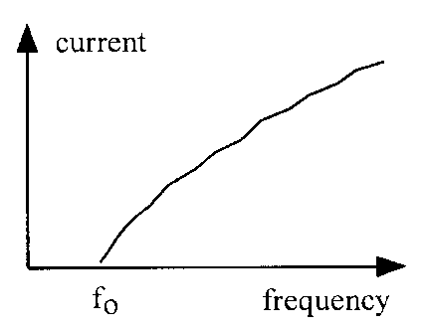

0

1. What name is given to the frequency *f*o?
2. Explain why no current is detected when the frequency of the incident radiation is less than *f*o.

9. For a certain metal, the energy required to eject an electron from the atom is 3·30 × 10−19 J.

1. Calculate the minimum frequency of radiation required to emit a photoelectron from the metal.
2. Explain whether or not photoemission would take place using radiation of:
3. frequency 4 × 1014 Hz
4. wavelength 5 × 10−7 m.

10. The minimum energy required to remove an electron from zinc is

6·10 × 10−19 J.

1. What is the name is given to this minimum energy?
2. Calculate the value of *f*o for zinc.
3. Photons with a frequency of 1·2 × 1015 Hz strike a zinc plate, causing an electron to be ejected from the surface of the zinc.
4. Calculate the amount of energy the electron has after it is released from the zinc.
5. What kind of energy does the electron have after it is released?

11. Radiation of frequency 5·0 × 1014 Hz can eject electrons from a metal surface.

1. Calculate the energy of each photon of this radiation.
2. Photoelectrons are ejected from the metal surface with a kinetic energy of 7·0 × 10−20 J. Calculate the work function of this metal.

12. An argon laser is used in medicine to remove fatty deposits in arteries by passing the laser light along a length of optical fibre. The energy of this light is used to heat up a tiny metal probe to a sufficiently high temperature to vaporise the fatty deposit.

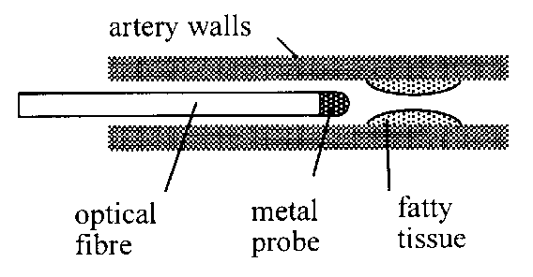

The laser has a power of 8·0 W. It emits radiation with a wavelength of 490 nm.

1. How much energy is delivered from the laser in 5 s?
2. Calculate the number of photons of this radiation required to provide the 5 s pulse of energy from the 8·0 W laser.

13. The apparatus shown is used to investigate photoelectric emission from a metal plate when electromagnetic radiation is shone on the plate.

The irradiance and frequency of the incident radiation can be varied as required.

A

metal plate

vacuum

glass tube

incident light

1. Explain what is meant by ‘photoelectric emission’ from a metal.
2. What is the name given to the minimum frequency of the radiation that produces a current in the circuit?
3. A particular source of radiation produces a current in the circuit. Explain why the current in the circuit increases as the irradiance of the incident radiation increases.

14. State whether each of the following statements is true or false.

(a) Photoelectric emission from a metal occurs only when the frequency of the incident radiation is greater than the threshold frequency for the metal.

(b) The threshold frequency depends on the metal from which photoemission takes place.

(c) When the frequency of the incident radiation is greater than the threshold frequency for a metal, increasing the irradiance of the radiation will cause photoemission from the metal to increase.

(d) When the frequency of the incident radiation is greater than the threshold frequency for a metal, increasing the irradiance of the radiation will increase the maximum energy of the electrons emitted from the metal.

(e) When the frequency of the incident radiation is greater than the threshold frequency for a metal, increasing the irradiance of the incident radiation will increase the photoelectric current from the metal.

# Section 5: Interference and diffraction

1. Explain how it is possible for interference to occur in the following situations:

1. a single loudspeaker emitting sound in a room with no other objects in the room
2. receiving radio reception in a car when passing large buildings.

2. In an experiment on interference of sound, two loudspeakers A and B are connected in such a way that they emit coherent sound waves.

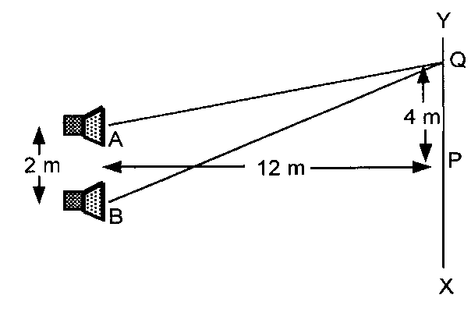

X

The loudspeakers are placed 2 m apart.

As a girl walks from X to Y she hears a point of maximum loudness at point P and the next maximum of loudness at point Q.

1. Calculate the distances AQ and BQ.
2. Calculate the wavelength of the sound.
3. Calculate the frequency of the sound.

(speed of sound in air is 330 m s−1)

3. A microwave transmitter is placed in front of a metal plate that has two slits A and B as shown.

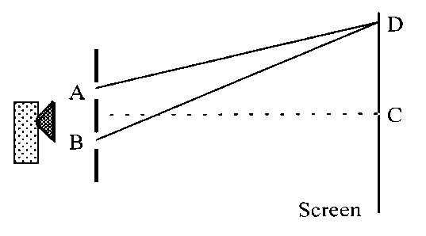

A microwave detector is moved along the line from C to D.

The zero- order maximum of radiation is detected at C and the first-order maximum is detected at D.

AD = 0·52 m and BD = 0·55 m.

1. Calculate the path difference between paths AD and BC.
2. What is the wavelength of the microwaves?
3. Calculate the path difference from slits A and B to the second-order maximum.
4. Calculate the path difference from slits A and B to the minimum of intensity between C and D.
5. Calculate the path difference from slits A and B to the next minimum after D.
6. What is the path difference from slits A and B to point C?

4. A microwave interference experiment is set up as shown.

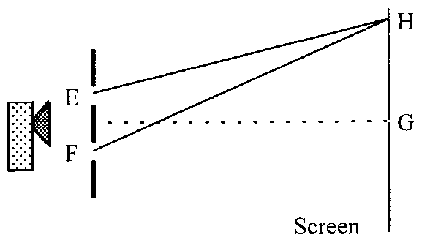

E and F are two slits in a metal plate. A microwave detector is moved along the line GH.

H is the second minimum from the straight through point at G. (This is sometimes called the first-order (*n* = 1) minimum, the first minimum being the zero order *n* = 0)

Measurement of distances EH and FH gives: EH = 0·421 m and FH = 0·466 m.

Calculate the wavelength and frequency of the microwaves used.

5. A microwave experiment is set up as shown.

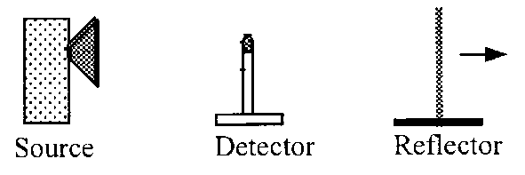

The waves reflected from the metal reflector plate interfere with the incident waves from the source. As the reflector is moved away from the detector, a series of maxima and minima are recorded by the detector.

A maximum is found when the reflector is at a distance of 0·25 m from the detector. A further eight maxima are found as the reflector is moved to a distance of 0·378 m from the detector.

1. Calculate the average distance between the maxima.
2. Calculate the wavelength of the microwaves.
3. Calculate the frequency of the microwaves.

6. A source of microwaves is placed in front of a metal sheet that has two slits S1 and S2 as shown.

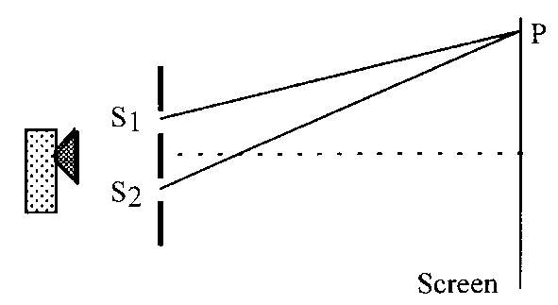

A microwave detector shows a minimum at P. P is the position of the first-order minimum, ie it is the second minimum from the centre.

S1P = 0·421 m S2P = 0·466 m

Calculate the wavelength of the microwaves.

7. A grating has 400 lines per millimetre.

Calculate the spacing between the lines on this grating.

8. A grating with 600 lines per millimetre is used with a monochromatic source of light. The first-order maximum is produced at an angle of 20·5° to the straight through position.

1. Calculate the wavelength of the light from the source.
2. A grating with 1200 lines per millimetre is now used.

Calculate the angle between the zero maximum and the new first-order maximum.

9. Light of wavelength 600 nm is shone onto a grating having 400, 000 lines per metre.

Calculate the angle between the zero maximum and first-order maximum.

10. Light of wavelength 6·50 × 10−7 m is shone onto a grating. The angle between the zero- and third-order maxima is 31.5°.

(a) Calculate the spacing between the slits on the grating.

(b) Calculate the number of lines per mm on the grating.

11. Light of wavelength 500 nm is used with a grating having 500 lines per millimetre.

Calculate the angle between the first- and second-order maxima.

12. White light, with a range of wavelengths from 440 nm to 730 nm, is shone onto a grating having 500 lines per millimetre. A screen is placed behind the grating.

1. Describe the pattern seen on the screen.
2. Explain the type of pattern produced.
3. Calculate the angle between the extremes of the first-order maximum, ie the angle between violet and red.

13. A source of white light is set up in front of a grating. A green filter is placed between the source and the grating. The grating has 300 lines per millimetre.

A pattern of bright and dark bands is produced on a screen.

1. What is the colour of the bright bands produced on the screen?
2. Explain what happens to the spacing between the bright bands on the screen when each of the following changes is made:
3. using a blue filter instead of a green filter
4. using a grating with 600 lines per millimetre
5. using a source producing a greater irradiance of light
6. moving the screen closer to the grating.

# Section 6: Refraction of light

1. A ray of monochromatic light passes from air into rectangular blocks of different materials A, B and C as shown.

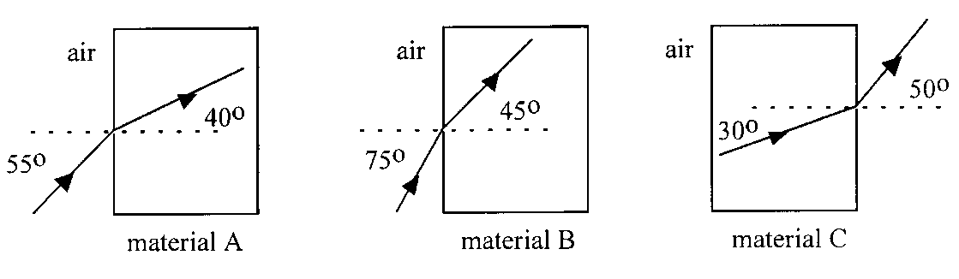

Calculate the refractive index *n* of each of the materials for this light.

2. A ray of monochromatic light passes from air into a thin glass walled container of water, a rectangular block of ice and a rectangular block of diamond as shown in the diagrams.

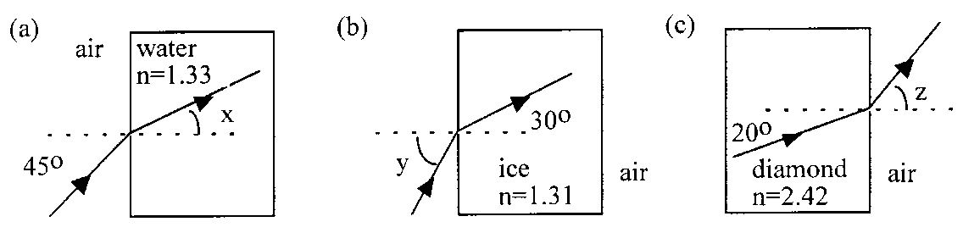

Calculate the values of the angles *x*, *y* and *z* in each of the diagrams.

3. A ray of monochromatic light passes from air into a certain material as shown.

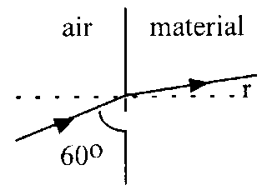

The refractive index of the material is 1·35.

1. Calculate the value of angle *r*.
2. Calculate the velocity of the light in the material.

4. A ray of light of wavelength 6·00 × 10−7 m passes from air into glass as shown.

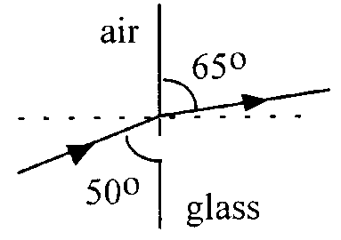

1. Calculate the refractive index of the glass for this light.
2. Calculate the speed of this light in the glass.
3. Calculate the wavelength of this light in the glass.
4. Calculate the frequency of this light in air.
5. State the frequency of this light in the glass.

5. A ray of light of wavelength 500 nm passes from air into perspex.

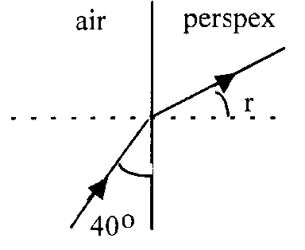

The refractive index of the perspex for this light is 1·50.

1. Calculate the value of angle *r*.
2. Calculate the speed of light in the perspex.
3. Calculate the wavelength of this light in the perspex.

6. The refractive index for red light in crown glass is 1·513 and for violet light it is 1·532.

(a) Using this information, explain why white light can produce a spectrum when passed through crown glass.

(b) A ray of white light passes through a semi-circular block of crown glass as shown and produces a spectrum.

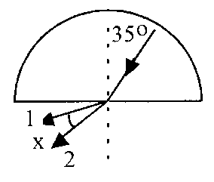

1. Which exit ray is red and which exit ray is violet?
2. Calculate the angle of refraction in air for each of the exit rays.
3. Find angle *x,* the angle between the red and violet rays.

7. A ray of white light is dispersed, by a glass prism, producing a spectrum S.

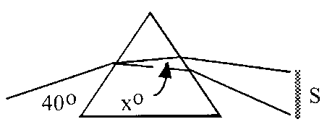

The angle *x* is found to be 0·7°.

The refractive index for red light in this glass is 1·51. Calculate the refractive index for blue light.

8. Calculate the critical angle for each material using the refractive *n* index given in the table below.

|  |  |
| --- | --- |
| *Material* | *n* |
| Glass | 1·54 |
| Ice | 1·31 |
| Perspex | 1·50 |

9. A beam of infrared radiation is refracted by a type of glass as shown.

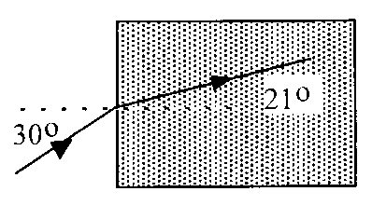

1. Calculate the refractive index of the glass for infrared.
2. Calculate the critical angle of infrared radiation for this glass.

10. A ray of light enters a glass prism of absolute refractive index 1·52, as shown.

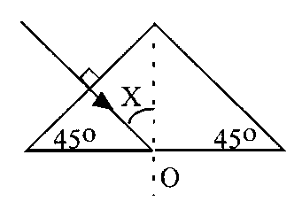

1. Explain why the ray does not change direction on entering the glass prism.
2. Calculate the value of angle X.
3. Why does the ray undergo total internal reflection at O?
4. Redraw the complete diagram showing the angles at O with their values.
5. Explain what would happen when the experiment is repeated with a prism of material with refractive index 1·30.

11. The absolute refractive indices of water and diamond are 1·33 and 2·42, respectively.

1. Calculate the critical angles for light in each of these materials when surrounded by air.
2. Comment on the effect of the small critical angle of diamond on the beauty of a well-cut diamond.

# Section 7: Spectra

## Irradiance and inverse square law

1. A satellite is orbiting the Earth. The satellite has solar panels, with a total area of 15 m2, directed at the Sun. The Sun produces an irradiance of 1·4 kW m−2 on the solar panels. Calculate the power received by the solar panels.

2. A 100 W light source produces an irradiance of 0·2 W m−2 at a distance of 2 m.

The light source can be considered to be a point source.

Calculate the irradiance produced at a distance of:

1. 1 m from the source
2. 4 m from the source.

3. An experiment is performed to measure the irradiance produced at different distances from a point source of light. The results obtained are shown in the table.

|  |  |  |  |  |  |
| --- | --- | --- | --- | --- | --- |
| Distance from point source *d* /m | 1·0 | 1·4 | 2·2 | 2·8 | 3·0 |
| Irradiance *I* /W m−2 | 85 | 43 | 17·6 | 10·8 | 9·4 |

1. Sketch the apparatus that could be used to obtain these results.
2. Use an appropriate format to show the relationship between the irradiance *I* and the distance *d*.
3. Calculate the irradiance at a distance of 5 m from the source.
4. At what distance from the source is the irradiance 150 W m−2?

4. The radiation from the Sun produces an irradiance of 200 W m−2 at a certain point on the surface of the Earth.

1. What area of solar cells would be required to produce a power output of 1 MW when the cells are considered to be 100% efficient?
2. The cells are only 15% efficient. What additional area of solar cells is required to produce a power output of 1 MW?

5. An experiment is set up in a darkened laboratory with a small lamp L1 with a power *P*. The irradiance at a distance of 0·50 m from the lamp is 12 W m−2. The experiment is repeated with a different small lamp L2 that emits a power of 0·5 *P*.

Calculate the irradiance at a distance of 0·25 m from this lamp.

## Line and continuous spectra

1. When the light emitted by a particular material is observed through a spectroscope, it appears as four distinct lines.

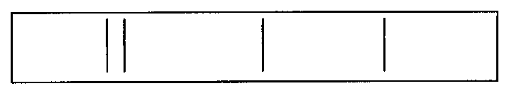

1. What name is given to this kind of emission spectrum?
2. Explain why a series of specific, coloured lines is observed.
3. The red line in the spectrum coincides with a wavelength of 680 nm.

Calculate the energy of the photons of light that produced this line.

1. The spectroscope is now used to examine the light emitted from a torch bulb (filament lamp). What difference is observed in the spectrum when compared with the one in the diagram?

2. The diagram shows some of the energy levels for two atoms X and Y.

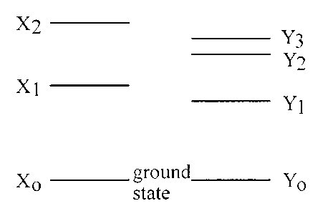

(a) (i) How many downward transitions are possible between these energy levels of each atom?

(ii) How many lines could appear in the emission spectrum of each element as a result of these energy levels?

(iii) Copy the diagram of the energy levels for each atom and show the possible transitions.

(b) Which transition in each of these diagrams gives rise to the emitted radiation of:

(i) lowest frequency

(ii) shortest wavelength?

3. The diagram shows some of the electron energy levels of a particular element.

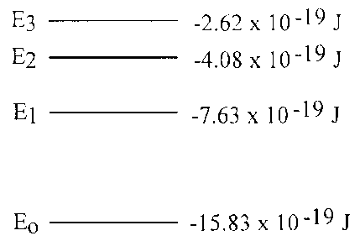

(a) How many lines could appear in the emission spectrum of this element as a result of these levels?

(b) Calculate the frequencies of the photons arising from:

(i) the largest energy transition

(ii) the smallest energy transition.

(iii) Show whether any of the emission lines in the spectrum correspond to frequencies within the visible spectrum.

(iv) Explain which transition would produce the photons most likely to cause photoemission in a metal.

4. The diagram shows some of the electron energy levels in a hydrogen atom.

W0

W1

W2

W3

–21·76 × 10–19 J

–5·424 × 10–19 J

–2·416 × 10–19 J

–1·360 × 10–19 J

1. How many emission lines are possible from electron transitions between these energy levels?
2. Which of the following radiations could be absorbed by the electrons in a hydrogen atom?
3. frequency 2·92 × 1015 Hz
4. frequency 1·57 × 1015 Hz
5. wavelength 4·89 × 10−7 m.

5. Explain why the absorption spectrum of an atom has dark lines corresponding to frequencies present in the emission spectrum of the atom.

6. (a) Explain the presence of the Fraunhofer lines, the dark lines that appear in the spectrum of sunlight.

(b) How are Fraunhofer lines used to determine the gases that are present in the solar atmosphere?

7. The light from a star can be analysed to show the presence of different elements in the star. How can the positions of the spectral lines for the elements be used to determine the speed of the star?

8. A bunsen flame is placed between a sodium vapour lamp and a screen as shown.

A sodium ‘pencil’ is put into the flame to produce vaporised sodium in the flame.

sodium vapour lamp

bunsen

dark shadow

sodium pencil

screen

1. Explain why a dark shadow of the flame is seen on the screen.
2. The sodium vapour lamp is now replaced with a cadmium vapour lamp. Explain why there is now no dark shadow of the flame on the screen.