National 5 Environmental Science Unit 1 Summary – The Living Environment
Definitions:
Term | Definition | Example
Habitat | The place where an organism lives | Wood, mountain
Population | A group of organisms of one type | Blue tits
Community | All organisms living in a habitat | Animals + plants
Ecosystem | Community + habitat | Pond, soil
Producer | An organism that makes its own food | Green plant
Consumer | An organism that eats other organisms | Animal

- Abiotic factors are non-living factors that affect an ecosystem. For example, temperature, moisture or pH.
Abiotic Factor | Method of Measurement | Source of Error | To reduce error
pH | pH paper or meter | Contamination of sample | Repeat readings and take an average.
Light intensity | Light meter | Shadow or cloud
Temperature | Thermometer | Human error or misuse of equipment
Soil moisture | Moisture probe | Probe not been wiped after each use.

- Abiotic factors affect the distribution of organisms
Organism | Abiotic Factor | Effect
Fruit fly | Light | Move towards light
woodlouse | Moisture | Move from dry to moist

- Organisms survive best in conditions that are most favourable
Sampling techniques:
Organism | Method of sampling | Source of error | To reduce error
Plants | Quadrat | Non random sampling | Random sampling
Beetles | Pitfall trap | Too few samples | Take many samples

Food Chains:
Producer consumer 1 consumer 2
Example:
Oak leaf caterpillar blue tit sparrow hawk
- The arrow shows the direction of energy transfer.
Food Web:
- A diagram showing the feeding relationships of animals and plants in an ecosystem
Example:
Oak leaf caterpillar blue tit sparrow hawk

Green fly lady bug
Shrew
- Removing one species affects the numbers of remaining organisms in a food web.
- Factors affecting food webs include:
  - Disease
  - Competition
  - Natural and human impacts
  - Predation
Example:
Organism removed | Organism affected | Effect | Reason
Sparrow hawk | Shrew | Numbers rise | Not eaten
Sparrow hawk | Caterpillar | Numbers fall | More shrews so more eaten
Three ways energy can be lost from a food web:
- Heat
- Movement
- Waste
Type of pyramid | Definition | Diagram
Numbers | Shows relative numbers at each stage of food chain | Consumer 2  Consumer 1  Producer
Biomass | Shows relative mass at each stage of food chain

Competition
- occurs when organisms have a need for the same resources
Example:
Organism | Resources | Effect
Plants | Light, moisture, nutrients | Stronger species survive and weaker species die.
Animals | Food, water, space
Photosynthesis
- is the process by which green plants make their own food
Light
Carbon dioxide + Water Glucose + Oxygen
Chlorophyll
Products
Raw materials
- Chlorophyll traps light energy
- Light energy is converted to chemical energy
- Oxygen is the waste product
- Glucose is used in respiration
Respiration
- Is the release of energy from food using oxygen
Food + Oxygen Energy + Carbon dioxide + Water
- All plants and animals respire.
- Plants respire at night when there is no light energy from the sun to photosynthesise
Nutrient cycles:
Nutrients – example: mineral salts and nitrogen – are in limited supply, are locked in the bodies of organisms and must be released back into the eco system. This is done through the carbon and nitrogen cycles.
The nitrogen cycle:
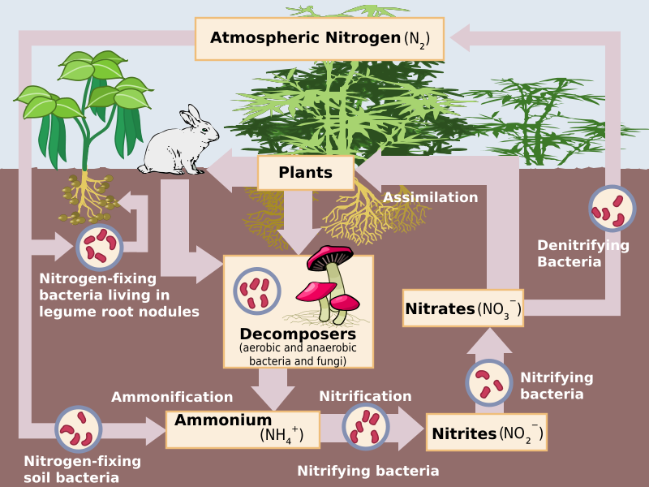
Nitrogen fixation – bacteria in root nodules convert nitrogen to nitrate
Decay – decomposers (fungi and bacteria) break down nitrogen compounds into ammonium compounds.
Nitrification – bacteria convert ammonium compounds into nitrates.
Nitrification – bacteria convert nitrites into nitrates.
Denitrification – bacteria convert nitrates to nitrogen gas
The carbon cycle
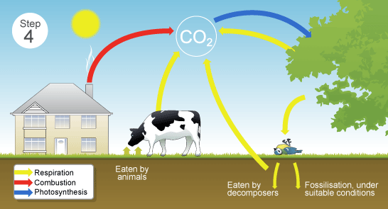
Human influences on biodiversity
Negative human impacts:
Human activity | Definition | Impact on biodiversity
Deforestation | The cutting down of trees from particular areas to make various wood products. | Loss of trees can destroy habitats for many organisms and destroy an ecosystem.
Pollution | The addition of harmful chemicals to the environment. Contributes to climate change. | Can pollute water supplies in areas for animals and plants and destroy habitats.
Climate change | The heating up of the Earth due to greenhouse gases. | Can affect the distribution of organisms as they have to move to a country with a lower climate
Over exploitation | Exploiting animals by selling or using them for medicines | Can cause a species to become endangered/extinct.

Organisations to help conserve biodiversity
- SEPA - The Scottish Environment Protection Agency:
  - Scotland’s environmental regulator. Their main role is to protect and improve the environment
  - Protect communities by regulating activities that can cause harmful pollution and by monitoring the quality of Scotland's air, land and water.
  - The regulations implemented also cover the keeping and use, and the accumulation and disposal, of radioactive substances.
- SNH – Scottish Natural Heritage
  - Scottish Natural Heritage is funded by the Scottish Government. Their purpose is to:
  - promote care for and improvement of the natural heritage
  - help people enjoy it responsibly
  - enable greater understanding and awareness
  - promote its sustainable use, now and for future generations

- FCS – Forestry Commission Scotland:
  - Work with the Scottish Government to deliver the Scottish Forestry Strategy.
  - They also contribute to many aspects of wider Scottish Government policy such as energy, environment and climate change, biodiversity, healthy living, rural transport, tourism and education.

- CNPA - The Cairngorms National Park Authority:
  - Together with partners, ensures that the special qualities of the Cairngorms National Park - the natural environment, the cultural heritage and the local communities - are cared for, sustained and enhanced for future generations to enjoy.

- Sites of Special Scientific Interest (SSSI) are those areas of land and water that Scottish Natural Heritage (SNH) considers to best represent our natural heritage
- its diversity of plants, animals and habitats, rocks and landforms, or a combinations of such natural features.

Legislation to help conserve biodiversity
- Wildlife and Countryside Act 1981:
prohibit certain methods of killing or taking wild animals
restrict the introduction of certain animals and plants
make provision with respect to the Countryside Commission
to amend the law relating to public rights of way; and for connected purposes.

- Environmental Protection Act 1990:
An Act to make provision for the improved control of pollution arising from certain industrial and other processes

