Environmental Science Unit 3 Summary – Sustainability
What is "sustainability"?
Sustainability is the endurance of systems and processes. It is how biological systems remain diverse and productive.
Long-lived and healthy wetlands and forests are examples of sustainable biological systems. Sustainability is important as it ensures the systems and processes on earth remain productive now and in the future.
The Brundtland report and Sustainable Development
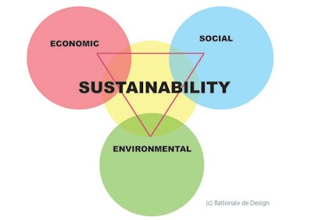
The Brundtland report defines sustainable development as development that meets the needs of the present without compromising the ability of future generations to meet their own needs.
Global Citizenship
Global citizenship is a person who places their identity with a "global community" above their identity as a citizen of a particular nation or place.
- A Global citizen is someone who:
- Is aware of the wider world and has a sense of his or her own role as a world citizen.
- Respects and values diversity.
- Has an understanding of how the world works.
- Is troubled by social injustice.
- Participates in the community at different levels from local to global
- Is willing to act to make the world a more equitable and sustainable place
- Takes responsibility for his or her actions.
- Feels an ethical responsibility to others around the globe.
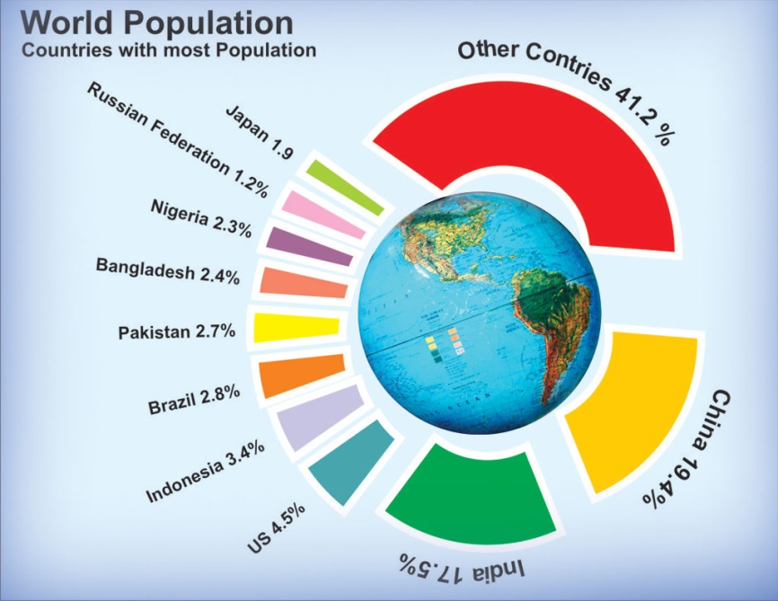
The World's Population
As of October 31st 2011, the world's population reached 7 Billion and is still increasing.
The World's Population and Demand for Food
As the world population increases and food demand has grown, globalization of trade has made the food supply more sensitive to environmental and market fluctuations. This leads to greater chances of food crises, particularly in nations where land and water resources are scarce and therefore food security strongly relies on imports.
The Food and Agricultural Organisation of the United Nations has said that if the population keeps increasing as it has done, then by 2051, food production will have to increase by 70%!!!
This means we will have to find more land to grow more crops for our increasing population.
Food
Too Much Food in the World?
The number of people suffering from chronic hunger is at 642 million in Asia and the Pacific, 265 million in sub-Saharan Africa, 53 million in Latin America and the Caribbean, and 42 million in the Near East and North Africa.
The FAO stated population growth as a reason for increasing chronic hunger in these places, as well as growing grain prices and the growing recession.
Food production in developing countries will have to double to cope with the demand of the world's increasing population.
Food Security and Strategies to Alleviate Food Shortage
The FAO estimates that a total of 925 million people were undernourished in 2010, compared with 1023 million in 2009. That is higher than before the food and economic crisis of 2007-2008 and higher than the number in 1996, the year that leaders at the World Food Summit set a goal of reducing the number of hungry people by half. The graph below shows the number of people hungry globally. 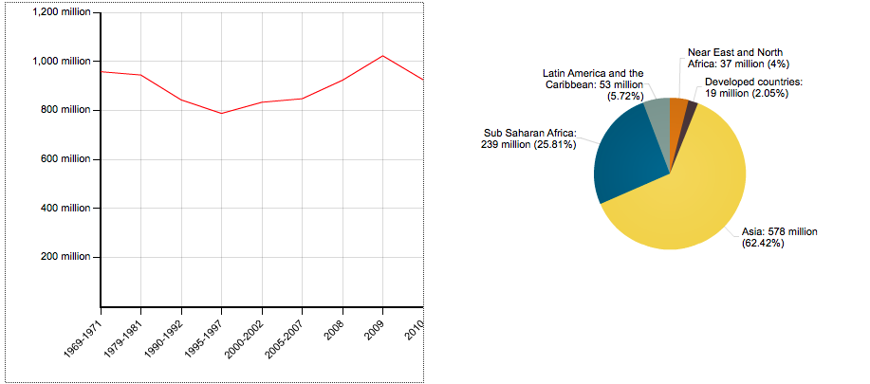
Reasons for Increasing Hunger in Developing Countries
1. Cheaper food imports undermine local food production and alongside reduced domestic support, local farmers find it difficult to compete on price. This leads to smaller incomes and increased food insecurity.
2. Global food supplies are volatile to price changes based on global conditions, including oil price as well as commodity trading. This trade in food as a commodity, leaves people more at risk to food shortage as prices increase.
3. The cost of food in family budgets is generally far greater in developing countries than for families in developed countries.
These factors have contributed to an increase in hunger of approximately 14% between 1995 to 2009.
Environmental Factors and Food Security
Water shortage caused by drought leads to soil degradation and eventually soil erosion.
This problem effects many places of the world, but is particularly prominent in the Sahel regions of Africa, where population pressure further exacerbates the problem.
Strategies in Farming for a Secure Food Supply
There are some strategies in farming that have been put in place to help secure food supplies. These include:
- Intensive Farming
- GM Crops
- Agrochemicals
Intensive Farming
Intensive farming or intensive agriculture is a kind of farming where a lot of capital and labour are used to increase the yield that can be obtained per area. The use of large amounts of pesticides for crops and of medication for animal stocks is common.
Intensive farming practices include growing high-yield crops, using fertilisers and pesticides and keeping animals indoors. Food production is increased but there are unwelcome side effects.
Organic farming bans chemical inputs and has a less harmful effect on the environment but often produces less, more expensive food.
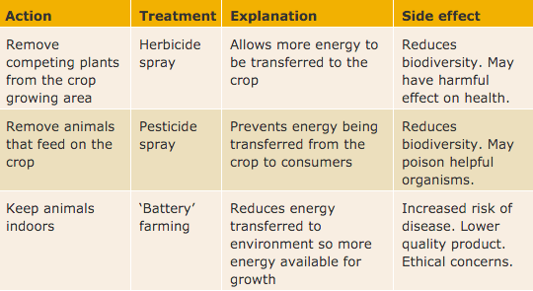
The Effects of Insecticides
Insecticides like DDT don't break down quickly. It's been responsible for a large reduction in bird numbers since intensive farming became widespread. DDT accumulates in food chains - as consumers eat large numbers of prey containing the insecticide. High levels of DDT have been found in birds of prey.
Alternatives to Pesticides
Biological control is an alternative to using pesticides. By releasing a natural predator into the crop growing area, the number of pests can be reduced. This can have unforeseen consequences as the numbers of different organisms in the food web are changed.

GM Crops
GM crops are crops that have been genetically modified. This means that their DNA has been altered so they can resist certain pests, diseases or environmental conditions.
Organic Farming
Organic farming is a form of agriculture that relies on techniques such as crop rotation, green manure, compost, and biological pest control.
Positives
- The environment benefits because natural habitats are less threatened.
- The soil can be in better condition because of the manure used.
- Biodiversity increases with fewer chemicals which harm bees and other insects.
Negatives
- More produce is damaged by pests.
- Some organic pesticides, such as copper can remain in the soil and be harmful.
- The crop yield is lower on organic farms (about 20% less compared to non-organic farming).
Why is the fishing industry important?
The fishing industry provides the main source of animal protein for over one billion people globally. While fish and shellfish are among the most highly traded food commodities, they are also among the most vulnerable in sustainability of supply.
What's happening in the fishing industry?
Factors including overexploitation, inadequate regulations, poor implementation and enforcement, inadequate information on exploited species and ecosystems and global warming, the majority of fisheries worldwide have been declining over the past several decades. Many capture fisheries are currently unsustainable, so the security of supply is under threat. To meet the increasing demand for fish and shellfish on the global market, aquaculture industry has been growing at an accelerated rate. Aquaculture is now one of the fastest growing food-production sectors, currently accounting for some 50% of the world’s fish supply.
Sustainable fisheries and aquaculture is now a priority of UN and other international organisations.
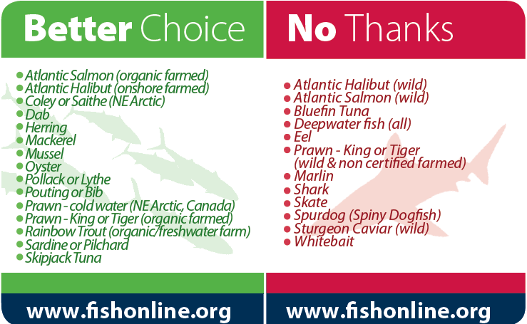
Intensive fishing is when more of that fish is being bred and caught for human consumption, but is a sustainable strategy of fishing. Another sustainable strategy for a secure food supply is by promoting other species of fish that are not over fished.

Fish conservation approaches
The world's fisheries are in crisis. Years of chronic overfishing, pollution, and habitat destruction have stripped our seas of much of their vitality and productivity.
There are three ways we can help conserve fish stocks:
- Marine conservation areas
- Zoning
- Sustainable fishing methods
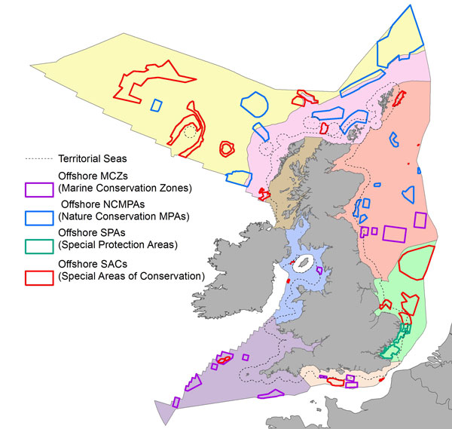
Marine conservation (protected) areas
Our seas are home to some of the most biologically diverse habitats and species in Europe. Marine Protected Areas (MPAs) are one of the tools that can help us to protect the marine environment, whilst also enabling it's sustainable use, ensuring it remains healthy and contributes to our society for generations to come.
Marine conservation or protected areas are protected areas of seas, oceans or large lakes. They restrict human activity for a conservation purpose, typically to protect natural or cultural resources.
Zoning
Zoning is an important component in managing marine areas. Zoning defines the activities that can occur in which locations. The level of protection increases from the General Use Zones up to the most restrictive, Preservation Zone. Each zone has different rules for the activities that are allowed, the activities that are prohibited and the activities that require a permit. Zones may also place restrictions on how some activities are conducted.
Sustainable fishing methods
- Cast-net fishing
- Fly fishing
- Using spears
- Fishing at specific times of the year
The environmental impact of food distribution
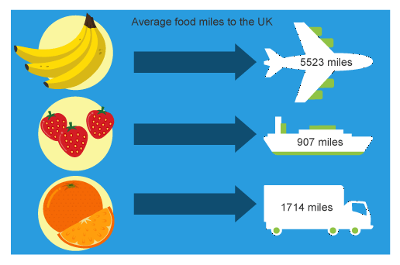
Transporting food is one of the fastest-growing sources of greenhouse gas emissions, according to the World Watch Institute. Each year, 817 million tons of food are shipped around the planet. The result is that a basic diet of imported products can use four times the energy and produce four times the emissions of an equivalent domestic diet!
Food Miles represent the distance your food travels from where it is made to where it is eaten. According to the National Sustainable Agriculture Information Service, this distance has been increasing over the last fifty years, and now processed food travels an average of 1,300 miles.
What's wrong with food miles?
Food miles specifically affect the environment by how they are related to emissions of greenhouse gases from transportation vehicles, most notably carbon dioxide.
However, “food miles” are not the only way our food contributes to climate change. In fact, 83% of food’s greenhouse gas emissions come from the growing and harvesting of the food. Agricultural practices, processing, storage, and the way we shop for food all play a role in food’s carbon footprint. Agricultural processes alone account for 21% of the food’s energy use.

Carbon footprint, carbon offsetting and carbon netural
- Our "carbon footprint" is the amount of carbon dioxide released into the atmosphere as a result of the activities of a particular individual, organization, or community.
- Carbon neutral is making or resulting in no net release of carbon dioxide into the atmosphere, especially as a result of carbon offsetting.
- Carbon offsetting is the counteracting of carbon dioxide emissions with an equivalent reduction of carbon dioxide in the atmosphere.
Lowering Carbon Emissions
There have been national and European policies and legislation put in place relating to how food is produced. One includes the Food Standards Act of 1999.
The Food Standards Agency (FSA) tell companies the food hygiene standards and that all food they produce must have a label of what is in it! This only applies to the EU, in America, it is the Food and Drug Administration (FDA), which set their guidelines for food production and labelling.
Water
Water is an important natural resource as all organisms need it to survive.
With the increasing population, water supplies are in high demand, which can cause problems now and in the future.
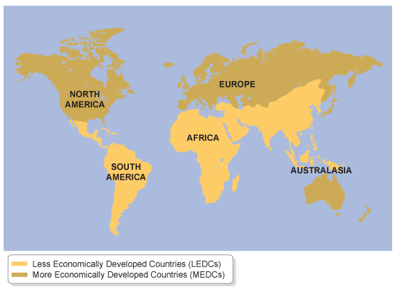
MEDCs and LEDCs
A MEDCs is a More Economically Developed Country like those in Europe. They are rich countries.
A LEDCs is a Less Economically Developed Country like Africa or South America. They are poor countries.

Clean Water Supplies in LEDCs
There are problems in supplying water in LEDCs. These are:
- lack of availability of clean water
- diseases spread via the water supply
- water pollution
One in eight people of the world population do not have access to safe water. Sixty million children are born each year in LEDCs who do not have access to safe water.
How LEDCs get water
Lack of technology in LEDCs means that they can only get their water using the following methods:
- Wells, dug by hand, are a common way of accessing water - but the supply can be unreliable and sometimes the well itself can be a source of disease.
- Gravity-fed schemes are used where there is a spring on a hillside. The water can be piped from the spring down to the villages.
- Boreholes can require more equipment to dig, but can be dug quickly and usually safely. They require a hand or diesel pump to bring the water to the surface.
In addition to locating new sources of water, some strategies help to reduce the need for water. These include:
- harvesting (collecting) rainwater landing on buildings
- recycling waste water to use on crops
- improving irrigation techniques
- growing crops less dependent on a high water supply
- minimising evaporation of water
As LEDC cities grow, so does the demand for water. The problem doesn't end when water supplies have been improved and pipes put in place. The water has got to come from somewhere, and the source of supply may be scarce.
Problems faced supplying clean water in MEDCs
There are problems in supplying water in MEDCs. These are:
- the quality of available water
- distribution
- the seasonal changes in supply
- broken pipes when transporting water
Both water supply and the demand for water need to be managed.
Clean Water in MEDCs
In the UK there is a big issue with water supply. Areas which receive high amounts of rainfall tend to be sparsely populated.
One third of the UK population live in South East England. This is also the driest area in the UK.
Ways to manage the water supply include:
- making sure the broken pipes are mended (as water loss from broken pipes can be as much as 30 per cent)
- using reservoirs and dams in one area to pipe water into large urban areas
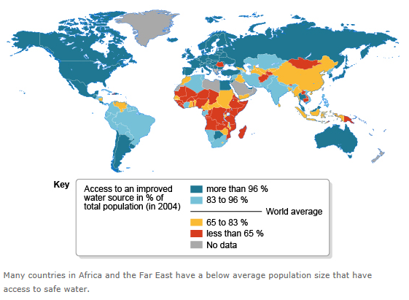
- making sure that the water supply is of good quality - reducing fertiliser use on farms helps this
Clean water in LEDCs
The map shows MEDCs and LEDCs that have access to clean water.
In December 2010 over 40,000 people had water supply problems in Northern Ireland. One reason was because the water pipes were quite old - some over 60 years old. This meant that when there was a spell of very cold weather, many pipes could not cope and the pipelines failed.
Managing the Demand of water in MEDCs
The demand for domestic water can be monitored. Households with water meters in the UK use less water in general than those without. Households can also conserve water. Ways to do this are:
- having a shower not a bath
- collecting rainwater to use on the garden rather than tap water
- recycling bath water to flush the toilets with
- installing more efficient versions of appliances such as washing machines
Industries can also look to recycle waste water. For example, when using water for cooling in steel-making, the water can be recycled again and again in the process.
In agriculture, drip-feed irrigation systems could be used rather than sprinkler systems.
Issues with water use in Industry
- For most industrial purposes, the water used needs to be freshwater, not salt water, because salt can corrode metal. (Freshwater = drinking water).
- 300-500 million tons of heavy metals, solvents, toxic sludge, and other wastes accumulate each year from industry, most of which gets into the freshwater supply.
- The water that pollutes the water supply can cause thermal pollution, which can cause invasive species and a loss of native species in water supplies, so effluents (water samples) need to be taken to monitor this.
Issues with water use in the home
- The increased population has increased the amount of water we use from washing, cooking and sanitation, which may lead to water shortages in times of drought.
- The increased use of water could lead to water restrictions, which could have an impact on public health with people being unable to use the water to clean themselves or their clothes.
Issues arising with water use in agriculture
- With increasing world population comes an increase in the demand for food. This then leads to an increase in water use and could lead to low water levels in rivers.
Sustainable approaches to water uses
In the home:
- Not using water to clean cars
- Don't leave taps running
- Choose and use your appliances wisely. Use energy star appliances whenever possible and always use them at full capacity. Choose economy settings and don’t run the dishwasher half-full.
In industry:
- Reuse water for process washing
- pH adjustment
In agriculture:
- Use methods alternative to irrigation such as rainwater harvesting and treated wastewater.
- Grow crops that use less water.
- Consider the water footprint of your diet and picking foods which take less water to produce.
Policies, legislation and organisations to regulate water use
The government and organisations such as SEPA help to ensure that we regulate water use.
SEPA risk assess proposed activities before granting, if appropriate, an authorisation. SEPA also patrol specific areas and enforce legislation from the Scottish government.
Legislation that has been passed includes:
- The Water Environment (Controlled Activities) (Scotland) Regulations 2011
- Water Environment and Water Services (Scotland) Act 2003 (WEWS Act).
Energy
Increasing global population and energy supplies
The population problem isn't just a matter of the number of people. It's the demand this then has on producing food, pumping groundwater, harvesting wood, mining minerals, and burning fuel, which all deplete our resource base and produce pollution.
In the UK, we have a population of 63 million people and we use 1,488 million barrels of oil. These oil barrels are used for supplying us with energy. 2.5%of the world’s total energy use.
Matters are worse in the USA. They have an overall population of 314 million people and use 16,389 million barrels of oil for energy production. 28% of the world’s total energy use!
Renewable and non-renewable energy resources
A renewable source of energy is one that will not run out.
Sources of renewable energy resources include:
- Wind power (wind turbines)
- Wave power (wave generators)
- Water power (hydroelectric)
A non-renewable source of energy is one that will eventually run out.
Sources of non-renewable energy resources include:
- Coal
- Oil
- Gas
- Nuclear
Issues arising from renewable energy resources
Renewable energy is a valuable and clean resource; however there are issues which arise from the use of these sources:
- The infrastructure of renewable energy, such as hydroelectric dams will not last forever and will need to be repaired.
- They can disturb habitats and ecosystems.
- They can be expensive to build.
Issues arising from non- renewable energy resources
Non-renewable energy is resource that has been used for hundreds of years, however there are issues which arise from the use of these sources:
- They pollute the environment with carbon dioxide and sulphur dioxide, causing global warming.
- Nuclear energy uses Uranium, which is a radioactive element and produces radioactive waste, which is dangerous.
- Oil spills kill many organisms by sticking to their fur or by mistaking it for food.
The Greenhouse Effect
The greenhouse effect is the trapping of the sun's warmth in a planet's lower atmosphere, due to the greater transparency of the atmosphere to visible radiation from the sun than to infrared radiation emitted from the planet's surface.
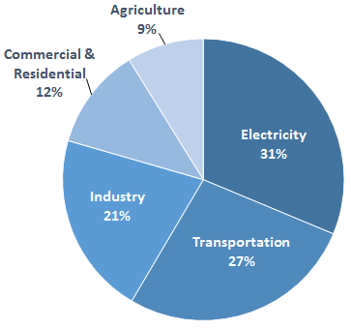
Greenhouse gases are gases that contribute to the greenhouse effect by absorbing infrared radiation. Carbon dioxide and chlorofluorocarbons are examples of greenhouse gases.
Sources of Greenhouse gases
- The production of electricity.
- Using tractors to harvest crops.
- Transport, such as cars and transporting food.
- The over production of cows and landfill and waste (produce methane gas).
Ways to reduce greenhouse gases
In order to save our planet from the greenhouse effect, we need to reduce our greenhouse gas emissions. Ways we can do this include:
- Reduce, Reuse, Recycle.
- Use Less Heat and Air Conditioning.
- Replace Your Light Bulbs.
- Drive Less and Drive Smart.
- Buy Energy-Efficient Products.
Social, economic and environmental impacts of climate change
Climate change is a change in global or regional climate patterns. Scotland's climate is already changing. Since 1980, temperatures in Scotland have increased by 0.8oC and the length of the growing season has increased by 4 weeks over the past half century.
Winter rainfall has increased in the past 50 years, by up to 70% in the North of Scotland.
If there are more changes to our Environment, what impacts would it have on Scotland?
- An increase in costal and river flooding.
- Droughts.
- Changes to the crops we grow, our fisheries and how we use our land.
- Changes to biodiversity and landscapes.
- An increased frequency and intensity of storms that may cause disruption and threaten life and property.
These impacts would result in declines in Scotland's social use of land and water, Scotland's economy and environment by:
- Less water and land leisure activities impacting our social lives, tourist industry and economy.
- A decline in our fish and crop markets; leading to a decline in Scotland's economy.
- Biodiversity of Scotland could decline leading to some species becoming endangered, extinct or immigrating to other parts of the UK.
Organisations, policies and legislation relating to energy use
SEPA is an organisation which is very involved with climate change and how it is affecting our environment. SEPA have a four year challenge to tackle climate change. SEPA will help by implementing the Climate Change (Scotland) Act 2009 by:
- Monitoring and having a scientific understanding of Scotland's climate.
- Help industries reduce their own emissions.
- Help Scotland be more resilient to the effects of climate change.
The Climate Change (Scotland) Act 2009
The Climate Change (Scotland) Act has been implemented to do the following:
- A reduction in Scotland’s greenhouse emissions of 42% by 2020 and 80% by 2050.
- Annual emissions reduction targets that are at least 3% less than the target of the previous year.
- Establish a statutory Adaptation Programme.
Waste
Increase in population, which has led to an increase in demand for food, energy and clothing resources.
Scotland generated about 2.5 million tonnes of waste in 2014. This waste can cause pollution and impact biodiversity as we need to find somewhere to put it (normally a landfill).
Of the 2.5 million tonnes of waste produced in 2014, not all was landfilled. 900,000 tonnes was recycled, but this isn't enough to keep up with the growing population and demand of supplies.
Recycling is a way that Scotland and the rest of the UK can reduce waste.
The Scottish Government introduced a "Reduce, Reuse, Recycle" scheme in 2003, which is a sustainable method to help scotland recycle more and reduce waste.
- Reduce - reduce the amount of food you throw away by only buying what you need.
- Reuse - reuse what you can, whether it be a bottle or plastic bag.
- Recycle - recycle when you can. Use the recycling bin for paper, cardboard and most plastics. Other recycling bins allow glass, wood and even old technology! You can also recycle your food waste by having a food bin (composter) which will help the environment.
Why is it so important to take responsibility for our own waste?
For hundreds of years we have been burying out waste in landfills and we are now quickly running out of space to hide our waste.
We have also discovered that the pollution effect of festering food and chemicals in the ground is seriously poisoning our environment.
For a sustainable future, we need to recycle when we can and only buy what we need to reduce waste so that we have a sustainable future in waste management.
What are we doing to raise awareness?
"Eco-schools" is a school programme where a team of pupils try to get the school a green flag. Currently all schools in East Renfrewshire have a green flag!
- The "eco-schools" group ensure:
- The school is recycling
- They are a fairtrade school
- They carry out surveys about water
- Inform people about saving electricity by putting up stickers
- Carry out litter picking activities
- Investigate the air pollution around the school during drop off and pick up times.
By raising awareness of personal responsibility of waste management to young people, we are ensuring a sustainable future.
National organisation, policies and legislation relating to waste management
The EU Waste Framework Directive provides the legislative framework for the collection, transport, recovery and disposal of waste.
For Scotland, the key areas of legislation are the Waste (Scotland) Regulations and the Carrier Bag Charge (Scotland) Regulations.
SEPA take an active role in waste management and undertake targeted operations to tackle:
- illegal landfill sites;
- unlicensed skip hire operators;
- large scale and persistent dumping of waste;
- unlawful collection, storage and breaking of scrap cars;
- unauthorised collection, storage and export of waste electrical and electronic equipment (WEEE).

