**N4**

**Waves and Radiations Problems Booklet**

**N4 Speed, Distance Time Problems**

1. 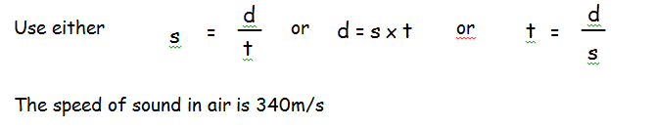A pupil watches a workman hammering in a post in the distance.
2. Explain why there is a delay between the pupil seeing the workman hammer the post and then hearing the noise of it.
3. The pupil times the delay as being 4.3 seconds. How far away is the workman?
4. At a sports event the starter fires his gun while standing at the finish line of a 100m race.
5. What is the time delay before the runners hear the gun?
6. If the winner runs the 100m at an average speed 8m/s, what will her winning time be?
7. A scientist tries to measure the speed of sound in water and find that it takes 0.00025 seconds to travel 1.3 metres.

What value will he get for the speed of sound in water?

1. A pupil observes a tree which she knows to be 2km away hit by lightning.

What time delay should she expect between seeing the flash and hearing the bang?

1. A pupil stands 250m from a wall and claps. He hears the echo 1.5 seconds later.

What speed of sound will she calculate?

1. A teacher measures the time for sound to travel distances in a classroom. She finds that it takes 12 milliseconds in the first experiment then 15 milliseconds in the second experiment.
2. Write 12 milliseconds and 15 milliseconds in seconds.
3. Calculate the 2 distances the teacher measures.
4. By how much has the distance increased?
5. When fireworks explode high in the air, you see the flash before you hear the bang from the explosion.
6. Explain why this happens.
7. At a fireworks display, John uses a stopwatch to measure the time interval between the flash and the bang. The reading on his stopwatch was 0.7s. John wants to calculate the height at which the fireworks are exploding.

What other piece of information would John need for his calculation?

1. Explain why John’s result for the height reached by the fireworks is likely to be very inaccurate.

**N4 Speed, Distance & Time Calculations**

=

t

d = s x t

d

d

__

s

s

__

=

Use either or or

t

The speed of sound in air is 340m/s

1. While visiting Venus a lightning strike is heard 13 seconds after it hits a transmission dish 2000m away. What is the speed of sound on Venus?
2. Back on earth, a tree is hit by lightning if the sound is heard 2 seconds after the tree is hit how far away was the tree?
3. During a relay race one of the runners is waiting on the opposite side of the track 70 meters away from the start. How long a delay is there between the starting gun going off and the waiting athlete hearing the bang?
4. An estate agent uses an ultrasonic echo sounder to measure the width of a room. If the sounder picks up the echo 0.034 seconds after sending it how wide is the room? (the speed of ultrasound is the same as the speed of sound).
5. Two ships are used to measure the speed of sound in water. One ship makes the sound and 5000m away and another ship picks up the sound 3.2 seconds later. What is the speed of sound in water?
6. The shockwave from an earthquake travels through the earth a distance of 12800km. What is the time delay between the earthquake and its detection if the wave travels at 10km/s through the earth?
7. Calculate the missing values in the table below.

|  |  |  |
| --- | --- | --- |
| ***Speed*** | ***Distance*** | ***Time*** |
| (*a*) | 40 metres | 5 seconds |
| (*b*) | 4 metres | 0·2 seconds |
| 340 m/s | 1700 metres | (*c*) |
| 5 m/s | 2 kilometres | (*d*) |
| 340 m/s | (*e*) | 8 seconds |
| 2 m/s | (*f*) | 10 seconds |

1. A wave travels along a beach at 1·5 metres per second. Calculate the time it will take to travel 30 metres.
2. Very high waves produced in the ocean due to earthquakes are called tsunamis. A tsunami travelled from Sumatra to Somalia, a distance of 6000 kilometres, in 7 hours. Calculate the speed of this wave in metres per second.
3. How long would it take a sound wave to travel from one end of a football pitch to the other if it is 105 metres long. (Speed of sound in air is 340 metres per second).
4. A surfer rides along the crest of a wave for a distance of 48 metres in 12 seconds. Calculate their speed.

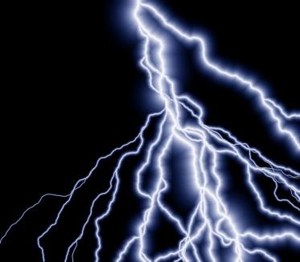**Thunder and Lightning**

* The electrical discharges that make up lightning can be spectacular to watch. Inside thunderclouds, electrical charges are produced largely by collisions between ice crystals.
* A huge electrical charge builds up as the cloud particles become electrified.
* An electric current is then discharged in a blinding flash as lightning zig zags between the ground and the earth.
* When the lightning is hidden or diffused by clouds we call it sheet lightning.
* Air around the discharge channel is heated by about 30, 000°C.
* The sound of thunder is made by heated air expanding very rapidly and causing sound waves.
* Thunder rumbles because you get sound waves coming from different parts of the storm.
* 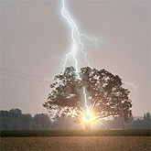The speed of sound (340) m/s) is very much less than the speed of light (300,000,000m/s). So you see a lightning flash almost immediately after it happens, while the sound can take several seconds to reach an observer.
* If you count the gap between the lightning and the thunder, you can tell how far away the storm is. For every kilometre count 3 seconds and for every mile, 5 seconds. So if you count 15 seconds, the storm is 5km or 3 miles away from where you are.
* A typical discharge delivers about 1.5 million volts. Much of this electrical energy is converted into heat energy and although these high temperatures only last a few millionths of a second, they are sufficient to vaporise the sap in a tree trunk causing it to explode.
* A typical flash fork lightning lasts only about 0.2 seconds.

**Questions** – Answer the following in sentences:

1. How are the electrical charges produced in thunderclouds?
2. What causes the lightning flash?
3. What type of lightning is hidden or diffused by clouds?
4. To what temperature is the air around a lightning discharge heated to?
5. How are the sound waves of thunder caused?
6. Why does thunder rumble?
7. Why do you hear the thunder after the flash is seen?
8. Dave sees a flash of lightning and then hears the thunder 30 seconds later. How far away is the thunderstorm?
9. What causes a tree to explode when it is hit by lightning?
10. How long does a typical flash of fork lightning last for?

Copy the following:

The speed of sound is 340 m/s and is very much less than the speed of light which is 300,000,000 m/s. So you see a flash of lightning almost immediately after it happens while the sound can take several seconds to reach the observer.

**N4 Wave Characteristics Problems**

**Longitudinal and transverse waves**

**1.** Look at the two diagrams below. State which represents a longitudinal wave and which a transverse wave.

Wave A

Wave B

**2.** Describe how you could use a ‘Slinky’ spring to demonstrate:

(*a*) a transverse wave

(*b*) a longitudinal wave.

**3.** State which of the waves below are longitudinal waves and which are transverse waves:

water waves light sound

4. What can waves be used to transmit?

5. Match the terms listed to the correct definition then copy:

|  |  |
| --- | --- |
| WAVE TERMS | DEFINITIONS |
| Frequency | Size of maximum disturbance measured from zero position |
| Wavelength | Distance travelled by a wave in one second |
| Wave-speed | Minimum distance in which a wave repeats itself |
| Amplitude | Number of complete wavelengths in one second |

6. Copy and complete:

|  |  |  |
| --- | --- | --- |
| WAVE TERM | SYMBOL | UNIT |
| Frequency |  |  |
| Wavelength |  |  |
| Wave-speed |  |  |
| Amplitude | No symbol |  |
| Time |  |  |
| Distance |  |  |

**Frequency and Wavelength Problems**

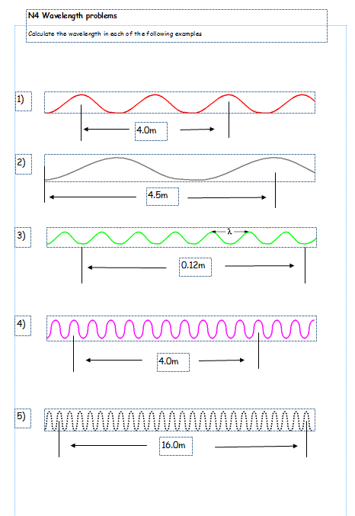

**Frequency Problems**

**1.** Ripples are produced on a ripple tank like the one shown opposite.

Calculate the frequency when:

(*a*) 10 waves pass a point in 2 seconds;

(*b*) 18 waves pass a point in 6 seconds;

(*c*) 4 waves pass a point in 4 seconds;

(*d*) 100 waves pass a point in 20 seconds;

(*e*) 5 waves pass a point in 10 seconds.

**2.** Look at the pictures of the waves below. From the information provided, find the frequency of the waves.

time

0·5 seconds

time

4 seconds

time

2 seconds

time

2 seconds

(*a*)

(*b*)

(*c*)

(*d*)

**3.** Use the information provided on the diagrams below to find the amplitude of each wave.

0·1 metres

1 metre

20 centimetres metre

2 metres

(*c*)

(*b*)

(*a*)

(*d*)

**4.** A loudspeaker vibrates at a frequency of 256 hertz to produce the note we call “middle C”

(*a*) How many waves does it produce in one second?

(*b*) How many waves does it produce in one minute?

**5.** Longitudinal waves are sent along a slinky spring. Four waves pass a point in   
2 seconds. What is the frequency of the waves.

**6.** An alarm on a phone produces a tone with a frequency of 500 hertz. How many waves will be produced in:

(*a*) 1 second;

(*b*) 5 seconds;

(*c*) 0·1 seconds.

**Frequency and Period Problems**

frequency (f) = Number divided by time or 1 ÷ period

period (T) = time divided by number or 1 ÷ frequency

1. A car engine turns at 3000 revolutions per minute (rpm). What is the frequency of the rotations?
2. A nuclear source gives out 8000 gamma rays in a minute. What is the frequency of these gamma ray emissions?
3. A Tuning fork vibrates at 550 Hz what is the period (time for one vibration) of the tuning fork?
4. When at the beach a holidaymaker counts 10 seconds for 7 waves.

a) What is the frequency of the waves?

b) What is the period of the wave?

1. Middle C on the piano has a frequency of 256 Hz. A bee’s wings flap up and down 12000 per minute. Which has the higher frequency?

**Amplitude and Frequency Sketches**

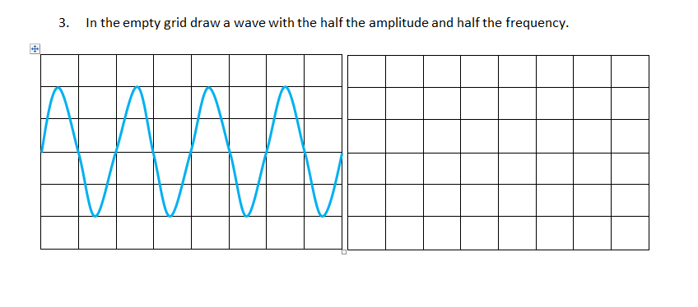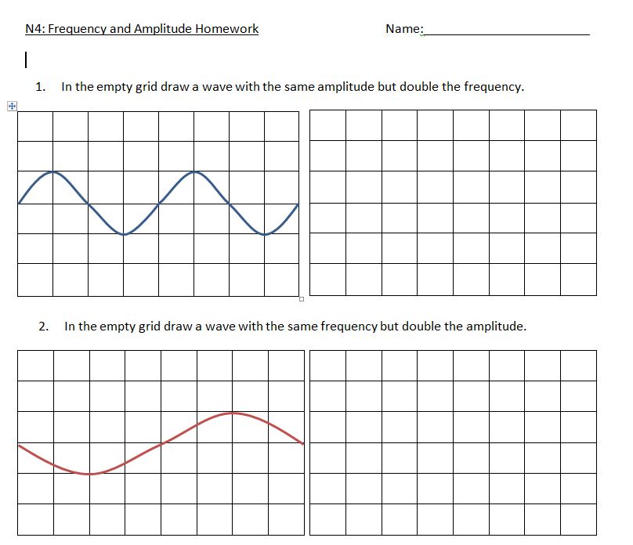

**Oscilloscope Problems**

**Mixed Wave Problems 1**

**Mixed Wave Problems 2**

**The Wave Equation**

**1.** State an equation that links wave speed, frequency and wavelength.

**2.** Calculate the missing values in the table below.

|  |  |  |
| --- | --- | --- |
| ***Wave speed*** | ***Frequency*** | ***Wavelength*** |
| (*a*) | 10 hertz | 2 metres |
| (*b*) | 0·5 hertz | 10 m |
| 4 metres per second | 2 hertz | (*c*) |
| 50 metres per second | 10 hertz | (*d*) |
| 340 metres per second | (*e*) | 5 metres |
| 2 metres per second | (*f*) | 10 metres |

**3.** A frequency meter is used in a laboratory to measure frequency. When used to find the highest frequency a student can hear it displays 17 000 hertz. Calculate the wavelength of the sound wave if sound travels at 340 metres per second.

**4.** A note played on a piano has a wavelength of 0·25 metres. Calculate its frequency if sound waves travel at 340 metres per second.

**5.** Water waves travelling along a canal have a wavelength of 2·0 metres and a frequency of 0·5 hertz. Calculate their speed.

**6.** A speedboat produces waves with a frequency of 2·0 hertz and a wavelength of   
3·0 metres. Calculate the speed of the waves.

**7.** On Mars a sound wave has a frequency of 500 Hz and a wavelength of 0.3 m. What is the speed of sound on Mars?

**8.** Water waves travel at 5 m/s and have a 2.5 m wavelength. What is the frequency of the wave?

**9**. Ultrasound waves travel at 1500 m/s in the human body. If the frequency is set at

20,000 Hz what is the wavelength of the wave?

1. 20 water waves pass a point in 10 seconds and have wavelength of 1.5 m. Calculate the frequency of the wave? What is the speed of the water wave?
2. A 1.5 m long wave travels down a metal 3 m long metal rod in 0.002 seconds. Calculate the speed of the waves. What was the frequency of the wave?
3. A tuning fork vibrates 18000 in a minute and sound has a speed of 340 m/s. Calculate the frequency of the wave? What is the wavelength of the sound waves?
4. A wave of frequency 6 Hz has a wavelength of 0.4m. What is the wave-speed?
5. A water wave travels at 15 m/s and has a wavelength of 5m. How many waves would pass you in one second?
6. A wave of frequency 8 Hz has a wave-speed of 16 cm/s. What is the wavelength?

**Extension Questions**

**1.** A ripple tank produces water waves through the up and down movement of a wooden bar. The bar moves up and down a total of 20 times in 4 seconds. The distance between each water wave produced is 0·04 metres.

(*a*) Calculate the frequency of the waves.

(*b*) State the wavelength of the waves.

(*c*) Calculate the wave speed of the waves.

(*d*) The ripple tank is 0·8 metres long. Calculate the time it takes a water wave to travel from one end to the other.

**2.** Read the passage below about wave motion then answer the questions which follow.

*Waves can be categorised into one of two groups – transverse waves and longitudinal waves.*

*Examples of transverse waves are waves found on the sea or when a stone is dropped into a pond. Transverse waves can be demonstrated by vibrating a rope back and fore. Although the wave travels along the rope the particles of the rope move at right angles to the direction of wave travel. The vibrations of a transverse wave are at right angles to the direction in which the wave transfers energy.*

direction of wave travel

rope

direction of rope   
movement

*Sound waves are an example of longitudinal waves. When the sound wave travels through the air the air particles vibrate back and fore in the same direction as the direction of travel of the wave. The vibrations of a longitudinal wave are parallel to the direction in which the waves are travelling.*

direction of particle movement

direction of wave travel

air particles

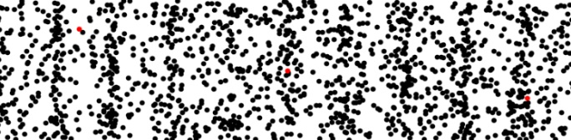

(*a*) What type of waves are:

(i) sound waves;

(ii) water waves?

(*b*) A knot is tied in a length of rope and a series of waves sent along it.

(i) Describe the direction of energy transfer.

(ii) Describe the movement of the knot.

**3.** Some pupils watch the passing of a wave along a pier.

waves

pier pile

12 metres

(*a*) The distance from a wave trough to a wave crest is 0·5 metres. What is the amplitude of the wave?

(*b*) The distance between two piers is 12 metres. What is the wavelength of the wave?

(*c*) The waves have a frequency of 0·2 hertz. Calculate the speed of the waves.

**The Electromagnetic Spectrum**

**Microwaves**

Answer the following questions in your jotter:

1. What generates the microwaves in a microwave oven?
2. What is the wavelength of the microwaves produced?
3. What mechanism allows the food to be cooked evenly?
4. Why are the walls of the microwave oven made of a reflective metal?
5. What do the microwaves do to the molecules inside the food as they pass through it and how does this heat the food up?
6. What generates the microwaves in a mobile phone?
7. Why do mobile phone companies need lots of transmitter towers?
8. What else are microwaves used for?
9. Explain how microwaves can be used to detect a speeding car, include a diagram in your answer.

**Electromagnetic Spectrum Problems**

1. Look at the list of different sorts of waves below Copy and complete the table by putting a tick in the appropriate column to show whether the waves are part of the electromagnetic spectrum (EM spectrum) or not. The first is done for you.

|  |  |  |
| --- | --- | --- |
| ***Wave*** | **EM spectrum** | **Not EM spectrum** |
| Visible light | **✓** |  |
| Ultrasound |  |  |
| Gamma radiation |  |  |
| Ultraviolet |  |  |
| Seismic waves |  |  |
| Infrared |  |  |
| Sound waves |  |  |
| Water waves |  |  |
| TV waves |  |  |
| Microwaves |  |  |
| Radio waves |  |  |
| X-rays |  |  |

**2.** The table below gives types of electromagnetic radiation and a possible source or detector Match the letters and numbers to correctly link them together.

|  |  |
| --- | --- |
| ***Wave*** | Source or detector |
| (*a*) radio & TV | 1 – sun bed |
| (*b*) microwave | 2 – glow stick |
| (*c*) infrared | 3 – Geiger counter |
| (*d*) visible light | 4 – mobile phone |
| (*e*) ultraviolet | 5 – radio one transmitter |
| (*f*) x ray | 6 – toaster |
| (*g*) gamma ray | 7 – photographic plate |

**3.** The diagram below shows the waves that form the electromagnetic spectrum.

radio and TV waves

microwaves

infrared radiation

visible light

ultraviolet radiation

X-rays

gamma radiation

(*a*) At what speed do waves in the electromagnetic spectrum travel at?

(*b*) The Sun emits both visible light and X-rays. If they are emitted at the same time, which will reach the Earth first?

(*c*) Copy and complete the following sentences using the words below

the same as smaller than greater than

(i) The wavelength of visible light is ______________________ the wavelength of radio and TV waves.

(ii) The frequency of ultraviolet radiation is ______________________ the frequency of infrared radiation.

(iii) The speed of microwaves is ______________________ the speed of X-rays.

**4.** Mobile phones use waves to transmit information.

(*a*) Name the radiation adjacent to microwaves which has a longer wavelength than microwaves.

(*b*) Name the radiation adjacent to microwaves which has a shorter wavelength than microwaves.

(*c*) Part of the microwave spectrum can have applications other than communication. Name one of these.

(*d*) Other waves in the electromagnetic spectrum are also used for communication in optical fibres. Name this radiation.

**5.** Infra red radiation is part of the electromagnetic spectrum.

(*a*) Name a possible source of infrared radiation.

(*b*) How can infrared radiation be detected.

(*c*) Describe one use of infrared radiation.

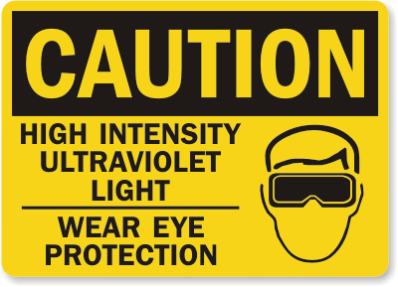**6.** The sign shown opposite is often displayed where there is the risk of exposure to high intensity ultraviolet light.

(*a*) How can ultraviolet light be detected?

(*b*) Explain why ultraviolet light can pose health risks for people who sunbathe.

(*c*) Ultraviolet light can have uses. Describe one medical and one non-medical use for ultraviolet light.

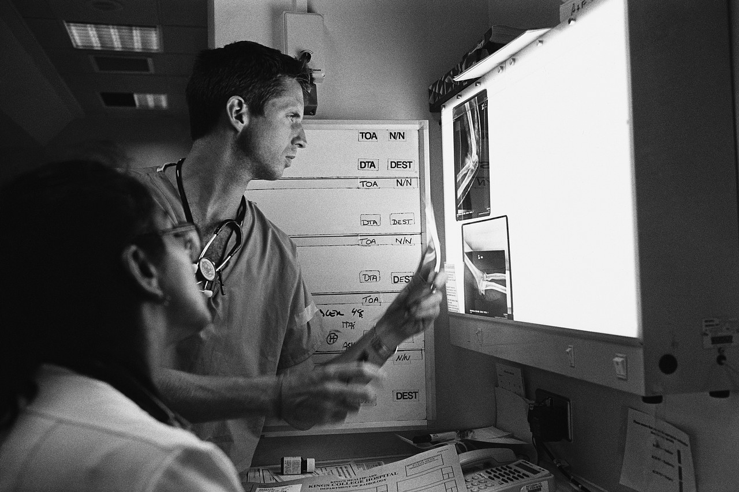

**7.** X rays are used in hospitals to help with the diagnosis of a patient.

(*a*) Copy and complete the following sentences using the words below

pass through damage block

(i) Thick lead sheets ______________________ X-rays.

(ii) X-rays ______________________ thin metal sheets

(iii) X-rays can ______________________ living tissue.

(*b*) Doctors avoid exposing healthy tissue to X-rays. Why is this?

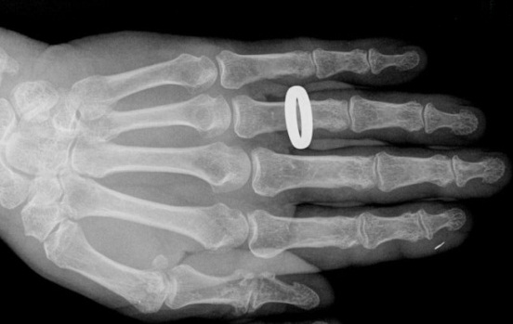

(*c*) The picture opposite shows an X-ray of a hand wearing a gold ring. Explain why the ring shows up so clearly.

**8**. A radioactive source is stored in a lead lined box. Explain why this is necessary.

**9.** Name two uses of gamma radiation in medicine.

**10.** Gamma radiation can be used to sterilise instruments. Explain why it is especially useful for this purpose.

**Electromagnetic Spectrum Calculations**

In the following calculations, remember that all parts of the electromagnetic spectrum travel at the **speed of light = 300, 000, 000 m/s.**

**v = f x λ f = v/ λ λ = v/f**

1. a) What is the frequency of microwaves which have a wavelength of 0.003m?

b) Would you expect infrared or radio waves to have a higher frequency than this?

1. What is the frequency of infrared rays which have a wavelength of 6μ

(0.000 006m)?

1. Red light has a wavelength 700nm (0.000 000 007m) and blue light has a wavelength 500nm (0.000 000 005m). Which has the higher frequency?
2. Radio waves from Capital FM have a frequency of 850 MHz (850 000 000 Hz). What is the wavelength of the radio waves?
3. Another radio station transmits waves of 510 MHz.
4. What is this frequency in Hz?
5. What wavelength do the waves have?
6. What is this wavelength in centimetres?
7. The radio wave from the previous question has a frequency of 510 MHz.
8. Find the frequency of a gamma ray with a wavelength of 1 x 10 -12 m

(0.000 000 000 001 m).

b) The amount of energy a wave has depends on its frequency. The higher the frequency, the more energy it has. Using this fact, explain why gamma rays are used for killing cancer cells and not radio waves.

1. Copy and complete the following table:

|  |  |  |  |
| --- | --- | --- | --- |
| Prefix name | Prefix symbol | Numerical Value | Scientific Notation |
| Micro |  | 0.000 000 001 |  |
|  | n |  | 1 x 10-6 |
| Milli |  | 0.001 |  |
|  | k |  | 1 x 103 |
| Mega |  | 1 000 000 |  |
|  | G |  | 1 x 109 |

**Visible Light Problems**

**Reflection Diagrams**

**Reflection Problems**

**Visible light in Medicine**

* Read the information in your notes on optical fibres, endoscopes, keyhole surgery and lasers before answering these questions.

1. Name one organ that a doctor can look at using an endoscope.
2. How are optical fibres used in an endoscope to:
3. illuminated the organ so the doctor can see what is happening
4. transmit the images back to the doctor’s eye.
5. What advantages does the use of an endoscope have over conventional surgery?
6. Explain what keyhole surgery is.
7. What can lasers be used for during keyhole surgery?
8. Why are lasers preferable to a regular scalpel?
9. What are some ways that lasers can be used to improve the appearance of the skin?
10. Lots of people in the UK now have their vision permanently corrected by laser eye surgery. Write down some advantages and disadvantages of this option for correcting vision over wearing glasses or contact lenses.

**Refraction Problems**

**Extension Questions**

**1.** The diagram below shows the electromagnetic spectrum.

radio and TV waves

microwaves

infrared radiation

visible light

ultraviolet radiation

X-rays

gamma radiation

(*a*) Which waves have the highest frequency?

(*b*) Give one use in medicine of:

(i). infrared radiation;

(ii). ultraviolet radiation.

(*b*) Exposure to too much ultraviolet radiation can be dangerous. Explain why.

(*c*) Sunglasses should block most of the ultraviolet radiation from the sun. This could be checked by placing the lens from sunglasses between an ultraviolet lamp and a material which will fluoresce.

ultra violet lamp

fluorescent screen

lens

(i) What is meant by the term fluoresce?

(ii) The ultraviolet lamp is switched on. What will be observed if no lens is present?

(iii) What changes will be noticed if a lens which blocks ultraviolet light, is placed in front of the lamp?

**2.** An X-ray is taken of a patient’s shoulder.

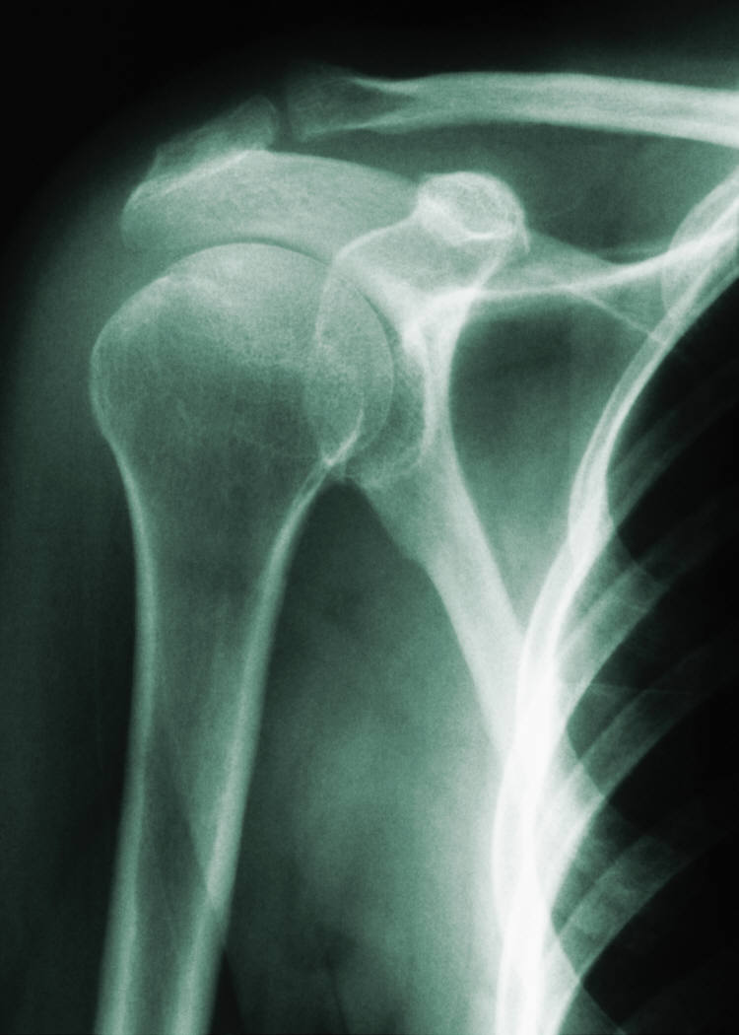

(*a*) What is used to detect the X-rays?

(*b*) Why do bones appear on the X-ray image?

(*c*) How would the X-ray image be different if there was a break in a bone? Explain this difference.

(*d*) The radiographer who takes the picture operates the equipment from a separate room. Why is this?

(*e*) Name a material that is good at blocking x-rays.

(*f*) Ultrasound is often used to examine patients. What advantage is there in using ultrasound rather than X-rays?

**Radioactivity Problems**

## **Types of radiation**

**1.** The diagram below represents and atom. Name the parts labelled (*a*), (*b*)   
and (*c*).

(*a*)

+

+

+

+

+

(*b*)

(*c*)

**2.** An atom is described as being neutral. What does this tell you about the numbers of electrons and protons in the atom?

**3.** Copy and complete the paragraph on nuclear radiation using the words given below.

air wave positive lead strongly

paper negative weakly

There are three different types of nuclear radiation – alpha, beta and gamma. Alpha radiation has a **___________** charge. It is a **___________** ionising radiation so will damage cells if it gets into the body. Fortunately, it is blocked by a thin sheet of **___________** or a few centimetres of **___________**. Beta radiation has a **___________** charge and requires 3 millimetres of aluminium to block it. The last type is gamma radiation which is not a particle but a **___________** and part of the electromagnetic spectrum. Gamma requires 3 centimetres of **___________** to block its path. Beta and gamma are **___________** ionising radiations and do not ionise as strongly as alpha radiation.

**4.** Look at the list of sources of nuclear radiation below. Copy and complete the table by putting a tick in the appropriate column to show whether the sources are natural or man-made. The first is done for you.

|  |  |  |
| --- | --- | --- |
| ***Source*** | **Natural** | **Man-made** |
| Building materials |  | **✓** |
| Nuclear medicine |  |  |
| Nuclear power stations |  |  |
| Cosmic radiation |  |  |
| Granite rock |  |  |
| Radon gas |  |  |
| Bananas |  |  |
| Water |  |  |
| Tobacco |  |  |
| Smoke detectors |  |  |
| Coal |  |  |
| Luminous watches |  |  |

**5.** What happens to the level of radiation emitted by a source over time?

## **Applications of nuclear radiation**

**6.** A manufacturer of tin foil uses an automatic thickness monitoring system which uses nuclear radiation. The pressure applied to the rollers will determine the thickness of the foil - the greater the pressure the thinner the foil. The radiation passing through the foil will vary with the thickness of the foil.

rollers

beta source

detector

aluminium foil

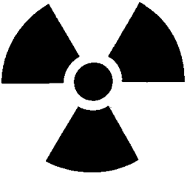

(*a*) Why is beta radiation used rather than alpha or gamma radiation?

(*b*) The count rate of the beta radiation decreases. What does this mean has happened to the thickness of the foil?

(*c*) How will the roller pressure be altered if the foil is found to be too thin?

**7.** A doctor uses radioactive tracers to check the flow of blood through a patient’s kidneys. One kidney is functioning normally and the other is blocked.   
A radioactive liquid which emits gamma radiation, is injected into the patients bloodstream. The level of radiation emitted from the kidney increases then falls for a normal kidney but increases and remains steady for a blocked kidney.

The two graphs below show the radiation levels for each kidney.

radiation  
level

time

Left kidney

radiation  
level

time

Right kidney

(*a*) Give two reasons why a gamma emitter is used rather than an alpha emitter as the radioactive source.

(*b*) Examine the graphs above and state which kidney is blocked.

(*c*) Why will the level of radiation in the patient slowly decrease?

(*d*) Iodine is naturally absorbed by the thyroid gland found in the neck. Radioactive iodine is injected into a patient and a gamma camera used to produce an image of their thyroid area. The image produced is shown below. The normal size and location of the thyroid is outlined.

normal thyroid

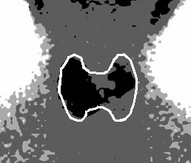

right side

left side

(i) What information does the image from the gamma camera give about the absorption of the radioactive iodine?

(ii) The radioactive iodine injected into the patient is prepared shortly before use. (e) Why are larger batches not produced and stored.

**8.** A long section of underground water main has developed a leak. To find its location some radioactive liquid is added to the water flowing through the pipe and levels of radioactivity measured in the area above the pipe.

The diagram below shows the radiation levels in counts per minute.

water main

houses

source

0

20

40

60

80

100

120

140

distance from source in metres

activity in counts per minute

95

120

103

116

82

308

1060

95

rocks and soil

(*a*) Why are the water supplies to houses supplied by the pipe disconnected during the test?

(*b*) Suggest the distance from the source where the leak might be.

(*c*) Why must a gamma emitting source be used for this test?

**9.** *(a*) What type of nuclear reaction takes place in a nuclear reactor power   
station – nuclear fission or nuclear fusion?

(*b*) Below are four statements numbered 1 to 4. Put these in their correct order to describe what happens in a nuclear reactor.

**1.** Energy is released

**2.** A uranium nucleus splits

**3.** A uranium nucleus is hit by a neutron

**4.** Neutrons are released

1. A chain reaction takes place in a nuclear reactor. Explain what is meant by a chain reaction.

**11.** Look at the block diagram of a nuclear power station below.

NUCLEAR REACTOR

BOILER

PRODUCES STEAM

###### A

GENERATOR

(*a*) Name the part labelled **A**.

(*b*) Heat is produced by the nuclear reaction. What happens to this heat?

(*c*) Describe the purpose of the generator.

(*d*) What energy conversion takes place in the nuclear reactor?

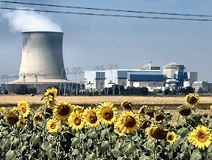

**12.** Listed below are some statements relating to the generating of electricity using nuclear reactors. For each statement, say whether you think it is true or false.

1. The vast majority of radiation we are exposed to comes from space and the ground beneath our feet.

2. Nuclear power stations will run out of fuel in just a few years.

3. Waste from nuclear reactors must be stored underground for a long time until the radiation emitted decreases.

4. Nuclear reactors use the process of nuclear fission to produce heat.

5. Nuclear reactors can be built very quickly.

6. Nuclear reactors produce a large amount of sulphur dioxide which produces acid rain.

7. Most of the radiation we are exposed to comes from nuclear power stations.

8. Nuclear reactors cannot generate enough electricity to meet high power demands like industry.

9. Nuclear reactors produce large volumes of greenhouse gases.

10. All the nuclear reactors in the world are the same type as the one that exploded in Chernobyl.

**13.** A handbook for a technician who is working with nuclear radiation lists a number of simple rules. Some of these are as follows.

1. Anyone present when radioactive substances are being handled must be over 16 years of age.

2. Always wear rubber gloves and a laboratory overall when handling radioactive sources.

3. There should be no smoking or eating within areas where radioactive substances are present.

4. Radioactive sources should always be handled using tongs.

5. Radioactive sources should always be pointed away from the body.

6. A radiation badge must be worn at all times when handling radioactive substances.

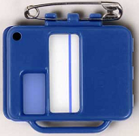

For each of the rules above, suggest how it would help reduce the risk posed by nuclear radiation.

**Extension Questions**

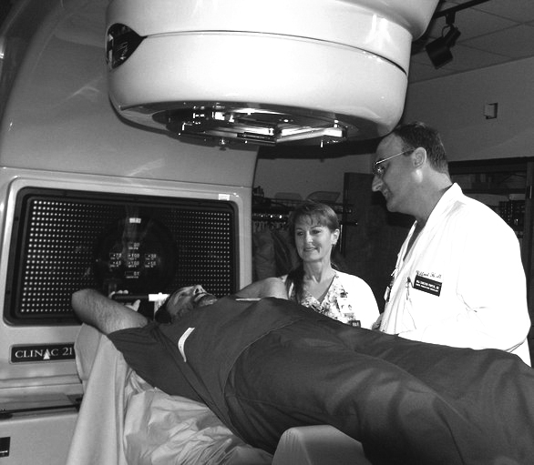**1.** Radiation is used to destroy cancer tumours within a patient’s body without the need for surgery. Beams of penetrating radiation are produced by a special machine housed in a lead-lined room to protect the radiographers who remain outside.

beam of radiation

radiation source

tumour

patient

The machine sends the narrow beams through the body and targeted area—the tumour—for the required length of time. It is then rotated around to different positions and the beam of radiation fired again. In this way the radiation is continually aimed at the tumour but only passes through healthy tissue for a short time.

(*a*) What type of radiation would have been used in the treatment described above?

(*b*) Why is it important that the dose of radiation used in treating cancer is not too high?

(*c*) Why is the beam of radiation direct from three different angles rather than just a single beam?

(*d*) Name one other use of radiation in:

(i) medicine;

(ii) industry.

**2.** A radioactive source is placed above a Geiger counter which will detect any radiation emitted. A shielding material separates the radiation from the Geiger counter.

10 centimetres



Geiger counter to detect radiation

radioactive source

shielding material

(*a*) Initially there is no shielding material between the source and the counter and they are separated by 10 centimetres. No radiation is picked up from the source until the separation between the source and the Geiger counter is less than 3 centimetres. What sort of radiation does this show is being emitted by the source?

(*b*) The source is replaced with one which emits alpha, beta and gamma radiation. What shielding material would be required to block each of these radiations.

(*c*) Give three safety precautions that would have to be followed to handle the radioactive source safely.

**Sound Problems**

**Sound waves**

**1.** An oscilloscope like the one shown below can be used to look at sound signals.

Oscilloscope traces for a number of different sounds are shown below. The oscilloscope settings are the same for every sound.

Which trace or traces display:

(*a*) sounds with the same wavelength;

(*b*) sounds with the same amplitude;

(*c*) sounds with the lowest frequency;

(*d*) human speech.

Trace 1

Trace 3

Trace 2

Trace 4

Trace 5

**2.** Two oscilloscope traces are shown below. The oscilloscope settings are not changed but the sounds are. What changes have been made to the sound between Trace A and Trace B?

Trace A

Trace B

**3.** An alarm clock is placed in a bell jar attached to a vacuum pump. The alarm clock is set so that it is ringing.

vacuum pump

bell jar

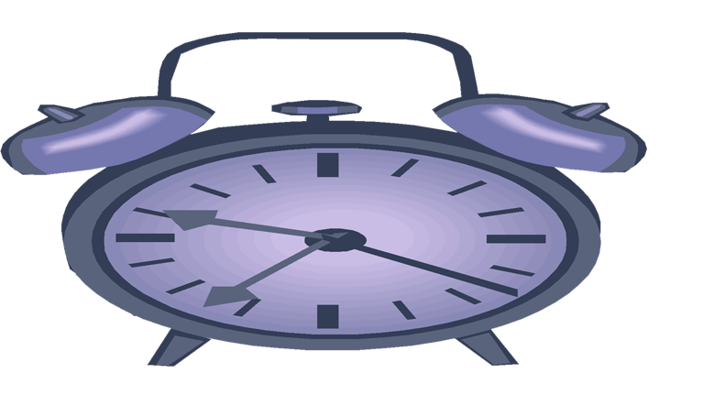

alarm clock

(*a*) Describe what would be heard:

(i) before the air is pumped of the bell jar;

(ii) after the air is pumped out of the bell jar.

(*b*) Explain why there is a difference between the answers to the questions above.

**Ultrasound and sonar**

**1.** What are the lowest and highest frequencies which humans are able to hear?

**2.** What name is given to sounds which are above the range of human hearing?

**3.** Ultrasound waves travel through tissue at 1540 metres per second. They have a frequency of 2 000 000 hertz. Calculate the wavelength of the waves.

**4.** Ultrasound has many uses as well as for scanning unborn babies.

Some of these are given below:

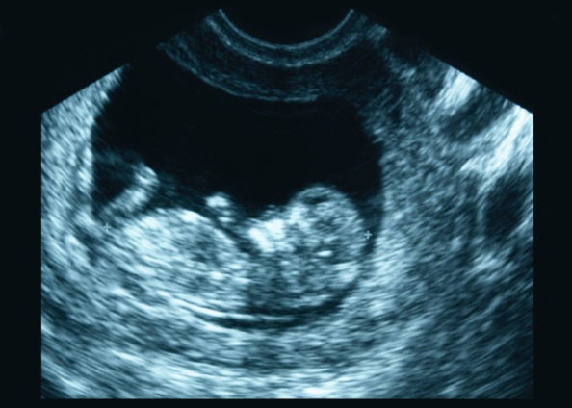

An example of an ultrasound scan of a baby in its mother’s womb.

* cleaning delicate instruments;
* detecting cracks or flaws in metal;
* sonar in ships to detect the seabed or shoals of fish;
* detecting tumours;
* measuring blood flow through the heart;
* detecting kidney stones.

Choose one of the above, or another of your own choosing and describe how ultrasound

is used in this application.

**5.** A fishing boat uses ultrasound in its sonar system.

20 m

(*a*) Sound travels at 1600 metres per second in water. Calculate the frequency of the sonar waves if they have a wavelength of 0·04 metres.

(*b*) The sea bed is 20 metres below the boat. How long will it take the pulse from the boat to reach the seabed **and** travel back to the boat.

**Sound production**

**1.** Sound is produced in a musical instrument by producing vibrations. Look at each of the instruments below and state what it is that is vibrating to create the sound.

(*a*) cello

(*d*) trumpet

(*b*) piano

(*c*) kettle drum

**2.** The sound from a tuning fork is fed into an oscilloscope to produce the trace shown below.

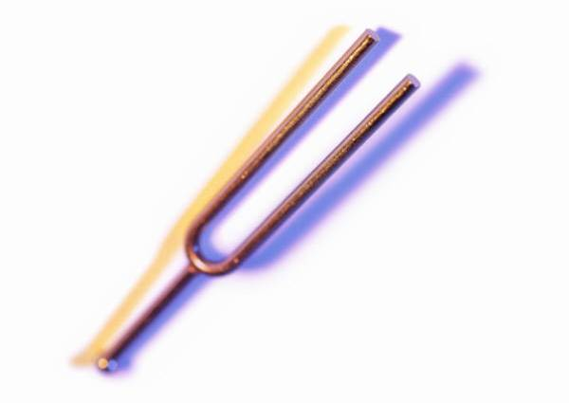

Sketch the oscilloscope trace that would be seen if:

(*a*) the same tuning fork was used producing a louder note;

(*b*) a longer tuning fork was used producing a lower pitched note.

**3.** A cross-section through a loudspeaker from a sound system is shown opposite. Describe how it produces sound.

coil of wire

permanent magnet

flexible cone of paper or plastic attached to coil of wire

electrical connections to coil of wire

**3.** State the effect on the note produced by a plucked guitar string if:

(*a*) the string is shortened;

(*b*) the string is made tighter?

**Noise pollution**

**1.** Name the unit in which sound level is measured.

**2.** (*a*) Some examples of noise producing activities are listed below. Copy the table then match them against the appropriate sound level.

|  |  |
| --- | --- |
| ***Activity*** | ***Sound level*** |
| (*a*) passing motorbike | 140 dB |
| (*b*) vacuum cleaner | 50 dB |
| (*c*) pneumatic drill | 70 dB |
| (*d*) rain | 100 dB |
| (*e*) jet engine | 90 dB |

(*b*) What sound level is regarded as being dangerous to our hearing and can cause permanent damage.

(*c*) State two ways in which hearing can be protected from loud sounds.

**3.** An employee working with noisy machinery has been told by his employers to wear ear defenders. Explain what ear defenders are and why he should wear them.

**Extension Questions**

**1.** Compare the two oscilloscope traces below. The oscilloscope settings remain the same. Describe in terms of wavelength, amplitude and frequency, the differences between the two traces.

Trace B

Trace A

**2.** The speed of sound can be measured in a school laboratory using an electronic timer and a sound operated flashgun. The apparatus is set up as shown below.



flashgun and loudspeaker unit

3·4 metres

microphone and light detector

electronic timer

0·01 s

The loudspeaker produces a sharp note which triggers the flash. This starts the timer. When the sound reaches the microphone the timer stops.

(*a*) Compare the speed of sound and the speed of light in air.

(*b*) The light and sound detectors are placed 3·4 metres away from the loudspeaker and flashgun. The time recorded on the timer is 0·01 seconds. Use this information to calculate the speed of sound.

**3.** Very high frequency sound waves can be used to make medical examinations of organs inside a patient’s body. They are also used to scan unborn babies in their mother’s womb.

(*a*) What are these high frequency sounds called?

(*b*) The diameter of the baby’s head can be measured and compared against a graph of the expected diameter of babies at different stages. This baby’s head measures 6 centimetres and the baby is 20 weeks old.

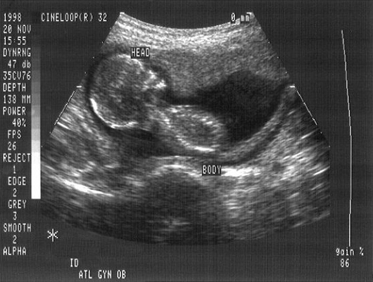

**6 centimetres**

Use the graph below to find if the baby is within the expected range.

diameter of babies head in centimetres

14

26

24

22

20

18

16

age in weeks

12

10

8

6

4

2

upper limit

lower limit

average diameter

**4.** An experiment is set up to measure how well sound travels through different mediums ie. a gas, a liquid and a solid.

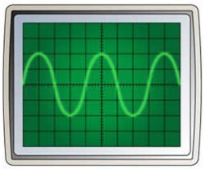

oscilloscope

signal generator connected to microphone

microphone

tank

A tank can be filled with either a solid, liquid or gas. A microphone attached to a signal

generator produces a sound which travels through the medium to a microphone at the

other end. The microphone is connected to an oscilloscope.

The oscilloscope screens below show the sound picked up by the microphone for each sound.

Liquid

Solid

Gas

(*a*) Why is it important that the same frequency and amplitude of sound is used for each test?

(*b*) The distance between the speaker and microphone is the same in each test. Why is this important?

(*c*) Which of the three mediums is best at transmitting sound? Give a reason for your answer.

(*d*) A vacuum is now created in the tank. Describe what would be seen on the oscilloscope now, giving reasons for your answer.

**5.** Read the passage below about noise cancellation then answer the questions which follow.

*People often work in a noisy workplace or simply want to listen to music in an otherwise noisy environment, such as inside an aircraft cabin. Prolonged exposure to loud sounds can damage our hearing and can even become painful. One way of overcoming these problems is to use noise cancellation technology in headphones.*

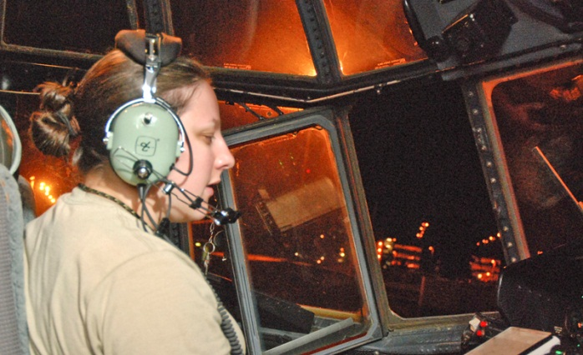

A helicopter pilot uses noise cancelling headphones to reduce the noise in a very noisy cockpit

*Noise cancellation can be either passive or active. Passive noise cancelling headphones usually completely cover the ear and are packed with layers of high density foam or other sound absorbing materials. This reduces external sounds by up to 20 decibels.*

*In noisy environments such as inside an aircraft cabin where sound levels can be up to 80 decibels, active noise cancelling earphones have to be used. These use special electronics to cancel out the sounds from outside the headphones. Small microphones pick up external sounds and an electronic circuit turns the sound wave ‘upside down’.*

+

=

sound wave from cockpit noise

sound wave turned ‘upside down’ and added to cockpit noise

silence

*This is then played through small speakers inside the headphones which, when combined with the outside noise, effectively cancels out the sound.*

(*a*) Explain why prolonged exposure to loud sounds should be avoided.

(*b*) How does ‘passive noise cancellation’ reduces noise levels?

(*c*) Explain how ‘active noise cancellation’ reduces noise levels.

**Revision Pages**

**Radiations**

1. What happens to a beam of light when it hits a mirror?
2. Name the imaginary line drawn at right angles to the surface of the mirror.

mirror

42°

θ

1. What name is given to the angle shown as 42° in the diagram?
2. What is the name given to θ?
3. What would you expect the value of θ to be?
4. What is the Law of Reflection?
5. What materials are optical fibres made from?
6. Name the process by which light passes from one end to the other?
7. Describe how an endoscope works.
8. What advantage do they have over conventional surgery?
9. How does light from a laser beam differ from light coming from a light bulb?
10. What part of the eye can be repaired using a laser?
11. Name the type of lens that will bring parallel rays of light to a focus.
12. Name the type of lens that will spread parallel rays of light out.
13. Copy and complete this table:

|  |  |  |  |
| --- | --- | --- | --- |
| Eye defect | Nature of problem | Where is light focussed? | Lens needed to correct |
| Short sight |  |  |  |
| Long sight |  |  |  |

1. Copy and complete this table to show how parts of the electromagnetic spectrum are used in the different industries:

|  |  |  |
| --- | --- | --- |
| Part of EM spectrum | Use in medicine | Other uses |
| Gamma Rays |  |  |
| X-rays |  |  |
| Ultra violet |  |  |
| Infrared |  |  |

**Waves and Sound**

1. What unit is frequency measured in?
2. What is the frequency range of human hearing?
3. What does the number of waves in a second tell us?
4. The length of time it takes a wave to pass a point is also known as what?
5. From the diagram below find:
6. the amplitude
7. the wavelength
8. the frequency
9. the speed of the wave

time = 5s

1.5 m

0.8 m

1. What speed to all radio and tv waves travel at?
2. Name all the colours of the visible spectrum starting with red
3. Copy and complete the diagram below to show what happens to the signals received by the dish:
4. When listening to the note produced by a signal generator, what happens to the sound you hear as you:
5. increase the frequency
6. decrease the amplitude?
7. What happens to the particles in the air when a sound is produced?
8. Copy and complete the following table:

|  |  |
| --- | --- |
| Type of wave | Speed in air (ms-1) |
| Sound |  |
| Light |  |
| Ultraviolet |  |
| Infrared |  |
| Gamma Ray |  |

1. Explain why during a thunderstorm you hear the sound of the thunder after you see the flash of lightning?

**Calculations**

Use the following formulae to help answer these questions:

speed = distance/time time = distance/speed distance = speed x time

1. A sound is heard 200m away from it’s source. If the speed of sound in air is 330m/s, how long did the sound take to travel to the observer?
2. An athlete finishes a 100m race in 10.5s. What was his average speed?
3. A rumble of thunder is heard 3 seconds after the lightning was seen. How far away was the lightning strike?

speed = frequency x wavelength frequency = speed/wavelength

wavelength = speed/frequency frequency = no. waves/time

1. 5 water waves pass a point in 0.8s. What is their frequency?
2. What is the wavelength of a sound wave of frequency 500Hz?
3. An experiment is carried out to calculate the speed of sound in air in the lab. 2 sound sensors are set up 5m apart and the time taken for the sound to travel between them is 0.015s. What value does this give for the speed of sound in air?
4. Some microwaves have a wavelength of 3cm. What is their frequency?