**N4 Electricity and Energy Problems**

**Renewable and Non-renewable Fuels** **Problems**

1. Which of the following are fossil fuels:

coal, wind, oil, nuclear, solar, gas

1. If an energy source is described as renewable, what does this mean?
2. Sources of energy can be classifies into renewable and non-renewable.

|  |  |
| --- | --- |
| Renewable | Non-renewable |
|  |  |

Copy the table above and enter the following sources of energy in the correct column:

coal, oil, solar, wind, nuclear, hydroelectric,

gas, biomass, wave, tidal, geothermal

1. State a disadvantage of each of the following renewable energy sources:
   1. Solar
   2. Wind
   3. Geothermal
2. State an advantage of each of the following renewable energy sources:
   1. Solar
   2. Wind
   3. Waves

**Energy Transformations Problems**

1. What is the useful energy transformation in the following electrical appliances?
   1. Light bulb
   2. Food mixer
   3. Fan
   4. Radio
   5. Television
   6. Door bell
   7. A lift going up
   8. Hair drier
2. List as many appliances as possible that have the main useful energy transformation of Electrical 🡪 Heat.
3. What is the useful energy transformation in the following situations?
   1. Ball dropping off a table.
   2. A skier skiing downhill.
   3. A petrol car driving at a steady speed.
   4. A car braking.
   5. A battery supplying energy to an electrical circuit.
   6. A nuclear reactor boiling water.
   7. Gunpowder pushing a bullet from a gun.
   8. Boiling water on a gas cooker.
   9. Boiling water over a wood campfire.
   10. A wind turbine generating electricity.
   11. A solar cell generating electricity.

**Energy, Power and Time Problems**

1. Find the missing values in the following table.

|  |  |  |  |
| --- | --- | --- | --- |
|  | *Power* (W) | *Energy* (J) | *Time* (s) |
| (*a*) |  | 1 500 | 30 |
| (*b*) |  | 180 000 | 36 000 |
| (*c*) | 100 |  | 600 |
| (*d*) | 1 200 |  | 2 |
| (*e*) | 3 000 | 120 000 |  |
| (*f*) | 2·5 | 25 |  |



2. How long will it take for a 60 W bulb to use 720 J of electrical energy?

|  |  |
| --- | --- |
| 3. A bulb uses 45 000 J of energy in 300 seconds. What is its power rating? |  |

4. A 50 W immersion heater is switched on for 80 seconds. How much electrical energy passes through it in this time?

|  |  |
| --- | --- |
| 5. | Calculate the power rating of an electric sewing machine which uses 4 560 J of energy in 8 minutes.  (Remember to change time into seconds) |

6. A 1 200 W hairdryer is switched on for 20 minutes. How much electrical energy does it use?

7. For how many minutes must a 600 W shaver be switched on in order to use 540 000 J of electrical energy?

8. How long will it take a 1400 W paint stripper to use 1 680 000 J of electrical energy?

9. An electric fire uses 5·22 MJ of electrical energy in 30 minutes. Calculate the power rating of the fire. (1 MJ = 1 x 106 J = 1 000 000 J)

10. A microwave oven is on for twenty minutes each day. If it uses 7·98 MJ of electrical energy in one week, what is its power rating?

**Efficiency Problems**

What is the efficiency of a machine which has a power input of 800W and a power output of 600W?

1. A machine has a useful input energy of 20000J and has an output energy of 16000J. Find its efficiency.
2. A motor has and output power of 480W and an input power of 800W. How efficient is it?

4. An electric motor has an input energy of 60000J and runs for 2 minutes.

a) How many seconds does it run for?

b) What is its input power?

c) If its output is 375W, how efficient is it?

5. A motor is rated at 750W (max input power). What is the efficiency of this motor if it uses 1000J of energy to lift a weight to a desired height in 2s?

**Electromagnetism Problems**

1. Describe how to make a simple electromagnet.
2. A coil of wide is connected to a voltmeter. A magnet is placed next to the coil. The magnet is continually moved back and forwards and a voltage is produced across the coil.

**V**

N

* 1. What will happen to the voltage if the speed of movement is increased?
  2. What will happen to the voltage if the magnet stops moving?
  3. What will happen to the voltage is a stronger magnet is used?
  4. What will happen to the voltage if more turns are put in the coil?
  5. Is the current in the coil ac or dc and what does this stand for?
  6. Describe what happens to the direction of the current.

**Series Circuits Problems**

1. What is the rule about current in a series circuit?
2. What is the rule about voltage in a series circuit?
3. Two identical 2.5 V bulbs are connected to a supply as shown. What is the voltage of the supply?

2·5 V

2·5 V

1. Two identical resistors are connected across a 12 V supply as shown in the diagram. What is the voltage across each of the resistors?

A

12 V

B

1. Four identical resistors are connected across a 12 V supply as shown in the diagram. What is the voltage across each of the resistors?

B

D

12 V

C

A

1. A simple circuit with a bulb and resistor in series is shown below.

36 V

R

12 V, 36 W

If the bulb is operating at its correct voltage and power rating what is the voltage across the resistor R?

If the current in the bulb is 3 A. What current flows in the resistor?

1. Two resistors are connected in series to a supply as shown in the diagram.

15 V

100 Ω

200 Ω

* 1. The current in the 200 Ω resistor is 0·05 A. What is the current in the other resistor?
  2. The voltage across the 100 Ω resistor is 5 V. What is the voltage across the 200 Ω resistor?

1. A variable resistor (also known as a rheostat) is used as a dimmer switch in a simple series circuit as shown.

14 V

The variable resistor is adjusted until the bulb is shining brightly. The voltage across the bulb is 13·8 V and the current through the variable resistor at this setting is 1·7 A.

Calculate the voltage across the variable resistor.

What is the current flowing in the bulb?

1. Two resistors are connected in series to a supply as shown in the diagram.

21 V

20 Ω

10 Ω

40 Ω

a. The current in the 10 Ω resistor is 0·3 A. What is the current in the 40 Ω resistor?

b. The voltage across the 10 Ω resistor is 3 V and voltage across the 20 Ω resistor is 6V. What is the voltage across the 40 Ω resistor?

**Parallel Circuits Problems**

1. What is the rule about current in a parallel circuit?
2. What is the rule about voltage in a parallel circuit?

R2

12 V

R1

0·2 A

0·3 A

1. Two resistors are connected in parallel to a 12 V battery.
   1. What is the voltage across R1?
   2. What is the voltage across R2?
   3. What size of current is drawn from the battery?
2. Two identical bulbs and a resistor are connected in parallel to a 6 V supply.

L1

L2

R1

6 V

4 A

* 1. What is the voltage across L2?
  2. A current of 1·8 A flows through each of the bulbs. What is the current flowing through the resistor?

1. An electric fire has three elements which can be switched on and off independently. The elements are connected in parallel to the mains supply. Each element draws a current of 0·3A when switched on.

230 V

* 1. What is the voltage across the middle element?
  2. What is the total current flowing from the supply when two of the elements are switched on?
  3. What is the maximum current drawn from the mains by the fire?

1. The headlamps and side lights in a car are connected in parallel. The diagram below shows how they are connected. The side lights (L1 & L2) may be switched on by themselves using switch S1. The headlights (H1 & H2) are switched on by switch S2 and only come on if the sidelights are already on.

S2

12 V

S1

L1

L2

H2

H1

* 1. What is the voltage across the sidelight L1?
  2. What is the voltage across the headlight H2?
  3. Each sidelight draws a current of 3 A from the car battery. What is the total current drawn from the battery when S1 only is closed?
  4. Each headlight draws a current of 5 A from the car battery. What is the total current drawn from the battery when S1 and S2 are closed?

1. A hairdryer contains a motor and two heating elements (resistors). The hairdryer shown below has three heat settings- cold, warm and hot. The circuit diagram shows how these settings are achieved using switches A, B and C.

C

B

A

H1

H2

230 V

M

The motor draws a current of 3 A from the mains and the heating elements draw a current of 2 A each from the mains.

* 1. Which switches must be closed to make the hairdryer blow warm air?
  2. What current is drawn from the mains when the hairdryer blows warm air?
  3. Which switches must be closed to make the hairdryer blow hot air?
  4. What current is drawn from the mains when the hairdryer blows hot air?
  5. What is the minimum current drawn from the mains when the hairdryer is on?
  6. What is the voltage across the motor?

**Mixed Series and Parallel Circuits Problems**

1. In the following circuits the bulbs are identical. Calculate the voltage across each lettered bulb.

(d)

(e)

(a)

6V

6V

(b)

(c)

(f)

6V

(w)

(u)

(v)

15V

(s)

(t)

(r)

(o)

(p)

(q)

12V

(m)

(n)

(k)

(l)

6V

(i)

(j)

(h)

6V

(g)

1. In the following circuits the bulbs are identical. Calculate the current through each lettered bulb.

4 A

4 A

(n)

(o)

(j)

(k)

(h)

(i)

(a)

(p)

(d)

(e)

12 A

(f)

(g)

(b)

(c)

15 A

5 A

9 A

(m)

(l)

11 A

(u)

(v)

(t)

(r)

(q)

12 A

6 A

3 A

(w)

(x)

(y)

(s)

**Kinetic Theory Problems**

1. What state of matter is represented by the following diagrams:

(a) (b) (c)

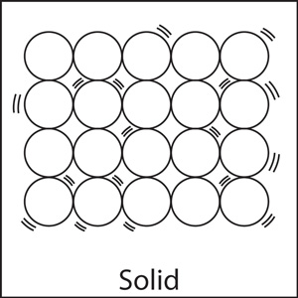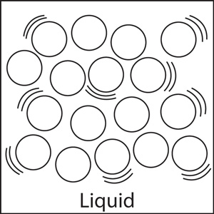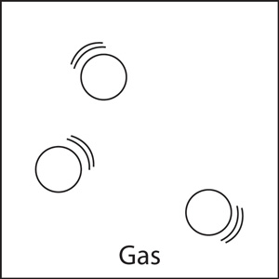

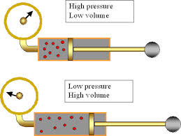

1. Copy and Complete: Explaining Boyle’s Law.

As the volume of gas increases the pressure decreases. This is because the particles are further apart and collide ­­­­____ frequently with the walls of the container.

1. Copy and Complete: 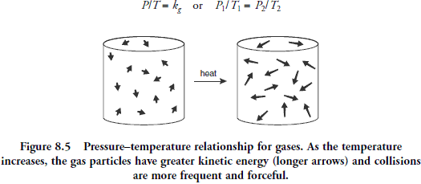 Explaining Gay Lussac’s Law

As the temperature of the gas increases the particles gain _____ energy (longer arrows in diagram below) and move _____. They hit the walls of the container _____ often and with ______ force thereby causing the pressure to increase.

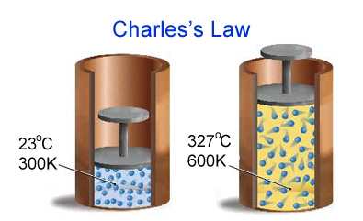

1. Copy and Complete: Explaining Charles’ Law

As the temperature of the gas increases, the particles gain ______ energy and move _______. The particles hit the walls of the container more often and with ______ force. The volume must _______ to give a greater surface area to keep the pressure constant.