**N4 Dynamics and Space Problems**

**Average Speed Problems**

1. A car travels a distance of 2 000 metres in a time of 160 seconds. Calculate the average speed of the car in metres per second.
2. A runner completes a 200mrace in 25s. What is his average speed in m/s?



1. Jane jogs to work every day at an average speed of 4 m/s. Most days it takes her 600 seconds to reach work. Calculate how far she jogs.
2. A model train travels round 10 m of track at an average speed of 1·5 m/s. How long does this take?
3. Christopher takes 26 seconds to swim one length of a swimming pool. If the pool is 50 metres long, calculate his average speed.
4. How far will a cyclist travel in 60 seconds if he is travelling at an average speed of 13 metres per second?
5. Calculate a hurdler’s time if she completes the 400 m hurdle race at an average speed of 7 m/s.
6. Describe how you could measure the average speed of a car as it passes along a section of the distributor road. You should include a diagram, equipment used and a list of measurements taken, along with any calculations made.
7. Concorde travels at 680 m/s.
8. How does this compare to the speed of sound?
9. How far will it travel in 30 seconds at this speed?
10. How far will it travel in a minute?
11. A jet aircraft travels for 5 minutes at 400 m/s.
12. How many seconds are in 5 minutes?
13. How far does the jet travel in this time?
14. An athlete takes 4 minutes 20 seconds to complete a 1500m race.
15. How many seconds did they take to complete the race?
16. What was their average speed?
17. In a fun run, a competitor runs 10km in 1 hour. What is her average speed in:
18. km/h
19. m/s?



1. The Channel Tunnel is approximately 50 km long.
2. How many metres are in 50km?
3. How long will it take a train travelling at 90 m/s to travel from one end of the tunnel to the other?
4. A hill walker walks at an average speed of 1·5 m/s. How long will it take her to cover a distance of 27 km? (Remember to convert to metres first!)
5. A girl can walk at an average speed of 2m/s. How far will she walk in 20 minutes?
6. How long will it take a cyclist to travel 40km at an average speed of 5 m/s?
7. Richard Noble captured the world land speed record in 1983 in his vehicle Thrust 2. The car travelled one kilometre in 3·5 seconds. Calculate the average speed of the car.
8. Andy Green broke the world land speed record in 1997 in his vehicle Thrust SSC. He travelled at an average speed of 340 m/s over a distance of 1000 m. Calculate what time he took to travel this distance.
9. On a motorway a car has a speed of 130 km/h. If it travels for 2 hours, calculate the distance it travels in km.
10. A lorry takes 4 hours to travel 160 km. Calculate the average speed of the lorry in km/h.
11. In 1889 the first Daimler car reached a speed of 20 km/h. How far would the car travel in 3 ½ hours if it travelled at a constant speed of 20 km/h?

**Instantaneous Speed Problems**

1. A car has a length of 4 m and passes a point in 0.5 s. Calculate the car’s instantaneous speed.
2. A card of length 0.05m is attached to a trolley. The card takes 0.2 s to pass a light gate. Calculate the instantaneous speed of the trolley at this point.

0·2 s

1. The same equipment is used again for measuring the instantaneous speed of a trolley as it travels down a runway.

Use the equation

$$instantaneous speed= \frac{length of card}{time taken to cut beam}$$

to find the missing values in the following table:

|  |  |  |  |
| --- | --- | --- | --- |
|  | *instantaneous speed* (m/s) | *card length* (m) | *time* (s) |
| (*a*) |  | 0·02 | 0·1 |
| (*b*) |  | 0·015 | 0·1 |
| (*c*) | 4·1 | 0·03 |  |
| (*d*) | 3·5 |  | 0·05 |
| (*e*) | 2·0 |  | 0·2 |
| (*f*) | 1·86 | 0·01 |  |

1. An observer wants to find the instantaneous speed of a car as it passes a pedestrian crossing. He measures the length of the car and finds it to be 3·5 m. He then stands with a stop watch at the crossing, starts timing as the front of the car passes him and stops when the back of the car has passed. The time recorded is 2·4 s. Calculate the instantaneous speed of the car.
2. A runner decides to analyse his track performance in order to improve his overall running time during the 400 m event. He sets up light gates at six points round the track so that he can work out his instantaneous speeds at each point.

As the runner cuts the beam of light from the light gate the timer operates. The results he recorded are shown below.

|  |  |  |  |
| --- | --- | --- | --- |
| *Position* | *width of runner* (m) | *time* (s) | *instantaneous speed* (m/s) |
| A | 0·2 | 0·025 |  |
| B | 0·2 | 0·026 |  |
| C | 0·2 | 0·030 |  |
| D | 0·2 | 0·029 |  |
| E | 0·2 | 0·025 |  |
| F | 0·2 | 0·024 |  |



Use the results to calculate his instantaneous speed at each position and hence say at which point he is running:

* 1. Fastest
  2. Slowest

1. Civil engineers need to know the speeds of a train as it enters a tunnel which they are planning to build. They set up their equipment to measure the length of a section of the train and time how long that section takes to pass the planned point of entry to the tunnel. The length of train is 150 m and the time to pass the point of entry is recorded as 1·42 s. Calculate the instantaneous speed of the train.
2. A coin is dropped from a height so that it passes through a light gate connected to a computer. The coin has a width of 0·02 m and it takes 0·005 seconds to pass through the light gate. Find its instantaneous speed.

**Acceleration problems**

1. If a car is accelerating, what is happening to its speed?
2. If a car is decelerating, what is happening to its speed?
3. If a car is travelling at a constant speed, what is the acceleration?
4. A jaguar can reach 27 m/s from rest in 9.0s. What is its acceleration?
5. The space shuttle reaches 1000m/s, 45 s after launch. What is its acceleration?
6. A car can reach 30m/s from a speed of 18m/s in 6s. What is its acceleration?
7. A train moving at 10m/s increases its speed to 45m/s in 10s. What is its acceleration?
8. A bullet travelling at 240m/s hits a wall and stops in 0.2s. What is its deceleration?
9. A car travelling at 20m/s brakes and slows to a halt in 8s. What is the deceleration?
10. Describe how you would measure the acceleration of a small vehicle as it runs down a slope in the lab.
11. On approaching the speed limit signs, a car slows from 30m/s to 12m/s in 5s. What is its deceleration?
12. A bowling ball is accelerated from rest at 3m/s2 for 1.2s. What final speed will it reach?
13. How long will it take a car to increase its speed from 8m/s to 20m/s if it accelerates at 3m/s2?
14. A cyclist can accelerate at 0.5m/s2 when cycling at 4m/s. How long will she take to reach 5.5m/s?
15. The maximum deceleration a car’s brakes can safely produce is 8m/s2. What will be the minimum stopping time if the driver applies the brakes when travelling at 60mph (27m/s)?

**Speed – Time Graphs Problems**

0

4 t(s)

b) s (m/s)

10

1. Describe the motion represented by each of the following speed – time graphs.

a) s (m/s)

40

0

d) s(m/s) 20

2 t(s)

0

0

c) s (m/s) 20

10

5 t(s)

2 t(s)

1. Look the speed time graphs drawn below and describe the motion of the vehicle in each section.

s (m/s)

10

20

10

0

10

4

10

6

10

t (s)

10

0

10

State if the speed is increasing, decreasing or constant at the following parts of the graph.

* 1. Between 0 and 4 s
  2. Between 4 and 6 s

1. Look the speed time graphs drawn below and describe the motion of the vehicle in each section.

s (m/s)

10

55

10

0

10

10

10

15

10

t (s)

10

0

10

20

10

What is the speed:

* 1. At 0 s
  2. At 10 s
  3. At 15 s
  4. At 20 s

State if the speed is increasing, decreasing or constant at the following parts of the graph.

* 1. Between 0 and 10 s
  2. Between 10 and 15 s
  3. Between 15 and 20 s

1. The motion of a lorry is shown in the graph below.

s (m/s)

10

30

10

0

10

40

10

60

10

t (s)

10

0

10

20

10

70

10

80

10

100

10

10

10

* 1. During what time interval was the lorry’s acceleration greatest?
  2. At what times was the lorry stopped?
  3. What is the motion of the lorry after 70s?

**Speed – Time Graphs, Calculating Distance problems**

1. Calculate the distance travelled in the following graphs.

0

2 t(s)

a) s (m/s)

15

0

4 t(s)

b) s (m/s)

10

0

6 t(s)

d) s (m/s)

50

0

4 t(s)

c) s (m/s)

12

0

10 t(s)

f) s (m/s) 100

50

0

2 t(s)

e) s (m/s) 20

10

1. Calculate the total distance travelled in the following graphs.

(a) (b)

s (m/s)

10

10

10

0

10

2

10

10

t (s)

10

0

10

12

10

s (m/s)

10

20

10

0

10

12

10

10

t (s)

10

0

10

20

10

1. Calculate the total distance travelled in the following graphs.

(a) (b)

s (m/s)

10

25

10

0

10

12

10

10

t (s)

10

0

10

18

10

10

10

s (m/s)

10

16

10

0

10

5

10

10

t (s)

10

0

10

9

10

6

10

1. Calculate the total distance travelled in the following graph.

s (m/s)

10

30

10

0

10

10

10

15

10

t (s)

10

0

10

20

10

1. Calculate the total distance travelled in the following graph.

s (m/s)

10

30

10

0

10

10

10

16

10

t (s)

10

0

10

24

10

4

10

15

10

**Forces and Friction Problems**

1. When a box is pulled along a floor there is a force between the box and the floor. This force tries to stop them moving.
   1. What is the name of this force?
   2. What direction does this force act?
2. A new aircraft is designed to reduce the air friction acting on it. What is the name of the design change which reduces the effect of air friction?
3. A car is being designed to travel at high speeds. State two ways in which the design of the car would allow the air to flow over it more easily.
4. Why is braking a car on a wet road more difficult than on a dry road?
5. Explain how a parachutist reaches a terminal velocity?

**Newton’s 1st Law Problems**

1. State if the following diagrams show balanced or unbalanced forces?

(*a*) (*b*) (*c*)

30 N

30 N

15 N

15 N

2 N

2 N

(*d*) (*e*) (*f*)

6 N

6 N

22 N

25 N

65 N

65 N

1. 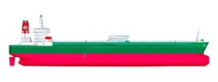A fully loaded oil tanker moves at a constant speed of 12 m/s. Its engines produce a constant forward force of 16 000 N. What is the size of the friction force acting on the tanker?

16000N Engine Force

Friction

1. A clock hangs from a peg on a wall. If the weight of the clock is 2 N what is the size of the upward force provided by the peg?
2. David cycles along the road at a constant speed of 8 m/s. The total friction force acting on David and the bike is 550 N.



Forward Force of Pedalling

550N

What size is the forward force provided by David pedalling?

**Resultant Forces Problems**

1. Calculate the resultant force of the following giving both the size and direction of the resultant force:

2 N

5 N

* 1. (b)

2 N

2 N

3 N

5 N

(c) (d)

3 N

5 N

20 N

15 N

10 N

10 N

15 N

(e) (f)

20 N

15 N

10 N

20 N

20 N

20 N

(g) (h)

1. Calculate the resultant force of the following giving both the size and direction of the resultant force:

(a) (b) (c)

6 N

6 N

22 N

25 N

165 N

65 N

1. Calculate the resultant force of the following giving both the size and direction of the resultant force:

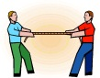

* 1. (b)

560 N

200 N

2 N

2 N



http://www.carclipart.com/free_car_clipart/black_and_white_cop_car_0515-1005-3104-4104_SMU.jpg

3300 N

5200 N

20 N

15 N

10 N

(c) (d)

1. If the forward force produced by a car engine is 2000 N and the total friction force is 600 N. Calculate the resultant force giving both the size and direction.



2000 N

600 N

1. A man pushes a box to the right with a force of 40N, but the box has a frictional force of 35N. Calculate the resultant force giving both the size and direction.



35 N

40 N

1. http://www.marysrosaries.com/collaboration/images/a/a8/Parachute_(PSF).pngThe weight of a parachute is 800N and the air resistance upwards is 1200N. Calculate the resultant force giving both the size and direction.

1200 N

800 N

1. The weight of a helicopter 10000N. It has two propellers; each one produces an upwards force of 6000N. Calculate the resultant force giving both the size and direction.

6000 N

6000 N

10000 N

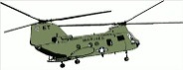

1. A hot air balloon has a weight of 1200 N. The balloon also produces a buoyancy force of 1300 N. Draw a diagram to show this and calculate the resultant force giving both the size and direction.

**Newton’s 2nd Law Problems**

1. Calculate the force required to accelerate a mass of 12 kg at 2 m/s2.
2. Calculate the force required to accelerate a car of mass 1000 kg at 5 m/s2.
3. If a force of 500 N is applied to a mass of 20 kg, calculate its acceleration.
4. A man pushes a stacked trolley of mass 25 kg with a force of 25 N. Calculate the acceleration of the trolley.
5. Find the mass of a boy and his bike if they accelerate at 1·5 m/s2 when pushed with a force of 65 N.
6. A car on an automatic wash machine is pulled by a force of 500 N and accelerates at 0·25 m/s2. What is the mass of the car?
7. A fork lift truck applies a force of 2000 N to move a crate of mass 1700 kg. Calculate the acceleration of the crate.
8. A bus applies a braking force of 2400 N in order to avoid a road accident ahead. The mass of the bus and the people on board is 4000 kg. Calculate the deceleration of the bus.
9. A table tennis ball of mass 30 g (0.03 kg) is found to accelerate at 150 m/s2 when hit with a bat. Calculate the force causing the ball to accelerate.
10. Calculate the acceleration of a steel ball bearing of mass 100 g (0.1 kg) when fired with a force of 1·5 N in a pin ball machine.
11. A 70 kg sledge is pulled along as shown below. There is assumed to be no friction. Calculate the acceleration of the sledge.



200N

|  |  |
| --- | --- |
| **Planet** | **g (N/kg)** |
| Mercury | 3.7 |
| Venus | 8.8 |
| Earth | 9.8 |
| Mars | 3.8 |
| Jupiter | 26.4 |
| Saturn | 11.5 |
| Uranus | 11.7 |
| Neptune | 11.8 |
| *Pluto* | 4.2 |
| *The Moon* | 1.6 |

**Weight Problems**

1. Calculate the weight of each of the following on Earth :
   1. a girl whose mass is 50 kg
   2. a dog of mass 20 kg
   3. a 9 kg box
   4. a ball of mass 0.5 kg
   5. an insect whose mass is 0.00005 kg
   6. a particle of mass 2 x 10-27 kg.
2. Calculate the mass of each of the following weighed on Earth:
   1. a man who weighs 750 N
   2. a tin of peas which weighs 4.5 N
   3. a chair which weighs 350 N
   4. a rabbit which weighs 40 N
   5. a car which weighs 14000 N
   6. a thread which weighs 0.003 N.
3. What does a 500 g packet of cornflakes weigh:
   1. (a) on Earth (b) on the Moon (c) in Space?
4. An astronaut has a weight of 800 N on Earth. What is his mass:
   1. on Earth?
   2. on the Moon?
   3. in Space?
5. A question in a Physics examination asked, ‘What is meant by the weight of an object?’

Two pupils, Steven and Nicola, answered as follows

Steven - ‘The weight of an object is the gravitational field strength.’

Nicola - ‘ The weight of an object is the force of gravity acting on the object.’

* 1. Who was correct?
  2. What does the term ‘gravitational field strength’ mean?

1. A rocket of mass 2 000 000 kg travels from Saturn to Earth.
   1. What is the weight of the rocket on Saturn?
   2. What is the weight of the rocket on Earth?
2. A small tin of oil has a mass of 300 g.
   1. What does the tin of oil weigh on Earth?
   2. What would be the mass of the tin of oil on Jupiter?
3. If a man has a weight of 700 N on Earth, what will he weigh on Neptune?
4. A snail has a weight of 0.5 N on Earth. What would be its mass on the Moon?

**Conservation of Energy Problems**

Name as many forms of energy as you can.

2. a) What form of energy does a space rocket have when it comes back into the earth’s atmosphere?

b) What form of energy does this get transformed into when the rocket re-enters the earth’s atmosphere?

c) What problems does this create for aircraft designers?

3. Copy and complete the table below to show what parts of electrical appliances are heat insulators and heat conductors:

|  |  |  |
| --- | --- | --- |
| **Appliance** | **Heat Conductor** | **Heat Insulator** |
| Kettle |  |  |
| Toastie maker |  |  |
| Hair straightners |  |  |

C:\Users\AlexanderR\AppData\Local\Microsoft\Windows\Temporary Internet Files\Content.IE5\6B0TO7YK\MC900434717[1].wmf

C:\Users\AlexanderR\AppData\Local\Microsoft\Windows\Temporary Internet Files\Content.IE5\9ELSYO6U\MC900290930[1].wmf4. Conventional filament lightbulbs are said to be less efficient than energy saving bulbs.

a) What is meant by the term “less efficient”?

b) What additional forms of energy are emitted as well as light in a filament light bulb?

5. Copy and complete the table below to show the energy changes in various appliances:

|  |  |  |
| --- | --- | --- |
| **Appliance** | **Energy in** | **Energy out** |
| Motor |  |  |
| Electric heater |  |  |
| TV |  |  |
| MP3 player |  |  |

**Our Universe and Solar System Problems**

1. What is a solar system?
2. Copy and complete: The moon orbits the Earth , it is an example of a natural _______
3. List the eight planets in our solar system, in order, from closest to the sun to furthest away from the sun.
4. Which of the planets is the largest?
5. What is the difference between the four planets nearest the sun compared to the four furthest away from the sun?
6. What is the description now given to describe Pluto?
7. What is a star mostly made of?
8. What is a galaxy?
9. What is the name of our galaxy?
10. What is the name given to the start of the Universe?
11. What is meant by ‘the Universe’?
12. Give one piece of evidence that supports the theory behind the start of the Universe?
13. What estimate do cosmologists put on the age of the Universe?
14. List three conditions which must exist for life, as found on Earth, to exist on another planet.
15. What is the name given to a planet which orbits around another star (but not our Sun)?
16. What is the name given to the area where planets which might be habitable are found?
17. List three ways we can explore space.

**Satellites Problems**

1. List three types of satellite and explain what they are used for.
2. What part of the electromagnetic spectrum is used to communicate with satellites?
3. What speed does this radiation travel at?
4. Copy and complete the following paragraph.

Geostationary satellites orbit above the ______________. Geostationary satellites always remain at the _____________ point above the earth’s surface. Geostationary satellites orbit ___________ every 24 hours. Other satellites complete several ________________ every 24 hours. Other satellites operate at a ______________ height than Geostationary satellites.

1. What do parabolic mirrors do to electromagnetic radiation coming from far away?
2. By adding an appropriate shaped mirror copy and complete the following diagram to show how signals are brought into focus.



1. Parabolic mirrors are used in torches and headlamps draw a diagram to show how they help to form a beam of light that can be directed.
2. Why can radio waves not be used to carry television signals from America to Britain using land based transmitters and receivers?
3. High frequency radio signals are sent from the USA to Britain. The signals are received by a ground station in Cornwall. Describe what happens to the signal after it leaves the American ground station.
4. It is recommended that people living in northern Scotland should use a 85-centimetre diameter dish, while those living in south-east England only need a 55-centimetre diameter dish.

a) State one advantage of having an 85 centimetre dish rather than a 55 centimetre dish.

b) What does this suggest about the satellite signals received in northern Scotland?

1. When the signal from the transmitter reaches a satellite, why does it have to be amplified?
2. What part in a satellite provides electrical power to operate the satellite?
3. Copy and complete the following diagram to show how a telecommunications signal is sent from the USA to the UK.

**USA**

**UK**



Orbit 1

Orbit 2

1. Copy and complete:
   1. The higher the orbit of a satellite the ____________ its period.
   2. Orbit 1 is closer to the Earth so the period is long / short.
   3. Orbit 2 is further away from the Earth so the period is longer / shorter.

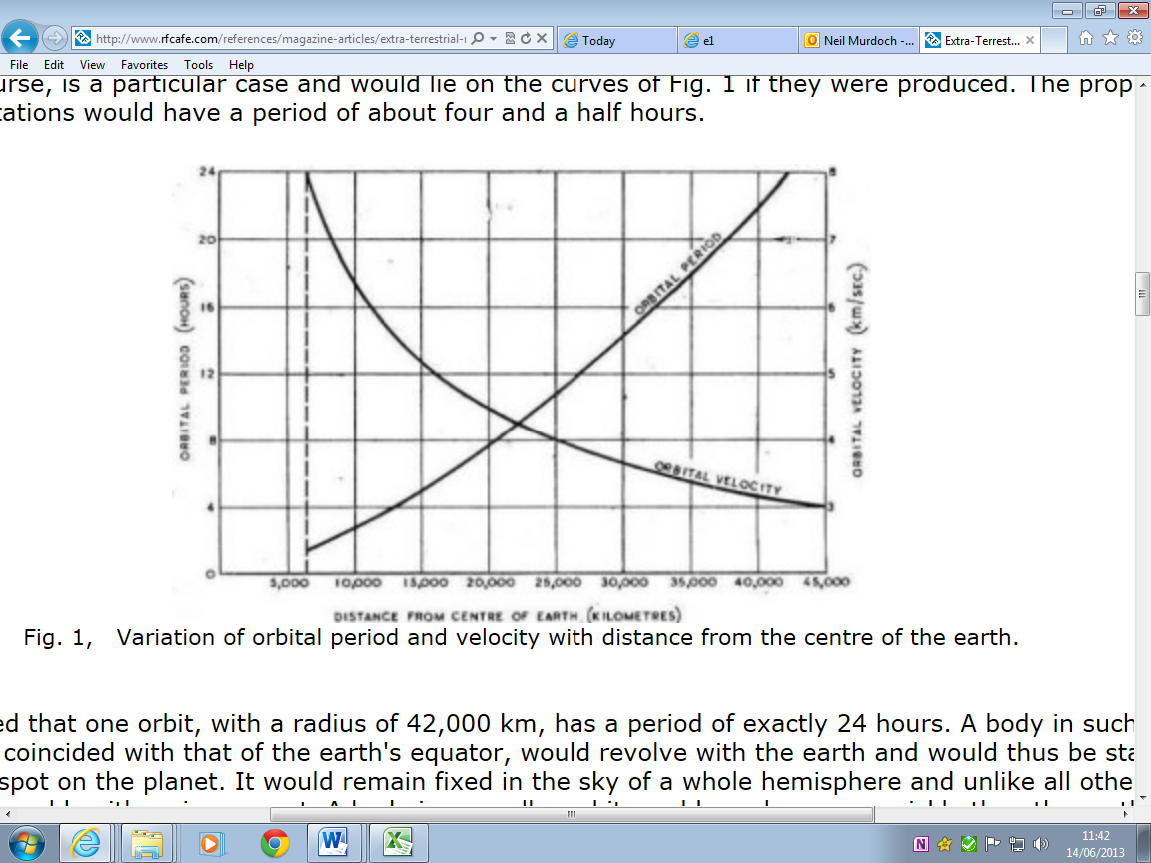32.

The graph shows two things

1) how the velocity of a satellite changes with distance from the earth.

2) how the period (time to orbit the earth) changes with distance from the earth.

a) Use the graph to explain how the velocity and period change the further you are from the earth.

b) A satellite is designed to orbit the earth twice every day.

i) What is its velocity?

ii) What is its height above the earth if the earth has a radius of 6400 km?

33. Radio signals travel at the speed of light (300,000,000 m/s)

a) How long does it take to send a signal to the Sky satellite which is in geostationary orbit 36000 km above the earth?

b) How long does it take to send a message to the moon and get a message back if the moon is 384,000,000 m away?

c) When Mars is at its closest to the earth it is 80 million km away. What is the shortest time to send and get a message back from Mars?

d) Draw a diagram to show how Mars can be different distances away from the earth.

**Interplanetary Space Travel Problems**

34. Explain why the speed of a spacecraft, travelling in outer space, is constant even although its engines are switched off?

1. Voyager 1 and Voyager 2 were launched in 1977. After 12 years Voyager 2 shot past Neptune at a distance of approximately 4.35 x 109 km from Earth. How long would it have taken for a signal to reach the Earth?

**Space Craft Re-entry**

1. a)When a space craft re-enters the Earth’s atmosphere why does it heat up?

b)What is done to protect the astronauts from this heat?

**Light Years**

1. What is the name given to the unit of distance typically used in space?
2. It takes ¾ of a day for light to cross our solar system. The nearest star (Proxima Centauri is 4.53 light years away. How many solar systems could be fitted into the space between the Sun and Proxima Centauri? What is the name given to the unit of distance typically used in space?