Higher Physics
H
Electricity

Alternating Current
An alternating current (a.c.) periodically changes direction — contrast this to direct current (d.c.), which only flows in one direction. Although it is possible that current could vary in any way, we will consider a sinusoidal function, i.e. the voltage constantly changes as a sine function. This is the most common form of a.c. since electricity generators work by spinning in circles, which means that the current is pushed one way then the other, with the instantaneous value of voltage constantly varying. Examples of each type of current when displayed on an oscilloscope are shown below.
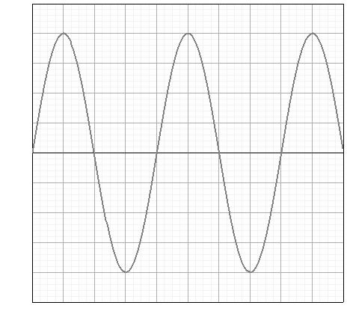
sinusoidal a.c. waveform
constant d.c. waveform
Measuring frequency and peak voltage
An oscilloscope plots a graph of changing voltage on the y-axis versus time on the x-axis. To read the scale on the graph we make use of two underneath the screen. The y-axis (voltage) scale is usually labelled ‘volts per division’ or ‘volts per centimetre’ and the x-axis (time) scale is called the ‘timebase’.
To calculate the frequency of an a.c. signal, we first have to find its period. This is the time for one complete cycle of to and fro current, so we measure the horizontal distance on the screen between crests.
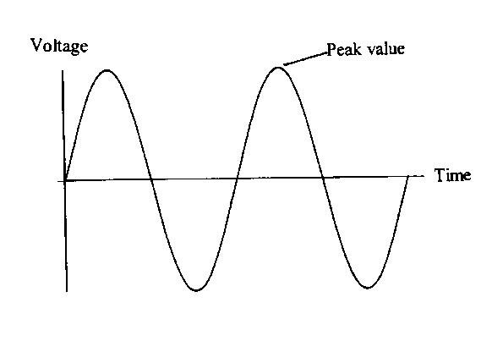
An alternating voltage varies between the same maximum negative and positive value as the voltage pushes first one way (positive) then the other (negative). This maximum is defined as the peak voltage. It can be measured from an oscilloscope by measuring the vertical distance on the screen from the bottom of the signal to the top. This then has to be halved and multiplied by the setting of the ‘volts per division’ dial to calculate the peak voltage.

Period
The period of a wave is the time taken for one wave to pass a particular point. It is also the inverse of the frequency. There is a formula relating period and frequency that does appear on the formula sheet and is given below:
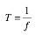
Period in seconds (s)
Frequency in hertz (Hz)
The number one

Example
In the picture below each box on the oscilloscope screen has a side of 1 cm.
The distance between crests is 4cm.The distance from bottom to top is 8cm.
The time base was set at 5 mscm^{–1}, the volts per division was set at 2V cm^{–1}
The period of the wave is:
T = 4 × 5 ms = 4 × 0.005 = 0.02 s
f = 50 Hz
The peak voltage is:
V_{peak} = ½ × 8 × 2
V_{peak} = 8 V
If the time base is switched off, the a.c. signal will not be spread along the x-axis. However, the voltage variation will continue, meaning a straight vertical line will be displayed on the screen. The height of this line from bottom to top can be processed in exactly the same way as above, i.e. halved then converted into voltage using the volts per division.

Peak and rms Voltage and Current
For a source of alternating current the values of current and coltage change constantly (completing 50 cycles every second in the UK). The mean value of the voltage during any complete cycle is zero.
We must use a different ‘average’ to measure the effective value of an a.c. voltage and this is called the root mean square (rms) voltage (V_{rms}).
The rms voltage is the equivalent of a direct voltage that produces the same power as the alternating voltage. The rms value is what is quoted on a power supply so that a fair comparison between a.c. and d.c. can be made, for example a 6 V battery will produce the same brightness of light bulb as a 6 V rms a.c. supply. The rms current has a similar relationship.
Consider the following two circuits, which contain identical lamps.
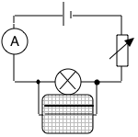
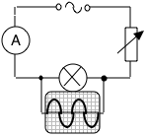
The variable resistors are altered until the lamps are of equal brightness. As a result the d.c. has the same value as the effective a.c. (i.e. the lamps have the same power output). Both voltages can be measured using an oscilloscope.
NB A multimeter switched to a.c. mode will always display rms values.
Calculating rms voltage/current from peak voltage/current
The rms voltage or current of an a.c. source can be calculated if its peak voltage or current is known using the formulae below. These are not on the formula sheet so you will need to remember them!
V_{rms} = V_{peak ÷} √2
I_{rms} = I_{peak ÷} √2
- Readings on meters that measure a.c. are rms values, not peak values.
- For power calculations involving a.c. always use rms values.
- The mains supply is usually quoted as 230V a.c. This is of course 230V_{rms}. The peak voltage rises to approximately 325V. Insulation must be provided to withstand the peak voltage.
Example
A transformer is labelled with a primary coil voltage of 230 Vrms and secondary coil voltage of 12 Vrms. Calculate the peak voltage which occurs in the secondary coil.
Current, Voltage, Power and Resistance
Revision
You are familiar with the concepts of current, voltage and power from the Electricity and Energy unit in National 5 as well as the following rules and laws:
Ohm’s law
Voltage measured in volts (V)
Current measured in amperes (A)
Resistance measured in ohms (Ω)
Total Resistance in a Series Circuit
R_{T} = R₁ + R₂ + …
Total Resistance in a Parallel Circuit
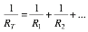
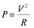
Power
Power measured in watts (W) or joules per second (Js^{–1})
Current measured in amperes (A)
Voltage measured in volts (V)
Power measured in watts (W) or joules per second (Js^{–1})
Resistance measured in ohms (Ω)
Voltage measured in volts (V)
Current measured in amperes (A)
Circuit rules
 | Series | Parallel
Current | I₁ = I₂ = I_{n} | I_{t} = I₁ +I₂ + …
Voltage | V_{s} = V₁ +V₂ + … | V_{s} = V₁ = V₂ = V_{n}

The Potential Divider aka The Voltage Divider
A potential divider provides a convenient way of obtaining a variable voltage from a fixed voltage supply.
Consider two fixed resistors, R₁ and R₂, connected in series across a supply with voltage V_{s}, as shown below:
R₁
R₂
V₁
V₂
V_{s}

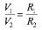
The current in the two resistors will be the same, however the voltage across the two resistors will be split. Whilst we could use Ohm’s Law to calculate V₁ and V₂ (Or R₁ and R₂) there are two ‘shortcut’ formulae we can use. Both are on the formula sheet. The first, given below, is useful when you know 3 out of the 4 variables:

The second is useful when you know the supply voltage and the value of both resistors but not V₁ or V₂. This is a very handy formula that can save you much time when solving potential divider questions. It is given below:
2Ω
3Ω
V₁
V₂
6V
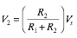
Example

Find the values of V₁ and V₂

Electrical Sources and Internal Resistance
Up to this stage in your study of physics it has been assumed that power supplies are ideal. This means that their voltage remains constant and they can supply any current we wish if we connect the correct resistance. In most cases these are good assumptions, but if you take a small battery and connect lamps one after another in parallel you will notice that eventually their brightness dims. A similar effect can be noticed if you start a car with the headlights on. Both these situations have one thing in common; they involve significant current being supplied by the battery. If you are able to touch the battery you may notice it getting warm when in use.
This is a wasted transfer of energy and can be modelled by considering that the battery, like all conductors, has some resistance of its own. This model explains why some of the chemical energy converted is dissipated as heat and is not available to the circuit — resistors convert electrical energy to heat energy. It is said that the power supply has an internal resistance, r.
In most cases this is so small (a few ohms) that it can be considered negligible. However, when the current in the circuit is large its effects can be significant. The greater the current the more energy is dissipated in the power supply until eventually all the available energy is wasted and none is available outside the power supply.
Energy is wasted in getting the charge through the supply (this energy appears as heat) and so the energy per unit charge available at the output (the terminal potential difference or t.p.d.) falls. There are ‘lost volts’ across the supply. The lost volts = Ir.
NB: A common confusion is that Ir stands for internal resistance but I is the symbol for current and r is the symbol for internal resistance and Ir (I × r) is the value of the lost volts.
The fact that a power supply has an internal resistance is not a very difficult problem to deal with because we can represent a real supply as:
real cell = ideal cell + a resistance r
real cell
ideal cell
internal resistance
Special case — Open Circuit (I = 0)
We now need to consider how we can measure the key quantities. It would be very useful to know the voltage of the ideal cell. This is called the electromotive force (or e.m.f. for short) of the cell, which is defined as the energy supplied per unit of charge. It is found by finding the voltage across the cell on ‘open circuit’, i.e. when it is delivering no current. This can be done in practice by using a voltmeter or oscilloscope.
Why should this be so?
I = 0
Since I = 0 the voltage V across the internal resistance will be:
V = I × r = 0 × r = 0V
So no voltage is dropped across the internal resistance and a voltmeter across the real cell would register the voltage of the ideal cell, the e.m.f.

Under Load (I ≠ 0)
When a real cell is delivering current in a circuit it is said that it is ‘under load’ and the external resistance is referred to as the load.
Consider the case of a cell with an internal resistance of 0.6Ω delivering current to an external resistance of 11.4Ω:
0.6Ω
11.4Ω

Cell emf = 6V
Current = 0.5A
The voltage measured across the terminals of the cell is the same as the voltage across the 11.4 Ω resistor:
V = IR = 0.5 × 11.4 = 5.7 V
Similarly, the voltage across the internal resistance:
V = Ir = 0.5 × 0.6 = 0.3 V
The voltage across the terminals is only 5.7 V (this is the terminal potential difference, or t.p.d.) and this happens because of the voltage dropped across the internal resistance (0.3 V in this case). This is called the lost volts.
Special Case — Short Circuit (R = 0)
The maximum current a cell can provide is achieved when the cell is short-circuited. This happens when the terminals of the supply are joined with a short piece of thick wire (i.e. there is no external resistance). The current that flows will be determined by the internal resistance of the cell:
I_{max} = E ÷ r

Internal Resistance Formula
If Ohm’s law is applied to a circuit containing a battery of e.m.f. E and internal resistance r with an external load resistance R (as shown below):
R
E
r
I
V

Where I is the current in the circuit and V is the p.d. across R (which is equal to the voltage across the cell or t.p.d.) then:
This is the internal resistance equation that appears on the formula sheet. It can be rearranged into different forms (since V = IR):
E = IR+Ir
E = I(R+r)
These handy shortcuts are not on the formula sheet, if you want to use them you will need to remember them.

Measuring E and r by Graphical Analysis
When the current in a circuit is increased the terminal potential difference will decrease. We can use a graph to measure the e.m.f. and internal resistance. If we plot V on the y–axis and I on the x–axis, we get a straight line of negative gradient. The gradient of the line is equal to –r (the negative of the internal resistance) and the y–intercept is equal to E (the e.m.f.).
t.p.d.
Current
y–intercept = E
gradient = –r

We know this because if we rearrange:
E = V + Ir
V = (–r)I + E
This follows the same form as the equation of a straight line:
y = mx + c
Where m is the gradient of the line and c is the y–intercept.

Example
A cell of e.m.f. 1.5 V is connected in series with a 28 Ω resistor. A voltmeter measures the voltage across the cell as 1.4 V.
Calculate:
- The internal resistance of the cell;
- The current if the cell terminals are short circuited;
- The lost volts if the external resistance R is increased to 58 Ω.

- E = V + Ir
In this case we do not know the current, I, but we do know that the voltage across the 28 Ω resistor is 1.4 V, and I = V/R, so I = 0.05 A.
1.5 = 1.4 + 0.05r
r = 2Ω
- Short circuit: Total resistance = 2 Ω
I = E ÷ r = 1.5 ÷ 2 = 0.75A
- E = I(R + r)
1.5 = I(58 + 2)
I = 1.5/60 = 0.025A
lost volts = Ir = 0.025 × 2 = 0.05V

Capacitors
Capacitance is the ability (or capacity) to store charge. A device that stores charge is called a capacitor.
Practical capacitors are conductors separated by an insulator. The simplest type consists of two metal plates with an air gap between them. The symbol for a capacitor is based on this:

Relationship Between Charge and Potential Difference
–
+
V
C
A
B

The capacitor is charged to a chosen voltage by setting the switch to position A. The charge stored can be measured directly by discharging through the coulomb meter with the switch set to position B. In this way pairs of readings of voltage and charge are obtained.
It is found that the charge stored on a capacitor and the p.d. (voltage) across it are directly proportional:
The gradient of the line is constant, therefore Q ÷ V is also a constant. This constant is defined as the capacitance, C. The formal definition of capacitance is therefore the charge stored per unit voltage. This means that capacitance is the gradient of the Q against V graph
Q
V
The unit of capacitance is the farad (F) and 1 farad = 1 coulomb per volt.
The farad is too large a unit for practical purposes so nearly all capacitors you will encounter will have a capacitance in the microfarad or nanofarad range.
Capacitance, Charge, Voltage Equation
As capacitance is defined as the charge stored in a capacitor per unit of voltage we can derive a simple formula for calculating capacitance. It appears on the formula sheet and is given below:
Capacitance measured in farads (F)
Charge measured in coulombs (C)
Voltage measured in volts (V)

NB: When a capacitor is charging, the current is not constant (more on this later). This means the formula Q = It cannot be used to work out the charge stored.
Example
A capacitor stores 4×10^{–4}C of charge when the potential difference across it is 100V. Calculate the capacitance.
C = Q ÷ V = 4×10^{–4} ÷ 100 = 4×10^{–6}F = 4μF

Energy Stored in a Capacitor
Work must be done to charge a capacitor. Capacitors charge in the following way:
V_{s}
Initially the capacitor is not charged. When the current is switched on electrons flow onto one plate of the capacitor and away from the other plate.
V_{s}
V_{c}
+
+
–
–

This results in one plate becoming negatively charged and the other plate becomes positively charged. These charges will cause a potential difference across the capacitor.

V_{c} = V_{s}
Vs
+
–
–
–
+
+
+
+
–
–

Eventually the current ceases to flow. This happens when the potential difference across the capacitor is equal to the supply voltage.

The negatively charged plate will tend to repel the electrons approaching it. To overcome this repulsion work has to be done and energy supplied. This energy is supplied by the battery. Note that current does not flow through the capacitor, electrons flow onto one plate and away from the other plate.
For a given capacitor the potential difference across the plates is directly proportional to the charge stored. Consider a capacitor being charged to a potential difference of V and holding a charge Q.
The work done moving a small charge q through a potential difference v is given by:
work done = qv
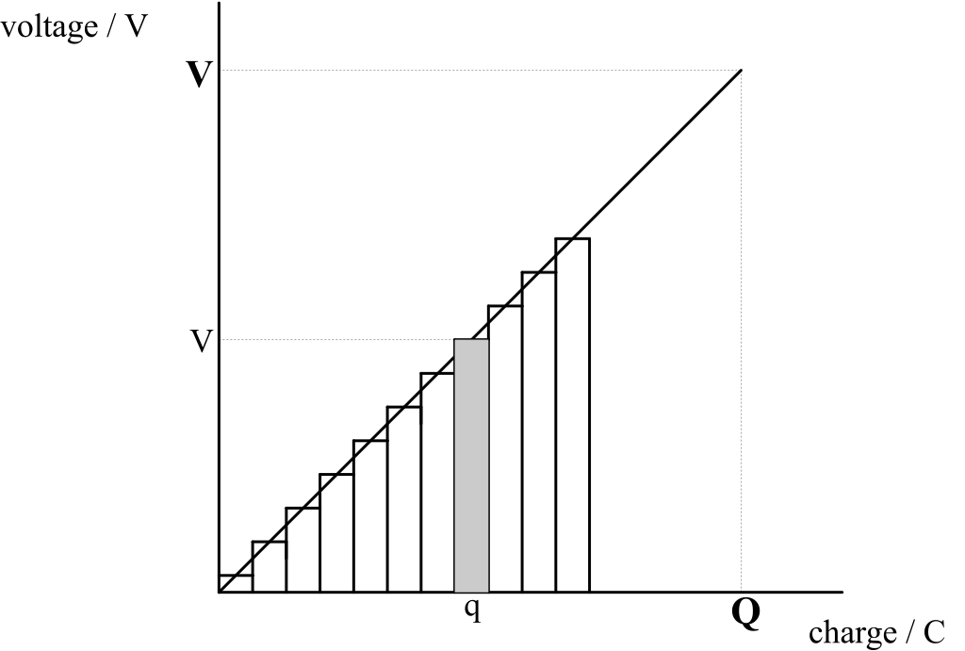
As each successive negative charge q is added to plate the voltage between the plates increases.
The work done moving charge q is qv which is equal to the area of the shaded strip on the graph.
The total work done in transferring charge Q is the sum of the areas of all the strips on the graph and this is equal to the area under the graph.
Thus total work done is given by:
W = ½QV (area of a triangle of sides Q and V)

Energy Stored in a Capacitor Equation
Since the energy stored equals the work done, i.e. the work is stored as electrical energy. Therefore we can state that the energy stored in a capacitor is equal to one half multiplied by the charge stored on the capacitor multiplied by the voltage across the capacitor. This formula appears on the formula sheet and is given below:
Energy stored in a capacitor measured in joules (J)
Charge on a capacitor measured in coulombs (C)
Voltage across a capacitor measured in volts (V)

Contrast this formula with the formula for work done moving a charge in an electric field (W=QV).
Do not make the mistake of using W=QV for capacitor questions!
However since Q=CV there are alternative forms of this relationship (that are also on the formula sheet):
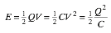
Which formula to use is dictated by the available quantities in the question.

Example
A 40 μF capacitor is fully charged using a 50 V supply. Calculate the energy stored in the capacitor.
E = ½CV²
E = ½ × 40×10^{–6} × 50²
E = 0.05J

Charging a Capacitor
Consider the following circuit:
V_{s}
V
A

When the switch is closed the current flowing in the circuit and the voltage across the capacitor behave as shown in the graphs below:
Current
Time
Time
Voltage
V_{s}

The graphs have these shapes because of the following:
- The instant the switch is closed (time = 0) there is no charge on the capacitor. This means there is no voltage across the capacitor (V=0).
- At t=0 the current at a maximum as it is limited only by the value of the resistor and can be found using Ohm’s Law.
- As charge builds on the capacitor so does the voltage across the capacitor.
- However the more charge there is on the plates of the capacitor the harder it is to add or remove electrons to and from the plates. This means that the current will decrease.
- Eventually the capacitor will be fully charged and the voltage across the capacitor will be the same as the supply voltage (V=V_{s}).
- Once the capacitor is fully charged no more electrons can be added or removed from the capacitor’s plates. This means that there will be no flow of electrons and therefore no current (I=0).

Discharging
Consider the circuit below in which the capacitor is fully charged but not connected to a power supply. Instead it is connected to a load (in this case a resistor). This will cause the capacitor to discharge.
A
V
+
–
–
+

This is because the charge on the capacitor is no longer being held there by a voltage produced by the power supply. Charges will flow off the plates of the capacitor and through the resistor.
While the capacitor is discharging, the current in the circuit and the voltage across the capacitor behave as shown in the graphs below:
Current
Time
Time
Voltage

Although the current/time graph has the same shape as that during charging, but is a mirror image in the x–axis. This is because the current is flowing in the opposite direction compared to when the capacitor was charging. The discharging current decreases because the voltage across the plates decreases as charge leaves them.
A capacitor stores charge, and energy but unlike a cell a capacitor discharges very quickly. Once discharged a capacitor cannot supply any more energy to a circuit. When discharging the energy stored will be used in the circuit, in the above circuit it would be dissipated as heat in the resistor.

Factors Affecting the Rate of Charge and Discharge
The time taken for a capacitor to charge is controlled by the resistance of the resistor R. This is because the resistor controls the size of the current. The capacitance of the capacitor will also affect how long the capacitor takes to (dis)charge since a larger capacitor will take longer to fill and empty. As an analogy, consider charging a capacitor as being like filling a jug with water. The size of the jug is like the capacitance and the resistor is like the tap you use to control the rate of flow.
The values of R and C can be multiplied together to form what is known as the time constant. Large capacitance and large resistance both increase the charge or discharge time.
The I/t graphs for capacitors of different value during charging are shown below:
Current
Time
large capacitor
small capacitor
Current
Time
large resistor
small resistor

NB: Since the area under the I/t graph is equal to charge, for a given capacitor the area under the graphs must be equal.

Example
The switch in the following circuit is closed at time t = 0.
10MΩ
10V
2μF

- Immediately after closing the switch determine the:
- Charge on C.
The initial charge on the capacitor is zero.
- Voltage across C.
The initial p.d. across the capacitor is zero since there is no charge.
- Voltage across R.
The p.d. across the resistor is 10 V (V_{R} = V_{S} – V_{C} = 10 – 0 = 10 V)
- Current through R.
I = V÷R = 10 ÷ 10×10⁶ = 1×10^{–5}A
- When the capacitor is fully charged determine the:
- Voltage across the capacitor.
The final p.d. across the capacitor equals the supply voltage, 10V.
- Charge stored.
Q = VC = 2×10^{–6} × 10 = 2×10^{–5}C

Conductors, Semiconductors and Insulators
Energy Levels
NB: Energy levels are covered in much more detail in the Particles and Waves unit.
You may be familiar from Chemistry of the idea that electrons ‘orbit’ the nucleus in discreet shells. In Physics we instead think of electrons occupying distinct and separate energy levels. We can represent the energy levels of an atom in an energy level diagram, an example of which is below:
By convention we define E=0 at the ionisation energy of the atom. This is the energy required to remove an electron from the atom completely. All the other energy levels therefore have ‘negative’ energies. The lowest energy level is known as the ground state. Electrons will always try to be in the lowest energy level possible, however each energy level can only hold a certain number of electrons.
If an electron is given enough energy (by hitting it with light, using a large electric field or by heating the atom) it can move up to a higher energy level. This is known as exciting the electron. Similarly if an electron moves from a higher energy level to a lower one it must get rid of energy to do so which it does by emitting a single photon of light. The frequency of this light can be calculated using the E=hf formula from the Particles and Waves unit.

Bands
When many atoms are combined into a crystalline solid the various energy levels of the atoms become ‘blurred’ so that electrons can have a range of energies. Instead of a discreet energy level electrons are now restricted to bands of energy. As with energy levels, electrons will always try to fill the lowest band first.
An empty band
A full band
A partially filled band

Bands can either be empty, partially filled, or full.
- Empty bands have no electrons and cannot conduct electricity.
- Partially filled bands can conduct electricity.
- Full bands cannot conduct electricity as there is nowhere for electrons to go.

Conductors
Conductors have a filled band, known as the valance band and a partially filled band known as the conduction band. As you learnt in the previous section a partially filled band will allow electricity to flow, thus conductors will conduct electricity.
Valance band
Conduction band

Insulators
Insulators have a full band, again known as the valance band. They also have an empty conduction band separated from the valance band. The difference between the lowest energy of the conduction band and the highest energy of the valance band is known as the band gap.
This is the same as the amount of energy an electron would need to be excited from the valance band to the conduction band. In an insulator this band gap is large. Because an insulator has no partially filled bands and it is very hard to move electrons between bands it will not (easily) allow electricity to flow.
Conduction band
Valance band
Band gap
Semiconductors
A semiconductor has a band structure very similar to an insulator. It will have a full valance band and an empty conduction band. However the band gap in a semiconductor is small.
Conduction band
Valance band
Band gap

The small band gap means that it is relatively easy to give electrons enough energy to be excited from the valance band to the conduction band. The amount of energy required is so low the ambient temperature of a room is sufficient to excite electrons.
When an electron is excited from the valance band to the conduction band it leaves behind a hole. Holes are the absence of an electron. Holes have a positive charge.
Conduction band
Valance band
Electron
Hole

NB: Semiconductors are electrically neutral.
Semiconductors Continued
The ability of a semiconductor to excite electrons from the valance band to the conduction band at room temperature is extremely useful. When this excitation does occur then the electron and hole created in the conduction and valance band will allow current to flow. The more electrons are excited (and holes created) the easier it will be for current to flow. This means that the resistance of a semiconductor decreases as its temperature increases (unlike conductors).
+
–
When a potential difference is applied to a semiconductor the excited electrons in the conduction band will (being negative) be attracted to the positive terminal. Holes in the valance band will also ‘move’ towards the negative terminal as they are positive. This is how current is able to flow through a semiconductor.
How can holes move?
Imagine a queue of people in a line. If the person at the front moves forward one pace then they leave a gap. The person behind them then moves forwards, closing the gap but opening a new one behind them. The gap appears to move backwards down the line. This is how you can think of holes ‘moving’ — electrons are behaving like the people in the line.

Doping
The pure or ‘intrinsic’ semiconductors covered in the previous section can be made using elements from group 4 of the periodic table, most typically silicon. It is however possible to take a pure silicon semiconductor and replace a few atoms of silicon with other elements. This is known as doping. There are two types of doped semiconductors, p-type and n-type semiconductors. Both types of doped semiconductor have a lower resistance than a pure silicon semiconductor, i.e. they are more like conductors.
n-type
n-type semiconductors are created by replacing some silicon atoms, which have 4 outer electrons, with atoms from group 5 on the periodic table. The group 5 elements (typically phosphorous, arsenic or antimony) have 5 outer electrons. This means that they have one electron more than the surrounding silicon atoms. These extra electrons will (due to the valance band being full) be in the conduction band, as shown below:
Conduction band
Valance band

p-type
p-type semiconductors are created by replacing some silicon atoms, which have 4 outer electrons, with atoms from group 3 on the periodic table. The group 3 elements (typically aluminium, indium or thallium) have 3 outer electrons. This means that they have one less electron than the surrounding silicon atoms. This will create holes in the valance band as shown below:
Conduction band
Valance band

The p-n junction
A p-n junction is created when a block of p-type and a block of n-type semiconductors are placed in contact with one another as shown below:
p-type
n-type

The positive holes in the p-type will be attracted to the negative electrons in the n-type (and vice versa). The holes will flow toward the n-type semiconductor, this is known as diffusion current (or I_{diff}). Similarly the electrons will flow towards the p-type, this is known as drift current (or I_{drift}).
I_{diff}
I_{drift}

Where the p-type and n-type meet electrons and holes will interact with each other. When this happens the electron ‘fills’ the hole and the positive and negative charges cancel each other out. This process also releases energy as a single photon of light, typically at infrared frequencies.
Hole
Electron
+
–
Filled hole (neutral)
Photon

At the boundary of the p and n-type semiconductors, where electrons and holes are combining and releasing photons, a region where there are no charge carriers, no electrons or holes, will form. This region with no charge carriers is known as the depletion layer. Once a depletion layer forms the drift and diffusion currents in the p-n junction will stop. No current is able to flow across the depletion layer (the depletion layer acts like an insulator). This can be thought of as a potential difference (or voltage) across the depletion layer which is called by convention V₀. The wider the depletion zone, the larger V₀ becomes.
p-type
n-type
Depletion layer
V₀

Diodes
You are familiar with diodes from National 5, you know that they only allow current to flow in one direction. This is because a diode is simply a p-n junction.
Forward Biased
When the positive terminal of a power supply is connected to the p-type side of a p-n junction (and the negative terminal to the n-type side) the junction, or diode, is forward biased. When a diode is forward biased it will allow current to flow through it. This happens because the power supply ‘pushes’ extra electrons into the n-type side and ‘sucks’ electrons out of the p-type side, creating more holes. These extra charge carriers will squash the depletion layer. Once the depletion layer is small enough current can flow through the junction. A certain voltage is required from the power supply to achieve this and it is equal to V₀. As current flows through the junction electrons and holes will constantly combine at the boundary between the p and n-type semiconductors. This will produce a constant stream of infrared photons, meaning that a diode will produce a small amount of heat.
+
–
Current will flow
No depletion layer
p-type
n-type
–
+

Reverse Biased
When the positive terminal of a power supply is connected to the n-type side of a p-n junction (and the negative terminal to the p-type side) the diode, is reverse biased. When a diode is reverse biased it will not allow current to flow through it. This happens because the power supply ‘pushes’ extra electrons into the p-type side and ‘sucks’ electrons out of the n-type side. This allows more holes and electrons to combine, making the depletion layer larger.
–
+
Large depletion layer
No current will flow
p-type
n-type
–
+

The graph of current versus voltage for a diode is shown below. If the diode is reverse biased the voltage is defined as being negative — no current will flow. Once V=V₀ current will begin to flow and then increasing the voltage also increases the current, just like a normal conductor.
Current
Voltage
V₀

Light Emitting Diodes (LED’s)
A p-n junction can be created so that when holes and electrons combine at the boundary between the p and n-type sides they do not produce photons with infrared frequencies but instead produce photons in the visible spectrum. This means that a forward biased LED will produce visible light of a particular frequency. By changing how the p-n junction is made the colour can be adjusted.
p-type
n-type
+
–
Current will flow
+
–
Photons of visible light
Photodiodes
You already know that when an electron and a hole combine they emit a photon of light. Sometimes this can work in reverse, a photon of light creates an electron and a hole, you learnt about this in the semiconductor section. A p-n junction can be created where it is very easy for photons of light to create these electron/hole pairs in the depletion zone. Photodiodes can be used in two different modes, photoconductive mode and photovoltaic mode.
Photoconductive mode
When a photodiode is reverse biased it will act in photoconductive mode. The photodiode will only allow current to flow through it if light shines on it. This is because when the light hits the photodiode’s depletion layer it will create electron/hole pairs. If enough electron hole pairs are created then the depletion layer will get small enough for current to flow through the photodiode.
–
+
Depletion layer
p-type
n-type
–
+
Current will flow

Photovoltaic mode
When a photodiode is connected to a circuit with no potential difference across it the photodiode is in photovoltaic mode. When a photon creates an electron/hole pair in the depletion zone the electrons will be attracted to the p-type side (and the holes to the n-type side) and will move in that direction. These moving charges create a small current and will cause a potential difference inside the photodiode. This is known as the photovoltaic effect and is the principle behind generating electricity using solar power.
p-type
n-type
Depletion layer
Current will flow
Examples
- Explain how a semiconductor is ‘doped’ to form a p-type semiconductor and how this doping affects the electrical properties of the semiconducting material.
- A potential difference of 0.7 V is maintained across the ends of a p–n diode. The diode is forward biased. Explain how current is able to flow through the diode.
Electricity
You need to know:
✓ ? ✘
What a.c. is
How to calculate peak and rms voltages
How to calculate the frequency of an a.c. signal from an oscilloscope trace
How to use the V=IR, P=IV=I²R=V²/R formulae
How to calculate the total resistance of series, parallel and mixed circuits
How to use the V₁/V₂=R₁/R₂ and V₂=((R₂/(R₁+R₂))×V_{s} formulae (voltage dividers)
How internal resistance works
How to use the E=V+Ir formula
How to calculate internal resistance or emf from a graph
How to use the C=Q/V formula
How to calculate the energy stored in a capacitor from a graph of charge vs voltage
How to use the E=½QV=½CV²=½Q²/C formulae
What the graphs of current vs time and voltage vs time for a charging and discharging capacitor look like
What effect changing the resistance or capacitance has on charging and discharging curves
How to use the Q=It formula
What a conductor, semiconductor and insulator are and how their band structure defines their behaviour
How p and n-type semiconductors are made
How a p-n junction works
How LED’s and photodiodes work

Holes behave like how you would imagine a positive electron would. Positive electrons however do exist and are known as positrons. Positrons do not behave like you would imagine a positive electron would. Positrons and holes are completely different.

