**Homework 5**

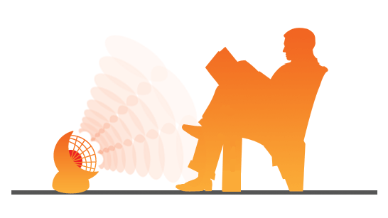**Heat Transfer - Radiation**

Heat can travel across empty spaces (such as a vacuum or through air) by **infrared radiation (“hot light”)**. This is a form of light (see "The electromagnetic Spectrum", which you studied in the light topic). Your eye has not evolved to see it (although some snakes have), but your skin can feel it. Heat from the sun reaches us through the vacuum of space by infrared radiation.

**Black** objects are **good absorbers** and **emitters** of IR radiation.

**White** and **shiny** objects are **poor emitters and absorbers** of IR radiation.

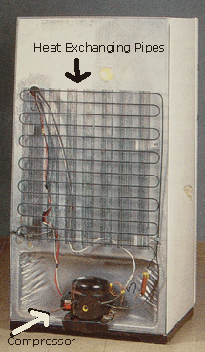

1. Two beakers are of identical size, shape and material, but one is painted white and one black. If they are both filled with hot water, which one cools the fastest and why?
2. 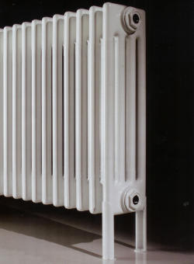Explain why the bars at the back of a refrigerator are painted black.
3. “Radiators” in houses are normally painted white. Explain why they should really be painted black!
4. At the end of a marathon, runners often have foil blankets put over them (especially on cold days). Why?
5. Takeaway food is often served in foil containers. Why?
6. 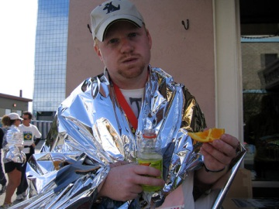The earth has been warmed by the radiation from the sun for millions of years, but its average temperature has remained fairly steady. Why hasn't the earth not just got hotter and hotter?

