Homework 4
The Thermos Flask

Explain how the features of a thermos flask prevent heat loss by conduction, convection and radiation.
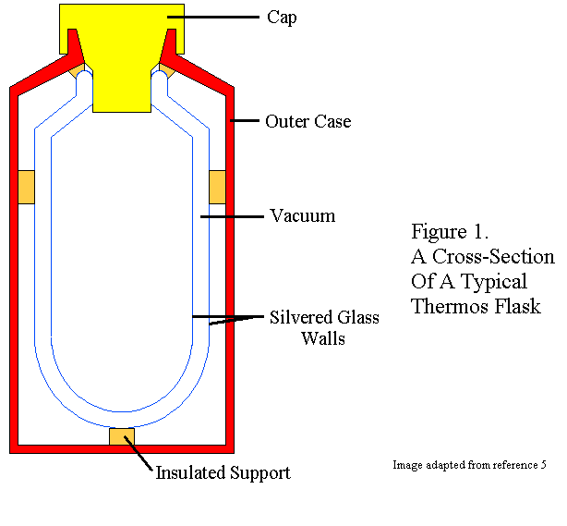Cap:

Outer case:

Vacuum:

Silvered glass walls:

Insulated support:

