**Homework 3**

1. Draw circuit diagrams for the following circuits:

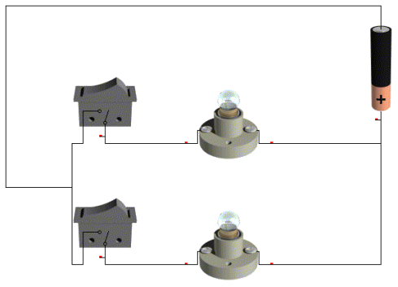

Circuit 1 Circuit 2

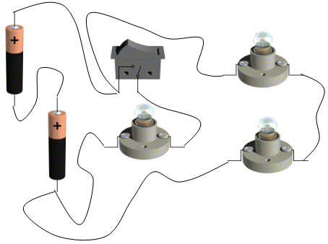

Circuit 3

