Waves & Radiation
Waves
Summary

A wave is a regular disturbance which carries energy but has no mass.
Some waves require a medium to travel through (e.g. water waves) others, like light, can travel through a vacuum.
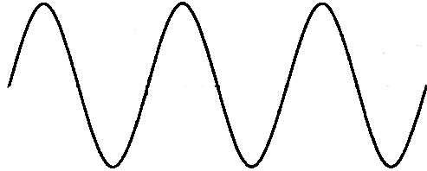
In transverse waves the particles of the medium vibrate at right angles to the direction of energy transfer. Water, light, radio and television waves are transverse.
In longitudinal waves the particles of the medium vibrate in the same direction as the energy transfer. Sound waves are longitudinal waves.
crest
trough
wavelength
amplitude

Wave Term | Symbol | Definition | Unit
frequency | f | number of waves passing a point each second | Hz
wavelength | λ | distance from one point on a wave to the same point on the next wave | m
speed | v | distance travelled by a wave in one second | m/s
amplitude |  | size of maximum disturbance from the zero position
period | T | time taken for a wave to pass a point | s

Hz
Frequency

$$frequency=\frac{number of waves}{time}$$

$$f=\frac{n}{t}$$
$$t=\frac{n}{f}$$

Frequency and Period

$$frequency=\frac{1}{period}$$

$$f=\frac{1}{T}$$
$$t=\frac{1}{f}$$

f
1
T
Hz
s

s
n
t
f

Speed, Frequency and Wavelength

$$speed=frequency × wavelength$$

$$v=fλ$$
$$f=\frac{v}{λ}$$
$$λ=\frac{v}{f}$$

f
v
λ
m/s
Hz
m
Distance, Speed and Time

$$speed=\frac{distance}{time}$$

$$v=\frac{d}{t}$$
$$d=vt$$
$$t=\frac{d}{v}$$

m
m/s
s
v
d
t

Diffraction is the ability of waves to bend round corners. All waves diffract to some extent, but the longer the wavelength of a wave, the greater the amount of diffraction that takes place.
long wavelengths diffract more
(radio wave reaches house behind hill)
short wavelengths diffract less
(television wave does not reach house behind hill)

