Waves & Radiation
Nuclear Radiation
Summary

The Atom
An atom is the basic unit of matter. An atom is made up of a central nucleus with orbiting electrons.
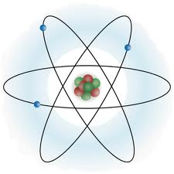
nucleus containing protons and neutrons
electron

The nucleus contains positively charged protons and uncharged (“neutral”) neutrons.
The nucleus contains nearly all the mass of the atom and contains all the positive charge
The electrons orbit the nucleus at high speed. Electrons are negatively charged and much lighter than neutrons or protons.
An atom is normally electrically neutral as it has the same number of negative electrons orbiting the nucleus as positive protons in the nucleus.
Isotopes are atoms of the same element with different numbers of neutrons in the nucleus.
Some isotopes are stable and some unstable. The nuclei of unstable isotopes undergo radioactive decay and emit nuclear radiation. The three main types of nuclear radiation are alpha, beta and gamma.

Type | Description | Range in air | Absorbed by
alpha  α | helium nucleus | a few centimetres | sheet of paper
beta  β | fast moving electron | a few metres | 2-3 mm aluminium
gamma  γ | electromagnetic radiation | infinite | 5-6 cm lead  (not completely)

Ionisation is the addition or removal of an electron from an uncharged atom. All three types of radiation cause ionisation, but alpha is the most strongly ionising.
Detectors of radiation rely on ionisation to detect the radiation and include Geiger-Muller tubes, film badges, spark counters, scintillation counters and cloud chambers.

Activity
Activity and Time

$$activity=\frac{number of decays}{time}$$

$$A=\frac{N}{t}$$
$$N=At$$
$$t=\frac{N}{A}$$

Bq
s
A
N
t
The activity of a radioactive source is the number of nuclei that decay each second.
The activity of a radioactive source is measured in becquerels, Bq.
The activity of a radioactive source decreases with time.
It is difficul to measure the activity of a source directly but it can be estimated from the count rate detected from the source.

Half life
The half-life of a radioactive source is the time taken for half the nuclei in the source to decay.
Each isotope has a particular half-life (e.g. the half life of strontium-90 is 28·8 years)
The half life of a radioactive source can be determined experimentally using the following procedure:
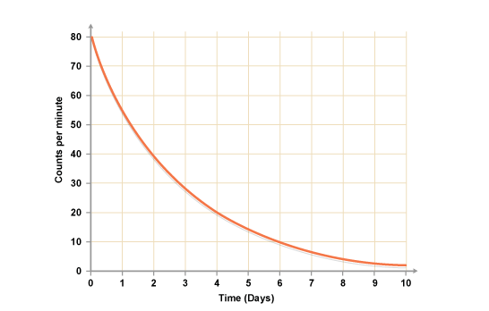
- use a Geiger Muller tube connected to a counter to measure count rate
- measure the background count rate
- measure the count rate due to the source at regular time intervals
- subtract the background count from each of these values to determine the corrected count rate
- draw a graph of corrected count rate against time
- determine the time taken for the corrected count rate to half
half-life = 1·9 days
Biological Effect of Radiation
Absorbed dose, Energy and Mass

$$absorbed dose=\frac{energy}{mass}$$

$$D=\frac{E}{m}$$
$$E=Dm$$
$$m=\frac{E}{D}$$

J
Gy
kg
D
E
m
Radiation can kill or damage living cells.
The biological effect of radiation depends on three factors:
- the absorbed dose
- The type of radiation
- The type of tissue absorbing the radiation
The absorbed dose, D, is the energy absorbed per unit mass of the absorbing material and is measured in grays, Gy. (1 Gy = 1 J/kg)
A radiation weighting factor, w_{R}, is given to each kind of radiation as a measure of its relative biological effect. Radiation weighting factor has no units.
Equivalent dose, Absorbed dose and Radiation weighting factor
$$\begin{matrix}equivalent \\ dose\end{matrix}=\begin{matrix}absorbed \\ dose\end{matrix}× \begin{matrix}radiation \\ weighting \\ factor\end{matrix}$$

$$H=Dw_{R}$$
$$D=\frac{H}{w_{R}}$$
$$w_{R}=\frac{H}{D}$$

D
H
w_{R}
Sv
Gy
The equivalent dose, H, is a measure of the biological risk caused by radiation. The equivalent dose is the product of the absorbed dose and the radiation weighting factor. Equivalent dose is measured in sieverts, Sv.
The equivalent dose rate, Ḣ (“H-dot”) is the rate at which the equivalent dose is received.
Equivalent dose rate is usually measured in mSvy⁻¹ or Svh⁻¹.
Background Radiation
Equivalent dose rate, Equivalent dose
and Time

$$equivalent dose rate=\frac{equivalent dose}{time}$$

$$\dot{H}=\frac{H}{t}$$
$$H=\dot{H}t$$
$$t=\frac{H}{\dot{H}}$$

Sv
Sv h⁻¹ or Sv y⁻¹
h or y
Ḣ
H
t
Radiation is always present in the environment from a variety of natural and artificial sources.
Natural sources of radiation include: radon and thoron gas from rocks and soil, gamma rays from the ground, carbon and potassium in the body and cosmic rays.
Artificial sources include: medical uses (e.g. X-rays), fallout from weapons testing, nuclear accidents (e.g. Chernobyl) and nuclear waste.
The average equivalent dose rate from background sources for an individual in the UK is 2 mSvy⁻¹.
Safety precautions
When using radioactive sources it is necessary observe certain safety precautions. For example:
- limit the time of exposure
- store sources in lead lined containers
- point sources away from body (especially eyes)
- handle with tongs
- wash hands after use

Uses of radiation
Radiation is used in medicine:
- gamma sources known as radioactive ‘tracers’ can be introduced into the body and their movement round the body monitored with a gamma camera
- high energy gamma rays can be directed at a tumour to kill cancerous cells
- an alpha source can be placed next to a tumour to kill cancerous cells
Alpha sources are used in smoke detectors and beta sources are used to monitor and control thickness in the manufacture of paper
Nuclear radiation is also used in power generation:
Nuclear fission
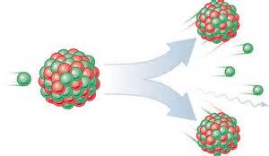
In nuclear fission large nuclei (e.g. uranium-235) are split by a neutron into two smaller nuclei with the release of energy and more neutrons. These neutrons can then split further nuclei in a chain reaction. Nuclear fission generates a huge amount of energy from a small amount of fuel, but the waste products are radioactive. Nuclear power stations use nuclear fission.
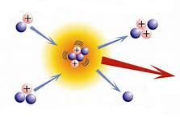
Nuclear fusion
In nuclear fusion small nuclei (e.g. isotopes of hydrogen) are joined together to make larger nuclei (e.g. helium) with the release of energy. Nuclear fusion generates a vast amount of energy from a small amount of fuel and does not produce radioactive waste. Nuclear fusion is the process by which the sun produces energy. Nuclear fusion is extremely difficult to control.

