Waves & Radiation
Light
Summary
Light is an electromagnetic wave that is visible to the human eye.
Light travels in straight lines

Reflection
When light is reflected from a mirror it is found that the angle of incidence is equal to the angle of reflection. This is known as the law of reflection.
r
i
i = angle of incidence
r = angle of reflection

mirror
normal
ray of light
reflected ray

Convex mirrors cause parallel rays of light to be spread apart.

Concave mirrors cause parallel rays of light to be brought to a focus.

concave mirror
parallel rays of light
focus
convexmirror
parallel rays of light

Refraction
Refraction is the change in speed of light as it passes from one material (medium) into another. This can cause a change in direction.
When light passes from a fast medium into a slow medium it bends towards the normal and when it passes from a slow medium into a fast medium it bends away from the normal.
i
normal
r

i = angle of incidence
r = angle of refraction

Lenses
A concave (diverging lens) causes rays of light to spread apart.

A convex (converging lens) causes rays of light to be brought to a focus.

Lenses are used in many optical instruments, including cameras, microscopes, telescopes and projectors.

Focal length
The focal length of a lens is the distance between a lens and the point where parallel rays of light are brought to a focus.
convex lens
parallel rays of light
principal focus
focal length

The focal length of a convex lens can be measured experimentally by placing the lens in front of a screen and moving the lens until a sharp image of a distant object is obtained on the screen, then measuring the distance from the lens to the screen (this is the focal length).

Correcting Short Sight
A short-sighted person cannot focus on distant objects, but can see clearly objects a short distance in front of them. This is usually because either the eyeball is too long or the eye lens is too powerful. This results in the parallel rays of light from a distant object being focused in front (short) of the retina
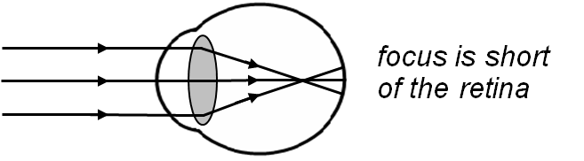

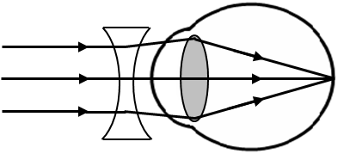
To correct short sight a concave lens is placed in front of the eye so as to spread the rays of light out before they enter the eye, allowing them to be focussed on the retina.

Correcting Long Sight
A long sighted person cannot focus on close objects, but can see clearly objects at a distance from them. This is usually because either the eyeball is too short or the eye lens is not powerful enough. This results in the diverging rays of light from a close object being focused in behind (long) the retina.
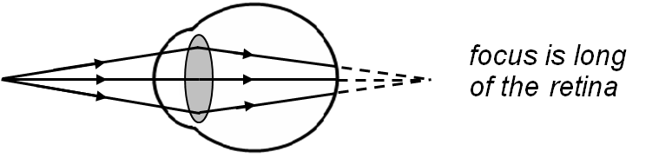

To correct long sight a convex lens is placed in front of the eye so as to bring the rays of light together before they enter the eye, allowing them to be focussed on the retina.
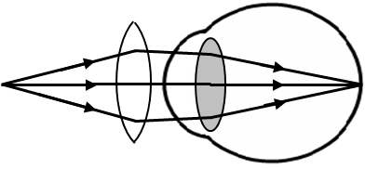

Prisms
A triangular block of glass, known as a prism, can be used to separate white light into the spectrum of visible light (red, orange, yellow, green, blue, indigo and violet). This occurs because different wavelengths of light are refracted by slightly different amounts.
ray of white light
prism
red
violet

