**National 5 Physics**

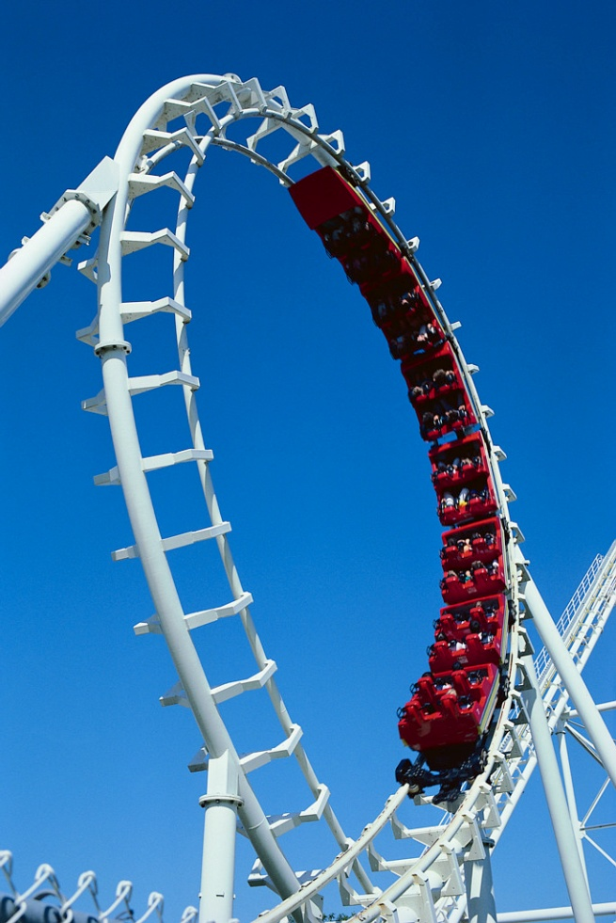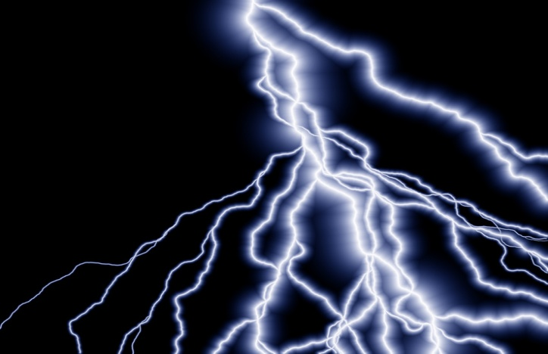

**Electricity and Energy**

**Problem Booklet**



**Contents**

|  |  |
| --- | --- |
| **Topic** | **Page** |
| Weight | 4 – 5 |
| Work Done | 6 – 7 |
| Gravitational Potential Energy | 8 – 9 |
| Kinetic Energy | 10 – 11 |
| Conservation of Energy – Falling Objects | 12 – 13 |
| Efficiency | 14 – 15 |
| Electric Charge | 16 – 17 |
| Electrical Current | 18 – 19 |
| Charges in Electric Fields | 20 |
| Series Circuits | 21 – 22 |
| Parallel Circuits | 23 – 24 |
| Mixed Circuits | 25 |
| Ohm’s Law | 26 – 27 |
| Variable Resistors | 28 |
| Solar (Photovoltaic) Cells | 29 |
| Capacitors | 30 |
| LEDs | 31 |
| Thermistors and LDRs | 32 – 33 |
| Resistors in Series | 34 |
| Resistors in Parallel | 35 |
| Resistors in Mixed Circuits | 36 – 38 |
| Voltage Dividers | 39 – 41 |
| Switching Circuits | 42 – 47 |
| Electrical Power | 48 – 50 |
| Power, Current & Voltage | 51 – 52 |
| Fuses | 53 |
| Power & Resistance | 54 – 57 |
| Specific Heat Capacity | 58 – 59 |
| Heat Transfer | 60 |
| Pressure | 61 – 62 |
| Gas Laws | 63 – 67 |

**Weight**

**Useful Equation:**

W = m g

where: W is the weight of on an object (N)

m is the mass of an object (kg)

g is the gravitational field strength (N/kg)

1. What is the difference between weight and mass?
2. Copy and complete this table:

|  |  |  |  |
| --- | --- | --- | --- |
|  | ***Weight* / N** | ***Mass* / kg** | ***Gravitational Field Strength (N/kg)*** |
| **(a)** |  | 3 | 10 |
| **(b)** |  | 0.25 | 9 |
| **(c)** | 300 |  | 10 |
| **(d)** | 210 |  | 7 |
| **(e)** | 520 | 65 |  |
| **(f)** | 3640 | 140 |  |

1. What is the weight of these objects on the surface of the Earth?
2. A 3 kg cat.
3. A 100 g apple.
4. A 65 kg pupil.
5. A 1200 kg car.
6. What happens to the weight of a space shuttle as it gets further away from the surface of the Earth? Give *two* reasons for your answer.
7. The mass of an astronaut is found to be 85 kg on Earth. What is the mass of the astronaut on the moon?

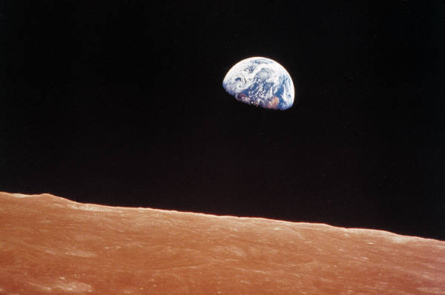

1. What is the weight of a 93 kg astronaut in the following places in the solar system:
2. The surface of Mars.



1. The surface of Jupiter.
2. The surface of Mercury.
3. Drifting in space on an ‘EVA’ – a space walk.
4. What is the mass of an astronaut who has a weight of 675 N on the surface of Venus?
5. An astronaut of mass 82.0 kg is standing on the surface of a planet in our solar system and measures his weight to be 902 N. Which planet is the astronaut standing on?
6. In a set of experiments being carried out on a far away planet, an alien measures the mass and weight of different objects. The results are shown.

|  |  |
| --- | --- |
| ***Mass /* kg** | ***Weight* / N** |
| 0.3 | 3.9 |
| 0.5 | 6.5 |
| 0.7 | 9.1 |
| 1.4 | 18.2 |
| 1.8 | 23.4 |
| 2.1 | 27.3 |

Draw a line graph of these results and use the gradient of the graph to calculate the gravitational field strength of the far away planet.

**Work Done**

**Useful Equation:**

Ew = F d

where: Ew is the work done on an object (J)

F is the force acting on an object (N)

d is the distance or displacement of an object (m)

1. What is meant by the term ‘work done’?
2. Copy and complete this table:

|  |  |  |  |
| --- | --- | --- | --- |
|  | ***Work Done* / J** | ***Force* / N** | ***Distance* / m** |
| **(a)** |  | 100 | 30 |
| **(b)** |  | 25 | 6.2 |
| **(c)** | 300 000 |  | 150 |
| **(d)** | 40 |  | 2 |
| **(e)** | 1250 | 125 |  |
| **(f)** | 144 000 | 3200 |  |

1. What is the work done by a shopper pushing a shopping trolley with an average force of 480 N over a distance of 35 metres?



1. What is the average force applied by a mother pushing a pram for a distance of 500 metres if her total work is 150 000 J?
2. What is the distance that a boy pushes his bike if he does 240 000 J of work and applies a constant force of 6000 N?
3. What is the work done by a truck if it drives 20 km with an average engine force of 1.5 kN?

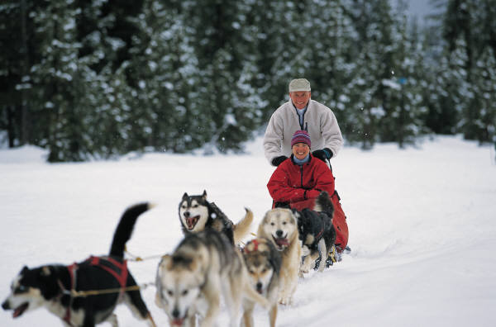

1. A group of 6 snow dogs pull a sledge with an average force of 600 N each. What is the distance that the sledge has been pulled when the total work done by all of the dogs is 90 MJ?
2. The Formula 1 Australian Grand Prix is a race where the winning car drives 308 km. The work done by a car that completes the full race is 2.43 x 109 J. What is the average engine force of the car?

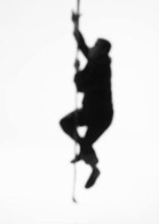

1. In a P.E. lesson, a pupil of mass 58 kg climbs 12 metres up a rope. What is the work done by the pupil during this climb?
2. In an experiment, a pupil measures the distance travelled and the work done by a battery powered toy car (using E = P t). The results are shown:

|  |  |
| --- | --- |
| ***Distance /* m** | ***Work Done* / J** |
| 0.0 | 0.00 |
| 2.5 | 11.25 |
| 5.0 | 18.00 |
| 7.5 | 33.75 |
| 10.0 | 45.00 |
| 12.5 | 56.25 |

Draw a line graph of these results and use the gradient of the straight line to find the average force of the motor of the toy car.



**Gravitational Potential Energy**

**Useful Equation:**

Ep = m g h

where: Ep is the gravitational potential energy (J)

m is the mass of an object (kg)

g is the gravitational field strength (N/kg)

h is the height of an object (m)

1. What is meant by the term ‘gravitational potential energy’?
2. Copy and complete this table.

|  |  |  |  |  |
| --- | --- | --- | --- | --- |
|  | ***Gravitational Potential Energy* / J** | ***Mass /* kg** | ***Gravitational Field Strength* / N/kg** | ***Height* / m** |
| **(a)** |  | 2 | 9.8 | 3 |
| **(b)** |  | 25 | 9.8 | 15 |
| **(c)** | 600 |  | 9.8 | 12 |
| **(d)** | 3400 |  | 9.8 | 40 |
| **(e)** | 1.4 | 0.4 |  | 0.5 |
| **(f)** | 3185 | 3.5 |  | 35 |
| **(g)** | 30 600 | 85 | 8 |  |
| **(h)** | 2.64 x 107 | 1600 | 11 |  |

*Unless told otherwise, assume that all questions take place close to the surface of the Earth.*

1. A pupil with a mass of 52 kg climbs a 9 metre rope in a PE lesson.
2. What is the weight of the pupil?
3. What is the work done by the pupil in order to climb the rope?
4. What is the gravitational potential energy gained by the pupil?
5. A 450 g ball is dropped from a 1.5 metre high table on to the ground. What is the gravitational potential energy lost by the ball?
6. A 450 g ball is thrown 1.5 metres in to the air. What is the gravitational potential energy gained by the ball?



1. A high jumper gains 1107 J of gravitational potential energy as she jumps 2.05 metres in to the air. What is the mass of the high jumper?
2. A helicopter has a mass of 4800 kg and a gravitational potential energy of 7.2 MJ. How far from the ground is the helicopter?
3. A space probe lands on the surface of a planet in our Solar System to collect rock samples. A rock of mass 50 g is picked up and lifted vertically to a height of 40 cm. The work done by the probe in lifting the rock is 0.08 J.
4. What is the gravitational field strength on the surface of the planet?
5. Name the planet that the probe has landed on.



**Kinetic Energy**

**Useful Equation:**

Ek = ½ m v2

where: Ek is the kinetic energy of an object (J)

m is the mass of an object (kg)

v is the speed of an object (m/s)

1. Copy and complete this sentence:

The kinetic energy of an object is dependent on the ____________ and the _____________ of the object.

1. Copy and complete this table:

|  |  |  |  |
| --- | --- | --- | --- |
|  | ***Kinetic Energy* / J** | ***Mass* / kg** | ***Speed* / m/s** |
| **(a)** |  | 6 | 3 |
| **(b)** |  | 72 | 4.5 |
| **(c)** | 101 250 |  | 15 |
| **(d)** | 0.75 |  | 0.5 |
| **(e)** | 800 | 25 |  |
| **(f)** | 4.8 x 10-3 | 1.5 x 10-2 |  |

1. What is the kinetic energy of a sprinter with a mass of 75 kg and a speed of 9.5 m/s?
2. A toy car has a kinetic energy of 24.5 mJ when it has a speed of 0.7 m/s. What is the mass of the toy car?

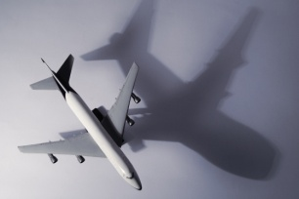

1. An aeroplane has a mass of 3.5 x 105 kg and a kinetic energy of 3.9375 GJ. What is the speed of the aeroplane?

1. A car of mass 1200 kg is driving down a motorway with a speed of 70 mph.
2. Convert the speed of the car in to metres per second. (1 mile = 1609 metres)
3. Calculate the kinetic energy of the car.
4. In an experiment, a trolley is sent down an air track by an elastic band, and the speed of the trolley is measured with a light gate and micro computer. The experiment is then repeated for different masses of trolley.

Light Gate

Air Track

Trolley

Elastic Band

Micro Computer

The results of the experiment are shown below:

|  |  |
| --- | --- |
| ***Mass /* g** | ***Speed of Trolley* / m/s** |
| 400 | 0.20 |
| 500 | 0.18 |
| 600 | 0.16 |
| 700 | 0.15 |
| 800 | 0.14 |
| 900 | 0.13 |

1. Why is the experiment carried out on an air track?
2. Draw a line graph of 1/m against v2 and use the gradient of the straight line to calculate the kinetic energy given to the trolley by the elastic band.

**Conservation of Energy – Falling Objects**

*Unless told otherwise, assume that all questions take place close to the surface of the Earth.*

1. A 57 g tennis ball is dropped from a height of 90 cm.
2. What is the gravitational potential energy of the tennis ball before it is dropped?
3. What is the kinetic energy of the ball as it lands?
4. What is the vertical speed of the ball as it lands on the ground?



1. A diver of mass 70 kg jumps off a 10 metre diving platform in to a swimming pool. What is the vertical speed of the diver as he enters the water?
2. After retrieving his 46 g golf ball from a bush, a golfer takes a penalty drop by holding the ball at arm’s length and allowing it to drop a height of 1.5 m to the ground.
3. What is the gravitational potential energy of the ball just before it is dropped?
4. What is the speed of the ball when it hits the ground?
5. What is the speed of the ball when it is 0.75 metres above the ground?
6. An 85 kg skydiver jumps out of an aeroplane which is at a height of 3800 metres. The parachute is opened at a height of 1300 metres above the ground.
7. What is the speed of the skydiver just before the parachute is opened?



1. In reality, the speed of the skydiver is 55 m/s at this point. Explain the difference in the speed calculated in part (a) and the actual speed of the speed diver.
2. A bouncy ball of mass 50 g is thrown in to the air with a kinetic energy of 1.6 J.
3. What is the gravitational potential energy of the bouncy ball at its highest point?
4. What is the maximum height that the ball will reach?
5. A roller coaster car has a mass of 5000 kg and is travelling with a speed of 18 m/s as it enters a loop which has a height of 12 metres.

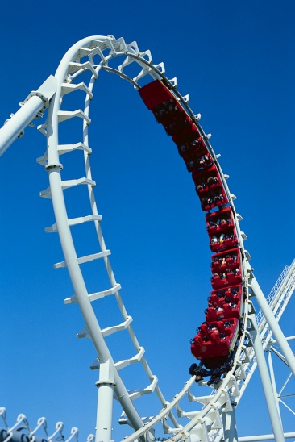

1. What is the kinetic energy of the roller coaster car at the moment it reaches the loop?
2. What is the gravitational potential energy of the roller coaster car at the top of the loop?
3. What is the kinetic energy of the roller coaster car at the top of the loop?
4. What is the speed of the roller coaster car at the top of the loop?
5. On the moon, an astronaut drops a coin of mass 7 g from a height of 1.2 metres to the ground. What is the speed of the coin when it hits the ground?

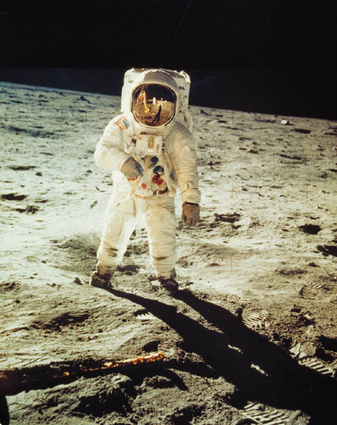

1. During a movie stunt, a car is dropped from a height of 23 metres. What is the speed of the car as it hits the ground?

**Efficiency**

**Useful Equation:**

Eff (%) = I t

Ein

x 100%

Eout t

where: Eff is efficiency of a machine (%)

Eout is the useful energy output of a machine (J)

Ein is the input energy of a machine (J)

1. State the main energy change in these objects:



1. Lamp
2. Microwave
3. Yo-yo
4. Solar panel
5. Radio
6. What is the main energy change in the following parts of a fossil fuel power station:
7. Boiler?
8. Generator?



1. State how a hydroelectric power station generates electricity.
2. Explain why a fossil fuel power station is not 100% efficient.



1. In one minute, a motor in a food mixer uses up 25 kJ of electrical energy. The kinetic energy given off by the motor in this time is 8750 J.
2. What is the total energy output of the motor?
3. How much energy was NOT turned in to kinetic energy?
4. What has happened to the ‘missing’ energy?
5. Copy and complete this table:

|  |  |  |  |
| --- | --- | --- | --- |
|  | ***Efficiency* / %** | ***Eout* / J** | ***Ein* / J** |
| **(a)** |  | 1500 | 2500 |
| **(b)** |  | 5 x 106 | 0.1 x 109 |
| **(c)** | 43 |  | 6500 |
| **(d)** | 38 |  | 3.2 x 107 |
| **(e)** | 5 | 5400 |  |
| **(f)** | 16 | 7.8 x 105 |  |

1. What is the efficiency of the motor in the food mixer (from question 5) that gives out 8750 J of kinetic energy when it uses up 25 kJ of electrical energy?
2. A light bulb is 27% efficient. What light energy will be emitted if the input electrical energy is 1800 J?

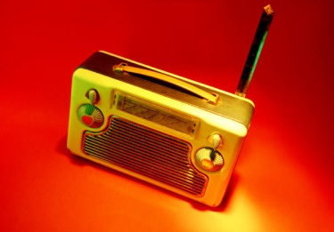

1. A radio is 82% efficient and gives off 4500 J of sound energy in 30 seconds.
2. What is the main energy change in the radio?
3. What is the input energy of the radio in 30 seconds?
4. A hydroelectric power station is 78% efficient. How much electrical energy can be expected from 20 000 kg of water that will be dropped a height of 40 metres?
5. A 550 W washing machine is 60% efficient. What is the useful output energy produced if the washing machine is on for 40 minutes?



**Electrical Charge**

1. In a classroom experiment, two metallised polystyrene spheres are hung from a thread, as shown below. Copy the diagrams below and use arrows to show the direction of movement of each sphere.

-

-

-

-

-

**(d)**

+

+

+

+

+

**(c)**

-

-

-

-

-

-

-

-

-

-

**(b)**

-

-

-

-

-

+

+

+

+

+

**(a)**

+

+

+

+

+

1. Explain how a photocopier uses a positively charged copy plate and negatively charged toner particles to create a copy of an image on a piece of paper.



1. Why will a static duster work better if it is ‘fluffed up’ or rubbed across a television screen before use?

1. Vehicle manufacturers charge the body of cars and use charged paint to give cars their final colour. By using your knowledge of electrostatics:
2. Explain how this results in an even coat of paint over the whole surface of the car.
3. Explain how this limits the amount of paint that is wasted.



1. Cling film is used to keep to keep food fresh. Cling film becomes sticky because of electrostatic charges.
2. Describe how a piece of cling film becomes charged.
3. Explain why cling film will stick to a plastic bowl for a long time but loses its sticking power quickly when placed on a metal bowl.
4. An electrostatic precipitator can be used to remove dust particles from the air.
5. Use the diagram below to explain how it works.
6. Why are electrostatic precipitators useful in fossil fuel power stations?

Negatively Charged Metal Grid

+

+

Positively Charged Collecting Plates

Air Particle

Dust Particle

**Electrical Current**

**Useful Equation:**

Q = I t

where: Q is the charge flowing through a component (C)

I is the current flowing through a component (A)

t is the time taken (s)

1. What is an electrical current?
2. Copy and complete this table:

|  |  |  |  |
| --- | --- | --- | --- |
|  | ***Charge* / C** | ***Current* / A** | ***Time* / s** |
| **(a)** |  | 0.5 | 30 |
| **(b)** |  | 0.14 | 25 |
| **(c)** | 4.2 |  | 15 |
| **(d)** | 3200 |  | 1280 |
| **(e)** | 1.6 x 10-3 | 3.2 x 10-4 |  |
| **(f)** | 270 | 0.3 |  |

1. A current of 6.5 A flows through a hairdryer for 5 minutes. What is the charge that flows through the hairdryer during this time?
2. When playing a game, an Xbox 360 has 1368 coulombs of charge flo wing through it an hour. What is the current flowing through the console?
3. An electric kettle has 9.5 A of current flowing through it as it boils water. How long does it take the kettle to boil if 1995 C of charge flows through it before it switches off?
4. What is the difference between alternating and direct current?
5. Copy these oscilloscope traces and indicate which one represents an alternating current and which one represents a direct current.

**(b)**

**(a)**

1. For each of these oscilloscope traces, calculate the:
2. Peak voltage
3. Frequency

**Y-gain**

**Timebase**

**2 V / div**

**5.0 ms**

**(a)**

**Y-gain**

**Timebase**

**1.5 V / div**

**2.5 ms**

**(b)**

**Charges in Electric Fields**

1. Copy and complete these diagrams to show the direction of the electric field.

**(c)**

+

-

**(b)**

-

**(a)**

+

+

+

+

+

+

+

+

+

+

+

+

+

-

-

-

-

-

-

-

-

-

-

-

-

**(d)**

1. Copy this diagram and add the paths of the following particles entering at right angles to the electric field:
2. Electron **(b)** Proton **(c)** Neutron

+

+

+

+

+

+

+

+

+

+

+

+

-

-

-

-

-

-

-

-

-

-

-

-

1. An alpha particle, a beta particle and a gamma ray enter an electric field at right angles to the field. Which letter shows the most likely position of the:
2. Alpha particle **(b)** Beta particle **(c)** Gamma ray

+

+

+

+

+

+

+

+

+

+

+

+

-

-

-

-

-

-

-

-

-

-

-

-

Y

Z

X

**Series Circuits**

1. Calculate the current at the given points in each series circuit.

**(b)**

6.5 A

I1

I2

M

**(a)**

0.4 A

I1

I2

1. Calculate the voltage across the resistor in each of these series circuits.

**(a)**

1.5 V

0.6 V

V

**(b)**

12 V

M

V

8.5 V

1. In the circuit in question 2 part (a), the lamp uses up 3600 J of electrical energy in one minute.
2. How much electrical energy is converted in to heat energy by the resistor in one minute?
3. How much electrical energy is given off by the cell in one minute?
4. In an experiment, two *identical* resistors are connected to a 9.0 V power supply. Calculate the voltage across each resistor.

9.0 V

V1

V2

1. Calculate the missing currents and voltages in these series circuits.

**(a)**

V

1.6 mA

1 V

2 V

I3

I2

I1

**(b)**

V

0.5 A

1.2 V

I3

I2

I1

0.45 V

**Parallel Circuits**

1. Calculate the current at the given points in each parallel circuit.

**(b)**

1.6 A

I1

0.7 A

I2

**(a)**

0.15 A

I

0.10 A

1. Calculate the voltage across the lamp in each of these parallel circuits.

**(b)**

15 V

**(a)**

2.5 V

1. In an experiment, two *identical* resistors are connected in parallel to a power supply which has 0.58 A drawn from it. Calculate the current through each resistor.

0.58 A

I1

I2

1. Calculate the missing currents and voltages in these parallel circuits.

0.45 A

I1

I2

10 Ω

10 Ω

10 Ω

1.5 V

I3

I5

I4

**(b)**

V1

V2

V3

**(a)**

12 V

V1

V2

I1

1.5 A

0.5 A

I3

I2

I4

I5

1. Lighting circuits in the home can be set up in three different ways, as shown below. State the advantages and disadvantages of each layout.

**(b)**

230 V

**(a)**

230 V

**(c)**

230 V

**Mixed Circuits**

1. Calculate the missing currents in this circuit. Assume that all lamps are identical.

0.24 A

I1

I2

I3

I4

1. Calculate the missing voltages in this circuit.

1.5 V

V1

V2

V3

1. Calculate the missing voltages and currents in this circuit. Assume that all lamps are identical.

8 V

2.2 A

V1

V2

V3

V4

I1

I2

I3

I4

I5

**Ohm’s Law**

**Useful Equation:**

I

V

R

V = I R

where: V is the voltage across a component (V)

I is the current flowing through a component (A)

R is the resistance of a component (Ω)

1. What is meant by the ‘resistance’ of a component?
2. What is the meaning of the term ‘voltage’ or ‘potential difference’?
3. Copy and complete this table.

|  |  |  |  |
| --- | --- | --- | --- |
|  | ***Voltage* / V** | ***Current* / A** | ***Resistance* / Ω** |
| **(a)** |  | 0.4 | 150 |
| **(b)** |  | 0.05 | 40 |
| **(c)** | 12 |  | 60 |
| **(d)** | 8 |  | 400 |
| **(e)** | 230 | 5 |  |
| **(f)** | 10 | 0.08 |  |

1. What is the resistance of a lamp that allows 600 mA of current to flow through it when there is a potential difference of 12 V across it?
2. What is the current flowing through a piece of 10 kΩ resistance wire when a voltage of 15 V is across it?
3. What is the voltage across a 125 Ω lamp that has a current of 1.84 A flowing through it?
4. In an experiment, a lamp is connected to a variable supply and left on for a few minutes until its brightness is constant.

The voltage across the lamp is changed to different values and the current flowing through it is measured.

The results are shown in the table.

A

V

|  |  |
| --- | --- |
| ***Voltage /* V** | ***Current* / A** |
| 0 | 0 |
| 2 | 0.44 |
| 4 | 0.88 |
| 6 | 1.33 |
| 8 | 1.78 |
| 10 | 2.22 |

Draw a line graph of these results and use the gradient of the straight line to find the resistance of the lamp.

1. The same experiment is repeated except this time, the measurements are made immediately after turning on the lamp. The results are shown in the table.

|  |  |
| --- | --- |
| ***Voltage /* V** | ***Current* / A** |
| 0 | 0 |
| 2 | 0.18 |
| 4 | 0.45 |
| 6 | 0.98 |
| 8 | 1.78 |
| 10 | 2.22 |

Draw a line graph of these results and explain why a straight line is not found.

**Variable Resistors**

1. What is the purpose of a resistor in a circuit?
2. What is the difference between a fixed-value resistor and a variable resistor?
3. A variable resistor can be used to control the speed of the electric motor in a portable fan. The variable resistor has a range of values from 300 Ω to 1.5 kΩ. Assume that the motor has no resistance.

3.0 V

**M**

300 Ω - 1.5 kΩ

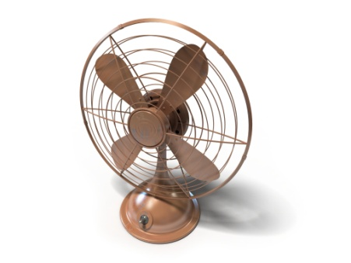

1. What is the maximum current that can flow through the motor?
2. What is the minimum current that can flow through the motor?
3. A variable resistor is used as a dimmer switch in a lighting circuit.

R

12 V

1. What is the resistance of the variable resistor if the current flowing through the *variable resistor* is 0.20 A and the voltage across it is 4 V?
2. What is the resistance of the variable resistor when the current flowing through the *lamp* is 5 mA and the voltage across the lamp is 2 V?

**Solar (Photovoltaic) Cells**

1. What is the energy conversion in a solar cell?
2. What happens to the voltage generated by a solar cell as the light incident on it becomes brighter?

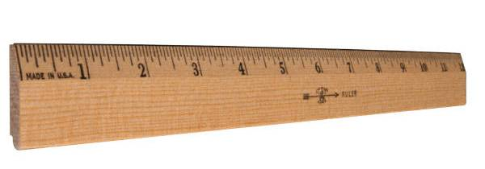

1. A photovoltaic cell is used to generate a voltage at a distance of 10 cm away from a small light bulb. The voltage is measured with a voltmeter.

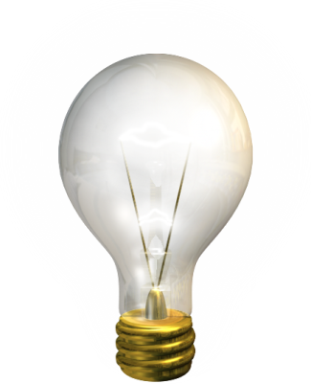

Solar Cell

Light bulb

Ruler

The experiment is then repeated with the photovoltaic cell at different distances from the light bulb.

The results of the experiment are shown.

|  |  |
| --- | --- |
| ***Distance / c*m** | ***Voltage* / V** |
| 10 | 7.20 |
| 20 | 1.80 |
| 30 | 0.80 |
| 40 | 0.45 |
| 50 | 0.29 |
| 60 | 0.20 |

Manipulate this data to find a linear relationship between distance and voltage.

(In other words, find a way of graphing this information as a straight line through the origin.)

**Capacitors**

1. What is the purpose of a capacitor in a circuit?
2. A discharged capacitor is placed in to a series circuit as shown.

R

C

V2

6 V

S

V1

1. What is the reading on the voltmeter, V2, when switch S is open?
2. The switch, S, is closed. What is the reading on voltmeter, V1, *immediately* after the switch is closed?
3. The switch, S, is closed. What is the reading on voltmeter, V2, *immediately* after the switch is closed?
4. The switch, S, remains closed. Draw a voltage-time graph that shows how the reading on the voltmeter, V1, changes until the capacitor is fully charged.
5. Describe *two* changes that could be made to the circuit to *increase* the time taken for the capacitor, C, to charge.
6. The capacitor is now discharged using the circuit below.

R

C

V2

S

V1

1. Draw a voltage-time graph that shows

how the reading on voltmeter, V2,

changes with time until it is fully

discharged.

1. State *two* changes that could be make

to the circuit to make the capacitor

discharge *faster*.

**LEDs**

1. What is a diode?
2. What is the energy change that takes place in an LED?
3. What are the advantages and disadvantages of using an LED in a circuit instead of a light bulb?
4. An LED is connected in series with a cell and a resistor, as shown. The LED operates when the voltage across it is 1.8 V and the current flowing through it is 1.5 mA.

6 V

1.5 mA

R

1.8 V

1. Why is the LED connected in series with a resistor?
2. What value of resistor is required for the LED to operate?
3. Which of these LEDs will operate?

A

B

C

D

1.8 V

**Thermistors & LDRs**



1. What happens to the resistance of a thermistor as temperature increases?
2. What happens to the current flowing through a resistor as temperature increases?
3. At a temperature of 23 °C, the resistance of a thermistor is 5700 Ω. Suggest a possible resistance of the thermistor when the temperature is 20 °C.
4. A thermistor is connected to an ohmmeter, as shown.

Ω

t

The temperature of the thermistor is measured and the resistance is observed.

The temperature of the thermistor is increased in 10 °C increments and the resistance is measured at each temperature.

The results of the experiment are shown.

|  |  |
| --- | --- |
| ***Temperature /* °C** | ***Resistance* / kΩ** |
| 0 | 100 |
| 10 | 20 |
| 20 | 10 |
| 30 | 5 |
| 40 | 2 |
| 50 | 1 |

Draw a line graph of these results.

1. What happens to the resistance of an LDR as the brightness of light incident on it increases?



1. What happens to the current flowing through an LDR as the brightness of incident light increases?
2. An LDR is used in an outdoor light sensor system. At noon, the resistance of the LDR is 3.3 kΩ. Suggest a possible resistance of the LDR when it is midnight.
3. An LDR is connected in to a circuit, as shown:

A

The brightness (luminosity) of light incident on an LDR is measured (in lux) and the current flowing through the circuit is observed.

The luminosity of light is increased and the current is measured at each value.

The results of the experiment are shown.

|  |  |
| --- | --- |
| ***Luminosity /* lux** | ***Current* / mA** |
| 50 | 0.5 |
| 100 | 19 |
| 150 | 24 |
| 200 | 27 |
| 250 | 29 |
| 300 | 30 |

Draw a line graph of these results.

**Resistors in Series**

**Useful Equation:**

Rt = R1 + R2 + R3 + ...

where: Rt is the total resistance (Ω)

R1, R2, R3, etc. are the values of resistors connected in series (Ω)

1. What happens to the total resistance of a circuit as more resistors are connected in series?
2. Copy and complete this table.

|  |  |  |  |  |
| --- | --- | --- | --- | --- |
|  | ***Rt* / Ω** | ***R1* / Ω** | ***R2* / Ω** | ***R3* / Ω** |
| **(a)** |  | 100 | 65 | 80 |
| **(b)** | 1450 |  | 250 | 250 |
| **(c)** | 2700 | 1320 |  | 550 |
| **(d)** | 1900 | 1230 | 45 |  |

1. Calculate the total resistance of these combinations of resistors.

**(a)**

120 Ω

240 Ω

190 Ω

**(b)**

4.5 kΩ

390 Ω

1.5 kΩ

**Resistors in Parallel**

**Useful Equation:**

Rt

1

=

R1

1

+

R2

1

+

R3

1

+ ...

where: Rt is the total resistance (Ω)

R1, R2, R3, etc. are the values of resistors connected in parallel (Ω)

1. What happens to the total resistance of a circuit as more resistors are added in parallel?
2. Copy and complete this table.

|  |  |  |  |  |
| --- | --- | --- | --- | --- |
|  | ***Rt* / Ω** | ***R1* / Ω** | ***R2* / Ω** | ***R3* / Ω** |
| **(a)** |  | 60 | 60 | 60 |
| **(b)** | 10 |  | 30 | 30 |
| **(c)** | 100 | 200 |  | 300 |
| **(d)** | 50 | 100 | 300 |  |

1. Calculate the total resistance of these combinations of resistors.

**(b)**

500 Ω

1.5 kΩ

1.5 kΩ

**(a)**

120 Ω

120 Ω

120 Ω

**Resistors in Mixed Circuits**

1. Calculate the total resistance between X and Y in these circuits:

**(a)**

60 Ω

40 Ω

20 Ω

X

Y

**(b)**

80 Ω

40 Ω

40 Ω

X

Y

**(c)**

100 Ω

100 Ω

X

Y

50 Ω

50 Ω

**(d)**

1.1 kΩ

300 Ω

1.3 kΩ

X

Y

500 Ω

**(e)**

45 kΩ

45 kΩ

30 kΩ

X

Y

45 kΩ

1. Show, by calculation, which resistor combination has the lowest resistance.

**(a)**

36 Ω

36 Ω

36 Ω

**(b)**

36 Ω

36 Ω

36 Ω

**(c)**

36 Ω

36 Ω

36 Ω

**(d)**

36 Ω

36 Ω

36 Ω

X

Y

1. In a science lesson, a student is given three 1.2 kΩ resistors.

1.2 kΩ

1.2 kΩ

1.2 kΩ

What is the lowest possible resistance that the student could achieve by combining these resistors in to a circuit?

1. In another science lesson, a student is given five 40 Ω resistors.

40 Ω

40 Ω

40 Ω

40 Ω

40 Ω

Show how the student could combine *all* five resistors so that the total resistance of the circuit is:

1. 200 Ω
2. 8 Ω
3. 48 Ω
4. 32 Ω
5. 50 Ω
6. 80 Ω

**Voltage Dividers**

**Useful Equation:**

R2

R1

=

V2

V1

where: R1 and R2 are the values of two resistors in a voltage divider circuit (Ω)

V1 is the voltage across resistor R1 (V)

V2 is the voltage across resistor R2 (V)

1. What happens to the voltage across a resistor as the resistance of the it is increased?
2. Explain your answer to question 1, making reference to the energy of electrons as they flow through the resistor.
3. Calculate the value of resistor R1 in each of these voltage divider circuits.

**(a)**

25 Ω

R1

3 V

12 V

+ 15 V

0 V

**(b)**

150 Ω

R1

4 V

6 V

+ 10 V

0 V

**(c)**

2 kΩ

R1

10 V

4 V

+ 14 V

0 V

1. Calculate the value of resistor R2 in each of these voltage divider circuits.

**(a)**

R2

500 Ω

3 V

6V

+ 9 V

0 V

**(c)**

R2

140 Ω

2 V

7 V

+ 9 V

0 V

**(b)**

R2

2.1 kΩ

2.5 V

17.5 V

+ 20 V

0 V

1. Calculate the value of voltage V1 in each of these voltage divider circuits.

**(a)**

50 Ω

50 Ω

3 V

V1

+ Vs

0 V

**(b)**

150 Ω

100 Ω

4.5 V

V1

+ Vs

0 V

**(c)**

1.5 kΩ

100 Ω

7.5 V

V1

+ Vs

0 V

1. Calculate the value of voltage V2 in each of these voltage divider circuits.

**(a)**

40 Ω

80 Ω

V2

7.6 V

+ Vs

0 V

**(b)**

150 Ω

120 Ω

V2

0.8 V

+ Vs

0 V

**(c)**

1 kΩ

3.5 kΩ

V2

2.1 V

+ Vs

0 V

**Useful Equation:**

R1 + R2

R2

V2 =

x Vs

where: R1 and R2 are values of resistors connected in a voltage divider circuit (Ω)

V2 is the voltage across resistor, R2 (V)

Vs is the supply voltage (V)

1. Calculate the voltages V1 and V2 in each of these voltage divider circuits.

**(b)**

750 Ω

300 Ω

V2

V1

+ 14 V

0 V

**(a)**

250 Ω

250 Ω

V2

V1

+ 12 V

0 V

**(c)**

180 Ω

420 Ω

V2

V1

+ 10 V

0 V

**(e)**

2.25 kΩ

750 Ω

V2

V1

+ 18 V

0 V

**(d)**

1.35 kΩ

3.6 kΩ

V2

V1

+ 22 V

0 V

**(f)**

1.2 kΩ

2.2 kΩ

V2

V1

+ 8.5 V

0 V

**Switching Circuits**

1. A capacitor, C, is placed in series with a resistor, R, as shown.

R

+ 15 V

0 V

C

1. What is the voltage across the capacitor when it is

discharged?

1. What is the voltage across the resistor when the

capacitor is discharged?

1. What is the voltage across the capacitor when it is fully

charged?

1. What is the voltage across the resistor when the

capacitor is fully charged?

1. A switch, S, is placed in parallel with a 350 Ω resistor in a voltage divider circuit, as shown.

350 Ω

+ 12 V

0 V

700 Ω

S

1. What is the voltage across the 350 Ω

resistor when the switch is open?

1. What is the voltage across the 700 Ω resistor

when the switch is open?

1. What is the voltage across the 350 Ω resistor

when the switch is closed?

1. What is the voltage across the 700 Ω resistor

when the switch is open?

1. The graph of the resistance of a thermistor over different temperatures is shown.

0

10

20

30

40

50

60

70

80

90

100

Temperature (°C)

0

100

200

300

400

500

600

700

800

900

1000

Resistance (Ω)



The thermistor is placed in series with a 500 Ω resistor, as shown.

1. What is the resistance of the thermistor when the

500 Ω

+ 6 V

0 V

t

temperature is 10 °C?

1. What is the voltage across the thermistor when the

temperature is 10 °C?

1. What is the voltage across the 500 Ω resistor when the

temperature is 10°C?

1. What is the voltage across the 500 Ω resistor when the

temperature is 20 °C?

1. At what temperature will the voltage across the 500 Ω

resistor be 5 V?

1. An LDR is placed in series with a fixed resistor as shown. The circuit is set up in a room where the lights can be turned off and on. The resistance of the LDR at different light settings is shown in the table.

480 Ω

+ 10 V

0 V

|  |  |
| --- | --- |
| **Light Setting** | **Resistance (Ω)** |
| Off | 720 |
| On | 160 |

1. What is the voltage across the LDR when the lights are off?
2. What is the voltage across the LDR when the lights are on?
3. What is the current flowing through the resistors when the lights are on?
4. A thermistor is used in a switching circuit, as shown.

R1

+ Vs

0 V

t

R2

R3

X

1. What is the name of component X?
2. State how this circuit will warn a chef that the temperature of a fridge is too high.
3. How could this circuit be altered to warn a chef that the temperature of a fridge is too low?



1. An LDR is used in a switching circuit, as shown.

0 V

R1

+ Vs

R2

Y

1. What is the name of component Y?
2. State how this circuit will automatically turn on a porch light when it gets dark.
3. What is the advantage of component R1 being a variable resistor?

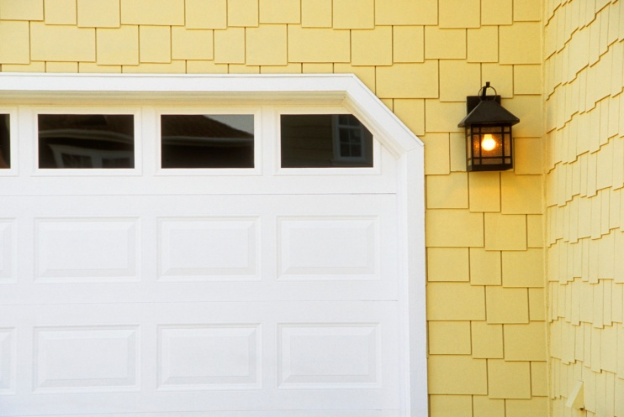

1. A thermistor is used in a switching circuit, as shown.

t

+ 14 V

M

0 V

The variable resistor is set to a value of 100 Ω and it is noted that the motor is off. The temperature of the thermistor is then increased.

1. What will be the voltage across the thermistor at the moment the motor turns on?
2. What will be the resistance of the thermistor at the moment the motor turns on?
3. The variable resistor is adjusted so that the motor turns on when the resistance of the thermistor is 2.85 kΩ. What is the resistance of the variable resistor?
4. Give a possible use for this circuit and explain how it would work.

**Electrical Power**

**Useful Equation:**

P =

E

t

where: P is the power of an electrical appliance (W)

E is the energy being used up by an electrical appliance (J)

t is the time that an appliance is turned on for (s)

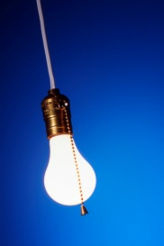

1. A student makes a statement:

*‘The power of a light bulb is 60 W.’*

What does this statement mean, in terms of energy?

1. Copy and complete this table:

|  |  |  |  |
| --- | --- | --- | --- |
|  | ***Power* / W** | ***Energy* / J** | ***Time* / s** |
| **(a)** |  | 800 | 10 |
| **(b)** |  | 5100 | 60 |
| **(c)** | 1500 |  | 30 |
| **(d)** | 1450 |  | 900 |
| **(e)** | 218 | 54 500 |  |
| **(f)** | 1500 | 210 000 |  |

1. What is the power of a radio that uses up 27 kJ of electrical energy in five minutes?
2. How much electrical energy is used up by a 725 W fridge in one day?
3. How long will it take a 1.2 kW vacuum cleaner to use up 720 kJ of electrical energy?
4. A 42 inch LED television has a power rating of 52 W when it is fully operational. When it is on standby, the television has a power rating of 0.8 W.



1. How much electrical energy will the television use if it is fully operational for 4 hours?
2. How much electrical energy will the television use if it is on standby for 10 hours?
3. Will the television use up more electrical energy being on standby for two days or being fully operational for 45 minutes?
4. The power consumption of three game consoles is given in the table.

|  |  |
| --- | --- |
| ***Games Console*** | ***Power Consumption* (W)** |
| Nintendo Wii | 14 |
| Playstation 3 | 85 |
| X Box 360 | 88 |

1. How much electrical energy will a Playstation 3 use up in 60 minutes?
2. How long, in hours, will it take an X Box 360 to use up 792 kJ of electrical

energy?

1. How much *less* energy does a Nintendo Wii use if it is played for half an hour,

compared to an X Box 360?

1. A hairdryer is connected to a joulemeter and the amount of energy used up every 60 seconds is observed. The results are shown in the table.

|  |  |
| --- | --- |
| ***Time* / s** | ***Energy Consumed* / J** |
| 0 | 0 |
| 60 | 78 000 |
| 120 | 156 000 |
| 180 | 234 000 |
| 240 | 312 000 |
| 300 | 390 000 |

Draw a line graph of energy consumed against time, and use the gradient of the straight line to calculate the power rating of the hairdryer.



**Power, Current and Voltage**

**Useful Equation:**

P = I V

where: P is the power of an electrical appliance (W)

I is the current flowing through an electrical appliance (A)

V is the voltage across an electrical appliance (V)

**Note:** *Mains voltage in the UK is 230 V.*

1. Copy and complete this table:

|  |  |  |  |
| --- | --- | --- | --- |
|  | ***Power* / W** | ***Current* / A** | ***Voltage* / V** |
| **(a)** |  | 0.3 | 4.5 |
| **(b)** |  | 1.5 | 12 |
| **(c)** | 750 |  | 25 |
| **(d)** | 1150 |  | 230 |
| **(e)** | 40 | 0.8 |  |
| **(f)** | 30 | 0.75 |  |

1. What is the power rating of a microwave that has a current of 3.3 A flowing through it when it is plugged in to the mains?
2. What is the current flowing through a 65 W laptop that has a potential difference of 18.5 V across it?
3. What is the voltage across a 6 W light bulb that has a current of 500 mA flowing through it?
4. Three 40 W light bulbs are connected in parallel with the mains power supply, as shown.

40 W

230 V

40 W

40 W

What is the current drawn from the mains?

1. In an American school laboratory, a pupil measures the current flowing through some different mains appliances with given power ratings. The results of this experiment are shown below:

|  |  |
| --- | --- |
| ***Power Rating of Appliance* / W** | ***Current* / A** |
| 100 | 0.91 |
| 250 | 2.27 |
| 400 | 3.64 |
| 600 | 5.45 |
| 800 | 7.27 |
| 1250 | 11.36 |

Construct a line graph of power against current, and use the gradient of the straight line to calculate mains voltage in the USA.



**Fuses**

1. What is the purpose of a fuse in the plug of a mains appliance?
2. Why is it not safe to use a 13 A fuse in the plug of a 350 W mains appliance?
3. What will happen if a 3 A fuse is connected in the plug of a 800 W mains appliance?
4. Why will a 350 W vacuum cleaner require a 13 A fuse, even though its normal operating current is less than 3 A?

*The answer to each of the following questions is one of these fuse sizes:*

13 A

10 A

5 A

3 A

1. Show, by calculation, what size of fuse is best suited for a 200 W mains electric blanket?
2. Show, by calculation, what size of fuse is best suited for a 1200 W mains toaster?
3. Show, by calculation, what size of fuse is best suited for a 2500 W mains oven?
4. Show, by calculation, what size of fuse is best suited for a 1000 W mains iron?



**Power and Resistance**

**Useful Equation:**

P = I2 R

where: P is the power of an electrical component (W)

I is the current flowing through an electrical component (A)

R is the resistance of an electrical component (Ω)

1. Combine the equations P = IV and V = IR in order to derive the equation, P = I2 R.
2. Copy and complete this table:

|  |  |  |  |
| --- | --- | --- | --- |
|  | ***Power* / W** | ***Current* / A** | ***Resistance* / Ω** |
| **(a)** |  | 1.5 | 100 |
| **(b)** |  | 0.8 | 50 |
| **(c)** | 500 |  | 125 |
| **(d)** | 34 |  | 850 |
| **(e)** | 735 | 7.0 |  |
| **(f)** | 36 | 0.06 |  |

1. What is the power rating of a lamp that has a resistance of 5 Ω and a current of 1.2 A flowing through it?



1. What is the current flowing through a 50 Ω heating element in a toaster if it has a power rating of 800 W?
2. What is the resistance of a 1200 W electric convection heater that has a current of 5.0 A flowing through it?

**Useful Equation:**

P =

V2

R

where: P is the power of an electrical appliance (W)

V is the voltage across an electrical component (V)

R is the resistance of an electrical component (Ω)

1. Combine the equations P = IV and I = V / R to derive the equation P = V2 / R.
2. Copy and complete this table:

|  |  |  |  |
| --- | --- | --- | --- |
|  | ***Power* / W** | ***Voltage* / V** | ***Resistance* / Ω** |
| **(a)** |  | 10 | 5 |
| **(b)** |  | 6 | 72 |
| **(c)** | 25 |  | 9 |
| **(d)** | 1.8 |  | 20 |
| **(e)** | 20 | 20 |  |
| **(f)** | 400 | 230 |  |

1. What is the power rating of a mains television that has a resistance of 529 Ω?



1. What is the voltage across a portable electric shaver that has a resistance of 2.45 Ω and a power rating of 20 W?
2. What is the resistance of an 800 W mains powered coffee machine?



1. A 130 W tropical fish aquarium is connected to the mains.
2. What is the resistance of the aquarium?
3. What is the current flowing through the aquarium?
4. How much energy is used up by the aquarium in 24 hours?
5. A hairdryer has three heat settings: *cold*, *warm* and *hot*. The hairdryer is made up of two 300 Ω resistors and a 50 Ω motor that are connected in parallel with the mains supply, as shown.

50 Ω

300 Ω

300 Ω

230 V

S1

S2

S3

1. What is the energy change that occurs when current flows through a resistor?
2. Which switches are closed when the hairdryer is blowing out warm air?
3. How much current is drawn from the mains when the hairdryer is blowing out cold air?
4. What is the power rating of the hairdryer when it is blowing out cold air?
5. What is the total resistance of the hairdryer when it is blowing out hot air?
6. What is the power rating of the hairdryer when it is blowing out hot air?
7. How much electrical energy will the hairdryer use if it blows cold air for 1 minute and hot air for 8 minutes?
8. Why is it useful that electricity flows through transmission lines at a very high voltage?
9. Wires used in transmission lines have a resistance of 0.0025 Ω/m. How much power is lost by transmission lines carrying a current of 12 A if the length of the lines are:
10. 1 m?



1. 30 m?
2. 2.5 km?

**Specific Heat Capacity**

**Useful Equation:**

Eh = c m ΔT

where: Eh is the heat energy absorbed by a material (J)

c is the specific heat capacity of a material (J / kg °C)

m is the mass of a material (kg)

ΔT is the change in temperature of a material (°C)

1. What is the difference between heat and temperature?
2. What is meant by the following statement:

“The specific heat capacity of water is 4180 J / kg °C.”

1. Copy and complete this table:

|  |  |  |  |  |
| --- | --- | --- | --- | --- |
|  | ***Heat Energy* / J** | ***Specific Heat Capacity / J* / kg °C** | ***Mass* / kg** | ***Change in Temperature* / °C** |
| **(a)** |  | 2350 | 2.0 | 10 |
| **(b)** |  | 902 | 5.0 | 25 |
| **(c)** | 36 900 |  | 4.5 | 2 |
| **(d)** | 6885 |  | 0.75 | 34 |
| **(e)** | 10 080 | 2100 |  | 12 |
| **(f)** | 105 600 | 480 |  | 40 |
| **(g)** | 2400 | 128 | 2.5 |  |
| **(h)** | 27 690 | 2130 | 3.25 |  |

1. What is the heat energy required to heat 3.0 kg of water from 20 °C to 80°C?
2. A 2.4 kg lump of brass is heated up by a Bunsen burner. When 9120 J of heat energy has been absorbed, the temperature of the brass increases by 10 °C. What is the specific heat capacity of the brass?



1. A pane of glass has a mass of 800 g. What is the temperature change of the glass if it is heated by 1000 J of heat energy?

1. A block of lead is heated from 24 °C to 28°C by a heat source that gives off 6144 J of heat energy. What is the mass of the lead block?
2. In an experiment, a 2 kg block of copper is warmed with a 70 W electrical immersion heater. The temperature of the copper is measured every minute using a thermometer. The heat energy used is calculated by finding the power of the heater and using E = P t. The results are shown.

Thermometer

Heater

Copper

|  |  |
| --- | --- |
| ***Heat Energy /* J** | ***Change In Temperature* / °C** |
| 0 | 0 |
| 4 200 | 3.4 |
| 8 400 | 6.8 |
| 12 600 | 10.2 |
| 16 800 | 13.6 |
| 21 000 | 17.0 |

1. Using *this data*, draw a line graph and use the gradient of the straight line to find the specific heat capacity of copper.
2. Is this experimental value for the specific heat capacity of copper larger, smaller or the same as the actual value? Explain any difference.

**Heat Transfer**

1. Describe how heat travels through a material by:
2. Conduction.
3. Convection.
4. Radiation.
5. Why will a cup of coffee with a temperature of 80 °C cause more damage when in contact with human skin than a spark from a sparkler with a temperature of 1600 °C?

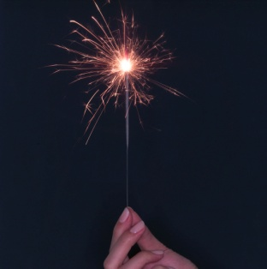

1. Why will a tomato feel colder than melted cheese in a hot cheese and tomato toastie?
2. Describe, by referring to heat transfer by conduction, convection and radiation, how the clothing of a fire fighter is designed to help them do their job.

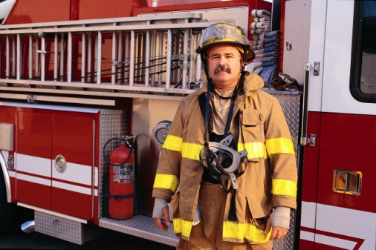

1. Describe how a central heating boiler can be made more efficient by stopping heat transfer by conduction, convection and radiation.



**Pressure**

**Useful Equation:**

P =

F

A

where: P is the pressure applied to a surface (Pa or N/m2)

F is the force applied to a surface (N)

A is the area of a surface that a force is being applied to (m2)

1. What is the meaning of the term ‘pressure’ in terms of force and area?
2. Copy and complete this table:

|  |  |  |  |
| --- | --- | --- | --- |
|  | ***Pressure* / Pa** | ***Force* / N** | ***Area* / m2** |
| **(a)** |  | 120 | 1.6 |
| **(b)** |  | 4000 | 0.5 |
| **(c)** | 1.1 x 105 |  | 2.0 |
| **(d)** | 9000 |  | 8.0 x 10-2 |
| **(e)** | 12 000 | 7.2 x 105 |  |
| **(f)** | 1.4 x 104 | 4.9 x 104 |  |

1. A 480 g tin of baked beans is a cylinder with a radius of 3.2 cm. It is placed on a kitchen counter. What is the pressure on the counter caused by the tin?
2. A car of mass 1250 kg is driven on to a bridge. The pressure on the surface of the bridge when all four tyres are on the ground is 39.0 kPa. What is the contact area of *one* tyre on the bridge?
3. A television has a length of 124 cm, a height of 93 cm and a depth of 7.0 cm.

124 cm

93 cm

8.0 cm

If it has a mass of 30 kg, what is the:

1. Maximum pressure that the television can exert on a surface?
2. Minimum pressure that the television can exert on a surface?
3. By measuring your weight and the area of your feet, calculate the pressure that you exert on the floor when:
4. You are standing normally.
5. You are standing on one foot.
6. Are you more likely to fall through an icy lake if you are on your tip toes or lying flat on your back with your arms and legs stretched out? Explain your answer.
7. In an experiment, a mass of 100 g (which has a weight of 1N) is placed on top of a syringe filled with trapped air. A Bourdon Gauge is used to measure the air pressure inside the syringe. This is then repeated for different masses. The results are given in the table.

|  |  |
| --- | --- |
| ***Force /* N** | ***Pressure* / x 105 Pa** |
| 0 | 1.01 |
| 1 | 1.03 |
| 2 | 1.05 |
| 3 | 1.07 |
| 4 | 1.09 |
| 5 | 1.11 |

Bourdon Gauge

Mass

Syringe

Trapped Air

Use this data to construct a line graph of force against change in pressure, and use the gradient of the straight line to calculate the surface area of the syringe plunger inside the syringe.

**Gas Laws**

**Useful Equation:**

= constant

P V

T

where: P is the pressure caused by a fixed mass of a gas (Pa or N/m2)

V is the volume of a fixed mass of gas (m3)

T is the temperature of a fixed mass of gas (K)

1. Explain, using the kinetic theory of particles, what happens to the particles in a liquid when it melts and becomes a gas.

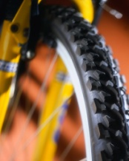

1. Explain, using kinetic theory, how the air in a bicycle tyre creates pressure on the inside surface of the tyre.
2. Why does the Kelvin temperature scale start at -273 °C?
3. Convert these temperatures from degrees Celsius to Kelvin.
4. 0 °C



1. 20 °C
2. -273 °C
3. 100 °C
4. A conical flask is sealed with air inside, and is placed in a heat bath. The temperature of the gas increases from 20 °C to 70°C. After every 10 °C temperature increase, the pressure of the gas is measured using a Bourdon gauge. The results are shown.

|  |  |
| --- | --- |
| ***Temperature /* °C** | ***Pressure* / x 105 Pa** |
| 20 | 1.01 |
| 30 | 1.04 |
| 40 | 1.08 |
| 50 | 1.11 |
| 60 | 1.15 |
| 70 | 1.18 |

Bourdon Gauge

Thermometer

Heat Bath

Air

1. Using the data, draw a line graph of pressure against temperature (in degrees Celsius). Make sure that your temperature axis goes from -300 °C to 70 °C.
2. On your graph from part (a), continue your straight line back until it crosses through the x-axis. At what temperature is the pressure of the gas zero?
3. Using the data, draw a line graph of pressure against temperature (in Kelvin).
4. What do these two graphs tell you about the relationship between the pressure and temperature of a fixed mass of gas?
5. Explain this relationship in terms of the kinetic theory of particles.
6. Explain, using the appropriate gas law, why it is important that car tyres are not filled up with so much air that the air pressure is above the car manufacturer’s guidelines?



1. At a temperature of 20 °C, the pressure of a fixed mass of gas in a sealed container is found to be 104 kPa. The gas is heated to a uniform temperature of 90 °C using a heat bath.

What is the pressure of the gas at a temperature of 90 °C?

1. The pressure of the air in a lorry tyre is found to be 2.58 x 105 Pa at the end of a journey.

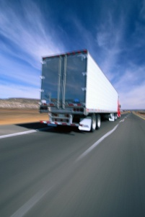

Once the tyre has cooled down, the temperature of the air inside the tyre is found to be 10 °C with the pressure decreasing to 2.41 x 105 Pa.

What was the temperature of the air in the tyre at the end of the journey? Give your answer in degrees Celsius.

1. In an experiment, the volume of a fixed mass of gas is decreased by trapping the gas at the top of a glass tube with a quantity of oil and then using a pump to push the oil up the tube.

The pressure of the gas is measured with a Bourdon gauge and the volume of gas is measured using a calibrated scale next to the glass tube. The results are shown.

Pump

Fixed Mass of Gas

Bourdon Gauge

Oil

|  |  |
| --- | --- |
| ***Volume / cm3*** | ***Pressure* / x 105 Pa** |
| 1.5 | 1.57 |
| 1.6 | 1.48 |
| 1.7 | 1.39 |
| 1.8 | 1.31 |
| 1.9 | 1.24 |
| 2.0 | 1.18 |

1. Using the data, draw a line graph of volume against 1 / pressure.
2. What does this graph tell you about the relationship between the volume and pressure of a fixed mass of gas?
3. Explain this relationship in terms of the kinetic theory of particles.
4. Explain, using the appropriate gas law, why a balloon will burst if you squeeze it.



1. A 5 cm3 syringe is filled with air and the pressure of the air is found to be 1.01 x 105 Pa. The syringe plunger is then pushed until there is 3 cm3 of air. What is the new air pressure?



1. A scuba diving air tank has a volume of 7.5 litres and is filled with air at a pressure of 1.21 x 107 Pa. What volume of air will be released by the tank at atmospheric pressure (1.01 x 105 Pa)?
2. In an experiment, an open capillary tube with a mercury thread is placed in to a heat bath.

As the temperature of the gas increases, the mercury thread moves up the capillary tube. The pressure of the gas remains constant because the capillary tube is open.

The temperature of the gas is measured with a thermometer and the volume of the gas is measured using a scale next to the open capillary tube. The results of the experiment are shown.

|  |  |
| --- | --- |
| ***Temperature / °C*** | ***Volume* / cm3** |
| 20 | 1.50 |
| 25 | 1.88 |
| 30 | 2.25 |
| 35 | 2.63 |
| 40 | 3.00 |
| 45 | 3.38 |

Open Capillary Tube

Thermometer

Heat Bath

Mercury Thread

1. Using the data, draw a line graph of volume against temperature (in degrees Celsius). Make sure that your temperature axis goes from -300 °C to 45 °C.
2. Using the data, draw a line graph of volume against temperature (in Kelvin).
3. What do these two graphs tell you about the relationship between the volume and temperature of a fixed mass of gas?
4. Explain this relationship in terms of the kinetic theory of particles.
5. The volume of a fixed mass of gas is 30.0 cm3 at 30 °C. The temperature of the gas is increased to 60 °C without changing the pressure.

A student makes this statement:

‘*As the temperature of the gas has doubled, the volume of the gas will also double. Therefore, the volume of the gas at 60 °C will be 60.0 cm3*.’

1. Explain why this statement is incorrect.
2. Calculate what the volume of the gas would actually be at 60 °C.
3. Air is trapped in a glass capillary tube by a bead of mercury. The volume of air is found to be 0.15 cm3 at a temperature of 27 °C.

Assuming that the pressure of the air remains constant, what is the volume of the air at a temperature of 87 °C?

1. A fixed mass of gas is trapped in to a syringe. The gas has a pressure of 1.63 x 105 Pa when it has a volume of 3.0 cm3 and a temperature of 22 °C.

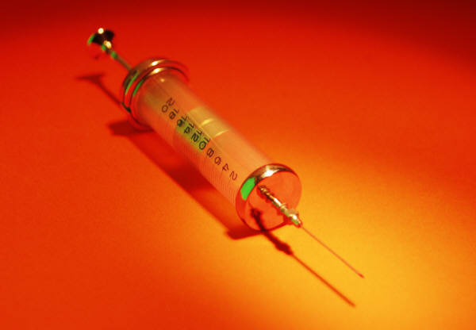

The gas is then heated until it has a uniform temperature of 57 °C. What will be the pressure of the gas if the volume of the gas is increased to 5.0 cm3?

**Answers**

**Weight (p4 – 5)**

1. *Mass* is a measure of how much of an object is there. It is measured in kg.

*Weight* is a downward force caused by gravity.

It is measured in N.

1. **(a)** 30 N
2. 2.25 N
3. 30 kg
4. 30 kg
5. 8 N/kg
6. 26 N/kg
7. **(a)** 30 N
8. 1 N
9. 650 N
10. 12 000 N
11. The weight of the space shuttle *decreases*.

This is because:

* There is less mass due to fuel being used up.
* The shuttle is getting further away from the surface of the Earth.

1. 85 kg
2. **(a)** 372 N
3. 2418 N
4. 372 N
5. 0 N
6. 75 kg
7. Saturn
8. **(a)** 13 N/kg
9. Person pushes down on scales. Scales push back up on person.

**Work Done (p6 – 7)**

1. Work done is the energy transferred to an object.
2. **(a)** 3000 J
3. 155 J
4. 2000 N
5. 20 N
6. 10 m
7. 45 m
8. 16 800 J
9. 300 N
10. 40 m
11. 3 x 107 J
12. 25 km
13. 7890 N
14. 6960 J
15. 4.5 N

**Gravitational Potential Energy (p8 – 9)**

1. Gravitational potential energy is the work done in moving an object from the ground to a certain height.
2. **(a)** 60 J
3. 3750 J
4. 5 kg
5. 8.5 kg
6. 7 N/kg
7. 26 N/kg
8. 45 m
9. 1500 m
10. **(a)** 520 N
11. 4680 J
12. 4680 J
13. 6.75 J
14. 6.75 J
15. 54 kg
16. 150 m
17. **(a)** 4 N/kg
18. Mercury or Mars

**Kinetic Energy (p10 – 11)**

1. Mass, Speed
2. **(a)** 27 J
3. 729 J
4. 900 kg
5. 6 kg
6. 8 m/s
7. 0.8 m/s
8. 3384 J
9. 0.1 kg
10. 150 m/s
11. **(a)** 31.3 m/s
12. 587 000 J (to 3 s.f.)
13. **(a)** to reduce frictional forces so that the speed of the trolley won’t drop as much as it moves along the air track.

**(b**) 0.008 J (approximately)

**Conservation of Energy – Falling Objects (p12 – 13)**

1. **(a)** 0.513 J
2. 0.513 J
3. 4.24 m/s
4. 14.1 m/s
5. **(a)** 0.69 J
6. 5.48 m/s
7. 5.48 m/s
8. **(a)** 224 m/s
9. Air resistance is slowing the skydiver down.
10. **(a)** 1.6 J
11. 3.2 m
12. **(a)** 810 000 J
13. 600 000 J
14. 210 000 J
15. 9.2 m/s
16. 1.96 m/s
17. 21.4 m/s

**Efficiency (p14 – 15)**

1. **(a)** Electrical → Light
2. Electrical → Heat
3. Gravitational Potential → Kinetic
4. Light → Electrical
5. Electrical → Sound
6. **(a)** Chemical → Heat
7. Kinetic → Electrical
8. Water is stored in a high reservoir behind a dam.

The water is released through the dam in to a low level reservoir.

The gravitational potential energy of the water is turned in to kinetic energy, which turns turbines which generate electricity.

1. Heat energy is lost to the surroundings in many places (boiler, etc.)
2. **(a)** 25 kJ
3. 16 250 J
4. Missing energy is lost as heat and sound energy to the surroundings.
5. **(a)** 60 %
6. 5 %
7. 2795 J
8. 12 160 000 J
9. 108 000 J
10. 4 875 000 J
11. 35 %
12. 486 J
13. **(a)** Electrical → Sound
14. 5488 J
15. 6 240 000J
16. 792 000 J

**Electrical Charge (p16 – 17)**

**(a)**

+

+

**(b)**

-

-

**(c)**

+

-

**(d)**

+

0

1. The image of the document is projected on to a positively charged copying plate.

Where light is incident on the plate, charge leaks away.

The negatively charged toner particles are attracted to the remaining positive areas.

Paper is placed over the copying plate.

The toner is transferred to the paper and sticks after heating.

1. ‘Fluffing up’ a static duster causes it to become charged. This attracts charged particles to the duster.
2. **(a)** The droplets of paint have the same charge so spread out more when sprayed. This keeps the coat of paint even.
3. The car body has an opposite charge so paint drops that would miss are attracted to it.
4. **(a)** When you unroll cling film, negative charges (electrons) from one layer get pulled across to the other.

This creates patches of positive and negative charges.

1. The plastic bowl is an electrical insulator.

The negative charges can flow through the conducting metal bowl and away from the cling film.

1. **(a)** Air and dust particles enter the precipitator through a negatively charged metal grid.

The dust particles can be charged but the air particles can’t.

Dust particles are then attracted to positively charged plates.

This only leaves air particles leaving the precipitator.

1. Fossil fuel power stations can clean their emissions so less smoke is released in to the atmosphere.

**Electrical Current (p18 – 19)**

1. Electrical current is a flow of electrons. It is the amount of charge that flows through a component in one second.
2. **(a)** 15 C
3. 3.5 C
4. 0.28 A
5. 2.5 A
6. 5 s
7. 900 s
8. 1950 C
9. 0.38 A
10. 210 s
11. Alternating current constantly changes direction.

Direct current only flows in one direction – from negative to positive.

1. **(a)** Alternating current
2. Direct current
3. **(a) (i)** 6V **(ii)** 50 Hz
4. **(i)** 3 V **(ii)** 100 Hz

**Charges in Electric Fields (p20)**

**(a)**

+

**(b)**

-

**(c)**

-

+

**(d)**

-

+

**(a)**

-

+

**(b)**

-

+

+

**(c)**

-

1. **(a)** Y **(b)** Z **(c)** X

**Series Circuits (p21 – 22)**

1. **(a)** I1 = 0.4 A, I2 = 0.4 A
2. I1 = 6.5 A, I2 = 6.5 A
3. **(a)** 0.9 V
4. 3.5 V
5. **(a)** 5400 J
6. 9000 J
7. **(a)** V1 = 4.5 V, V2 = 4.5 V
8. **(a)** V = 3 V

I1 = 1.6 mA, I2 = 1.6 mA, I3 = 1.6 mA

1. V = 0.75 V

I1 = 0.5 A, I2 = 0.5 A,

I3 = 0.5 A

**Parallel Circuits (p23 – 24)**

1. **(a)** 0.05 A
2. I1 = 0.9 A, I2 = 0.9 A
3. **(a)** 2.5 V
4. 15 V
5. I1 = 0.29 A, I2 = 0.29 A
6. **(a)** V1 = 12 V, V2 = 12 V

I1 = 1.5 A, I2 = 0.5 A,

I3 = 1.0 A, I4 = 1.0 A,

I5 = 1.5 A

1. V1 = 1.5 V, V2 = 1.5 V,

V3 = 1.5 V

I1 = 0.15 A, I2 = 0.15 A,

I3 = 0.15 A, I4 = 0.15 A,

I5 = 0.30 A

1. **(a)** Advantage – easy to set

up. Less wiring.

Disadvantage – if one lamp blows, all lamps turn off.

1. Advantage – if a lamp blows, the rest stay on.

Disadvantage – high current, difficult to set up.

1. Advantage – if a lamp blows, the rest stay on. Low current.

Disadvantage – Difficult set up.

**Mixed Circuits (p25)**

1. I1 = 0.08 A, I2 = 0.16 A,

I3 = 0.16 A, I4 = 0.24 A,

1. V1 = 0.75 V, V2 = 0.75 V,

V3 = 1.5 V

1. V1 = 4 V, V2 = 4 V,

V3 = 4 V, V4 = 4V.

I1 = 1.1 A, I2 = 1.1 A,

I3 = 1.1 A, I4 = 1.1 A,

I5 = 2.2 A

**Ohm’s Law (p26 – 27)**

1. Resistance is a component’s opposition to current.
2. Voltage is the energy gained or lost by a (coulomb of) charge flowing through a component.
3. **(a)** 60 V
4. 2 V
5. 0.2 A
6. 0.02 A
7. 46 Ω
8. 125 Ω
9. 200 Ω
10. 0.0015 A
11. 230 V
12. 4.5 Ω
13. The resistance of the lamp changes as the tungsten filament changes temperature.

**Variable Resistors (p28)**

1. A resistor decreases the current flowing in a circuit.
2. A fixed-value resistor can only have one value.

A variable resistor can have a range of values.

1. **(a)** 0.01 A
2. 0.002 A
3. **(a)** 20 Ω

**(b)** 2000 Ω

**Solar (Photovoltaic) Cells (p29)**

1. Light → Electrical
2. As more light is incident, the voltage generated by a solar cell increases.
3. A graph of 1/V2 against d will give a straight line.

*1 / V2* / V-2

0

*d* / cm

**Capacitors (p30)**

1. A capacitor stores energy / charge.
2. **(a)** 0 V
3. 6 V
4. 0V

*V* / V

0

*t* / s

6 V

1. Increase the value of resistor, R, or increase the value of the capacitor, C.
2. **(a)**

*V* / V

0

*t* / s

6 V

1. Decrease the value of resistor, R, or decrease the value of capacitor, C.

**LEDs (p31)**

1. A diode is an electrical component that only allows current to flow in one direction through it.
2. Electrical → Light
3. Advantages: Less current, Less heat given off.

Disadvantage: Not as bright.

1. **(a)** The resistor protects the LED from being damaged by a high current.
2. 2800 Ω
3. B only.

**Thermistors & LDRs (p32 – 33)**

1. As temperature increases, resistance decreases.
2. As temperature increases, current increases.
3. Any value greater than 5700 Ω.

*R* / Ω

0

*T* / °C

1. As brightness of light increases, the resistance decreases.
2. As brightness of light increases, the current increases.
3. Any resistance greater than 3.3 kΩ.

I / A

0

*Luminosity* / lux

**Resistors in Series (p34)**

1. As more resistors are connected in series, the total resistance increases.
2. **(a)** 245 Ω
3. 950 Ω
4. 830 Ω
5. 625 Ω
6. **(a)** 550 Ω
7. 6390 Ω

**Resistors in Parallel (p35)**

1. As more resistors are connected in parallel, the total resistance decreases.
2. **(a)** 20 Ω
3. 30 Ω
4. 600 Ω
5. 150 Ω
6. **(a)** 40 Ω
7. 300 Ω

**Resistors in Mixed Circuits (p36 – 38)**

1. **(a)** 44 Ω
2. 30 Ω
3. 75 Ω
4. 600 Ω
5. 45 Ω
6. **(a)** 108 Ω
7. 12 Ω
8. 54 Ω
9. 24 Ω

(b) Is the lowest resistance

1. 400 Ω

**(a)**

**(b)**

**(c)**

**(d)**

**(e)**

**(f)**

**Voltage Dividers (p39 – 41)**

1. As its resistance increases, voltage across a resistor also increases.
2. As resistance increases, electrons will lose more energy as they pass through the resistor. Therefore, the voltage across the resistor will increase.
3. **(a)** 125 Ω
4. 225 Ω
5. 1.2 kΩ
6. **(a)** 250 Ω
7. 300 Ω
8. 40 Ω
9. **(a)** 3 V
10. 3V
11. 0.5 V
12. **(a)** 3.8 V
13. 1.0 V
14. 0.6 V
15. **(a)** V1 = 6 V, V2 = 6 V
16. V1 = 4 V, V2 = 10 V
17. V1 = 7 V, V2 = 3 V
18. V1 = 16 V, V2 = 6 V
19. V1 = 4.5 V, V2 = 13.5 V
20. V1 = 5.5 V, V2 = 3 V

**Switching Circuits (p42 – 47)**

1. **(a)** 0V
2. 15 V
3. 15 V
4. 0V
5. **(a)** 4V
6. 8 V
7. 0 V
8. 12 V
9. **(a)** 700 Ω
10. 3.5 V
11. 2.5 V
12. 3 V
13. 100 °C
14. **(a)** 6 V
15. 2.5 V
16. 0.016 A
17. **(a)** (NPN) Transistor
18. As the temperature increases, the resistance of the thermistor decreases.

The voltage across the thermistor decreases and the voltage across R1 increases.

When this voltage reaches 0.7 V, the transistor switches on and the LED lights.

1. Swap the positions of the thermistor and R1.
2. **(a)** MOSFET
3. As brightness of light decreases, the resistance of the LDR increases.

The voltage across the LDR increases.

When this reaches a high enough voltage, the MOSFET switches on and the lamp lights.

1. The brightness at which the lamp turns on can be altered.
2. **(a)** 13.3 V
3. 1900 Ω
4. 150 Ω
5. This circuit could turn on a fan when a computer overheats.

As the temperature increases, the resistance of the thermistor decreases.

The voltage across the thermistor decreases and the voltage across R1 increases.

When this voltage reaches 0.7 V, the transistor switches on and the LED lights.

**Electrical Power (p48 – 50)**

1. The light bulb uses up 60 J of electrical energy every second.
2. **(a)** 80 W
3. 85 W
4. 45 000 J
5. 1 305 000 J
6. 250 s
7. 140 s
8. 90 W
9. 62 640 000 J
10. 600 s
11. **(a)** 748 800 J
12. 28 800 J
13. Standby = 138 240 J

Full Power = 140 400 J

Full power for 45 minutes uses up more energy.

1. **(a)** 306 000 J
2. 2.5 hours
3. 158 400 – 25 200

= 133 200 J

1. 1300 W

**Power, Current & Voltage (p51 – 52)**

1. **(a)** 1.35 W
2. 18 W
3. 30 A
4. 5 A
5. 50 V
6. 40 V
7. 759 W
8. 3.5 A
9. 12 V
10. 0.52 A
11. 110 V (approximately)

**Fuses (p53)**

1. The fuse protects the *flex* of an appliance from damage due to a high current.
2. If a fault occurs, the current can get much higher than is safe (up to 13 A). This can cause dangerous overheating of the flex.
3. The fuse will blow as the current is greater than 3 A.
4. The current is above 3A when the vacuum is turned on although the current drops below 3A when it is in normal operation. More current is required to start the motor.
5. 3 A fuse (I = 0.87 A)
6. 10 A fuse ( I = 5.2 A)
7. 13 A fuse (I = 10.9 A)
8. 5A fuse (I = 4.35 A)

**Power & Resistance (p54 – 57)**

1. P = I V

P = I x IR

**P = I2 R**

1. **(a)** 225 W
2. 32 W
3. 2 A
4. 0.2 A
5. 15 Ω
6. 10 000 Ω
7. 7.2 W
8. 4 A
9. 48 Ω
10. P = I V

P = (V/R) x V

**P = V2 / R**

1. **(a)** 20 W
2. 0.5 W
3. 15 V
4. 6 V
5. 20 Ω
6. 132.25 Ω
7. 100 W
8. 7 V
9. 66 Ω
10. **(a)** 407 Ω
11. 0.57 Ω
12. 11 232 000 J
13. **(a)** Electrical → Heat
14. S1 and S2
15. 4.6 A
16. 1058 W
17. 37.5 Ω
18. 1411 W
19. 63 480 + 677 280 =

740 760 J

1. High current in transmission lines results in high energy loss. Using high voltages reduces the current in transmission lines and therefore reduces energy loss.
2. **(a)** 0.36 W
3. 10.8 W
4. 900 W

**Specific Heat Capacity**

**(p58 – 59)**

1. Heat is a form of energy.

Temperature is a measure of how hot or cold an object is.

1. 4180 J of heat energy is needed to change the temperature of 1 kg of water by 1 °C.
2. **(a)** 47 000 J
3. 112 750 J
4. 4100 J / kg °C
5. 270 J / kg °C
6. 0.4 kg
7. 5.5 kg
8. 7.5 °C
9. 4 °C
10. 752 400 J
11. 380 J / kg °C
12. 2.5 °C
13. 12 kg
14. **(a)** 618 J / kg °C
15. The experimental value is larger. This is because not all heat energy is absorbed by the copper block.

**Heat Transfer (p60)**

1. **(a)** Heat energy is

transferred by vibrations of particles that are in contact with each other.

1. Particles that are heated rise while particles that have cooled fall. There must be space between particles for this to happen.
2. Heat energy travels in straight lines in the form of electromagnetic radiation. No particles are required for heat to be transferred by radiation.
3. Despite having a lower temperature, a cup of coffee has more heat energy than a single spark from a sparkler.
4. The tomato has a higher specific heat capacity. More heat energy is required to change its temperature.
5. Fire fighting clothing is made of a substance that is fire resistant and a poor conductor of heat.

The clothing is insulated using trapped air which prevents heat transfer from surroundings.

Reflective panels are used for added visibility but also reflect heat radiation.

1. Conduction: a fabric insulating cover on the outside of the boiler prevents heat loss.

Convection: The top of the boiler is air-tight to prevent heat loss.

Radiation: The interior (or exterior) of the boiler can be coated with a reflective material (such as foil) to prevent heat loss.

**Pressure (p61 – 62)**

1. Pressure is the force applied to an area of a surface.
2. **(a)** 75 Pa
3. 8000 Pa
4. 220 000 N
5. 720 N
6. 60 m2
7. 3.5 m2
8. 149 Pa
9. 0.08 m2
10. **(a)** 4032 Pa
11. 260 Pa
12. **(a)** Answer depends on

student.

*P* / Pa

0

*T / °C*

-273

1. Answer depends on student.
2. A person is more likely to fall through an icy lake on tip-toes.

The area of contact with the ice is low, so the pressure on the ice will be high.

1. 0.0005 m2

**Gas Laws (p63 – 67)**

1. When a particle is heated, it vibrates. If it is heated enough, the particle will vibrate enough to break free from surrounding particles. This turns a substance from a liquid to a gas.
2. The particles in the air are moving around all the time. When the air particles collide with the inside surface of the tyre, they impart a force and, therefore, a pressure is created.
3. -273 °C is the temperature at which particles stop vibrating and so, as a result, it’s the coldest possible temperature.
4. **(a)** 273 K
5. 293 K
6. 0 K
7. 373 K
8. **(a) and (b)**

0

*T* / K

*P* / Pa

1. Pressure is directly proportional to temperature (in Kelvin).
2. As temperature increases, the particles in the gas gain kinetic energy.

Therefore, they collide with the sides of the container more often and with more force.

This results in a pressure increase.

1. As the tyre heats up during travel, the air particles inside will collide with the inside surface of the tyre more often and with more force.

If the pressure gets too high, the tyre could burst.

1. 129 kPa
2. 30 °C
3. **(a)**

0

*V / cm3*

*1 / P*

1. Pressure is inversely proportional to volume.
2. As the volume of a gas increases, the particles will hit the sides of a container less often so the pressure decreases.
3. If a balloon is squeezed, the volume of the air inside decreases. Therefore, the pressure of the gas increases and the balloon could burst.
4. 1.68 x 105 Pa
5. 899 Pa
6. **(a)**

*V* / cm3

0

*T / °C*

-273

0

*T* / K

*V* / cm3

1. Volume is directly proportional to temperature (in Kelvin).
2. As temperature increases, the kinetic energy of gas particles will increase.

If the pressure is to be kept constant, the volume of the gas must increase to ensure that the gas particles collide with the sides of the container at the same rate.

1. **(a)** The statement is

incorrect because the student has doubled temperature in degrees Celsius instead of Kelvin.

1. 33.0 cm3
2. 0.175 cm3
3. 1.09 x 105 Pa