Dynamics & Space
Cosmology
Summary

The Universe consists of many galaxies separated by empty space.
A galaxy is a large cluster of stars (e.g. the Milky Way).
A star is a large ball of matter that is undergoing nuclear fusion and emitting light. The Sun is a star (as are Sirius, Rigel and Proxima Centauri).
A planet is a large ball of matter (rounded by its own gravity) that orbits a star (e.g. Earth or Jupiter). Planets do not emit light themselves.
The Sun and many other stars have a solar system. A solar system consists of a central star orbited by planets. Planets orbiting stars other than the Sun are known as exoplanets.
Many planets have moons. A moon is a lump of matter that orbits a planet (e.g. the Moon orbits the Earth and Deimos and Phobos orbit Mars).

The Universe is thought to have begun in an event, known as the Big Bang, around 13·8 billion years ago when all matter, and even space and time itself, came into existence. The universe began at a single point in space-time, known as a singularity; since then the universe has expanded and (according to observations) will continue to expand.

Distances in space are so enormous that we use units known as light-years to measure them. A light-year (ly) is the distance travelled by light in one year (around 9·5 × 10¹⁵ m).
For example: Proxima Centauri (the nearest star, apart from the Sun) is 4·3 light-years away; our galaxy (the Milky Way) is around 100 000 light-years across and the next nearest spiral galaxy (Andromeda) is 2·5 million light-years away.

Our current understanding of the Universe comes from observations of it using telescopes.
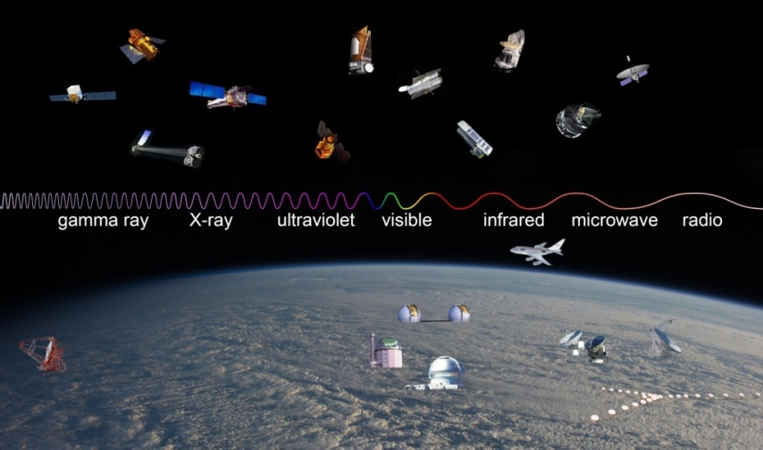
Today we use telescopes which cover all parts of the electromagnetic spectrum to investigate astronomical objects:
Part of Spectrum | Examples of telescopes | Observations made
radio | Arecibo  Joddrell Bank  Very Large Array (VLA) | - discovery of pulsars and quasars  - studying plasma clouds  - studying the Sun’s magnetic field
microwaves | Holmdel Horn Antenna  Cosmic Background Explorer (COBE) | - the existence of cosmic microwave background radiation – evidence of the Big Bang
infrared | Spitzer  Herschel | - studying nebulae, gas clouds and the formation of stars  - identification of exoplanets
visible light | Hooker  Kepler  Very Large Telescope (VLT)  Hubble Space Telescope | - observations of galactic redshift – evidence of the expanding Universe  - imaging planets, stars and galaxies
ultraviolet | Galaxy Evolution Explorer (GALEX) | - studying star formation  - measurement of distances to distant galaxies
X-rays | Solar and Heliospheric Observatory (SOHO) Chandra | - studying the Sun’s atmosphere  - studying supernovae
gamma rays | Fermi | - evidence of supermassive black holes at centres of galaxies  - studying gamma ray bursts – probably due to hypernovae
e.g.

One of the techniques used in astronomy is spectroscopy
A complete (continuous) spectrum is made up of all the colours of the spectrum (red, orange, yellow, green, blue, indigo and violet).
A line spectrum consists of a complete (continuous) spectrum with certain colours missing which appear as black line in the spectrum. Every element produces a unique line spectrum.
Studying line spectra allows the elements present in a light source (e.g. a star) to be identified. This can allow the type, distance, age or speed of a star to be identified.

