St Ninian’s High School
National 5 Dance

Name……………………………………………
Teacher…………………………………………
CONTENTS
The Course Page 3
Timeline Page 4 – 6
Contemporary Page 7
Contemporary Dance Page 8
Technical Skills: The Qualities of a Dancer Pages 9 – 11
Self-evaluation: Technique and Peer-evaluation: Technique Pages 12 – 13
Self-evaluation: Set Dance and Peer-evaluation: Set Dance Pages 14 – 16
Jazz Page 17
Jazz Dance Page 18
Self-evaluation: Technique Page 19
Peer-evaluation: Technique Page 20
Self-evaluation: Set Dance Page 21
Peer-evaluation: Set Dance Page 22
Prelim Assessment Page 23
Evaluation and Target Setting Page 24
Choreography Page 25
Section 1: Analysis of Choreography Page 26
Classroom Activity Pages 27 – 28
Homework Pages 29 – 30
Reflective Task Pages 31 – 33
Choreographic Structures and Devices Pages 34 – 35
Theatre Arts Page 36
Professional Choreography Review Pages 37 – 39
Section 2: Planning Page 40
Research, Theme and Tasks Pages 41 – 45
Costume and Make-up Pages 46 – 48
Evaluations Pages 49 – 52
Mid-choreography Review Pages 53 – 54
Final Reflection Page 55 – 57
Choreography Review Outline Page 58
The Course
The course contains 2 units titled TECHNICAL and CHOREOGRAPHY.
To be assessed you are required to perform a technical solo and complete a practical activity through choreography. You will also sit an exam.
The weightings for each part of the course are as follows;
Set Performance (Contemporary or Jazz) – 35%
Choreography and Choreography Review – 45%
Question Paper – 20%
REQUIREMENTS
You will be expected to:
- Be on time and prepared for every class
- Complete all homework to the best of your ability on time
- Risk making mistakes and learn from them
- Work hard to make yourself a more confident and skilful dancer
- Manage your time appropriately
- Work on your own to complete personal work tasks
- Work in pairs or in small groups to complete tasks
- Give and receive feedback
What to wear:

Hair should always be up and out of your face.
Jazz
Black leotard/Fitted Vest Top
Black Leggings/Footless Tights
Jazz shoes/Bare Feet

Contemporary
Black Fitted Vest Top
Black Leggings/Footless Tights
Bare Feet

If you agree to the above requirements and will work towards adhering to them; sign below.
Signed................................................ Date..............

20/8  TIMELINE | Standards & Expectations  Warm-up  Introduction to Contemporary Dance – Posture and alignment, Turnout and Parallel, Roll down exercises, Floor exercises, Swing sequences, Plies
27/8 | Contemporary- Floor exercises, Swing sequences, Plies, Tendu & Glisse, Preparation for Jumps, Swing to stand, Travelling through space  Assessment of technical skills
3/9 | Start to teach set Contemporary dance.  Theory lesson 1- Evaluation of own work/personal performance
10/9 | Continue to teach Contemporary dance. Self/peer assessment homework task.  Theory lesson 2- Knowledge and Understanding of chosen dance style
17/9 | Jazz- Reaches and Roll downs, Isolations, Tendue, Glissee and Kicks
24/9 | Jazz- Travelling, Hops, Leaps, Pirouettes, Turns, Pas De Bouree  Assessment of technical skills
1/10 | Start to teach set Jazz dance.  Theory lesson 3- Evaluation of own work/personal performance
8/10 | Continue to teach Jazz dance. Self/peer assessment homework task.  Theory lesson 4- Knowledge and Understanding of chosen dance style
22/10 | Set dances warm-up  Introduction to Choreography  Six dance actions and choreographic devices  Complete logbook
29/10 | Set dances warm-up  Choreography  Use of stimulus (visual, written and audio), floor space, structure  Complete logbook
5/11 | Work-experience
12/11 | Set dances warm-up  Continue with choreography tasks, discuss theatre arts. Complete logbook.  Theory lesson 5 – Evaluation of professional choreography (example 1)  Homework task (mind map)- research theme, stimulus, space, devices, music etc for final choreography piece
19/11 | Set dances warm-up  Create motifs for chosen choreography theme- feedback from teacher  Complete logbook  Theory lesson 6 – Evaluation of professional choreography (example 2)
26/11 | Set dances warm-up  Create motifs for chosen choreography theme- feedback from teacher  Complete logbook  Theory lesson 7 – Evaluation of professional choreography (example 3)
3/12 | Set dances warm-up  Create motifs for chosen choreography theme- feedback from teacher  Complete logbook
10/12 | Set dances warm-up  At least one minute of choreography taught to dancers and presented to teacher  Complete logbook
17/12 | Set dances warm-up  At least one minute of choreography taught to dancers and presented to teacher  Homework over Christmas- practice set dances and finish choreography (1 minute 30 secs-2minutes)
7/1 | Set dances warm-up  Teach the finished piece of choreography  Complete logbook  Theory lesson 8- preparation for prelim paper
14/1 | Set dances warm-up  Teach the finished piece of choreography  Complete logbook  Theory lesson 9- preparation for prelim paper
21/1 | Set dances warm-up  Teach the finished piece of choreography  Theory lesson 10- preparation for prelim paper
28/1 | Practical and theory prelim week  Pupils will present their choreography, two set dances and complete written exam paper
4/2 | Prelim feedback  Focus: one set dance, make choreography adaptations  Theory 11- choreography review
18/2 | Prelim feedback  Focus: one set dance, make choreography adaptations  Theory 12- choreography review
25/2 | Prelim feedback  Focus: one set dance, make choreography adaptations  Theory 13- choreography review
4/3 | Set dance focus, refine all technical skills  Final draft of choreography review hand-in
11/3 | Set dance warm up  Choreography full dress rehearsal
18/3 | Potentially final practical exam week
25/3 | Potentially final practical exam week
15/4 | Theory exam preparation
22/4 | Theory exam preparation

CONTEMPORARY
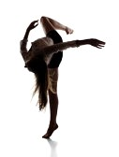

CONTEMPORARY DANCE
Contemporary Dance is a collection of methods developed from modern and post-modern dance. Rather than being a single specific technique, Contemporary Dance is more concerned with the choreographic and performance process. As a result Contemporary Dance draws on modern dance techniques along with a wide array of still developing dance styles of movement based on study of the human body and the relationship between body and mind. Contemporary Dance principles include: centring, alignment, gravity, breath, contraction, release, fall and recovery, suspension, balance and off-balance, tension and relaxation, opposition and emotion.
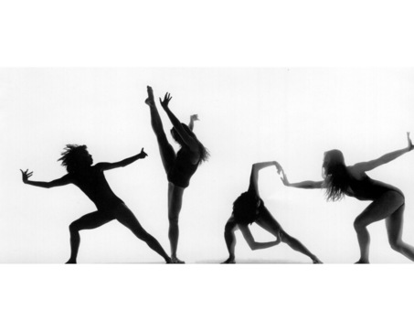
Contemporary Dance styles include:
- José Limon
- Merce Cunningham
- Martha Graham
- Rudolph Laban

Martha Graham – Choreographer José Limon – Choreographer

Technical Skills: The Qualities of a Dancer

Each individual dancer will possess the following qualities:
Technical Qualities refer to the dancer’s ability to perform different skills that show refinement, timing and effectiveness of performance. A performance which shows refinement pays particular attention to the fine detail required by the body or parts of the body, e.g. in the performance of an arabesque balance. Timing is demonstrated through the control, co-ordination and articulation that occurs during the performance of a skill or between one skill and another. Effectiveness will be evident when consistency is maitained throughout.
Physical Qualities refer to how different skills require different degrees of emphasis. Some skills require strong, powerful movements such as leap, whilst others will emphasise lighter, more gentle movements like linking a step sequence. The dancer requires the ability to demonstrate the use of different degrees of body tension at the appropriate times.
Personal Qualities refer to the dancer’s ability to manage their emotions and cope with the challenges of performance. Determination, motivation and concentration are but to name some of the many qualities in this area.
Special Qualities refer to the dancer’s ability to demonstrate qualties such as imagination and flair. When choreographing the design and style of a movement phrase, the dancer must try to be creative to ensure that its original and unique. For this to happen, careful attention must be given to the choice of movements and their combinations so that they effectively link well together. The dynamics would be varied, i.e. degrees ofstrength and lightness, combined with variations in timing to produce contrasting and harmonious rhythms. Interesting use of space provided in terms of directions, levels and patheways would also be evident.
The qualities of an effective dancer are dependant upon physiological and psychological factors. Physiological factors such as skill, fitness, physique and the psycological factors such as personality, motivation, arousal and stress will influence the choreography selection and application of design elements. The application of design elements will depend on the combined choreographic, physical and technical skills of the indiviual dancer or group of dancers.
A good dancer must:
- Have good coordination, balance, movement and rhythm
- Have sound technique and control of basic movements
- Be able to use a variety of movement factors and effort actions
- Have good posture/alignment

Alignment and Posture
What is good alignment?
Ideal alignment is balanced posture in which positioning is centred and relaxed for all the joints of the body. With joints in non-awkward positions, muscles relax, and unnecessary tension can be released.
Ideal alignment is the most mechanically efficient positioning for the body.

Correct Alignment Incorrect Pelvic Placement Incorrect Chest Placement
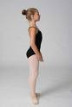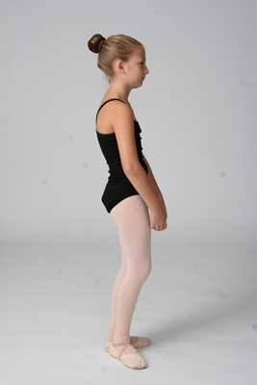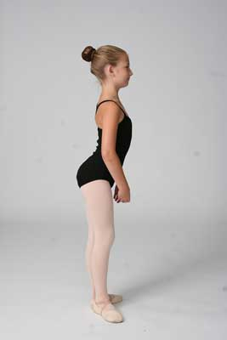
Correct Lift (pull up) Incorrect (sinking hip)
Turnout
A dancer with good technique requires good placement (or alignment), and turnout. Where alignment refers to the dancer's ability to keep the head, shoulders, and hips aligned vertically, turnout refers to the dancer's ability to complete movements with the legs rotated outward. This can be in areas such as clean footwork, graceful port de bras (carriage of the arms), and overall correct positions and lines/angles.
Correctly pointed foot Incorrect sickled foot
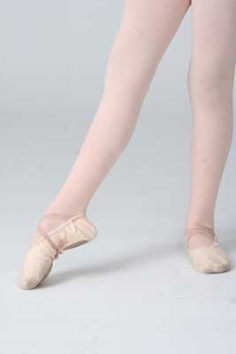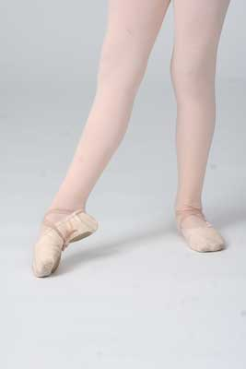
Incorrect winged foot
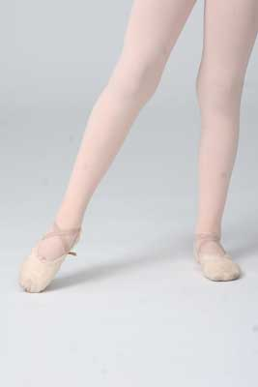
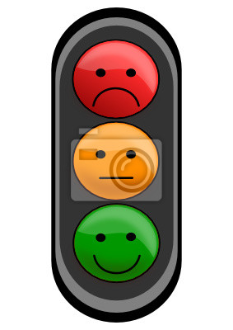SELF-EVALUATION: TECHNIQUE
Watch your performances several times and record what you see on to the observation schedule below. Be honest and accurate when recording the information in order to provide yourself with a detailed description of your Contemporary performance strengths and areas for development. Rate your performance with ‘Red, Amber or Green’ depending on how well you think you have performed that technique.
Technique | Comment | Rating
Centre Work
Plies in Parallel/Turnout (1st position)
Plies in Parallel/Turnout (2nd position)
Tendus in Parallel/Turnout
Glissé
Roll Downs in Parallel
High Release/Contractions
Preparation for Jumps
Floor Work
Swings
Brushes
Tilts
Travelling
Triplets
Leaps
Skips
Turns

Technique | Needs further Improvements | Few errors occurred | Performed Well
Centre Work
Plies in Parallel/Turnout (1st position)
Plies in Parallel/Turnout (2nd position)
Tendus in Parallel/Turnout
Glisse
Roll Downs in Parallel
High Release/Contractions
Preparation for Jumps
Floor Work
Swings
Brushes
Tilts
Travelling
Triplets
Leaps
Skips
Turns
PEER-EVALUATION: TECHNIQUE
Watch your partner perform each technique. Place in a tick in the box that you feel is most relevant to their performance.

SELF-EVALUATION – SET DANCE
Now that you have completed the Contemporary unit, you will watch back the recording of your assessment. Watch your performance several times and record what you see on to the observation schedule below. Be honest and accurate when recording the information in order to provide yourself with a detailed description of your Contemporary performance strengths and areas for development.
Key: 1 = Unsatisfactory, 2 = Satisfactory, 3 = Good, 4= Very Good

TECHNICAL | Specific Comments | 1 | 2 | 3 | 4
Technical accuracy
Posture
Turnout
Alignment
MUSICAL
Timing
Dynamics
Spatial Awareness
Expression
PHYSICAL
Stamina
Flexibility
Co-ordination
Quality
Dynamics
PSYCHOLOGICAL
Focus
Confidence
Motivation
Memory retention

SUMMARY
Strengths:
____________________________________________________________________________________________________________________________________________________________________________________________________________________________________________________________________________________________________________________________________________________________________________________________________________________________________________________________________________________________________________________________________________________________________________________________________________________________________________________________________________________________________________________________________________________________________________________________________________________________________________________________________________________________________________________________________
Areas for Development:
______________________________________________________________________________________________________________________________________________________________________________________________________________________________________________________________________________________________________________________________________________________________________________________________________________________________________________________________________________________________________________________________________________________________________________________________________________________________________________________________________________________________________________________________________________________________________________

PEER-EVALUATION – SET DANCE
What is your partner doing well? What could they improve on? Think about the elements of the category and what it looks like in a model performance and what they look like in comparison.
TECHNICAL; Technical Accuracy, Posture, Turnout, Alignment, Coordination

MUSICAL; Timing, Dynamics, Spatial Awareness and Expression

PERFORMANCE; Recall, Stamina

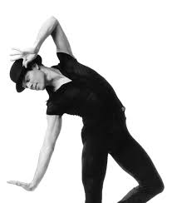
JAZZ

JAZZ DANCE
The term ‘Jazz Dance’ has been used to describe and ever-evolving form of popular dance with strong links to popular culture and originated from the African American vernacular of the late 1800’s to the mid 1900’s. In the early to mid 1900’s Jazz dancing was very closely related to Tap dancing and a jazz or tap dancer was traditionally part of a jazz band. As a Jazz Dance developed and spread to the audience and the wider public it resulted in social dances like the Charleston, Jitterbug, Boogie – woogie and Swing.
After the 1950’s Jazz Dance developed into a performance art which evolved on Broadway to the new smooth style that is taught today and known as Modern jazz. Some of the most influential figures in Jazz Dance include Jerome Robbins - who co-created West Side Story and later became the Ballet master of the New York City Balllet – and Bob Fosse a film and theatre choreographer whose most noted works include Cabaret and Chicago.
Jazz Dance is taught in many different forms and venues. It is widely taught in dance schools and performed by dance companies worldwide. Common Jazz Dance moves include: ball change, barrel turn, cat walk, jazz turn and split leap.

Leading Choreographers:
Jack Cole
Bob Fosse
Matt Mattox
Ann Reinking

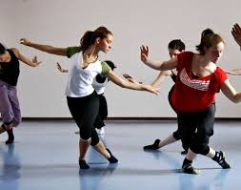

Luis Xtravaganza Camacho
“Vogue” Choreographer

Technique | Needs further Improvement | Few errors occurred | Performed Well
Centre Work
Plies in Parallel/Turnout (1st position)
Plies in Parallel/Turnout (2nd position)
Tendus in Parallel/Turnout
Glissés
Isolations
Preparation for Pirouettes
Pas de Bourée
Kicks
Reaches
Floor Work
Sweeps/Swings
Travelling
Turns – Open/Jazz
Step-ball-change
Cross-ball-change
Flick-ball-change
Kick combinations
Jetés
Sautés
Jazz Walks
SELF-EVALUATION: TECHNIQUE
Watch back your performance and evaluate each technique. Place in a tick in the box that you feel is most relevant to their performance.

Watch back your performance and evaluate each technique. Place in a tick in the box that you feel is most relevant to their performance.

PEER-EVALUATION: TECHNIQUE
Watch your partner perform each Jazz technique. Highlight the ‘Traffic Light’ column (Red, Amber or Green). Discuss this with your partner and explain why you selected this.
Technique | Traffic Light | Signatures
Centre Work
Plies in Parallel/Turnout (1st position)
Plies in Parallel/Turnout (2nd position)
Tendus in Parallel/Turnout
Glissés
Isolations
Preparation for Pirouettes
Pas de Bourée
Kicks
Reaches
Floor Work
Sweeps/Swings
Travelling
Turns – Open/Jazz
Step-ball-change
Cross-ball-change
Flick-ball-change
Kick combinations
Jetés
Sautés
Jazz Walks
SELF-EVALUATION: SET DANCE
Consider each aspect of the criteria:
- Posture and Alignment (Stance and posture in relation to your whole body)
- Balance and Control (Control of your movements and balance throughout)
- Accuracy of Technical Skills (Are you performing the skills how they have been taught?)
- Concentration and Focus (Are you concentrating on what you are doing?)
- Use of Dynamics (Are you applying the correct dynamics throughout? Light and shade moments)
- Rhythm and Timing (Are you in time with the music? Are you applying the correct timing?)
Think about someone else in the class or look online for a dancer who performs this aspect well; they can be your MODEL PERFORMER – compare yourself to them. This will help you work out what next steps to take to improving.
Using principles of dance previously stated – assess your performance by identifying 2 stars (2 positive aspects) and a wish (something you can improve).

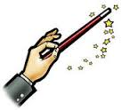

PEER EVALUATION: SET DANCE
Watch back the recording of your partners assessment. Watch their performance several times and record what you see on to the observation schedule below. Be honest and accurate when recording the information in order to provide your partner with a detailed description of your Jazz performance strengths and areas for development.
Key: 1 = Unsatisfactory, 2 = Satisfactory, 3 = Good, 4= Very Good
TECHNICAL | Specific Comments | 1 | 2 | 3 | 4
Technical accuracy
Posture
Turnout
Alignment
MUSICAL
Timing
Dynamics
Spatial Awareness
Expression
PHYSICAL
Stamina
Flexibility
Co-ordination
Quality
Dynamics
PSYCHOLOGICAL
Focus
Confidence
Motivation
Memory retention

PRELIM ASSESSMENT: SET DANCE

Application of Technique | Mark Awarded  /5 | Comment
- Technical Accuracy, Use of turnout/parallel
- Centring, Balance, Alignment and Posture
- Stamina, Strength and Flexibility
- Spatial Awareness and Accurate Recreation of Choreography
Application of Performance Skills
- Timing and Musicality
- Quality and Dynamics
- Self-expression, Sense of Performance, Concentration and Focus
Total

/35
PRELIM SELF-EVALUATION
- Identify a technical weakness in your own dance performance.

- Explain the overall impact this had on your performance.
________________________________________________________________________________________________________________________________________________________________________________________________________________________________________________________________________________________________________________________________
- Describe what you could do to improve this technical weakness.
________________________________________________________________________________________________________________________________________________________________________________________________________________________________________________________________________________________________________________________________
Target Setting
Set yourself 3 targets that you would like to achieve by the final exam.
1…………………………………………………………………………………………………………………………………………………………..…………
2.………………………………………………………………………….……………………………………………………………………………………………
3.…………………………………………………………………………..……………………………………………………………………………..…………

CHOREOGRAPHY
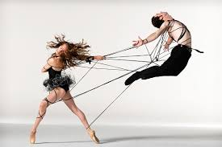

SECTION 1
ANALYSIS OF CHOREOGRAPHY
WHAT?
What are they doing? Tell me about the movement.
WHEN?
How does this piece relate to its time and what was happening in the world at that time?

HOW?
How are they doing the movements? (force, timing, etc.)

WHERE?
What spacing are they using? Are they in specific formations or groupings?
What is the effect?

WHO?
What are the dancer’s relationships to each other? Are they interacting or not?

CLASSROOM ACTIVITY

Title – “Calling You” by Mia Michaels

WHAT?
What is the theme? What movements are they doing to tell you this is the theme? TELL ME ABOUT THE MOVEMENT!!

WHEN?
Is this happening in the modern day? Is the topic of dance a common thing in this time? Why is it appropriate for the audience?

HOW?
How are they moving? Tell me about the timing and the force etc. that is helping convey the theme.

WHERE?
What spacing are they using? Are they forming groups at any point? Are they displaying any specific formations? Levels?

WHO?
What are the dancer’s relationship to each other? Do they interact at any point?

HOMEWORK

Title: “Reunion in Heaven” by Mia Michaels
WHAT?
What is the theme? What movements are they doing to tell you this is the theme? TELL ME ABOUT THE MOVEMENT!!

WHEN?
Is this happening in the modern day? Is the topic of dance a common thing in this time? Why is it appropriate for the audience?

HOW?
How are they moving? Tell me about the timing and the force etc. that is helping convey the theme.

WHERE?
What spacing are they using? Are they forming groups at any point? Are they displaying any specific formations? Levels?

WHEN?
Is this happening in the modern day? Is the topic of dance a common thing in this time? Why is it appropriate for the audience?

Reflective Tasks

Task 3: Date:
Task 2: Date:
Task 1: Date:

Task 4: Date:

Task 5: Date:

Task 6: Date:

Task 9: Date:

Task 8: Date:

Task 7: Date:

CHOREOGRAPHIC STRUCTURES

TASK 1 – Research the following choreographic structures.
NAME OF STRUCTURE | DESCRIPTION OF STRUCTURE
BINARY

TERNARY

NARRATIVE

CHOREOGRAPHIC DEVICES
Task 2 - Research the following choreographic devices
NAME OF STRUCTURE | DESCRIPTION OF STRUCTURE
UNISON
CANON
REPETITION
MIRRORING
RETROGRADE
CONTACT IMPROVISATION
THEATRE ARTS
Theatre arts are used in Dance, Drama and Theatre to enhance a performance.
Task:
- Watch the following clip of a professionally choreographed performance.
http://youtu.be/z1OTo4ktYM0
What theatre arts are used in this piece? (use the list below if you are stuck)

Select 1 -
How has this strengthened the intentions of the theme of this piece?

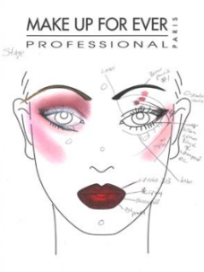
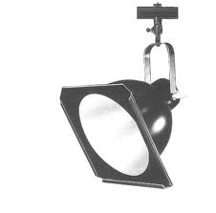
KEY POINTS TO FOCUS ON:
- Lighting
- Costume
- Set
- Props
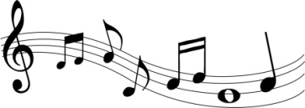
- Music/Sound Effects
- Make up

PROFESSIONAL CHOREOGRAPHY

(GOT TO DANCE 4: DIVERSITY (FULL PERFORMANCE)
Now, using the knowledge you have developed about choreographic structure, devices and space/formations, answer the questions below. Ensure you complete your answers using as much detail as you can. You must justify your answers.

What do you think the Theme/Stimulus is that the choreographer has used?

Identify what structure the choreographer has used and comment on how effective/ineffective this was in relation to the choreographer’s portrayal of the theme.

Identify and explain 3 Devices the Choreographer has used and comment on how effective/ineffective this was in relation to the choreographer’s portrayal of the theme.
Device 1

Device 2

Device 3

Identify how the choreographer has used levels, pathways, formations/groupings to help enhance the performance and evaluate the effectiveness of this.
Levels

Pathways

Formations/Groupings

SECTION
SECTION 2
PLANNING
Task 1: In the box below, write down 3 possible themes/stimulus you would like to consider for your choreography assignment. Write down any words you associate with that theme/stimulus.
Examples: Four elements (water, fire, air, earth), opposites, recycling, addiction, storm at sea, the stages of growing older, phobias…
FOR EXAMPLE

WATER

- Swirling
- Cold/Hot
- Calm/Fierce
- Waterfall
- Ripple
- Blue
- Powerful
- Dangerous

REMEMBER: YOU WILL BE CHOREOGRAPHING A DUET.
Task 2: Choose one of your themes/stimulus to investigate in more detail. You will then create a “Mood Board” to showcase your ideas. An example is provided in the booklet.
Consider:
- Photographs
- Poems
- Films
- Books
- Other dances associated with theme/stimulus (YouTube)
- Information Leaflets/Blogs/Symptoms (if a medical condition)
- Emotions associated with theme/stimulus

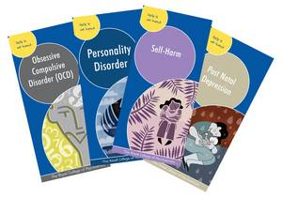

RESEARCH
Task 3: Research can be produced in many different ways using various types of equipment. Below list 5 different methods

Now select 3 out of these 5 methods of research and produce detailed information about your chosen theme. Think carefully about how this may help you create movement or ideas for your choreography.
Research Method 1 _______________________________________
What did you learn? ________________________________________________________________________________________________________________________________________________________________________________________________________________________________________________________________________________________________________________________________________________________________________________________________________________________________________________________________
How will you use this to develop your Choreography? ________________________________________________________________________________________________________________________________________________________________________________________________________________________________________________________________________________________________________________________________________________________________________________________________________________________________________________________________
Research Method 2 _______________________________________
What did you learn? ________________________________________________________________________________________________________________________________________________________________________________________________________________________________________________________________________________________________________________________________________________________________________________________________________________________________________________________________
How will you use this to develop your Choreography? _______________________________________________________________________________________________________________________________________________________________________________________________________________________________________________________________________________________________________________________________________________________________________________________________________________________________________________________________
Research Method 3 _______________________________________
What did you learn? ________________________________________________________________________________________________________________________________________________________________________________________________________________________________________________________________________________________________________________________________________________________________________________________________________________________________________________________________
How will you use this to develop your Choreography? ________________________________________________________________________________________________________________________________________________________________________________________________________________________________________________________________________________________________________________________________________________________________________________________________________________________________________________________________

Task 4: In the box below, jot down ideas of how you would like your theme and choreography to develop.
Consider how you can use the stuff that you put on your mood board and all of the research that you have just told me about. How can you use this to tell your story/form your motifs/ create movement/ form your characters.

Task 5: From your knowledge of Choreographic principles, choose an appropriate Structure for your theme.
The choreographic structure I will use for my choreography assignment is:

__________________________.
I have chosen this because (what will it allow you to do and why did you decide to do this?)

Task 6: From your knowledge of choreographic principles, choose a minimum of 3 choreographic devices you will use to fully develop your theme.
Why have you chosen these devices? What are they going to allow you to do? Where did you get the idea to use this device? What effect do you hope it will have on your audience?
Device 1:____________________

Device 2:____________________

Device 3:____________________

COSTUME
In the space below, provide examples of COSTUME you would choose to further develop your theme. Remember you have two Dancers.
FRONT BACK

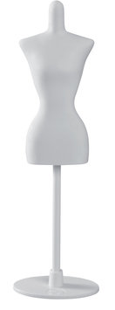

MAKE-UP

In the space below, provide examples of MAKE UP you would choose to further develop your theme. Remember you have two Dancers.

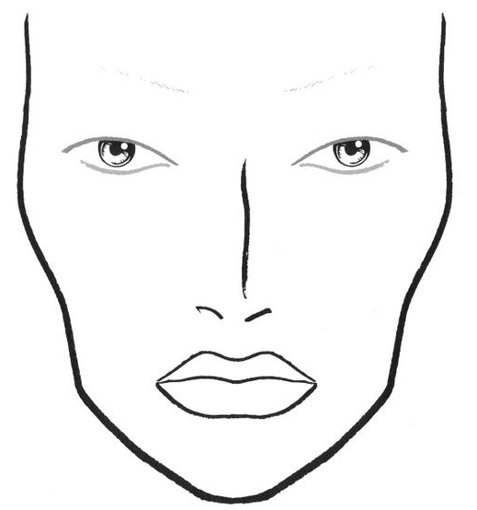
DANCER 1

In the space below, provide examples of MAKE UP you would choose to further develop your theme. Remember you have two Dancers.

DANCER 2

Use the boxes below to jot down ideas for movements, what you have done in each session and how well you are working with your dancers.

My Dancers are: ___________________ & _____________________

SESSION 1 DATE ______________

SESSION 2 DATE ______________

SESSION 3 DATE ______________

SESSION 4 DATE ______________

SESSION 5 DATE ______________

SESSION 6 DATE ______________

SESSION 7 DATE ______________

SESSION 8 DATE ______________

SESSION 9 DATE ______________

SESSION 10 DATE ______________

Task 1: Comment on the process you have gone through already.
- Have you made any changes to your original idea?
- Have your rehearsals gone to plan so far?
- How well are you and your dancers working together?
- What changes, if any, will you make to ensure you complete your choreographic assignment on time?

Task 2: MID-CHOREOGRAPHY REVIEW
CHOREOGRAPHER _______________________
DANCERS’ ______________________________________________
THEME
STRUCTURE
DEVICE 1
DEVICE 2
DEVICE 3
MUSIC
NEXT STEPS
PUPIL NOTES

REFLECTIVE TASK
Now you have completed your Choreographic Assignment, reflect on the process you have gone through.

Task 3: Comment on how effective you think your initial research was for your theme. Was it enough to fully develop your theme? In hindsight, would you have done anything differently?
_____________________________________________________________________________________________________________________________________________________________________________________________________________________________________________________________________________________________________________________________________________________________________________________________________________________________________________________________________________________________________________________________________________________________________________________________________________________________

Task 4: Comment on how well you planned for your sessions, your relationship with your dancers, and your use of communication to keep your choreography on track.
________________________________________________________________________________________________________________________________________________________________________________________________________________________________________________________________________________________________________________________________________________________________________________________________________________________________________________________________________________________________________________________________________________________________________________________________________________________

Task 5: Did you encounter any unforeseen problems while choreographing your duet? How did you deal with these problems?
________________________________________________________________________________________________________________________________________________________________________________________________________________________________________________________________________________________________________________________________________________________________________________________________________________________________________________________________________________________________________________________________________________________________________________________________________________________
Task 6: If you had more time, how would you further develop your theme?
Consider: Developed story line
Alternative Ending
Theatre Arts – props?
________________________________________________________________________________________________________________________________________________________________________________________________________________________________________________________________________________________________________________________________________________________________________________________________________________________________________________________________________________________________________________________________________________________________________________________________________________________

Task 7: Comment on what you feel you have learned from the experience of developing a theme and choreographing a routine for 2 performers.
________________________________________________________________________________________________________________________________________________________________________________________________________________________________________________________________________________________________________________________________________________________________________________________________________________________________________________________________________________________________________________________________________________________________________________________________________________________

Task 8: Comment on what you feel you were particularly good at throughout the process of choreographing your piece.
________________________________________________________________________________________________________________________________________________________________________________________________________________________________________________________________________________________________________________________________________________________________________________________________________________________________________________________________________________________________________________________________________________________________________________________________________________________

CHOREOGRAPHY REVIEW OUTLINE

Task 1
When you planned your choreography, you carried out research into your theme or stimulus. Describe two useful things you found out during your research and, for each, explain the movement ideas you generated.
Total: 6 marks

Task 2
Describe the choices you made in your choreography and explain the reasons for them. The reasons you give can relate to things like your theme or stimulus, or the meanings, ideas or effects you intended.
Make sure you cover all the following:
a one choreographic structure 3 marks
b three choreographic devices 8 marks
c use of space 4 marks
d use of music/sound 3 marks
Total: 18 marks

Task 3
During the choreographic process you worked as a choreographer to research, make and develop plans, and work with others.
a Describe at least one strength you demonstrated as a choreographer during this process, giving two examples from your work. 3 marks
b Describe at least one area for development that you had as a choreographer during this process, giving two examples from your work. 3 marks
Total: 6 marks
TOTAL: 30 MARKS

