St Ninian’s High School
Higher Dance

Name……………………………………………
Teacher…………………………………………
CONTENTS
Course Overview Page 3-4
Standards and Expectations Page 5
Timeline Page 6-8
Technical Skills: The Qualities of a Dancer Pages 9 – 11
Contemporary Page 12
Contemporary Technical Skills Pages 13-14
Contemporary Skills Observation Checklist Page 15
Contemporary Assessment Criteria Page 16
Teacher Feedback Page 17
Evaluation and Target Setting Page 18
Jazz Page 19
Jazz Dance Page 20-21
Peer evaluation: Technique Page 22
Jazz Assessment Criteria Page 23
Teacher Feedback Page 24
Evaluation and Target Setting Page 25
Choreography Page 26
Structure and Devices Page 27-28
Developing a Motif Pages 29-33
Theatre Arts Pages 34
Choreographic Process Pages 35-36
Choreographic Structures and Devices Pages 34 – 35
Theatre Arts Page 36
Developing your own choreography Pages 37
Logbook Page 38-42
Choreography Assessment Criteria Pages 43-44

Course overview
The course assessment has three components.
Component 1: question paper (30%)
A two hour exam paper which assesses:
- Evaluation of technical and performance skills in relation to self, peer and model performers
- Comparison of technical skills, characteristics, and appreciation of performance styles of two contrasting dance styles
- Principles of safe dance practice
- Technical requirements of two contrasting dance styles
- Impact of performance on two contrasting dance styles and methods used to enhance performance
- Origins and historical development of dance style
- Evaluation of a professional live or recorded choreography for three or more people
- Understand how a variety of choreography aspects impact on the audience

Component 2: Practical Activity
The practical activity has two sections: choreography and a choreography review
Choreography assesses:
- Understanding a range of choreographic skills and principles to create a group dance (2-3 minutes)
- Working imaginatively and demonstrating creativity
- Using: motif to convey theme, complex structure, three complex devices, spatial elements, music or sound and two theatre arts

Choreography review assesses:
- The relationship and reasons behind your chosen research, theme, movement, choreographic principles, spatial elements, music and theatre arts
- The evaluation of a choreographic skill and the impact this has on the finished dance

Component 3: Performance
The performance assesses:
- Development of a range of technical dance and performance skills in Jazz and Contemporary
- Stamina, strength and flexibility
- Spatial awareness
- Timing and musicality
- Quality and dynamics
- Self-expression and sense of performance

Standards and Expectations
The Higher Dance Course is a physically demanding course where there is a significant emphasis on practical work. Lessons will require you to bring appropriate footwear and dance wear.
STYLE | FOOTWEAR | CLOTHING (TOP) | CLOTHING (BOTTOM)
Jazz | Jazz Shoes | Black Vest, School poloshirt, Black Leotard | Jazz Pants, Shorts, Black Leggings
Contemporary | Bare feet | Black Vest, School poloshirt, Black Leotard | Footless tights, Shorts, Black Leggings

- Pupils should try to adhere to the list given above.
- Pupils will not wear any low cut tops
- Pupils should invest in a pair of Jazz Shoes.
- Pupils must own or have access to a plain leotard and leggings for assessment purpose.
- Hair must be tied back and jewellery taken off

W/B | Timeline
19/8 | Standards & Expectations  Set warm-up  Introduction to Contemporary Dance – Posture and alignment, Turnout and Parallel, Roll down exercises, Floor exercises, Swing sequences, Plies  Theory 1 – key characteristics of Contemporary dance including quality of movement, performance style, posture and alignment, music and sound, theatre arts
26/8 | Contemporary- Floor exercises, Swing sequences, Plies, Tendu & Glisse, Preparation for Jumps, Swing to stand, Travelling through space  Assessment of technical skills  Theory 2 – principles and technical requirements of Contemporary dance including style-specific steps, posture and alignment, centre and balance, use of turnout and parallel, use of control, flexibility, stamina, strength, power and co-ordination
2/9 | Start to teach set Contemporary dance.  Theory 3- performance skills of Contemporary including timing, musicality, quality, dynamics, spatial awareness, self-expression, projection, concentration, focus and sense of performance in relation to self, others and performance style
9/9 | Continue to teach Contemporary dance. Self/peer assessment tasks.  Theory 4- history of contemporary dance and the influences of various factors on the developments a selected dance including origin; historical developments; race; gender; social and cultural factors; and influential choreographers, companies and their work
16/9 | Jazz- Reaches and Roll downs, Isolations, Tendue, Glissee and Kicks  Theory 5 – key characteristics of Jazz dance including quality of movement, performance style, posture and alignment, music and sound, theatre arts
23/9 | Jazz- Travelling, Hops, Leaps, Pirouettes, Turns, Pas De Bouree  Assessment of technical skills  Theory 6 – principles and technical requirements of Jazz dance including style-specific steps, posture and alignment, centre and balance, use of turnout and parallel, use of control, flexibility, stamina, strength, power and co-ordination
30/9 | Start to teach set Jazz dance.  Theory 7- performance skills of Jazz including timing, musicality, quality, dynamics, spatial awareness, self-expression, projection, concentration, focus and sense of performance in relation to self, others and performance style
7/10 | Continue to teach Jazz dance. Self/peer assessment homework task.  Theory 8- history of contemporary dance and the influences of various factors on the developments a selected dance including origin; historical developments; race; gender; social and cultural factors; and influential choreographers, companies and their work
21/10 | Set dances warm-up  Introduction to Choreography, six dance actions and choreographic devices  Complete logbook
28/10 | Set dances warm-up  Choreography  Use of stimulus (visual, written and audio), floor space, structure  Complete logbook  Theory lesson 9 – Evaluation of professional choreography – theme, stimulus, motif and selected movements
4/11 | Set dances warm-up  Continue with choreography tasks, discuss theatre arts. Complete logbook.  Homework task (mind map)- research theme, stimulus, space, devices, music etc for final choreography piece  Theory lesson 10 – Evaluation of professional choreography – spatial elements, structure, devices
11/11 | Set dances warm-up  Create motifs for chosen choreography theme- feedback from teacher  Complete logbook  Theory lesson 11 – Evaluation of professional choreography – music/sound, theartre arts including lighting, set, props, make-up, costume
18/11 | Set dances warm-up  Create motifs for chosen choreography theme- feedback from teacher  Complete logbook  Theory lesson 12 – Evaluation of professional choreography – impact of choreography, effect, mood and atmosphere created
25/11 | Set dances warm-up  Create motifs for chosen choreography theme- feedback from teacher  Complete logbook
2/12 | Set dances warm-up  Create motifs for chosen choreography theme- feedback from teacher  Complete logbook
9/12 | Set dances warm-up  At least one minute 30 seconds of choreography taught to dancers and presented to teacher  Complete logbook
16/12 | Set dances warm-up  At least one minute of choreography taught to dancers and presented to teacher  Homework over Christmas- practice set dances and finish choreography (2-3 minutes)
6/1 | Set dances warm-up  Teach the finished piece of choreography  Complete logbook  Theory lesson 13- Choreography review Question 1a)
13/1 | Set dances warm-up  Teach the finished piece of choreography  Complete logbook  Theory lesson 14- Choreography review Question 1 b) c)
20/1 | Set dances warm-up  Teach the finished piece of choreography  Theory lesson 15- Choreography review Question 2a) b)
27/1 | Set dances warm-up  Teach the finished piece of choreography  Theory lesson 16- Choreography review Question 3
3/2 | Set dances warm-up  Teach the finished piece of choreography  Theory lesson 17- preparation for prelim paper. Hand in completed choreography review
17/2 | Prelim week  Practical- Present two set dances and full choreography  Theory- Written exam paper
24/2 | Prelim feedback  Focus: set dance development needs, make choreography adaptations
3/3 | Set dance focus, refine all technical skills  Choreography  Theory 18- exam preparation
10/3 | Practical- exam preparation  Theory 19- exam preparation
17/3 | Practical- exam preparation  Theory 20- exam preparation
24/3 | SQA practical examination
14/4 | Theory exam preparation
21/4 | Theory exam preparation
Technical Skills: The Qualities of a Dancer

Each individual dancer will possess the following qualities:
Technical Qualities refer to the dancer’s ability to perform different skills that show refinement, timing and effectiveness of performance. A performance which shows refinement pays particular attention to the fine detail required by the body or parts of the body, e.g. in the performance of an arabesque balance. Timing is demonstrated through the control, co-ordination and articulation that occurs during the performance of a skill or between one skill and another. Effectiveness will be evident when consistency is maitained throughout.
Physical Qualities refer to how different skills require different degrees of emphasis. Some skills require strong, powerful movements such as leap, whilst others will emphasise lighter, more gentle movements like linking a step sequence. The dancer requires the ability to demonstrate the use of different degrees of body tension at the appropriate times.
Personal Qualities refer to the dancer’s ability to manage their emotions and cope with the challenges of performance. Determination, motivation and concentration are but to name some of the many qualities in this area.
Special Qualities refer to the dancer’s ability to demonstrate qualties such as imagination and flair. When choreographing the design and style of a movement phrase, the dancer must try to be creative to ensure that its original and unique. For this to happen, careful attention must be given to the choice of movements and their combinations so that they effectively link well together. The dynamics would be varied, i.e. degrees ofstrength and lightness, combined with variations in timing to produce contrasting and harmonious rhythms. Interesting use of space provided in terms of directions, levels and patheways would also be evident.
The qualities of an effective dancer are dependant upon physiological and psychological factors. Physiological factors such as skill, fitness, physique and the psycological factors such as personality, motivation, arousal and stress will influence the choreography selection and application of design elements. The application of design elements will depend on the combined choreographic, physical and technical skills of the indiviual dancer or group of dancers.
A good dancer must:
- Have good coordination, balance, movement and rhythm
- Have sound technique and control of basic movements
- Be able to use a variety of movement factors and effort actions
- Have good posture/alignment

Alignment and Posture
What is good alignment?
Ideal alignment is balanced posture in which positioning is centred and relaxed for all the joints of the body. With joints in non-awkward positions, muscles relax, and unnecessary tension can be released.
Ideal alignment is the most mechanically efficient positioning for the body.

Correct Alignment Incorrect Pelvic Placement Incorrect Chest Placement
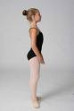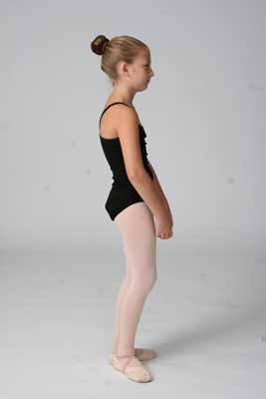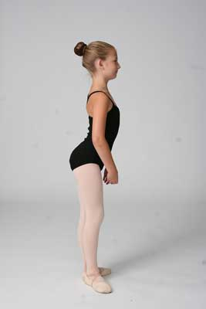
Correct Lift (pull up) Incorrect (sinking hip)
Turnout
A dancer with good technique requires good placement (or alignment), and turnout. Where alignment refers to the dancer's ability to keep the head, shoulders, and hips aligned vertically, turnout refers to the dancer's ability to complete movements with the legs rotated outward. This can be in areas such as clean footwork, graceful port de bras (carriage of the arms), and overall correct positions and lines/angles.
Correctly pointed foot Incorrect sickled foot
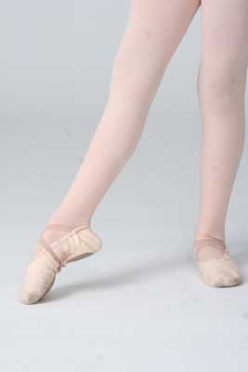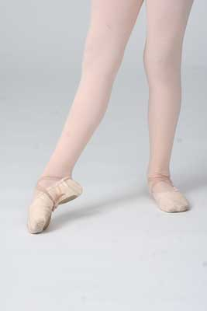
Incorrect winged foot
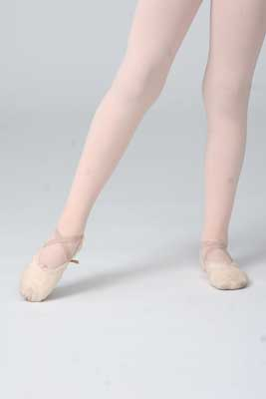

CONTEMPORARY
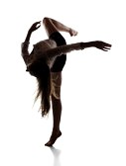

Contemporary

Technical Requirements

Alignment Shoulders over hips
Spine in a neutral position (not lordotic/flat back)
Knees over middle of feet
Shoulders relaxed
Abdominals engaged

Turn Out Turn out should come from hips at all times
Hips, knees and feet should be in alignment i.e. knees and feet should not be rotated independently of hips

Parallel Feet should be hip width apart (not thigh width)
As in turn out, hips, knees and feet should be aligned
Feet- big toe joint and inside of heel should be on a straight line

Pliés Knees positioned over middle feet
Insteps not rolling in (pronation)
Body in alignment
Heels on floor during demi plies (full plié in 2nd position)

Tendus Knees straight on all movements
Feet making full use of the floor
Hips in a level position
Weight of body on supporting leg without leaning into hip

Jumps/Leaps Legs straight and turned out in the air
Feet pointed
Heels on floor when landing
Body in alignment

Contractions Body in gentle curve
Shoulders should remain over hips as back curves
Do not sink into hips and push out thoracic spine

Spirals Body should remain in alignment throughout spiral
Body should rotate around spine with hips and shoulders moving in opposition
Shoulders should not move independently of back or each other

High Release Chest lifts to the ceiling in a high arch of the upper back
Head lifts without neck ‘breaking’ at the back, i.e. do not allow the neck to over extend
Lower back remains in neutral – keep alignment
Take care not to push ribs forward

Triplets Aim to make each step the same length
Legs are straight on relevé
Alignment should be maintained throughout
Spirals can be added

General Notes
Floor work:
It is important that body alignment (spine, hips, knees and ankles) is maintained on all movements. The use of weight is important and will help you to achieve smooth movements.
For example: Contractions, swings, breathings, spirals, rolls
Swings:
You should experience the use of suspension and fall in sequences incorporating swing movements. Movements should have breath and weight and avoid being jerky and stiff.
Sequences:
For sequence of movement you will combine the above basic skills and apply them in all aspects of the dance technique. For example, maintaining alignment and turn out whilst executing triplet sequence across the floor.

Contemporary Dance Assessment Criteria
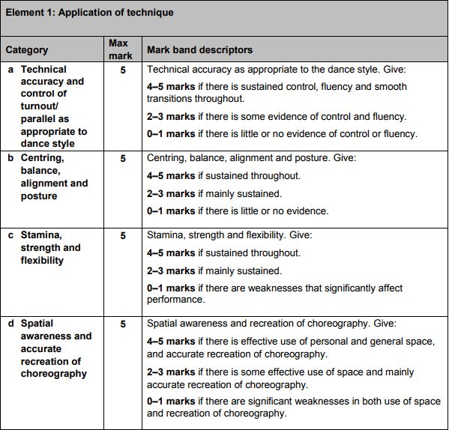
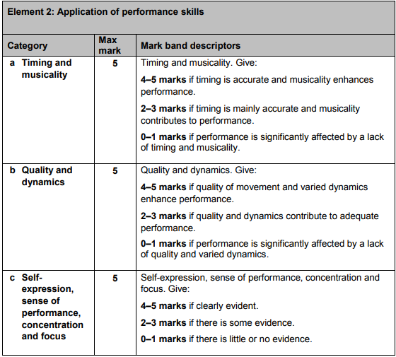

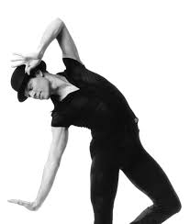
JAZZ

Jazz Technical Requirements
Alignment Shoulders over hips
Spine in a neutral position
Knees over middle of feet
Shoulders relaxed
Abdominals engaged

Turn Out Turn out should come from hips at all times
Hips, knees and feet should be in alignment i.e. knees and feet should not be rotated independently of hips

Parallel Feet should be hip width apart (not thigh width)
As in turn out, hips, knees and feet should be aligned
Feet- big toe joint and inside of heel should be on a straight line

Pliés Knees positioned over middle feet
Insteps not rolling in (pronation)
Body in alignment
Heels on floor during demi plies (full plié in 2nd position)

Tendus Knees straight on all movements
Feet making full use of the floor
Hips in a level position
Weight of body on supporting leg without leaning into hip

Jumps Legs straight and turned out in the air
Feet pointed
Heels on floor when landing
Body in alignment

Pirouettes Preparation – parallel with weight place in the centre
Supporting leg must be pulled up on the relevé
Shoulders over the hips
Working foot must be full pointed, placed in retiré in parallel
Abdominals engaged
Arms held in 1st position
Sporting action with the head
Jazz Pirouette Commence in a wide 4th position in parallel with the left foot in front, both legs are relaxed. The right foot is placed derrieré on the demi-point. The arms are placed in jazz 3rd position with the shoulders and hips square. Relevé taking the right foot to retiré position in parallel making a single/double turn to the right side. The arms come in to jazz 1st position. The head spots to the front. This pirouette can also be taken at low level with the supporting leg bent.
Leap Starts and finishes in a demi-plié. The legs are equally turned out from the hips. The hips are square, abdominals engaged. It commences with a grand battement action which extends both legs equally. The feet are stretched and you should be aiming to achieve the splits in the air. Land quietly going through the feet.
Kicks Legs turned out equally from the hips
Both legs should be pulled up and the working foot pointed
Kicks should begin with a glissé action
Emphasis on the upward movement
Hips square, pelvis in neutral position
Height of leg is determined by the suppleness of the dancer
Posture and placement should not be sacrificed in order to achieve a higher leg
Front Kick Grand battement the working leg brushing the foot along the floor. The working and supporting leg remain stretched with the working foot pointed. The hips remain square with the abdominals lifted and the shoulders relaxed. The shoulders must remain over the hips.
Side Kick As in front kick but the working leg takes a grand battement action to 2nd position. The hips must remain square and the degree of turn out depends on individual’s facility. The shoulder must remain over hips.
Back Kick The working leg grand battements derrieré brushing the foot along the floor. The supporting leg remains straight or can be taken on a fondue. The working leg remains stretched with the foot pointed. The hips must remain square with abdominals lifted and the shoulders relaxed. The shoulders will move slightly forward of the hips as the leg lifts to the back.
Isolation Isolate one part of the body e.g. head, shoulder, rib cage, arm, hip etc. The rest of the body must remain as still as possible.

CHOREOGRAPHY
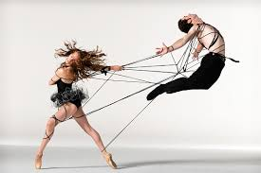

Choreography Notes and Study Materials

In this section you will learn about developing your own choreography and analysing others. You will research ideas using a variety of methods, select a theme as the basis of your choreography and implement a selection of different formations, structures and devices etc. You will teach your created dance(s) to a group of pupils and will then evaluate your process.
Structure
The way in which motifs and sections in the choreography are linked together to create a dance. Choreographic structures are typically known as A, B and C. The elements are arranged in order by the choreographer and follow the equivalent definition as used in music- binary, ternary, rondo, theme and variation.

Types of Structure:

Narrative (A B C)
This structure tells an unfolding story

Binary Form (A B)
Commonly used in dance composition. The first Section A is contrasted by a new Section B, but both have a common thread which binds one to the other. Each section may have contrasting elements, but there must be something similar in nature too.

Ternary Form(A B A)
A conventional and satisfying form because going back to the beginning ‘rounds it off’. The return to Section A can be achieved by exact repetition of the initial section, or by reversing, highlighting parts, changing a few elements and changing the order of elements. They must be closely linked, while Section B forms the contrast.

Rondo Form (A B A C A D A)
This provides the choreographer with a verse and chorus framework which gives room for variation in the verses and development in the choruses. Variation can produce something new each time, but it must still have enough of the original to be considered a related part to the whole. Development can recall the origin in many ways without changing the essence. This is again a satisfying form to watch, as the viewer can quickly identify the chorus movement and enjoy its repetition – it becomes a ‘joining in’ process.

Motif
Movement motifs are short movement phrase which encapsulates a theme or part of a theme within a dance. Movement motifs can identify an emotion, character, feeling or a more abstract idea to an audience.
Choreographic Devices
Unison- Where a movement or Motif is performed by all performers at the same time.
Cannon:
Reverting Cannon- Dancers begin individually at the same point in a movement phrase
Simple Cannon- Each dancer dances an entire motif then keeps still while another dancer takes over. Dancers timings can overlap. Requires awareness of other dancers.
Cumulative Cannon- Each dancer joins in with the lead dancer at various stages and all finish at the same time.

Loose Cannon- Manipulation of the motif. Use of different levels, facings, or space.

Simultaneous Cannon- Dancers do the same motif at the same time, but start at different points. For example, Dancer 1 may do counts 1-8, Dancer 2 may do 6-5, and Dancer 3 may do counts 4-3.

Mirroring- Where one movement is copied using opposition symmetry creating a mirror effect.
Repetition- A choreographic device where movements or motifs are repeated.
Spatial patterns- Patterns created in the performance space with the use of performers.
Retrograde: a choreographic device whereby movements or a motif are performed backwards (like a rewound video).
Reversal: the performance of the movements of a motif or sequence in reverse order (but not in a backwards direction).
Contact- points of physical contact provide the starting point for movement improvisation and exploration.
Embellishment. Apart of the body can be embellished as it is involved in the movement. (eg as the arm moves, wiggle the fingers or make a fist.)

Developing a Motif
TASK – Developing a Motif
Motif development
Motif development is a way of producing a lot from a little, while avoiding too much repetition, which may be monotonous for the audience.
The motif is the ‘building blocks’ of a dance. Rather than continually inventing new movements for a dance once a motif has been developed variations can be used to develop the motif into a dance composition. By varying the motif the choreographer is making the dance unique.
In small groups you will attempt to develop the following motif:
Starting standing with feet together and arms by side
Count 1 jump with feet together and land together
Count 2 jump again to land with feet apart
Count 3 right shoulder roll
Count 4 left shoulder roll
Count 5 raise both arms up, lifting right knee up and over left leg
Count 6 land right leg on floor, arms lower
Count 7 turn to face back by untwisting legs
Count 8 jump to bring feet together

You will select 4 from the list below and try to develop the motif shown above so that you have 4x8 counts (4 different varieties of the original motif)
1. Mix up the order of the original motif
2. Change level
3. Change pathway
4. Repeat in new direction
5. Add in jumps
6. Change speed
7. Add travel
8. Dynamics – bigger/smaller movements
9. Reverse the phrase

Using Stimulus to Create Movement
Research and rehearse movement, e.g. starting points, themes, motifs, etc.
A starting point is a stimulus that rouses the mind and incites activity. It is the inspiration and the basis of the dance. From a stimulus a choreographer then creates movement material.
There are five types of stimuli that you can choose from.
- Auditory: This is also known as the aural setting for the dance and the most obvious choice is music. However, there are other options such as poems, songs, words, percussion instruments, human voice sounds and silence. If the stimulus is auditory then the dance is normally performed to that stimulus. For example, music from any of the following artists would be appropriate choices as a stimulus or as an accompaniment for choreography:
Michael Nylan Yiling Huang
Hans Zimmer Luis Bacalov
John Williams John Powell
Sigur Ros

- Visual: A visual stimulus is something that you can see, for example pictures, sculptures, objects, patterns or paintings. The choreographer will take the idea behind the images or the shapes and translate this into movement.

For example:
A chair could be viewed: For its angularity, for its purpose, as a throne, as a trap, as an object to hide behind/underneath, as a weapon
Water could be explored for: The different forms it adopts, how it moves, the sounds it makes, the contrasts between when the sea is calm and rough, the fact that it is a basic but essential unit of life

Famous sculptures which you may have seen, such as the statue of Eros or the Angel of the North. It may be interesting to explore a human character from a painting.

Ideational/Narrative: This is the most popular stimulus and it will result in the choreography conveying an idea or unfolding a story.
For example:
- The candidate may decide to base their choreography on a specific historical or political event

- Written: You may want to base your choreography on a poem, a case study, a well-known saying, mythology, a story or a news article that you have studied in another subject or that you are particularly interested in.
- Tactile: This type of stimulus may produce a kinaesthetic response which then becomes the starting point for the piece. The feel of something, such as a piece of soft velvet, might inspire the choreographer. A tactile stimulus can often become an accompanying object in the dance.

- Kinaesthetic: Movement itself and movement phrases may inspire you to create a dance piece. There is no communication purpose other than the nature of the movement.
Any movement can take the role of a kinaesthetic stimulus and the dance is then derived from this basis. The dance is then about the movement itself. This is usually referred to as a dance study, in which you select a particular choreographer and study their choreographic style and methodology and use this as the basis of your choreography.
The movement does not have to have a communicative purpose other than the nature of itself, but it can have a:
Style Mood Dynamic range Pattern or form

Similarly you may decide to base your dance on specific movement components such as:
Impulse, momentum and falling Swing, suspend and drop
Legato, staccato and allegro Circles, spiral and strike
Ricochet and revolution Velocity

Or you could compare and contrast the movement associated with the following words:
Hold out and surrender Suppression and expression
Torment and pleasure Vulnerable and confident
Agitation and contentment

Once you have selected a starting point or stimulus you must identify a theme on which to base your choreography and articulate why you have chosen this particular theme. You will be guided through this process in worksheet 3.

Ask your teacher for guidance in selecting a theme.

Research
Before creating any movement you must research your chosen theme in depth so that you can portray it in a realistic manner which is sensitive to the audience. You must also decide which aspect of your chosen theme you wish to portray through your choreography and what you hope to convey to the audience through the performance of your choreography. Research will also provide the choreographer with an insight into their theme, which will inspire movement ideas.
There are a wide variety of methods you can use to research such as the internet, books, documentaries, case studies, museums, the library, the media and professional dance repertoire. You should use as wide a variety as possible to gain a broad understanding of your theme and inspire your imagination.
You should collect all of your research in a folder and take time to organise your information and describe your theme by making mind maps, brainstorming words relating to your theme and finding images, pieces of music and art work that relate to the theme. All of these resources will help you to choreograph movements that illustrate your theme. These movements will later combine to form a motif. Examples of the most influential research should go into the appendices of the action plan.
Once you have completed your research you should search for an aural setting that will enhance your theme. There are many ways you can do this depending on what type of aural setting you decide to use; advice can be found in the section on theatre arts.
Movement Development and Forming a Motif
Once the aural setting has been decided the choreographer can then analyse it and see how they might reflect the music in their choreography, for example what is the structure of the music and is there a climax? Is more than one piece being edited together? Following this, the choreographer will be able to take all the research and accompaniment into the dance studio and use it to experiment and improvise movement that will relate to the theme. The movements that the choreographer creates will be inspired from the research and will therefore embody the essence of the chosen theme.
Improvisation
Improvisation is when dancers create movement spontaneously, ranging from free-form to highly structured environments, but always with an element of chance. It provides the dancer with the opportunity to bring together elements quickly, and requires focus and concentration. Improvisation is instant and simultaneous choreography and performance.
Movements created through improvisation are evaluated through the following questions:
- What movements feel right?
- What movements fit into the image to be portrayed?
- What movements have meaning and are relevant to the dance idea?
- What movements are interesting?
- What movements are original?
- What movements have potential for development?

From the evaluation, you will be able to select and refine the movements that you want to use in your choreography. The choreographer will then develop these movements through rehearsal to form the initial motifs and sequences for their choreography.
What is a motif?
A motif is an easily identifiable single movement or short movement phrase which embodies the style or intention of the dance and which can be manipulated and developed. How you devise your motif will depend on the stimulus of your dance, but the actions should link clearly to your theme. For example, if your stimulus is a picture then the movement in your motif might reflect the shapes, lines and colour of the images. A motif must be seen more than twice within a dance, as a dance without a motif is like a song without a chorus.
The motif can be repeated, varied and developed by manipulating the movements within it. This allows the choreographer to develop the essence of the idea and move their choreographic ideas on. The audience has a sense of coherence as it sees echoes of significant movement recur but with something adapted, creating more variety and interest. The motifs may be associated with character, enabling the audience to identify clearly the essence of specific characters. Once the original motif has been composed, pictures can be taken of the individual movements and put into the appendices along with an explanation of each movement.

Theatre Arts
Costume
In the space below, provide examples of COSTUME you would choose to further develop your theme. Remember you have a minimum of three Dancers.
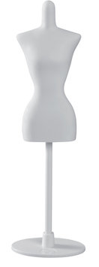

Make-Up
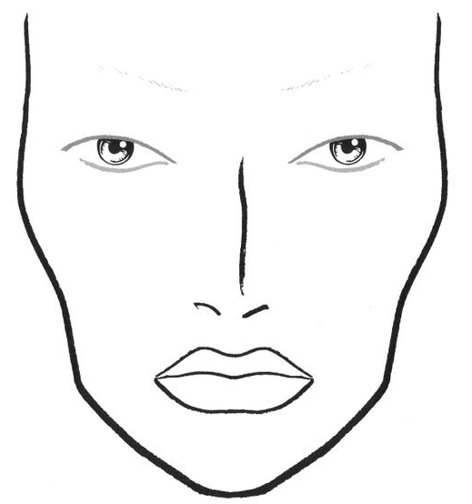
In the space below, provide examples of MAKE-UP you would choose to further enhance your theme.

Choreographic Process
You should keep a careful record of everything you gather, plan or do during the choreographic process. You are not assessed on any records you keep, but doing this will help you to be well-organised during the process, and provide you with the notes or other material you need to complete all your assessment tasks.
You also need to arrange for three dancers who can work with you during the process and perform your choreography for assessment. You should arrange this as early as possible, and certainly before you begin step three, as you will need to arrange a rehearsal schedule and work with them throughout the development stage of your choreography.
Step one
Select a theme or stimulus as a starting point.
The theme or stimulus can be anything that inspires, interests or motivates you to create your dance, such as:
- Photographs | - Paintings | - Sculptures | - Objects
- Patterns | - Textures | - Ideas | - Books
- Issues | - Experiences | - Memories | - Events
- History | - Family | - Music | - Dance
- Film | - Emotion | - News | - Nature

Step two
Carry out at least two pieces of research into your theme or stimulus, and use these to generate movement ideas.
The research you gather could be in the form of photographs, audio or visual material, written information, internet research, or anything else appropriate.
This research should be used to help you generate movement ideas for your choreography. You might wish to choreograph an initial motif which will be the starting point from which all your movement will develop. Keep a careful record of your movement ideas.Step three
Develop your choreography - This stage in the choreographic process requires careful organisation and decision-making. In this stage, you need to plan and develop your movement using each of the following:
- Choreographic structures — use at least one of:
Narrative Ternary Rondo Short Rondo

- Choreographic devices — use at least three from:
- motif and development  - unison  - complex canon  - repetition | - mirroring  - partner work  - retrograde  - contact improvisation
- Use of space — use, as appropriate:
- direction  - floor patterns | - level  - pathways
- Music/sound:
Choose music and/or sound that you think enhances what you are trying to communicate about your theme or stimulus.

There should be reasons for all the choices you make — you should try to communicate meanings and ideas about your theme or stimulus. What do you want your audience to think, feel, experience or understand?
Make sure you have your dancers available by this stage. You should work with them to experiment with, finalise and rehearse your choreography. Organise and lead rehearsals, keeping notes and making changes as you go, until you are happy with the final choreography. You should make sure that you use safe dance practice throughout.
Plan and organise anything else you want to include to enhance the final performance. This might include costumes, props and so on. By the end of this stage, your choreography should be complete and ready for performance.
Step four
Present the finished choreography. Your teacher will tell you of any arrangements that need to be made for the performance event. Remember to make sure you have finished your choreography review by the time you present your finished choreography.

Developing your own choreography
Choreography Assessment
You will now produce a 2-3 minute dance which you must choreography yourself. The dance you create must have a theme, a design element and must be your own work. You are not permitted to dance in your own choreographed dance. You will be given some class time to do this; therefore I would like you to use dancers from within the class to complete this task.
- Points to remember: Choose a theme
Select at least 3 dancers
Plan with dancers a rehearsal timetable
Select Music / Cut music if necessary/Breakdown Music into counts
Find costumes / props etc.
Structure your dance using a Motif (shouldrepresent theme)
Consider using Choreographic devices to enhance theme

- Complete the following:

- Theme:

- Dancers:

- Music:

- Days to Rehearse:

- Costume:

- Make up:

- Props:

- Stage Design:

- Motif:

- Choreographic Devices used:

- Levels:

- Pathways:

Logbook- Class Tasks
Date: Choreography focus:
Evaluation of process:

Date: Choreography focus:
Evaluation of process:

Date: Choreography focus:
Evaluation of process:

Choreography Logbook- Class Tasks
Date: Choreography focus:
Evaluation of process:

Date: Choreography focus:
Evaluation of process:
Date: Choreography focus:
Evaluation of process:

Logbook- Choreography process
Date:
Evaluation of choreography:

Adaptations/changes to be made:
Date:
Evaluation of choreography:

Adaptations/changes to be made:
Date:
Evaluation of choreography:

Adaptations/changes to be made:

Logbook- Choreography process
Date:
Evaluation of choreography:

Adaptations/changes to be made:
Date:
Evaluation of choreography:

Adaptations/changes to be made:
Date:
Evaluation of choreography:

Adaptations/changes to be made:

Logbook- Choreography process
Date:
Evaluation of choreography:

Adaptations/changes to be made:
Date:
Evaluation of choreography:

Adaptations/changes to be made:
Date:
Evaluation of choreography:

Adaptations/changes to be made:

Choreography Assessment Criteria
