**ST NINIAN’S HIGH SCHOOL**

**PSHE Newsletter & Lessons**

**Week Beginning 30th August 2021**

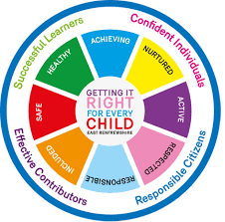

***Focus:***

[**Daily Prayers**](../../2021/Prayers/Monday%2030%20August%202021.docx)

[**Learning for Sustainability Survey – All classes to complete**](../../2021/Materials%20for%20Newsletter/QRCode%20for%20Pupil%20Survey%20-%20Rights%20Respecting%20Schools%20and%20Learning%20for%20Sustainability.png)

[**Health and Wellbeing Committee**](../../2021/Materials%20for%20Newsletter/Health%20and%20Wellbeing%20Committee.pptx)

**Mental Health Awareness**

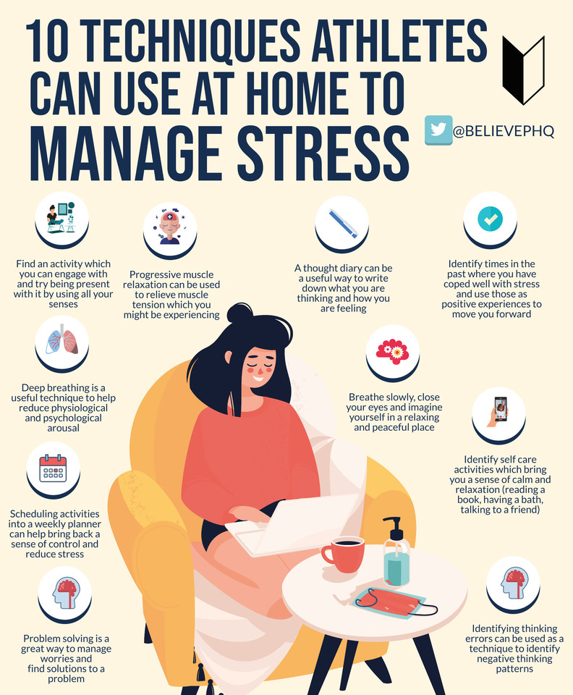

**S1**

**Early break and lunch - 10.20 / 12.15 until the 3rd of August**

[**Talented Athletes**](../../2021/Materials%20for%20Newsletter/Talented%20athletes%20programme%202021%20powerpoint%20-%20Copy.pptx)

[**Friendships**](../../PSHE%20Newsletter%20content%202018%202019/S1/Friendships%202021.pptx)

[**Body Image**](../../PSHE%20Newsletter%20content%202018%202019/S1/body%20image%20slides%2025%2008%2017.pptx)

**Pupil Council Nominations to be completed ASAP. Please forward names to year head.**

**S2**

[**Friendships**](../../PSHE%20Newsletter%20content%202018%202019/S2/Friendships%202021.pptx)

[**Body Image**](../../PSHE%20Newsletter%20content%202018%202019/S2/S2%20Body%20Image%20updated.pptx)

**Pupil Council Nominations to be completed ASAP. Please forward names to year head.**

**S3**

[**Friendships**](../../PSHE%20Newsletter%20content%202018%202019/S3/Friendships%202021.pptx)

[**Body Image**](../../PSHE%20Newsletter%20content%202018%202019/S3/Body%20Image.ppt)

**Pupil Council Nominations to be completed ASAP. Please forward names to year head.**

**S4**

**Mental Health and Wellbeing Award – Understanding Mental Health Issues.**

* [**Lesson**](../../../SCQF%20Awards%202018-onwards/Mental%20Health%20and%20Wellbeing%20Award/Understanding%20Mental%20Health%20Issues/Lessons%20for%20Understanding%20Mental%20Health%20Unit%20update.pptx)
* [**Marking Scheme**](../../../SCQF%20Awards%202018-onwards/Mental%20Health%20and%20Wellbeing%20Award/Understanding%20Mental%20Health%20Issues/Understanding%20Mental%20Health%20Issues%20Marking%20Scheme.docx)

**Pupil Council Nominations to be completed ASAP. Please forward names to year head.**

**S5**

**Mental Health and Wellbeing Award – Influences on Mental Health**

* **[Marking Scheme](\\\\snhm02\\Staff$\\All Staff\\SCQF Awards 2018-onwards\\Mental Health and Wellbeing Award\\Influences on Mental Health\\Influences on Mental Health and Wellbeing SCQF 4 Marking Scheme.docx)**
* **Slides to be covered for Unit 2** **Outcome 1**

**Pupil Council Nominations to be completed ASAP. Please forward names to year head.**

**S6**

**Pupil Council Nominations to be completed ASAP. Please forward names to year head.**

**Please complete ‘All about Me’ Microsoft Forms ASAP**

[**Diploma**](../../PSHE%20Newsletter%20content%202018%202019/S6/s6%20diploma%20slides%202021.pptx)

**S6 Service and Volunteering Opportunities**

**Fast Track pupils to complete personal statement ASAP**

[**Link to school website and advice on completing Personal Statement**](https://blogs.glowscotland.org.uk/er/StNinians/2016/09/19/good-advice-on-preparing-your-personal-statement/)

[**Link 1 – Advice on completing Personal Statement**](https://blogs.glowscotland.org.uk/er/StNinians/2016/09/19/good-advice-on-preparing-your-personal-statement/)

[**Link 2 – How to structure Personal Statement**](https://blogs.glowscotland.org.uk/er/SNHPastoralSupportWebsite/ucas/personal-statement/)

E Ward