ST NINIAN’S HIGH SCHOOL
PSHE Newsletter & Lessons
Week Beginning 27th September 2021

Focus:

Daily Prayers

Young WEIR-WISE - Discovering Engineering with S2 Girls

Faith matters
Eucharistic Adoration from 12.20-1.00pm every Friday with the Rosary at 12.30pm. Mass in the Oratory, Tuesday, Thursday, Friday, 8.25am.

Mental Health Awareness

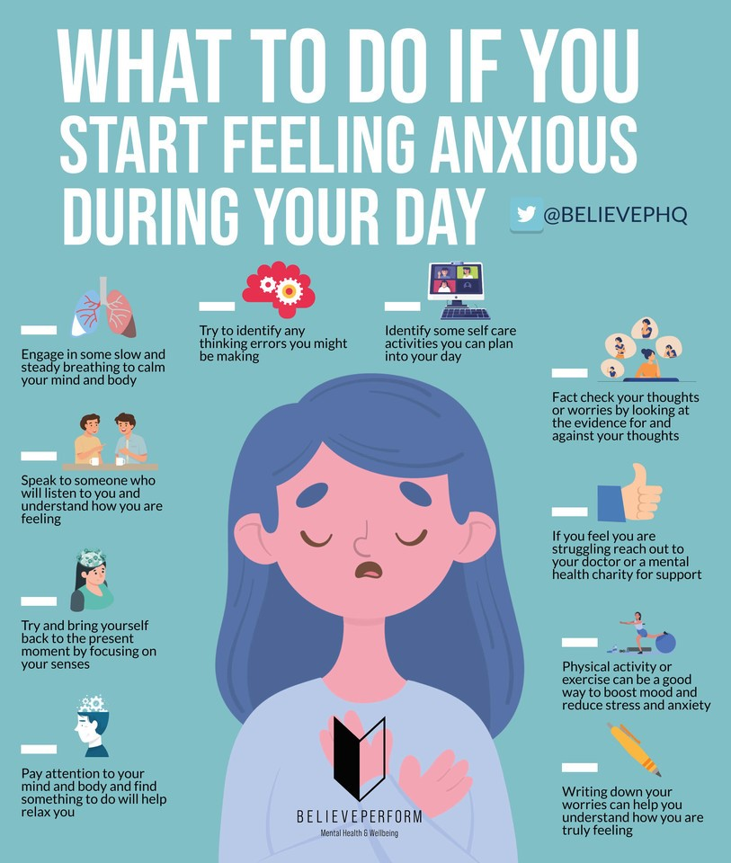

S1

1a8 – Mrs Ward’s class to go to the oratory

Physical Activity

Healthy Eating

GIRFEC – Wellbeing Wheel

Online Safety

S2

Parents evening reflection sheet

Physical Activity

Healthy Lifestyle

GIRFEC – Wellbeing Wheel

S3

Physical Activity

Diet Culture

GIRFEC – Wellbeing Wheel

Online Reputation

S4

4a8 - Miss Green’s class to go to the oratory

Please complete report survey – Mrs Boyle has posted the link on Year Group Teams

Editing link for staff

Relationships

S5

Relationships

S6

NHS Healthcare virtual work experience

One to One Tutoring Opportunity – Please complete with pupils if they would be interested in being a tutor for an S4 pupil

Careers

Writing your Personal Statement

E Ward

