ST NINIAN’S HIGH SCHOOL
PSHE Newsletter & Lessons
Week Beginning 25th October 2021
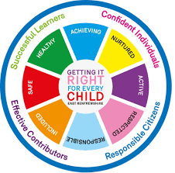

Focus:

Daily Prayers

Pupil Voice Team 2021 – Please cover with all classes

Black History Month Part 2

Faith matters
Eucharistic Adoration from 12.20-1.00pm every Friday with the Rosary at 12.30pm. Mass in the Oratory, Tuesday, Thursday, Friday, 8.25am.

Mental Health Awareness
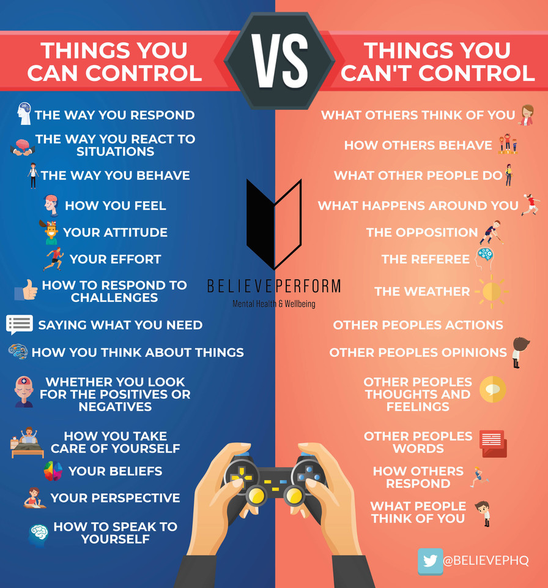

S1

Road Safety talks - Please collect speakers from the school office at the start of the lesson. Slides for the lesson are saved here

Wednesday - 1a7 & 1a8
Friday – 1a1 & 1a2

Health and Wellbeing IDL Log – Please spend 10 minutes at the start of the lesson filling out Log. Class packs to be collected from the Pastoral Base.

Firework Safety

Positive Mental Health

Physical Activity

S2

Firework Safety

Positive Mental Health

Physical Activity

S3

Firework Safety

Study Skills

Mental Health – Eating Disorders

Physical Activity

S4

4a10 – Mr McKean’s class to go to the oratory – take bags with you

Mental Health and Wellbeing Award – Influences on Mental Health (Unit 2)

- Marking Scheme
- Slides to be covered for Unit 2 Outcome 1

S5

Mental Health and Wellbeing Award – Influences on Mental Health (Unit 3)

- Marking Scheme
- Slides to be covered for Unit 3 Outcome 1

S6

All pupils should be working on their personal statement this period. Pupils who were fast track should ensure diploma is complete.

Careers

Writing your Personal Statement

Mental Health – Eating Disorders

E Ward

