ST NINIAN’S HIGH SCHOOL
PSHE Newsletter & Lessons
Week Beginning 20th September 2021
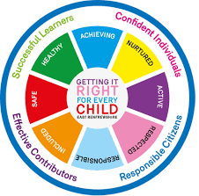

Focus:

Daily Prayers

Royal Navy Opportunity

Faith matters
Eucharistic Adoration from 12.20-1.00pm every Friday with the Rosary at 12.30pm. Mass in the Oratory, Tuesday, Thursday, Friday, 8.25am.

Mental Health Awareness

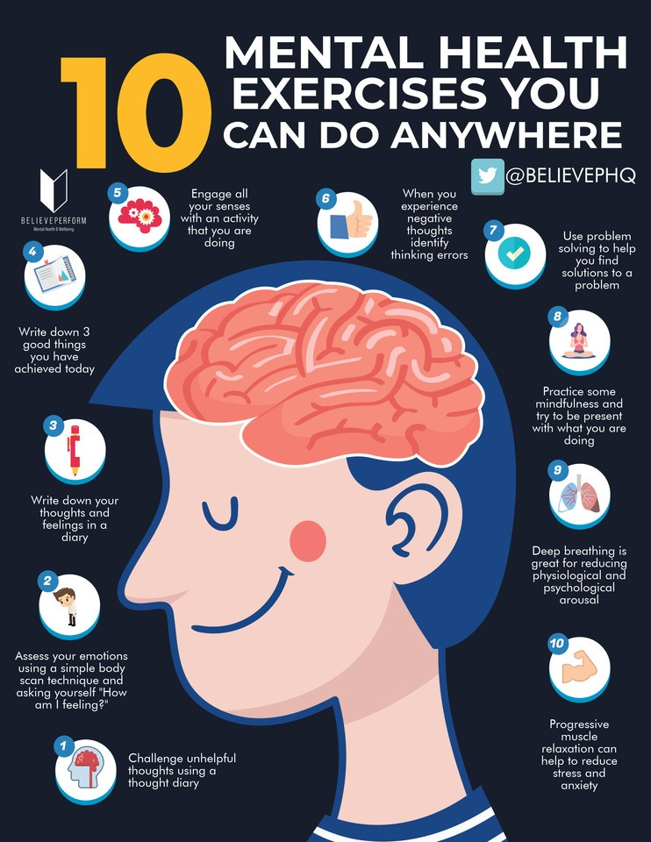

S1

1a7 – Mr Gallagher’s class to go to the oratory – take bags with you

Healthy Eating

GIRFEC – Wellbeing Wheel

Online Safety

Friendships

S2

Report Reflection – please complete full report targets and areas for development in PSHE Booklet – Page 43

Healthy Lifestyle

Subject Choices – Lesson 2

Subject Choices - Lesson 1

GIRFEC – Wellbeing Wheel

Friendships

S3

Diet Culture

GIRFEC – Wellbeing Wheel

Online Reputation

Friendships

S4

4a6 – Mr Gallagher’s class to go to the oratory – take bags with you

Please aim to finish all Mental Health and wellbeing work by the end of the lesson today

Mental Health and Wellbeing Award – Understanding Mental Health Issues.

- Lesson
- Marking Scheme

S5

Please aim to finish all Mental Health and wellbeing work by the end of the lesson today

Mental Health and Wellbeing Award – Influences on Mental Health
- Marking Scheme
- Slides to be covered for Unit 2 Outcome 1

S6

This will be the last period in class for you to complete your Diploma. Please complete using each QR code from the slides below.

One to One Tutoring Opportunity – Please complete with pupils if they would be interested in being a tutor for an S4 pupil

Diploma

S6 Service and Volunteering Opportunities

Writing your Personal Statement

E Ward

