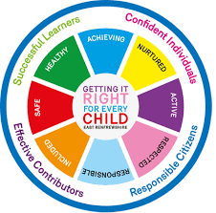
St Ninian’s High School
PSHE Newsletter
Week Beginning 16th August 2021

Pupil Focus:

Prayers

Floreat Iuventus

- Uniform Standards
- Health and Safety

Staff Focus / Professional Learning:

- Bullying- It’s Never Acceptable
- Fetal Alcohol Spectrum Disorder
- United Nations COP26 Climate Summit
- Ways of praying

Mental Health Awareness

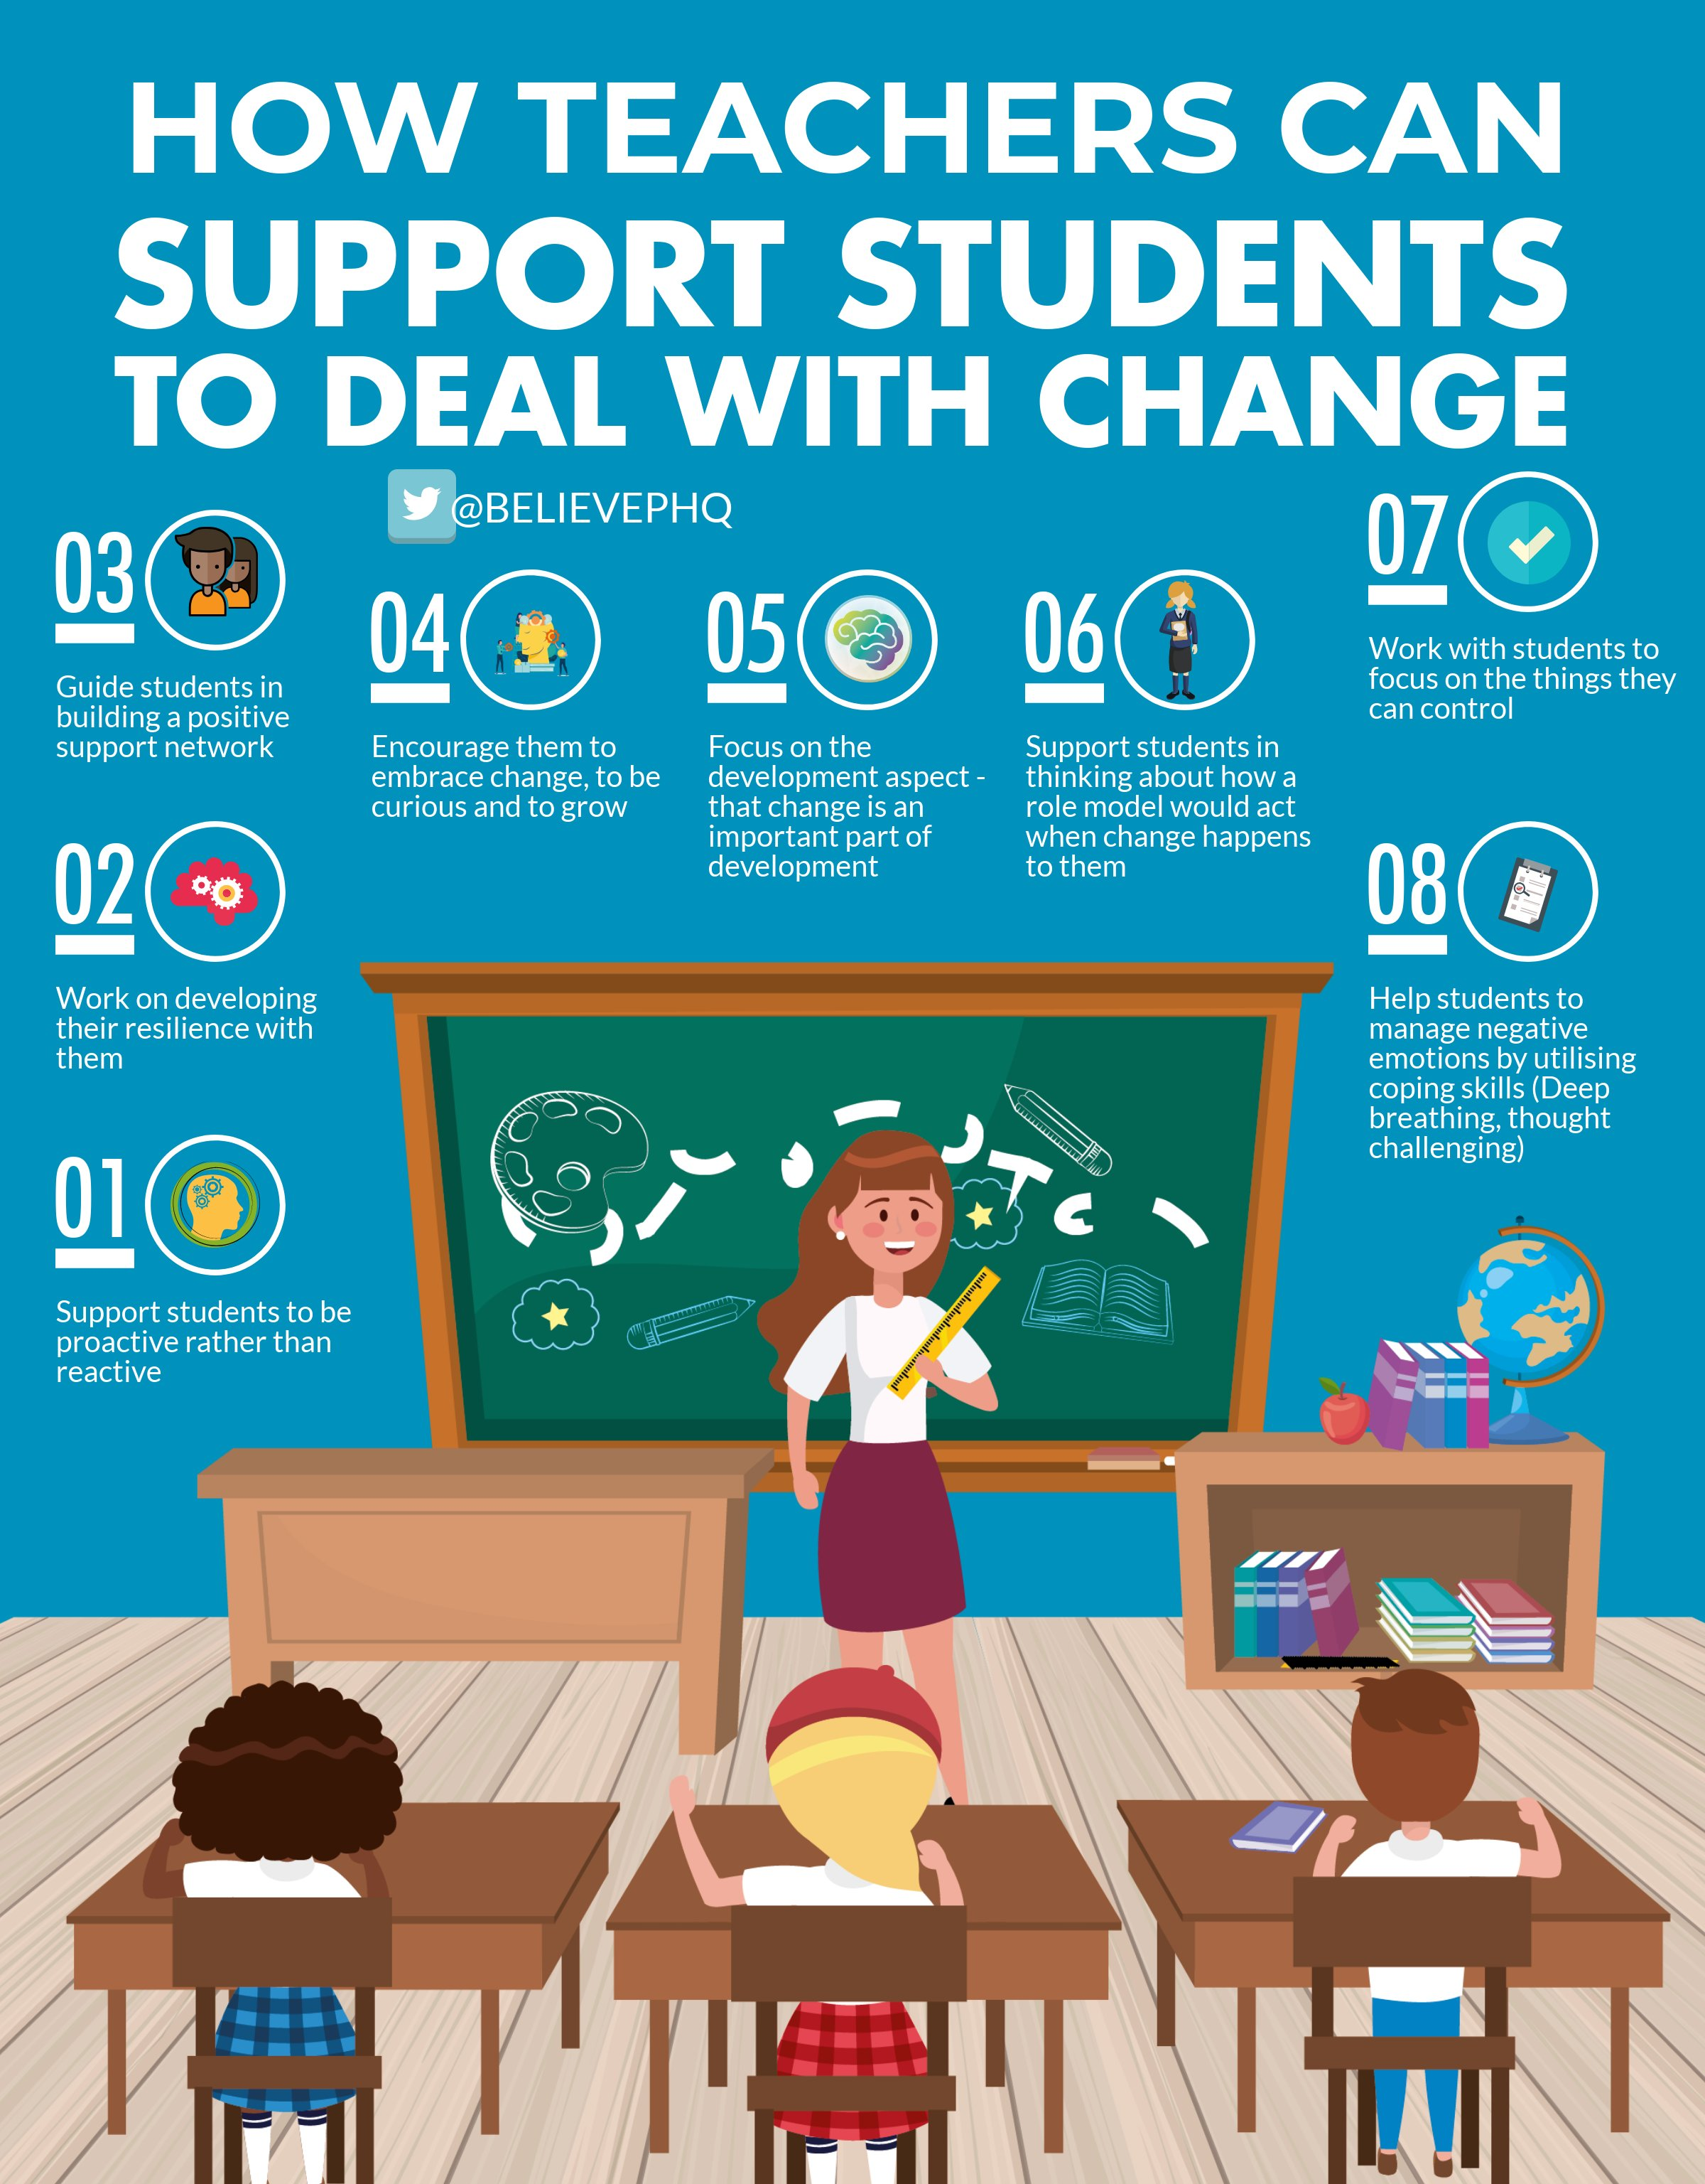

S1

From the 18th- 25th break will be 10.15 and lunch 12.10
From 26th-3rd break will be 10.20 and lunch 12.15

Induction Slides

Pupil Council Nominations to be completed ASAP. Please forward names to year head.

S2

Induction Slides

Pupil Council Nominations to be completed ASAP. Please forward names to year head.

S3

Induction Slides

Pupil Council Nominations to be completed ASAP. Please forward names to year head.

S4

Induction Slides

Pupil Council Nominations to be completed ASAP. Please forward names to year head.

S5

Induction Slides

Pupil Council Nominations to be completed ASAP. Please forward names to year head.

S6

Those applying for Medicine, Dentistry or Oxford should discuss with their Pastoral Support teacher a timeline of when they should complete a draft of their personal statement. This process must be completed as soon as possible.

Induction Slides

Diploma QR Codes for All Sections – Please ask pupils to complete any section they have not yet completed

- Responsible Citizen

- Effective Contributor

- Confident Individual

- Successful Learner

Pupil Council Nominations to be completed ASAP. Please forward names to year head.

E. Ward

