ST NINIAN’S HIGH SCHOOL
PSHE Newsletter & Lessons
Week Beginning 13th September 2021
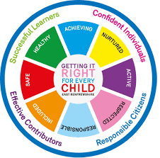

Focus:

Daily Prayers

Survey – Pupil Voice Have your Say S1-S6

Cross Stitch & Crochet Club – S1-S3

Debating & Public Speaking Club - S1-S3

Faith matters
Eucharistic Adoration from 12.20-1.00pm every Friday with the Rosary at 12.30pm. Mass in the Oratory, Tuesday, Thursday, Friday, 8.25am.

Mental Health Awareness

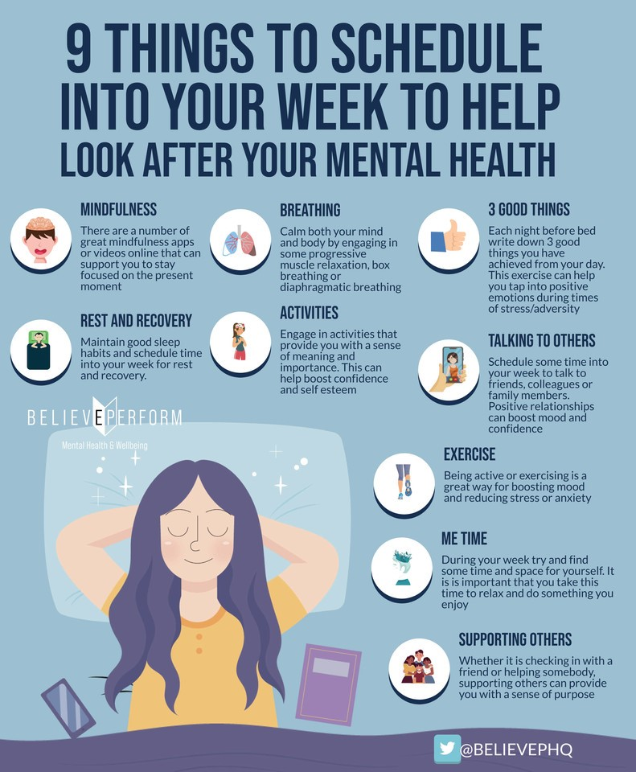

S1

1a6 – Mr McArthur’s class to go to the oratory

GIRFEC – Wellbeing Wheel

Online Safety

Friendships

Body Image

S2

Subject Choices – Lesson 2

Subject Choices - Lesson 1

GIRFEC – Wellbeing Wheel

Friendships

Body Image

S3

GIRFEC – Wellbeing Wheel

Online Reputation

Friendships

Body Image

S4

4a7 – Mrs Ward’s class to go to the oratory – take bags with you

Report Reflection – please complete report targets in booklet / diary

2nd last Period to complete you’re booklet!
Mental Health and Wellbeing Award – Understanding Mental Health Issues.

- Lesson
- Marking Scheme

S5

2nd last Period to complete you’re booklet!
Mental Health and Wellbeing Award – Influences on Mental Health
- Marking Scheme
- Slides to be covered for Unit 2 Outcome 1

S6

Diploma

S6 Service and Volunteering Opportunities

Writing your Personal Statement

E Ward

