ST NINIAN’S HIGH SCHOOL
PSHE Newsletter & Lessons
Week Beginning 6th September 2021
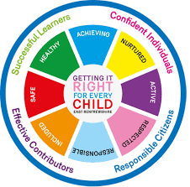

Focus:

Daily Prayers

Racial Equality

Library Info

Golf Competition

PE – Important Information

Faith matters
Eucharistic Adoration from 12.20-1.00pm every Friday with the Rosary at 12.30pm. Mass in the Oratory, Tuesday, Thursday, Friday, 8.25am.

Mental Health Awareness

S1

Learning for Sustainability

Friendships

S2

Subject Choices

S3

Learning for Sustainability

Friendships

S4

Learning for Sustainability

Mental Health and Wellbeing Award – Understanding Mental Health Issues.

- Lesson
- Marking Scheme

S5

Learning for Sustainability

Mental Health and Wellbeing Award – Influences on Mental Health
- Marking Scheme
- Slides to be covered for Unit 2 Outcome 1

S6

PLC Volunteering

Learning for Sustainability

Diploma

S6 Service and Volunteering Opportunities

Writing your Personal Statement

E Ward

