ST NINIAN’S HIGH SCHOOL
PSHE Newsletter & Lessons
Week Beginning 4th October 2021

Focus:

Daily Prayers

Flourishing in St Ninian’s

Faith matters
Eucharistic Adoration from 12.20-1.00pm every Friday with the Rosary at 12.30pm. Mass in the Oratory, Tuesday, Thursday, Friday, 8.25am.

Mental Health Awareness

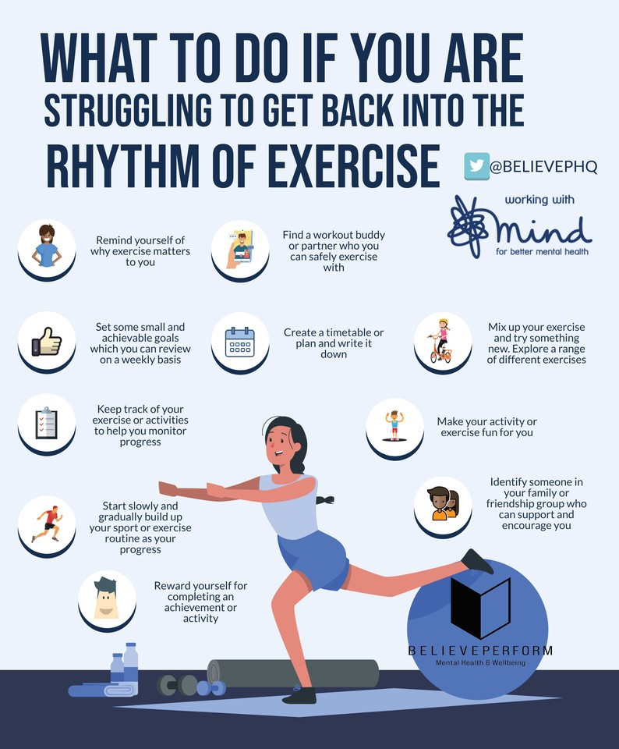

S1

Please pass pupil council names to year head by the end of the week – copy Mrs McCoy in to the email

1a9 – Miss Green’s class to go to the oratory – take bags with you

Health and Wellbeing IDL Log – Please spend 10 minutes at the start of the lesson filling out Log. Class packs to be collected from the Pastoral Base.

World Mental Health Day

Physical Activity

Healthy Eating

S2

Please pass pupil council names to year head by the end of the week – copy Mrs McCoy in to the email

World Mental Health Day

Physical Activity

Healthy Lifestyle

S3

Please pass pupil council names to year head by the end of the week – copy Mrs McCoy in to the email

World Mental Health Day

Mental Health – Eating Disorders

Physical Activity

Diet Culture

S4

Please pass pupil council names to year head by the end of the week – copy Mrs McCoy in to the email

4a9 – Mr McArthur’s class to go to the oratory – take bags with you

World Mental Health Day

Mental Health – Eating Disorders

Relationships

S5

Please pass pupil council names to year head by the end of the week – copy Mrs McCoy in to the email

World Mental Health Day

Mental Health – Eating Disorders

Relationships

S6

Please pass pupil council names to year head by the end of the week – copy Mrs McCoy in to the email

One to One Tutoring Opportunity – Please complete with pupils if they would be interested in being a tutor for an S4 pupil

World Mental Health Day

Mental Health – Eating Disorders

Careers

Writing your Personal Statement

E Ward

