ST NINIAN’S HIGH SCHOOL
PSHE Newsletter & Lessons
Week Beginning 1st November 2021
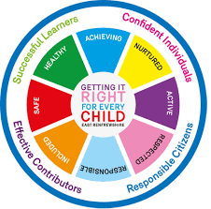

Focus:

Daily Prayers

Faith matters
Eucharistic Adoration from 12.20-1.00pm every Friday with the Rosary at 12.30pm. Mass in the Oratory, Tuesday, Thursday, Friday, 8.25am.

Mental Health Awareness
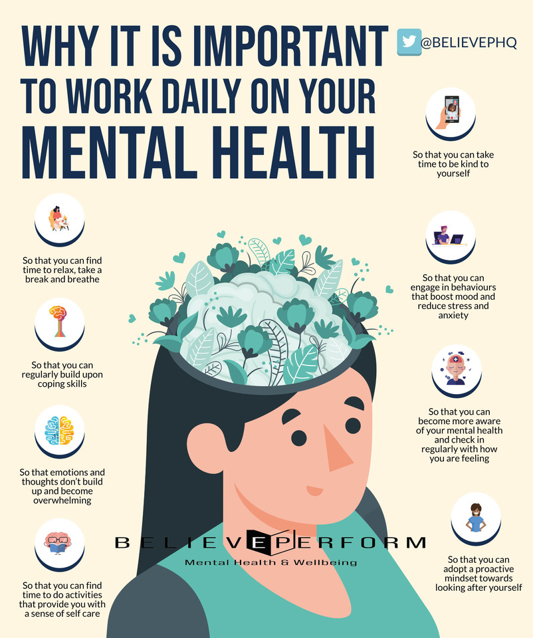

S1

Road Safety talks - Please collect speakers from the school office at the start of the lesson. Slides for the lesson are saved here

Wednesday - 1a9 & 1a10
Friday – 1a3 & 1a4

1a11 – Mr Low’s class to go to the oratory and take bags with you

Health and Wellbeing IDL Log – Please make sure sheets are completed and collected in

Positive Relationships

Firework Safety

Positive Mental Health

S2

Positive Relationships

Firework Safety

Positive Metal Health

S3

Complete report reflection in PSHE Booklet

Positive Relationships

Firework Safety

Study Skills

Mental Health – Eating Disorders

S4

4a6 – Mr Gallagher’s class to go to the oratory – take bags with you

Mental Health and Wellbeing Award – Influences on Mental Health (Unit 2)

- Marking Scheme
- Slides to be covered for Unit 2 Outcome 1

S5

Mental Health and Wellbeing Award – Influences on Mental Health (Unit 3)

- Marking Scheme
- Slides to be covered for Unit 3 Outcome 1

S6

All pupils should be working on their personal statement / completing UCAS form. Pupils who were fast track should ensure diploma is complete.

Careers

Writing your Personal Statement

E Ward

