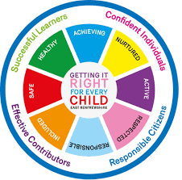
St Ninian’s High School
PSHE Newsletter
Week Beginning 31st August 2020

Focus:

Daily Prayers

• Faith matters
Eucharistic Adoration from 12.20-1.00pm every Friday with the Rosary at 12.30pm. Mass in the Oratory, Tuesday, Thursday, Friday, 8.25am. We will be putting in place guidance to manage social distance. National regulations for the celebration of Mass will be followed.

Updated Government Guidance – Please cover the below links with classes:

• FACTS – Please cover with all classes

• How to wear a face mask safely – Please cover the video with classes

• Education Maintenance Allowance – Please cover with S5 and S6

Career Appointments
• Any pupil who would like an appointment with the Careers Advisor should use their phone to complete the attached QR Code

Mental Health Awareness
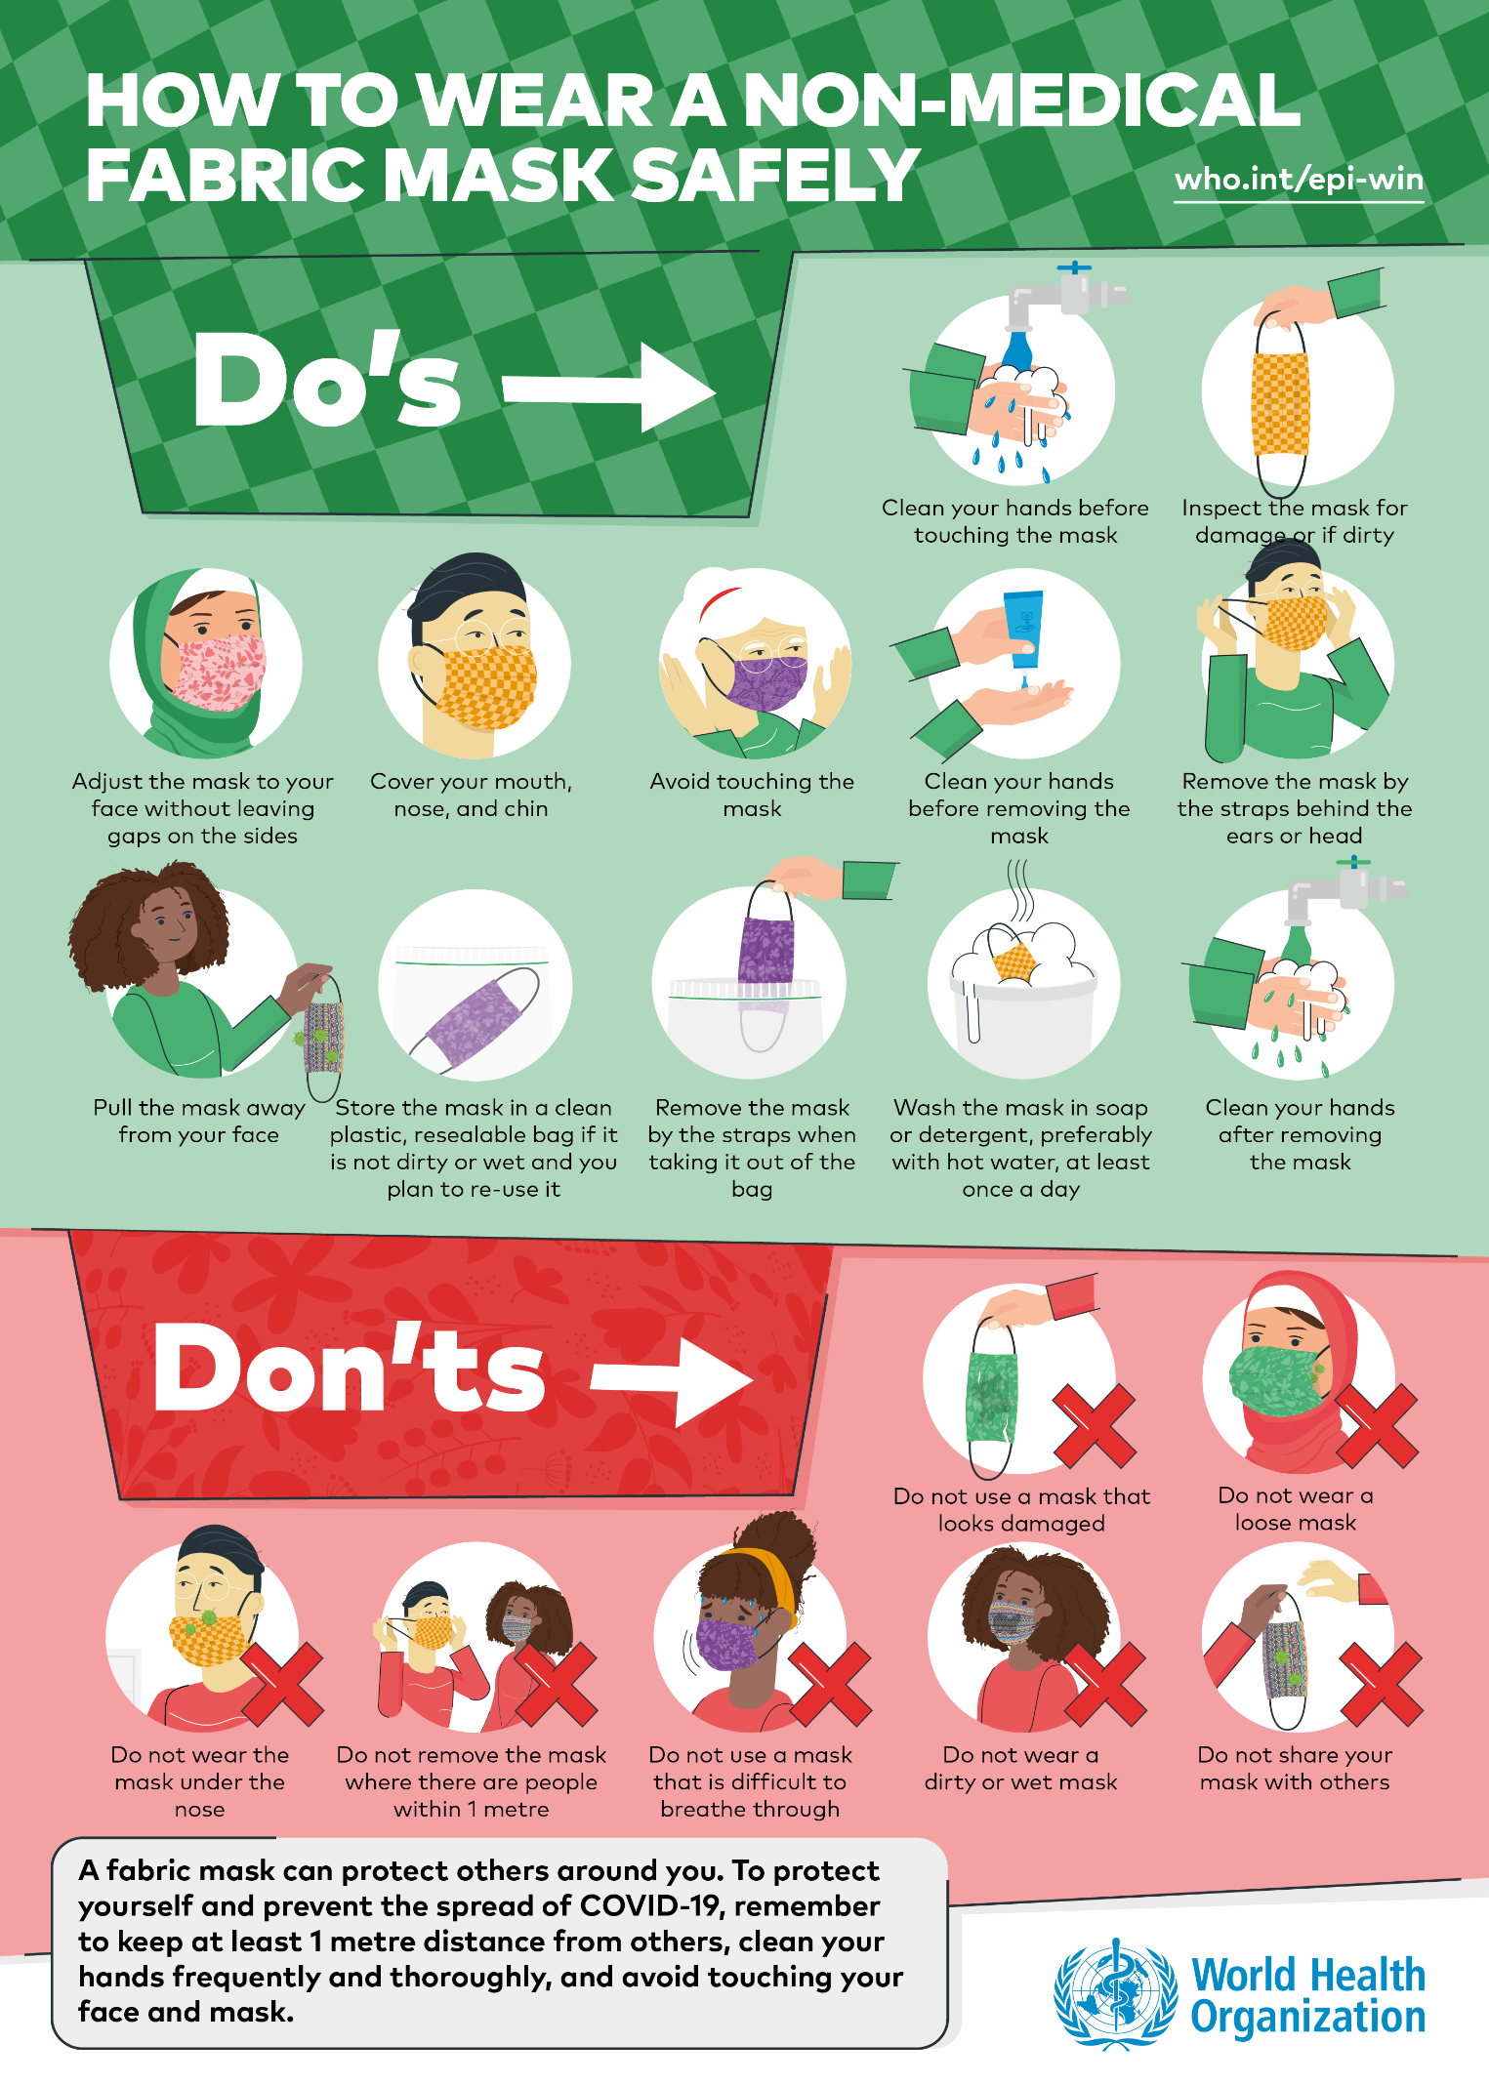

S1

Microsoft Teams – Please spend 10mins with classes to help familiarise themselves with how to use Microsoft Teams – If any pupil in your class is proficient please ask them to log on so that they can show the class how to navigate Teams.

GIRFEC Booklet – Work through SHANARRI Indicators and complete with class

Body Image

Health and Safety – Please cover with all classes

Pupil Council Nominations to be completed ASAP. Please forward names to year head.

S2

GIRFEC Booklet – Work through SHANARRI Indicators and complete with class

Study Skills for year ahead

Health and Safety – Please cover with all classes

Please ask pupils to use their phones to complete the form accessed through the linked QR code

What is Covid 19? – Please deliver to all classes

Body Image

Pupil Council Nominations to be completed ASAP. Please forward names to year head.
S3

Please ask pupils to use their phones to complete the form accessed through the linked QR code

GIRFEC Booklet – Work through SHANARRI Indicators and complete with class

Balanced Diet

Exercise Health and Fitness

Health and Safety – Please cover with all classes

What is Covid 19? – Please deliver to all classes

Pupil Council Nominations to be completed ASAP. Please forward names to year head.

S4

Mental Health and Wellbeing Award – Understanding Mental Health Issues
- Lesson
- Marking Scheme

Health and Safety – Please cover with all classes

What is Covid 19? – Please deliver to all classes

DYW Online Seminars 2020

S5

Opportunity for e-sgoil online Maths Tuition

Young Ambassador – Volunteering opportunity for pupils

GIRFEC Booklet – Work through SHANARRI Indicators and complete with class

Study Skills – in booklets, highlight the different types of approach to studying. Use ‘Notes’ page for this activity

Study Tips – Inside the mind of a Procrastinator

Health and Safety – Please cover with all classes

What is Covid 19? – Please deliver to all classes

DYW Online Seminars 2020

Pupil Council Nominations to be completed ASAP. Please forward names to year head.

S6

Deadline for YASS applications is 5pm this Friday, 4th September 2020

Referee Presentation – Mr Cheshire will visit classes to discuss with interested pupils

Health and Safety – Please cover with all classes

What is Covid 19? – Please deliver to all classes

Pupils should log on to their respective Google Classrooms/Microsoft Teams and complete their “All About Me” forms

Please ask pupils to check the DYW page on the school website for a range of opportunities regarding jobs and apprenticeships

ICE engineering opportunity for pupils

DYW Online Seminars 2020

Engineering Academy – Please cover with all S6 pupils

Can you pass the following information to those in your S6 Class applying for either Medicine, Dentistry, Veterinary Medicine, Oxford, Cambridge.

Pupil Council Nominations to be completed ASAP. Please forward names to year head.

Pupils should log on to the school website to see the advice available on how to complete their Personal Statement – See Below Hyperlinks

Link to school website and advice on completing Personal Statement

Link 1 – Advice on completing Personal Statement

Link 2 – How to structure Personal Statement

Fast Track applicants should hand first draft of personal statement to teacher for feedback. Also, log on to UCAS using phones or computers to ensure all information is up to date.

Diploma Completion for S6 pupils – See the below instructions

- Pupils go on to “Pupil Shared Area”
- Click on “PSHE”
- Pupils go on to “Diploma 2021”
- Pupils click on their own respective Alpha
- Click on the “S6 Diploma” and immediately save in the folder using their name.
- Pupils are to complete each section of the Diploma by writing in to the text box at the bottom of each section
- This will be a working document and pupils should save their work as they go
- It is important that when pupils are writing information in to the text box that they do not hit the return key as this will not work with the software when transferring on to the Diploma

Link to examples of previous diplomas

Link to Lesson for “Responsible Citizen”
Link to Lesson for “Confident Individual”
Link to Lesson for “Successful Learner”
T. Low

