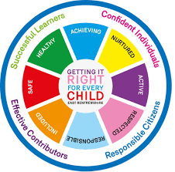
St Ninian’s High School
PSHE Newsletter
Week Beginning 24th August 2019

Focus:

Daily Prayers

•Pupils travelling on coaches are to be aware that there is no eating or drinking allowed when travelling to and from school. Please respect this rule and do not eat/drink whilst traveling on the school bus.

•School Entrances

To minimise large numbers around the entrances. Pupils must enter and exit through specific doors depending on the class that they will be in that session. Pupils must make sure they have checked their timetable.
- Front Door: Modern languages/ Business/ Computing ICT 4 and 5/ Art
- English doors: English/ Maths/ Music /RE
- Technical doors: Technical/Home Economics/ Modern Studies and History (access via HE corridor)
- Science doors: The Sciences/ Geography/ Computing ICT 2 and 3
Hand sanitiser will be available at each entrance which pupils must use when entering the building.

• Faith matters
Eucharistic Adoration from 12.20-1.00pm every Friday with the Rosary at 12.30pm. Mass in the Oratory, Tuesday, Thursday, Friday, 8.25am. We will be putting in place guidance to manage social distance. National regulations for the celebration of Mass will be followed.

• Blessings and Prayers I have attached a letter of solicitude from Archbishop Tartaglia offering his prayers and support for the school year.

Lockers

All S2-S6 locker holders should ensure their locker is securely closed and padlocked.

All lockers must be secure by Friday 28th August. After this date, any insecure lockers will be reallocated and you will lose your locker. If procedures are not followed, Pupils are at risk of losing their lockers.

S1 pupils are currently NOT able to purchase a locker.

Career Appointments
• Any pupil who would like an appointment with the Careers Advisor should use their phone to complete the attached QR Code

Mental Health Awareness
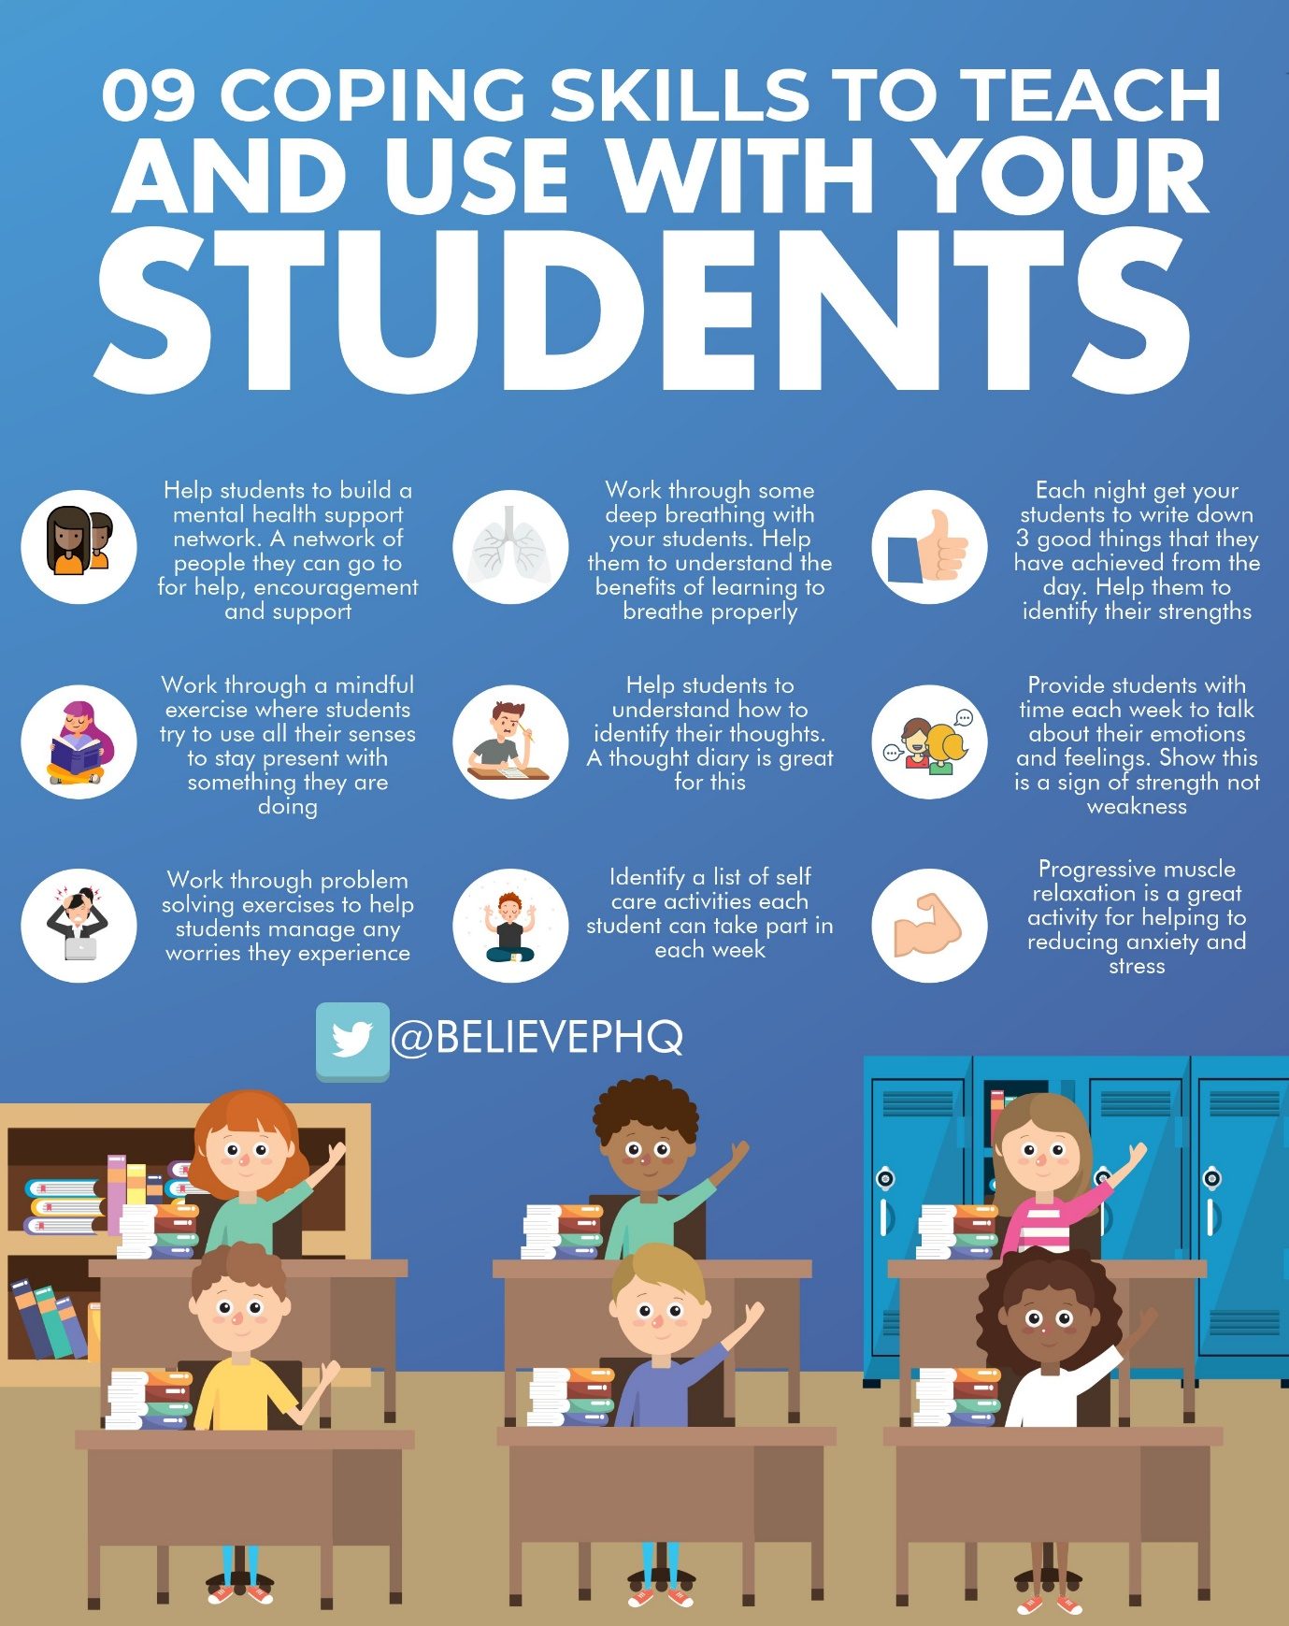

S1

Health and Safety – Please cover with all classes

What is Covid 19? – Please deliver to all classes

Until the 21st August S1 pupils will receive their lunch from 12.10pm

Induction Slides

Pupil Council Nominations to be completed ASAP. Please forward names to year head.

S2

Health and Safety – Please cover with all classes

Please ask pupils to use their phones to complete the form accessed through the linked QR code

What is Covid 19? – Please deliver to all classes

Body Image

Induction Slides

Pupil Council Nominations to be completed ASAP. Please forward names to year head.

S3

Health and Safety – Please cover with all classes

Please ask pupils to use their phones to complete the form accessed through the linked QR code

What is Covid 19? – Please deliver to all classes

Induction Slides

Pupil Council Nominations to be completed ASAP. Please forward names to year head.

S4

Health and Safety – Please cover with all classes

What is Covid 19? – Please deliver to all classes

DYW Online Seminars 2020

Mental Health and Wellbeing Award – Understanding Mental Health Issues
- Lesson
- Marking Scheme

Induction Slides

Pupil Council Nominations to be completed ASAP. Please forward names to year head.
S5

Health and Safety – Please cover with all classes

What is Covid 19? – Please deliver to all classes

DYW Online Seminars 2020

Induction Slides

Pupil Council Nominations to be completed ASAP. Please forward names to year head.

S6

Health and Safety – Please cover with all classes

What is Covid 19? – Please deliver to all classes

Pupils should log on to their respective Google Classrooms/Microsoft Teams and complete their “All About Me” forms

Please ask pupils to check the DYW page on the school website for a range of opportunities regarding jobs and apprenticeships

ICE engineering opportunity for pupils

DYW Online Seminars 2020

Engineering Academy – Please cover with all S6 pupils

Can you pass the following information to those in your S6 Class applying for either Medicine, Dentistry, Veterinary Medicine, Oxford, Cambridge.

Pupil Council Nominations to be completed ASAP. Please forward names to year head.

Pupils should log on to the school website to see the advice available on how to complete their Personal Statement – See Below Hyperlinks

Link to school website and advice on completing Personal Statement

Link 1 – Advice on completing Personal Statement

Link 2 – How to structure Personal Statement

Fast Track applicants should hand first draft of personal statement to teacher for feedback. Also, log on to UCAS using phones or computers to ensure all information is up to date.

Diploma Completion for S6 pupils – See the below instructions

- Pupils go on to “Pupil Shared Area”
- Click on “PSHE”
- Pupils go on to “Diploma 2021”
- Pupils click on their own respective Alpha
- Click on the “S6 Diploma” and immediately save in the folder using their name.
- Pupils are to complete each section of the Diploma by writing in to the text box at the bottom of each section
- This will be a working document and pupils should save their work as they go
- It is important that when pupils are writing information in to the text box that they do not hit the return key as this will not work with the software when transferring on to the Diploma

Link to examples of previous diplomas

Link to Lesson for “Responsible Citizen”
Link to Lesson for “Confident Individual”
Link to Lesson for “Successful Learner”
T. Low

