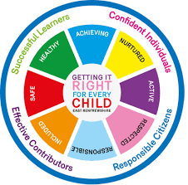
St Ninian’s High School
PSHE Newsletter
Week Beginning 19th October 2020

Focus:

• Faith matters
Eucharistic Adoration from 12.20-1.00pm every Friday with the Rosary at 12.30pm. Mass in the Oratory, Tuesday, Thursday, Friday, 8.25am. We will be putting in place guidance to manage social distance. National regulations for the celebration of Mass will be followed.

PSHE Prayers

• The Dangers of mobile phone/tablet use for young people – “Dear Student” film. Please show to all classes

• Assembly Slides
Please cover relevant information with each PSHE Class

• The Science of Learning

Sports Ambassadors Announcement

Firstly, thank you to those who applied for Sports Ambassador. A massive congratulations in particular, to Orla Mulhern and Gemma Tolland who have been selected to be this year’s S5 Sports Ambassadors 2020. Can all those who applied please meet Miss Miller on Friday at break time.

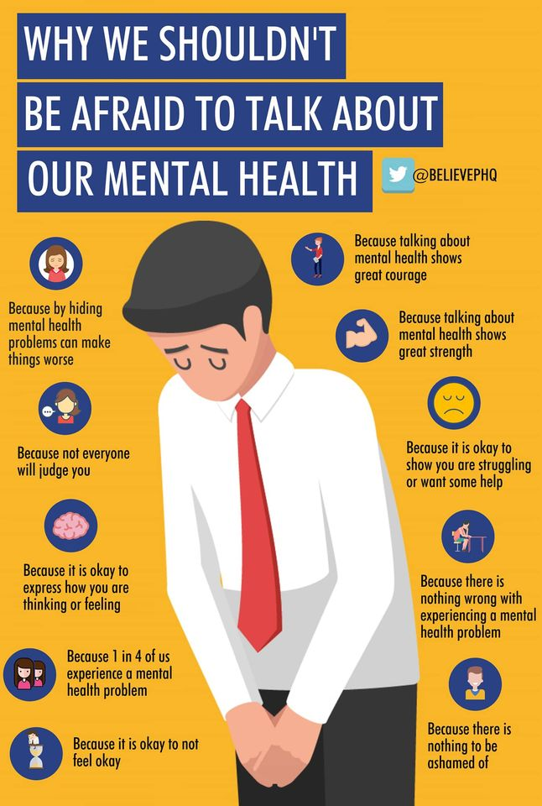
Mental Health Awareness

S1

Online friends and Gaming – Keep yourself safe

Survey following Interim report TBC by all pupils – click for QR Code

Homework Diary Checks

• Talented Athletes programme – Please encourage S1 pupils

Sponsored event for S1 pupils – Please cover with all classes

Complete Wellbeing Web for Term 1 in PSHE booklets Page 19 and complete All About Me on page 21 & 22

Carolside Sports Club 2008s opportunity for pupils

S2

The Impact of Bullying

Survey following Interim report TBC by all pupils – click for QR Code

• Talented Athletes programme – Please encourage S2 pupils

Sponsored event for S2 pupils – Please cover with all classes

Please ask all S2 pupils to complete the online survey regarding their interim report using their SCN

Tracking conversation with pupils / Target setting. Ask pupils to use their School Diaries to set targets from Pastoral Conversation

Hunting the Cyber Bullies - Clickview -Panorama February 2012. Watch video and use Powerpoint with class
S3

My World of Work

Survey following Interim report TBC by all pupils – click for QR Code

Please ask all S3 pupils to complete the online survey regarding their interim report using their SCN

Tracking conversation with pupils / Target setting. Ask pupils to use their School Diaries to set targets from Pastoral Conversation

Homework Diary Check – Please check and sign pupils Diaries

My World of Work

Body Image

Sound Sleep

GIRFEC Booklet – Work through SHANARRI Indicators and complete with class

S4

BGE Badges – Please cover with all classes and give out badges

PSHE Booklet – Health and Wellbeing Pages 10, 11, 12 & 13.
Complete Term 1 Sections

Study Timetable Template – Please highlight to pupils and print off if pupils would like a copy.

Tracking Reports to be covered by Pastoral Teachers – See email from Mrs Wilson

Wednesday 21st / 28th October – Campus Police officer talk will commence in each class at different stages throughout the period

21st October
28th October
4a9
4a10

4a6
4a7
4a8

Friday 23^{rd /} 30th October – Campus Police officer talk will commence in each class at different stages throughout the period

23rd October
30th October
4a4
4a5

4a1
4a2
4a3

Mental Health and Wellbeing Award – Influences on Mental Health
- Marking Scheme
- Slides to be covered for Unit 2

S5

Keeping Myself Safe- Safety at Parties & Nights Out -Jo’s story

Study Timetable Template – Please Highlight to pupils and print off if pupils would like a copy.

Sound Sleep

Prepare a Study Plan – What do top students do?
Watch the video and look to see how you can create an effective study plan for yourself

Complete S5 achievements profile on Pages 36, 37, 38 and 39. Also complete Academic transferable skills and Attributes Page 40.
GIRFEC Booklet – Work through SHANARRI Indicators and complete with class

S6

SCQF Volunteering Unit 1 - Unit 1 booklet will be sent out to staff who will then upload as an assignment on teams / Google classrooms. Pupils should complete this on computers and save their progress on their own individual H drives

Engineering Webinars – Please show to all classes

Year Book – Please show slide to all S6 pupils

Maths Textbooks – Please return any Maths books that you used last year. These books cannot be replaced by the department and are needed by pupils who are sitting Maths this year

Mental Health Committee – Please pass any names on to
C. McCallum if pupils are interested in becoming a Mental Health First Aider

SCQF Volunteering Unit 1 - Unit 1 booklet will be sent out to staff who will then upload as an assignment on teams / Google classrooms. Pupils should complete this on computers and save their progress on their own individual H drives

Career Appointments
• Any pupil who would like an appointment with the Careers Advisor should use their phone to complete the attached QR Code

Pupils should log on to their respective Google Classrooms/Microsoft Teams and complete their “All About Me” forms

Please ask pupils to check the DYW page on the school website for a range of opportunities regarding jobs and apprenticeships

Pupils are to leave class at 1.45pm to avoid corridor congestion

All about me – Complete with class

Pupils should log on to the school website to see the advice available on how to complete their Personal Statement – See Below Hyperlinks

Link to school website and advice on completing Personal Statement

Link 1 – Advice on completing Personal Statement

Link 2 – How to structure Personal Statement

Fast Track applicants should hand first draft of personal statement to teacher for feedback. Also, log on to UCAS using phones or computers to ensure all information is up to date.

Diploma Completion for S6 pupils – See the below instructions

- Pupils go on to “Pupil Shared Area”
- Click on “PSHE”
- Pupils go on to “Diploma 2021”
- Pupils click on their own respective Alpha
- Click on the “S6 Diploma” and immediately save in the folder using their name.
- Pupils are to complete each section of the Diploma by writing in to the text box at the bottom of each section
- This will be a working document and pupils should save their work as they go
- It is important that when pupils are writing information in to the text box that they do not hit the return key as this will not work with the software when transferring on to the Diploma

Link to examples of previous diplomas

Link to Lesson for “Responsible Citizen”
Link to Lesson for “Confident Individual”
Link to Lesson for “Successful Learner”
T. Low

