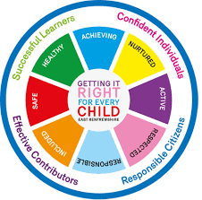
St Ninian’s High School
PSHE Newsletter
Week Beginning 17th August 2019

Focus:

Daily Prayers

•Pupils travelling on coaches are to be aware that there is no eating or drinking allowed when travelling to and from school. Please respect this rule and do not eat/drink whilst traveling on the school bus.

• Pupils are reminded that they should not at any point use the Playground at OLM to access St. Ninian’s. Please use the public footpath

• Faith matters
Eucharistic Adoration from 12.20-1.00pm every Friday with the Rosary at 12.30pm. Mass in the Oratory, Tuesday, Thursday, Friday, 8.25am. We will be putting in place guidance to manage social distance. National regulations for the celebration of Mass will be followed.

Lockers

All S2-S6 locker holders should ensure their locker is securely closed and padlocked.

All lockers must be secure by Friday 28th August. After this date, any insecure lockers will be reallocated and you will lose your locker. If procedures are not followed, Pupils are at risk of losing their lockers.

S1 pupils are currently NOT able to purchase a locker.

Mental Health Awareness
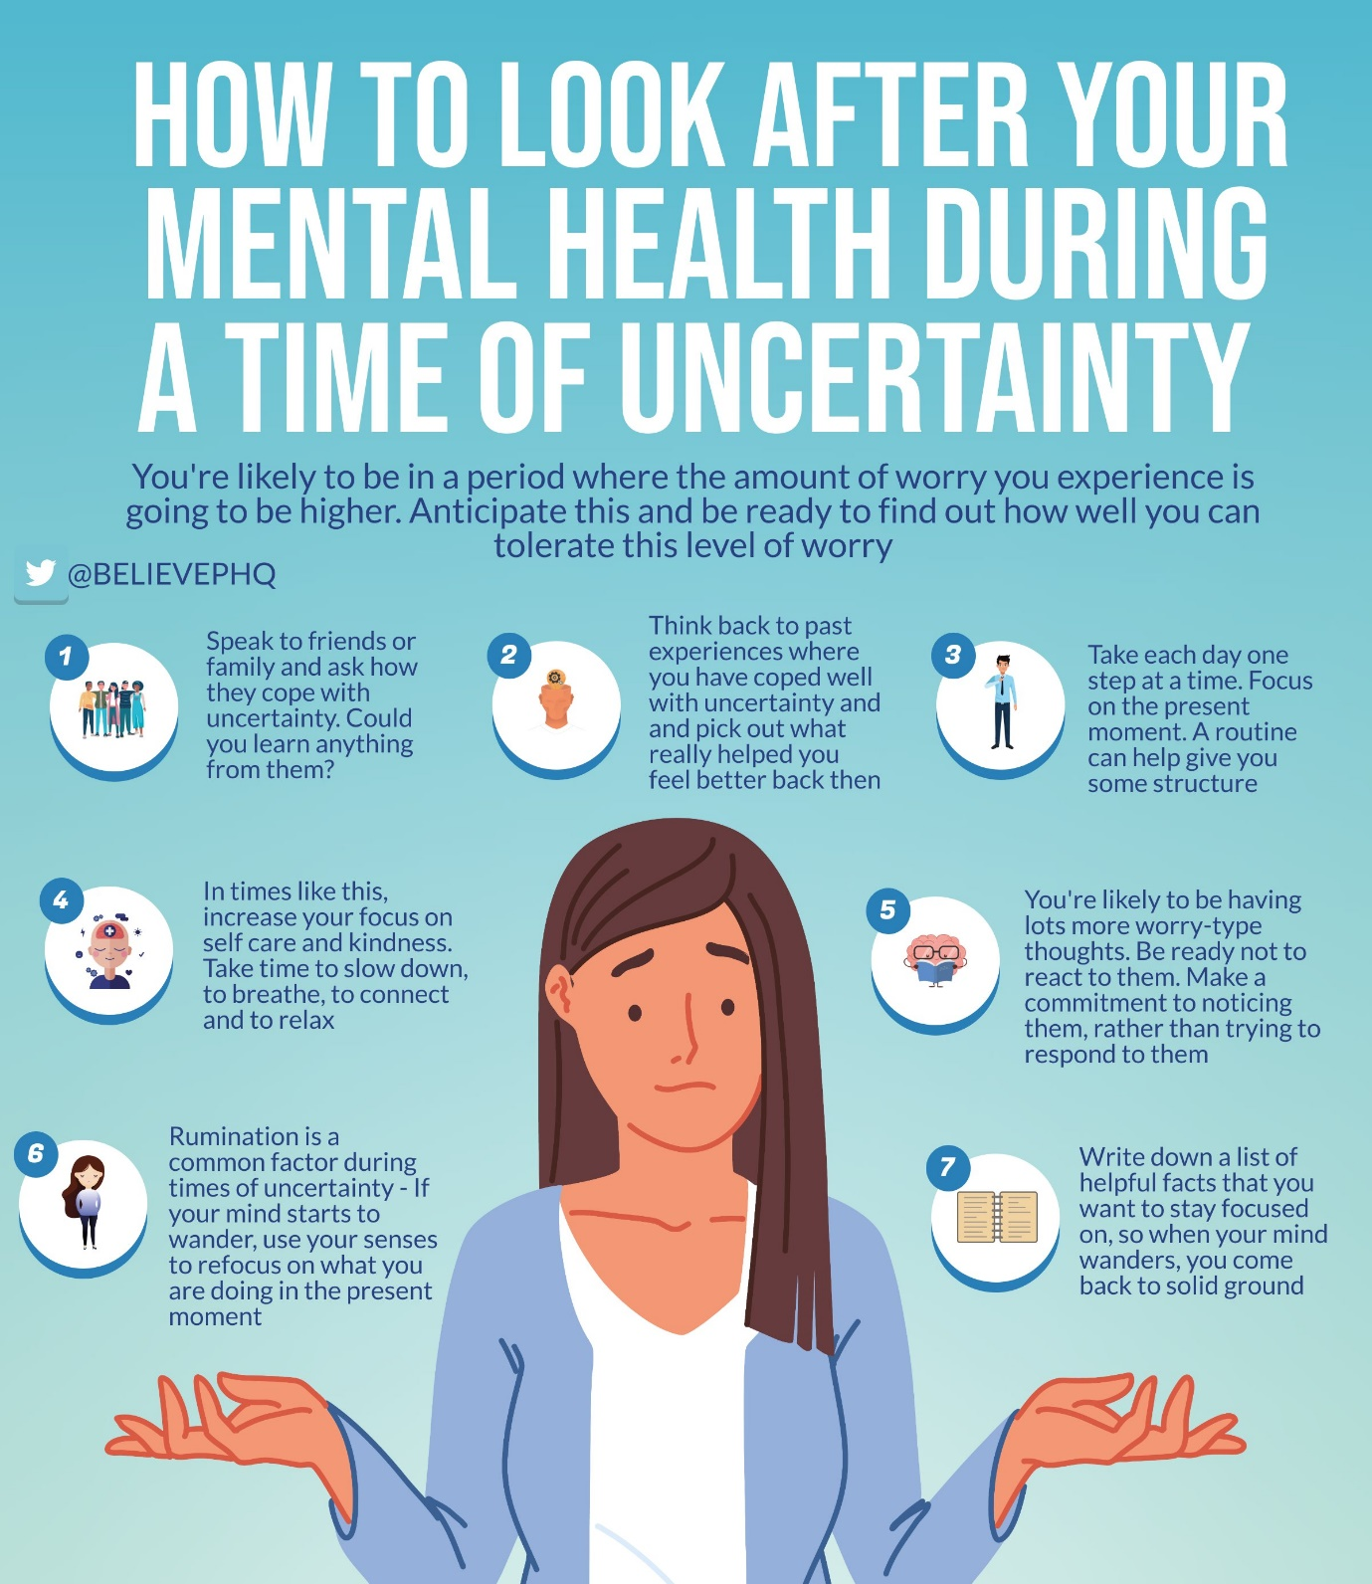

S1

Until the 21st August S1 pupils will receive their lunch from 12.10pm

Induction Slides

Pupil Council Nominations to be completed ASAP. Please forward names to year head.

S2

Body Image

Induction Slides

Pupil Council Nominations to be completed ASAP. Please forward names to year head.

S3

Induction Slides

Pupil Council Nominations to be completed ASAP. Please forward names to year head.

S4

DYW Online Seminars 2020

Mental Health and Wellbeing Award – Understanding Mental Health Issues
- Lesson
- Marking Scheme

Induction Slides

Pupil Council Nominations to be completed ASAP. Please forward names to year head.

S5

DYW Online Seminars 2020

Induction Slides

Pupil Council Nominations to be completed ASAP. Please forward names to year head.

S6

ICE engineering opportunity for pupils

DYW Online Seminars 2020

Engineering Academy – Please cover with all S6 pupils

Can you pass the following information to those in your S6 Class applying for either Medicine, Dentistry, Veterinary Medicine, Oxford, Cambridge.

Pupil Council Nominations to be completed ASAP. Please forward names to year head.

Pupils should log on to the school website to see the advice available on how to complete their Personal Statement – See Below Hyperlinks

Link to school website and advice on completing Personal Statement

Link 1 – Advice on completing Personal Statement

Link 2 – How to structure Personal Statement

Fast Track applicants should hand first draft of personal statement to teacher for feedback. Also, log on to UCAS using phones or computers to ensure all information is up to date.

Diploma Completion for S6 pupils – See the below instructions

- Pupils go on to “Pupil Shared Area”
- Click on “PSHE”
- Pupils go on to “Diploma 2021”
- Pupils click on their own respective Alpha
- Click on the “S6 Diploma” and immediately save in the folder using their name.
- Pupils are to complete each section of the Diploma by writing in to the text box at the bottom of each section
- This will be a working document and pupils should save their work as they go
- It is important that when pupils are writing information in to the text box that they do not hit the return key as this will not work with the software when transferring on to the Diploma

Link to examples of previous diplomas

Link to Lesson for “Responsible Citizen”
Link to Lesson for “Confident Individual”
Link to Lesson for “Successful Learner”
T. Low

