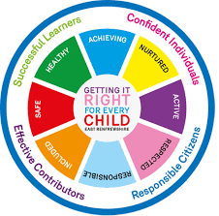
St Ninian’s High School
PSHE Newsletter
Week Beginning 14th September 2020

Focus:

• Faith matters
Eucharistic Adoration from 12.20-1.00pm every Friday with the Rosary at 12.30pm. Mass in the Oratory, Tuesday, Thursday, Friday, 8.25am. We will be putting in place guidance to manage social distance. National regulations for the celebration of Mass will be followed.

• Library procedures – Please cover with classes

- Discussion of Interim report for S4
Teachers should discuss the Negotiated Target and On Track to Achieve Grades with pupils explaining how the grades have been decided. Pastoral staff and Year Head will review the Reports and discuss the action required by pupils, support required from parents, & areas for action through support

• Assembly Slides
Please cover relevant information with each PSHE Class

• How to wear a face mask safely – Please cover the video with classes

Promoting Children and Young People’s Mental Health

Scroll to bottom of the link and watch “How to talk about mental health” video

Mental Health Awareness

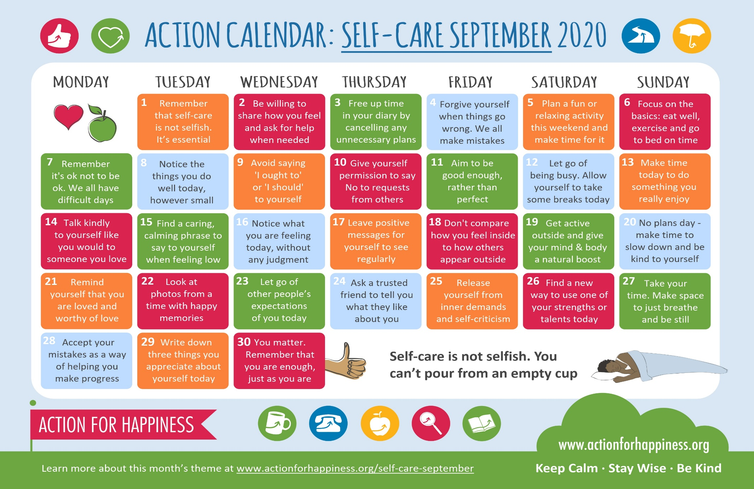

Personal Hygiene – Covid 19
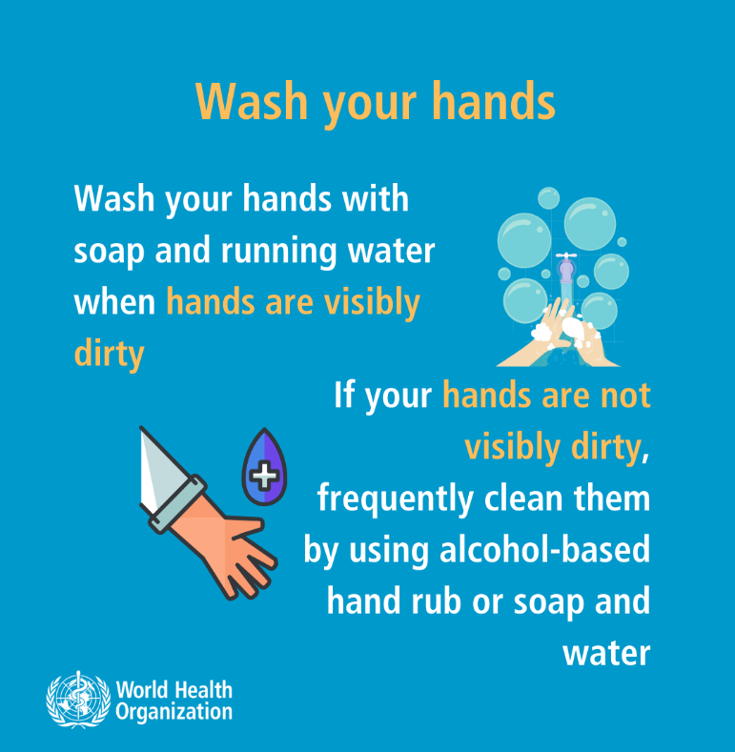
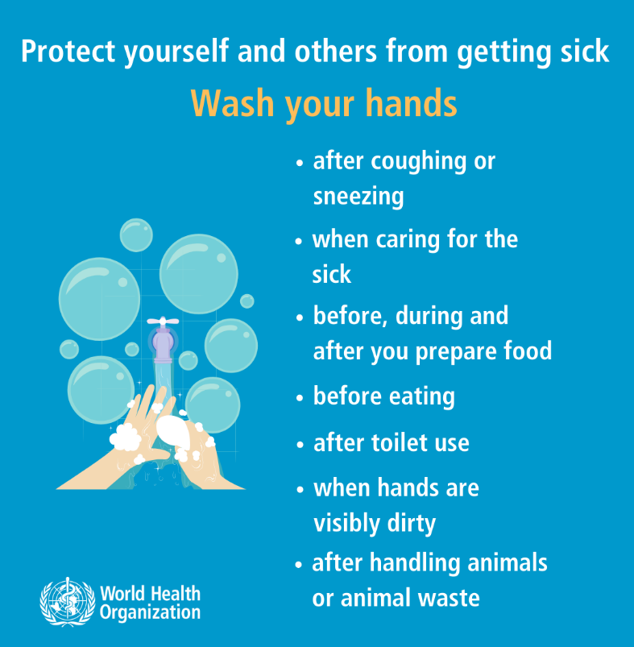

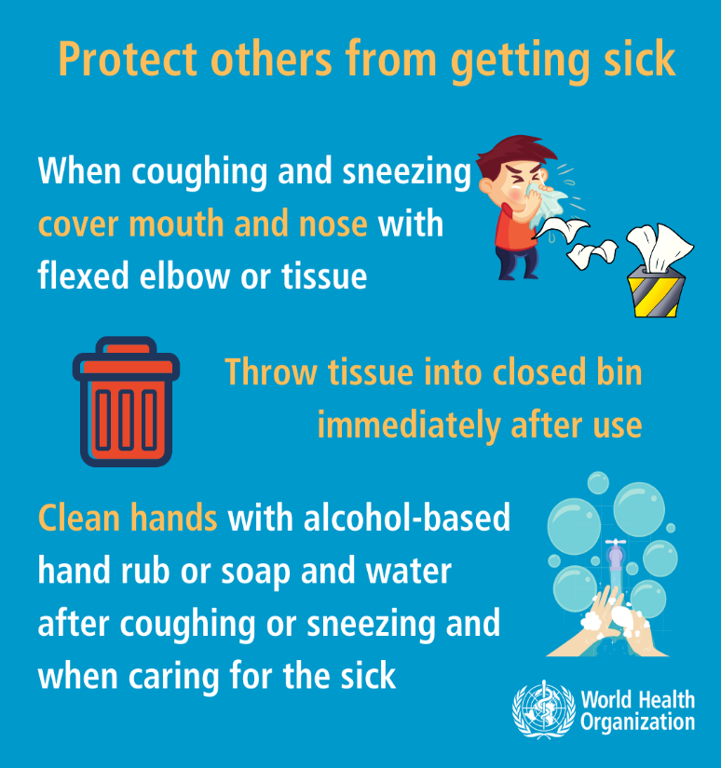

S1

Football Trials – Please ask pupils to complete the Microsoft form via the QR code if they are interested in trying out for the team. Pupils will need to log in with the @glow.sch.uk addresses.

- Boys
- Junior Girls

Olympics Event for all S1 pupils beginning 14th September – Please promote to all pupils

Staying Safe Online

GIRFEC Booklet – Work through SHANARRI Indicators and complete with class

Pupil Council Nominations to be completed ASAP. Please forward names to year head.

S2

Extracurricular Sports Opportunities – Please cover with all pupils
- Slide 1
- Slide 2

Football Trials – Please ask pupils to complete the Microsoft form via the QR code if they are interested in trying out for the team. Pupils will need to log in with the @glow.sch.uk addresses.

- Boys
- Junior Girls

Child Protection

Please ask pupils to use their phones to complete the form accessed through the linked QR code

Internet Safety

GIRFEC Booklet – Work through SHANARRI Indicators and complete with class

Pupil Council Nominations to be completed ASAP. Please forward names to year head.

S3

Football Trials – Please ask pupils to complete the Microsoft form via the QR code if they are interested in trying out for the team.
Pupils will need to log in with the @glow.sch.uk addresses.

- Boys
- Junior Girls

Please ask pupils to use their phones to complete the form accessed through the linked QR code

Sound Sleep

GIRFEC Booklet – Work through SHANARRI Indicators and complete with class

Pupil Council Nominations to be completed ASAP. Please forward names to year head.

S4

Football Trials – Please ask pupils to complete the Microsoft form via the QR code if they are interested in trying out for the team.
Pupils will need to log in with the @glow.sch.uk addresses.

PSHE Booklet – Health and Wellbeing Pages 10, 11, 12 & 13.
Complete Term 1 Sections

Study Tips – Inside the mind of a Procrastinator

Study Skills for S4 – Study Skills Video

Mental Health and Wellbeing
The attached slides cover how pupils, parents and staff can access support for a range of Mental Health issues. The information here can also be accessed on the main school website.

Mental Health and Wellbeing Award – Understanding Mental Health Issues
- Marking Scheme

S5

Football Trials – Please ask pupils to complete the Microsoft form via the QR code if they are interested in trying out for the team.
Pupils will need to log in with the @glow.sch.uk addresses.

Career Appointments
• Any pupil who would like an appointment with the Careers Advisor should use their phone to complete the attached QR Code

Prepare a Study Plan – What do top students do?
Watch the video and look to see how you can create an effective study plan for yourself

Complete S5 achievements profile on Pages 36, 37, 38 and 39. Also complete Academic transferable skills and Attributes Page 40.

Education Maintenance Allowance – Please cover with S5 and S6

Opportunity for e-sgoil online Maths Tuition

GIRFEC Booklet – Work through SHANARRI Indicators and complete with class

Study Skills – in booklets, highlight the different types of approach to studying. Use ‘Notes’ page for this activity

DYW Online Seminars 2020

Pupil Council Nominations to be completed ASAP. Please forward names to year head.

S6

Engineering Webinars – Please show to all classes

Year Book – Please show slide to all S6 pupils

Maths Textbooks – Please return any Maths books that you used last year. These books cannot be replaced by the department and are needed by pupils who are sitting Maths this year

Football Trials – Please ask pupils to complete the Microsoft form via the QR code if they are interested in trying out for the team.
Pupils will need to log in with the @glow.sch.uk addresses.

Mental Health Committee – Please pass any names on to
C. McCallum if pupils are interested in becoming a Mental Health First Aider

SCQF Volunteering Unit 1 - Unit 1 booklet will be sent out to staff who will then upload as an assignment on teams / Google classrooms. Pupils should complete this on computers and save their progress on their own individual H drives

Career Appointments
• Any pupil who would like an appointment with the Careers Advisor should use their phone to complete the attached QR Code

Pupils should log on to their respective Google Classrooms/Microsoft Teams and complete their “All About Me” forms

Please ask pupils to check the DYW page on the school website for a range of opportunities regarding jobs and apprenticeships

Pupils are to leave class at 1.45pm to avoid corridor congestion

All about me – Complete with class

Pupils should log on to the school website to see the advice available on how to complete their Personal Statement – See Below Hyperlinks

Link to school website and advice on completing Personal Statement

Link 1 – Advice on completing Personal Statement

Link 2 – How to structure Personal Statement

Fast Track applicants should hand first draft of personal statement to teacher for feedback. Also, log on to UCAS using phones or computers to ensure all information is up to date.

Diploma Completion for S6 pupils – See the below instructions

- Pupils go on to “Pupil Shared Area”
- Click on “PSHE”
- Pupils go on to “Diploma 2021”
- Pupils click on their own respective Alpha
- Click on the “S6 Diploma” and immediately save in the folder using their name.
- Pupils are to complete each section of the Diploma by writing in to the text box at the bottom of each section
- This will be a working document and pupils should save their work as they go
- It is important that when pupils are writing information in to the text box that they do not hit the return key as this will not work with the software when transferring on to the Diploma

Link to examples of previous diplomas

Link to Lesson for “Responsible Citizen”
Link to Lesson for “Confident Individual”
Link to Lesson for “Successful Learner”
T. Low

