St Ninian’s High School
PSHE Newsletter
Week Beginning 12th August 2020

Focus:

Daily Prayers

• Staff Information Bulletin incorporating new session reminders for staff. Please take time to remind yourself of the policies, procedures & professional standards expected of employees of ERC.

• Code of Conduct (School Circular C9).

• Pupil Movement (School Circular C10) – PTs should discuss at a DM the times when their corridors are busy and exit and entry procedures from classrooms and labs will require close attention.

• The Return to School: Transition and Recovery video can be accessed here: https://youtu.be/QKwAAu0k-DQ
The video is 25 minutes long and involves input from some East Renfrewshire children, young people and practitioners.

• Pupils are reminded that they should not at any point use the Playground at OLM to access St. Ninian’s. Please use the public footpath

Mental Health Awareness

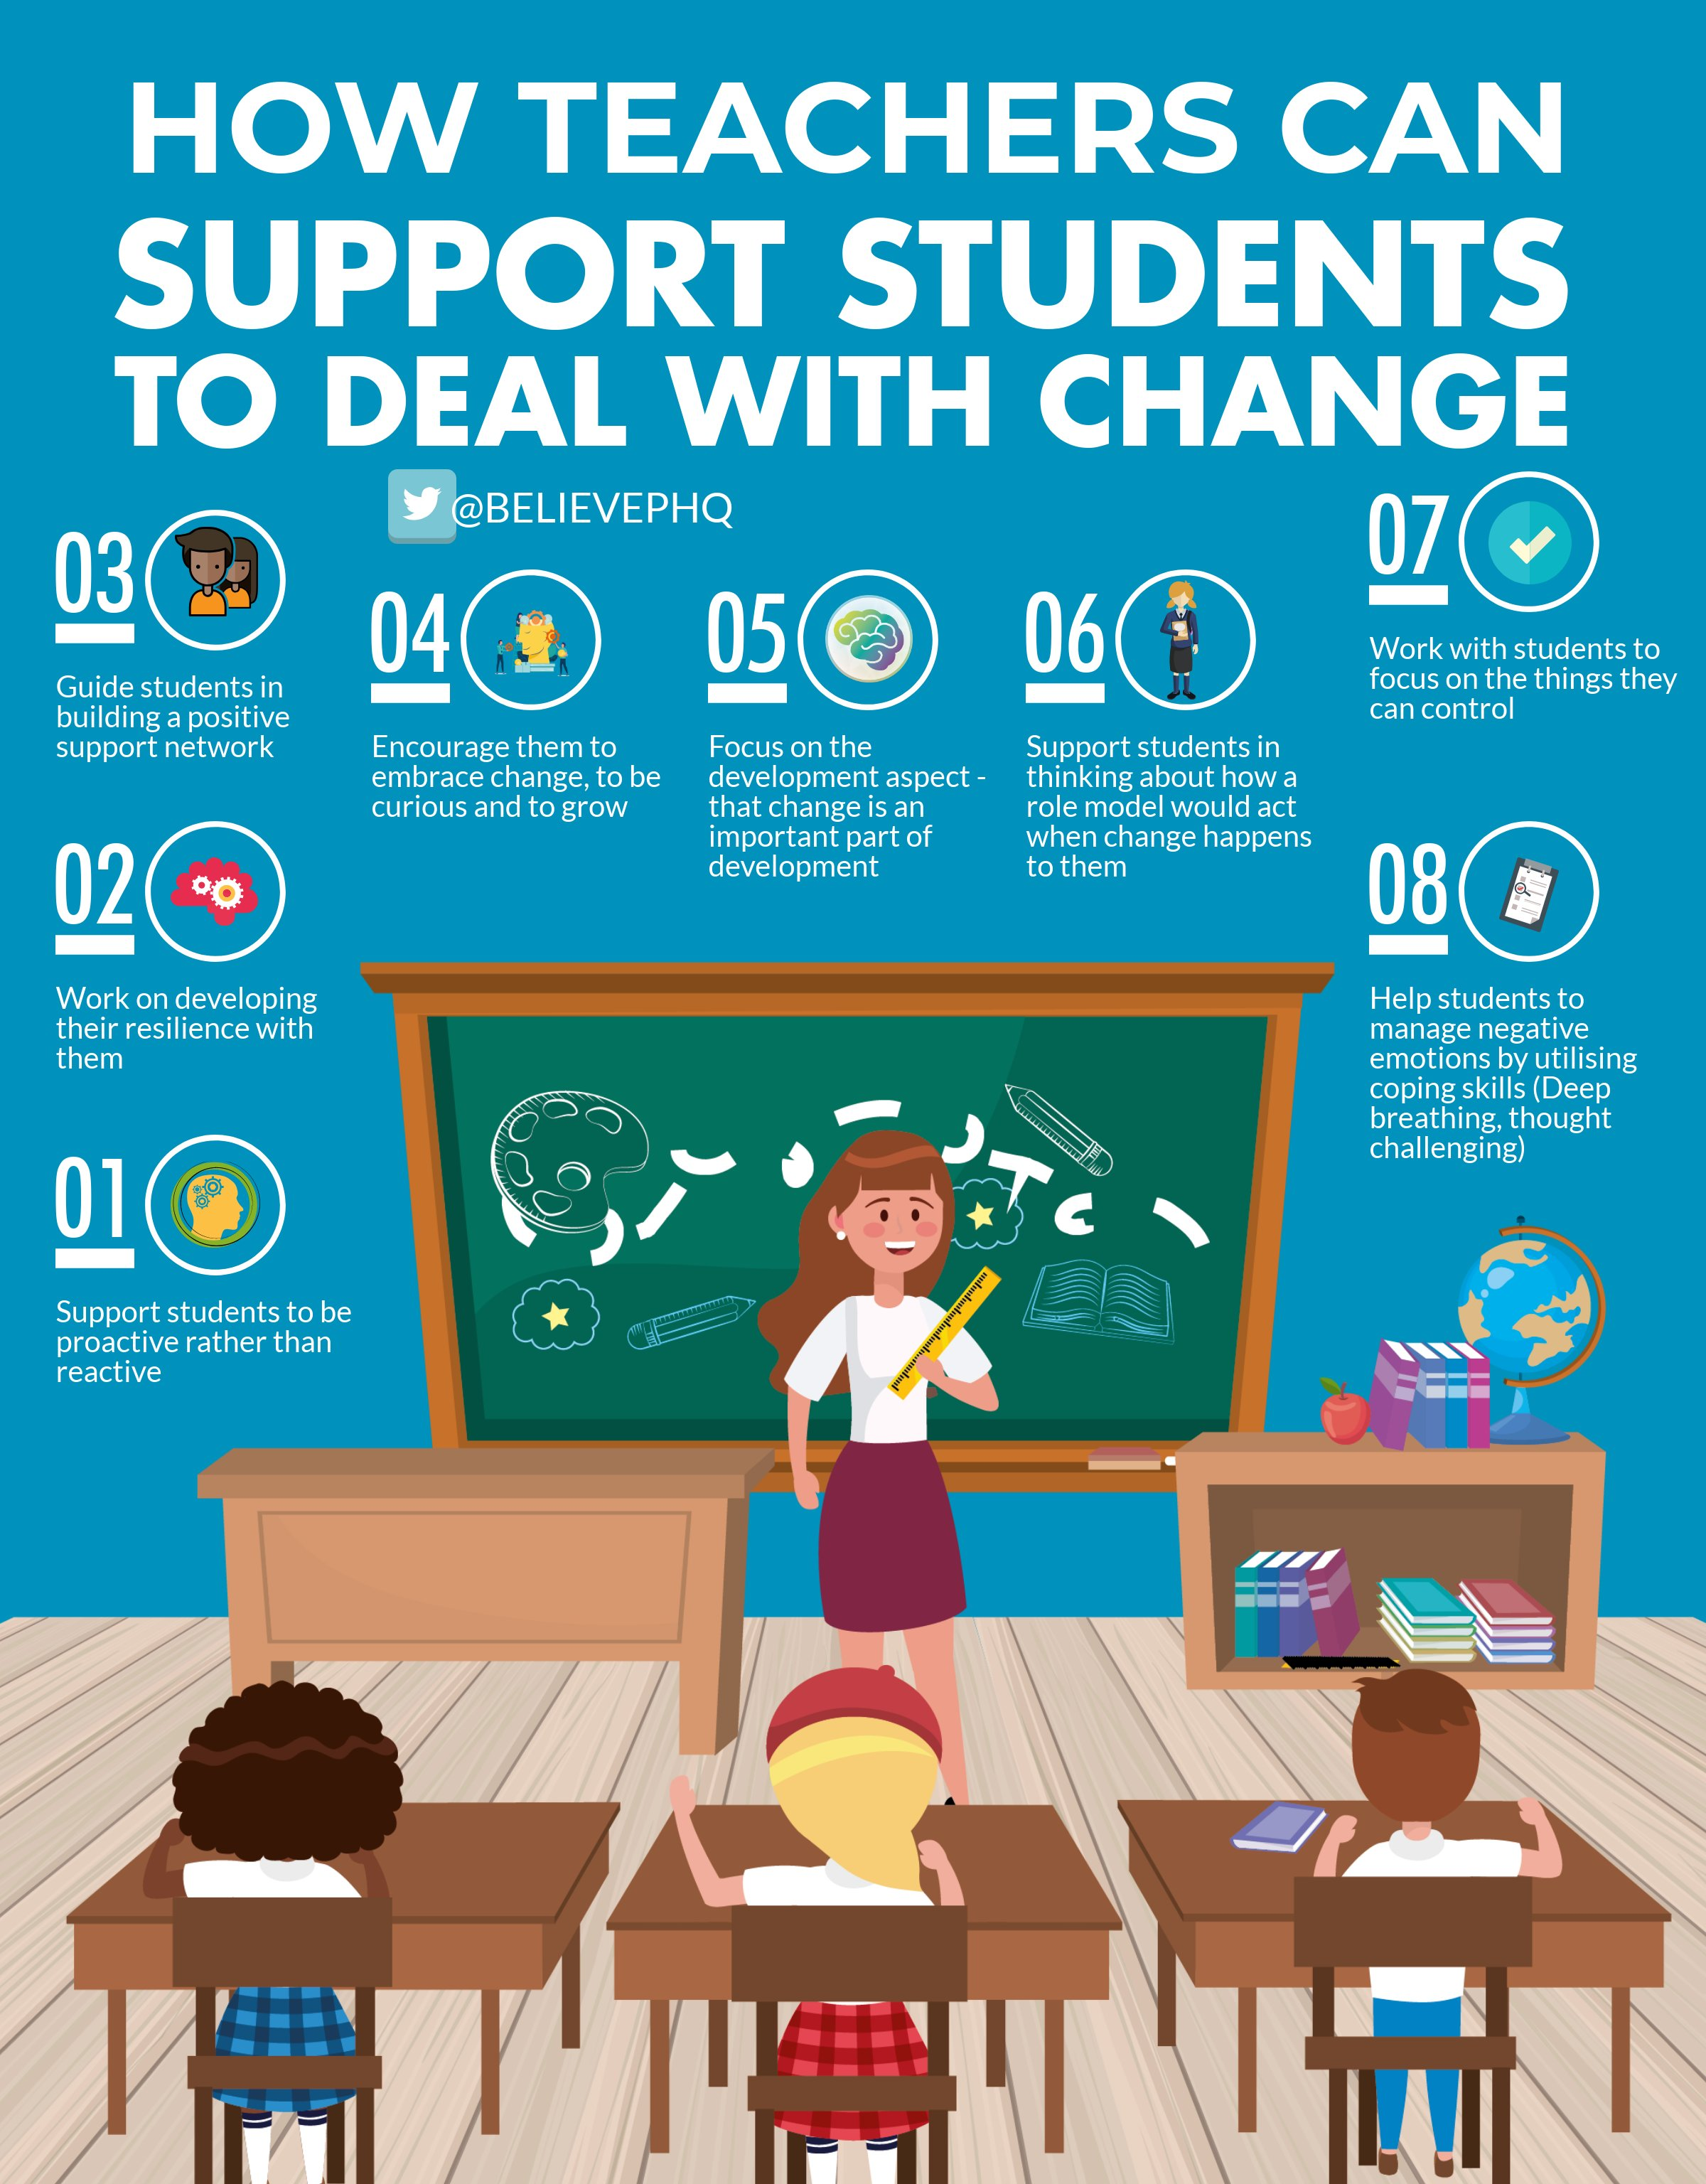

S1

Until the 21st August S1 pupils will receive their lunch from 12.10pm

Induction Slides

Pupil Council Nominations to be completed ASAP. Please forward names to year head.

S2

Induction Slides

Pupil Council Nominations to be completed ASAP. Please forward names to year head.

S3

Induction Slides

Pupil Council Nominations to be completed ASAP. Please forward names to year head.

S4

Induction Slides

Pupil Council Nominations to be completed ASAP. Please forward names to year head.

S5

Induction Slides

Pupil Council Nominations to be completed ASAP. Please forward names to year head.

S6

Those applying for Medicine, Dentistry or Oxford should discuss with their Pastoral Support teacher a timeline of when they should complete a draft of their personal statement. This process must be completed as soon as possible.

Engineering Academy – Please cover with all S6 pupils

Induction Slides

Pupil Council Nominations to be completed ASAP. Please forward names to year head.

T. Low

