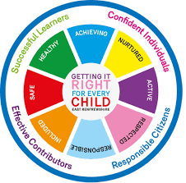
St Ninian’s High School
PSHE Newsletter
Week Beginning 7th September 2020

Focus:

Mental Health Committee – Please pass any names on to
C. McCallum if pupils are interested in becoming a Mental Health First Aider

• Assembly Slides
Please cover relevant information with each PSHE Class

Updated Government Guidance – Please cover the below links with classes:

• FACTS – Please cover with all classes - updated

• How to wear a face mask safely – Please cover the video with classes

Promoting Children and Young People’s Mental Health

Scroll to bottom of the link and watch “What is mental health” video

• Racial Equality – Please cover with classes

Mental Health Awareness

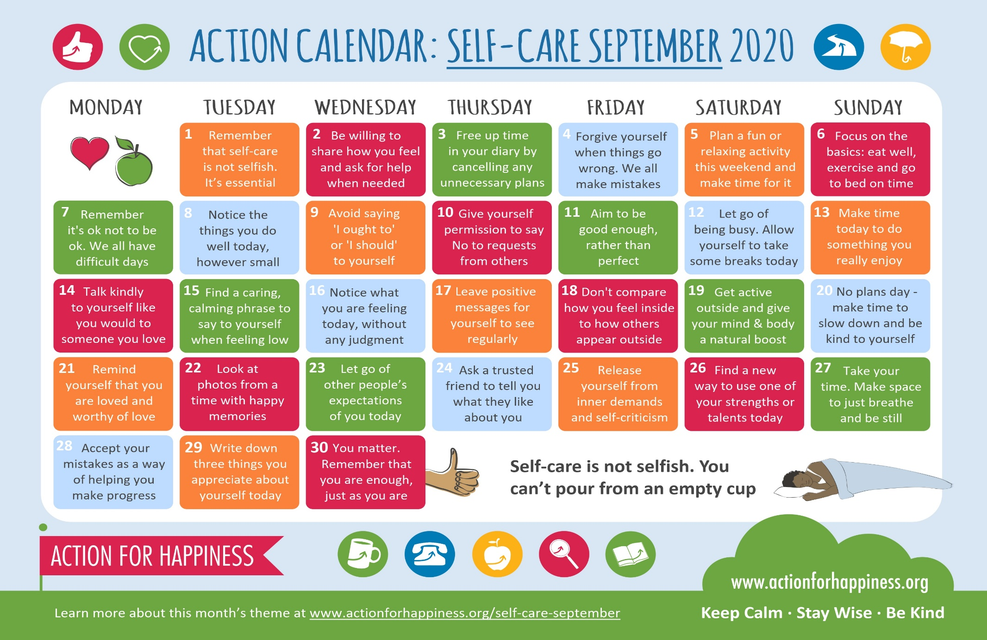

Mental Health Awareness

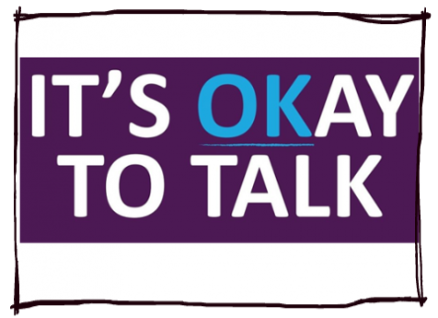

What is World Suicide Prevention Week?
World Suicide Prevention day will be held on the 10th September. It's an annual awareness raising event organised by International Association for Suicide Prevention (IASP) and the World Health Organisation (WHO)

Why is it important?
More than 800,000 people take their lives each year across the world. In the UK and ROI, more than 6,000 people die by suicide a year - an average of 18 a day.

Other sources of information

Samaritans is here round the clock every single day for the year for anyone struggling to cope. If you're worried about someone, or would like emotional support yourself, please get in touch.

What you can do
- Start a conversation today if you think a friend, colleague or family member may be struggling.
- You can also join us on Twitter to spread the word.

How can people reach out?
It can be daunting to approach someone who is struggling to cope; you may not know what to say, how to start a difficult conversation or worry that you'll make things worse. However, you don’t need to be an expert. Often, just asking if someone's OK and letting them know you're listening can give people the confidence to open up about how they're feeling.

S1

Football Trials – Please ask pupils to complete the Microsoft form via the QR code if they are interested in trying out for the team

- Boys
- Junior Girls

Olympics Event for all S1 pupils beginning 14th September – Please promote to all pupils

Healthy Eating

GIRFEC Booklet – Work through SHANARRI Indicators and complete with class

Body Image

Body Image Video – 6 mins, please watch with classes

Pupil Council Nominations to be completed ASAP. Please forward names to year head.

S2

YPI video – Please show to all classes

Please ask pupils to use their phones to complete the form accessed through the linked QR code

Internet Safety

GIRFEC Booklet – Work through SHANARRI Indicators and complete with class

Body Image

Pupil Council Nominations to be completed ASAP. Please forward names to year head.

S3

Please ask pupils to use their phones to complete the form accessed through the linked QR code

Mental Health and Wellbeing
The attached slides cover how pupils, parents and staff can access support for a range of Mental Health issues. The information here can also be accessed on the main school website.

GIRFEC Booklet – Work through SHANARRI Indicators and complete with class

Balanced Diet

Exercise Health and Fitness

Pupil Council Nominations to be completed ASAP. Please forward names to year head.

S4

Mental Health and Wellbeing
The attached slides cover how pupils, parents and staff can access support for a range of Mental Health issues. The information here can also be accessed on the main school website.

Mental Health and Wellbeing Award – Understanding Mental Health Issues
- Marking Scheme

Study Tips – Inside the mind of a Procrastinator

Study Skills for S4 – Study Skills Video

S5

Career Appointments
• Any pupil who would like an appointment with the Careers Advisor should use their phone to complete the attached QR Code

Education Maintenance Allowance – Please cover with S5 and S6

Opportunity for e-sgoil online Maths Tuition

Young Ambassador – Volunteering opportunity for pupils

GIRFEC Booklet – Work through SHANARRI Indicators and complete with class

Study Skills – in booklets, highlight the different types of approach to studying. Use ‘Notes’ page for this activity

Study Tips – Inside the mind of a Procrastinator

DYW Online Seminars 2020

Pupil Council Nominations to be completed ASAP. Please forward names to year head.

S6

SCQF Volunteering Unit 1 - Unit 1 booklet will be sent out to staff who will then upload as an assignment on teams / Google classrooms. Pupils should complete this on computers and save their progress on their own individual H drives

Career Appointments
• Any pupil who would like an appointment with the Careers Advisor should use their phone to complete the attached QR Code

Pupils should log on to their respective Google Classrooms/Microsoft Teams and complete their “All About Me” forms

Please ask pupils to check the DYW page on the school website for a range of opportunities regarding jobs and apprenticeships

ICE engineering opportunity for pupils

DYW Online Seminars 2020

Engineering Academy – Please cover with all S6 pupils

Study Tips – Inside the mind of a Procrastinator

Pupils are to leave class at 1.45pm to avoid corridor congestion

All about me – Complete with class

Pupil Council Nominations to be completed ASAP. Please forward names to year head.

Pupils should log on to the school website to see the advice available on how to complete their Personal Statement – See Below Hyperlinks

Link to school website and advice on completing Personal Statement

Link 1 – Advice on completing Personal Statement

Link 2 – How to structure Personal Statement

Fast Track applicants should hand first draft of personal statement to teacher for feedback. Also, log on to UCAS using phones or computers to ensure all information is up to date.

Diploma Completion for S6 pupils – See the below instructions

- Pupils go on to “Pupil Shared Area”
- Click on “PSHE”
- Pupils go on to “Diploma 2021”
- Pupils click on their own respective Alpha
- Click on the “S6 Diploma” and immediately save in the folder using their name.
- Pupils are to complete each section of the Diploma by writing in to the text box at the bottom of each section
- This will be a working document and pupils should save their work as they go
- It is important that when pupils are writing information in to the text box that they do not hit the return key as this will not work with the software when transferring on to the Diploma

Link to examples of previous diplomas

Link to Lesson for “Responsible Citizen”
Link to Lesson for “Confident Individual”
Link to Lesson for “Successful Learner”
T. Low

