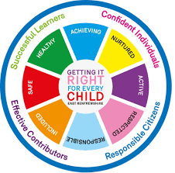
St. Ninian’s High School
PSHE Newsletter
Week beginning 29th April 2019

Focus:

- 5 steps to wellbeing video – Please show all classes

- May: the month dedicated to Mary. Among the names given to Our Lady is “Queen of Peace.” Pope Francis has asked us to “Make use of the prayer of the Holy Rosary, that it may bring peace to our heart, to our family, to the Church and the world”. Each Friday we pray the rosary for our school community

- SQA Exams: thank you to teachers for your support for pupils sitting the exams and for the additional tuition being provided each day

- S1 Parents’ Evening; Newsletter and advice for interviewing teachers.

- Health and Wellbeing Committee Needs You!!!

Daily Prayers

Mental Strength HWB
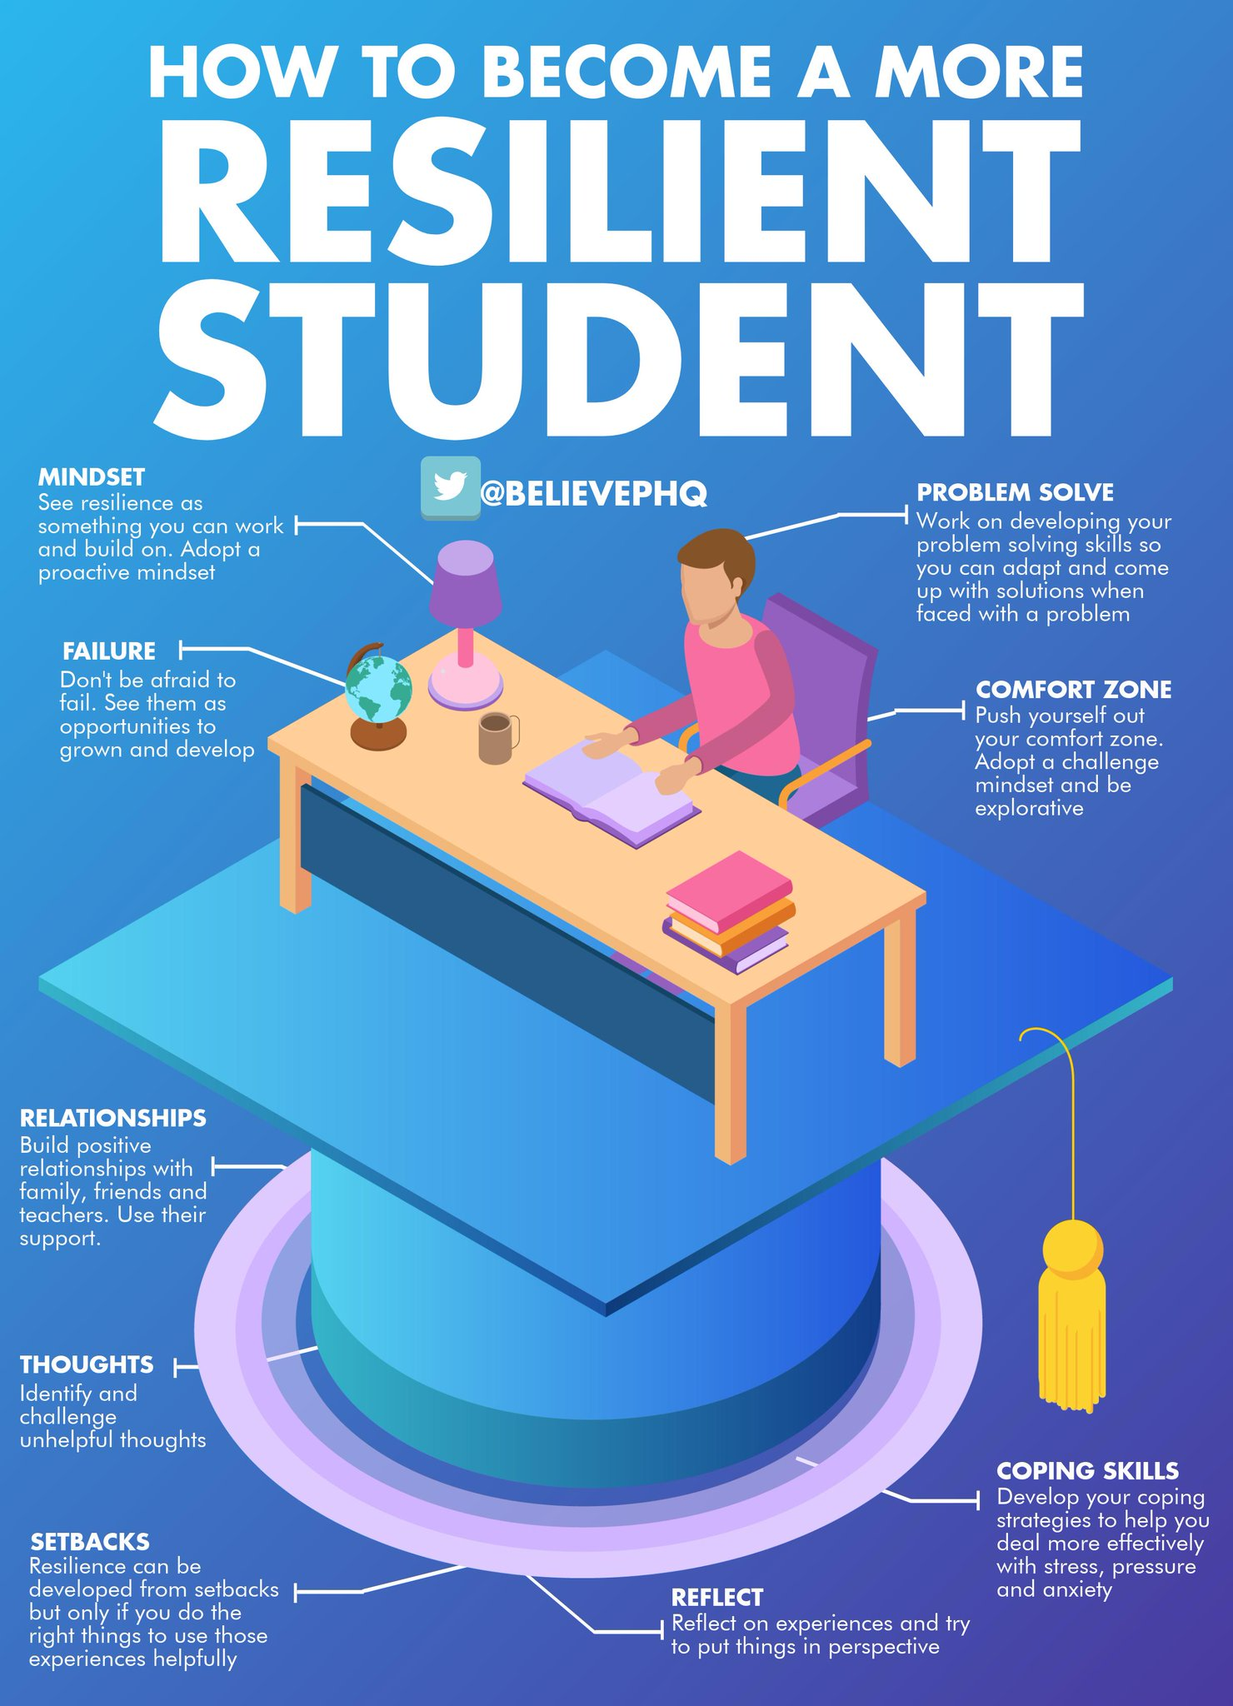

S1
Subject Choices – please complete with classes

Alcohol Part 2

Alcohol Part 1

Stressed Out

PSHE Evaluation

S2
Friends and Friendship

Stressed Out

Getting the Lowdown

PSHE Evaluation

S3
SDS Workshops
- Monday 29th April period 6 3a7
- Tuesday 30th April Period 6 3a3

Understanding Prejudice

Alcohol lessons Click view- ‘Kick it, Binge Drinking’

Alcohol lesson

PSHE Evaluation
T. Low

