St Ninian’s High School
PSHE Newsletter
Week Beginning 27th August 2018

Focus:

Daily Prayers

- A Vision of Education for Our Young People

- C19: Permission for Pupils to be Out of Class

- Focus On Corridor Movement, Racism, Bullying

- Thursday 30 August Mass of Welcome at 7pm in the school Oratory for all families and the marking of the Ascensio Scholarum.

- The first Catholic Leadership Meeting of this School Year will take place at 3.30pm – 4.15pm on Monday 3 September and will be led by Fr Baillie. This is for any pupil involved or who would like to be involved in the faith life of the school including pupils who are part of the Life Group, the SCIAF Group, No Child Taken, those who read at Mass or are involved in any other activity.

Lockers

All S2-S6 locker holders should ensure their locker is securely closed and padlocked.

If it has a tie or a School padlock on it a new 40mm padlock should be purchased asap and you must see Mrs Callan or Mrs Zochowska in School office. It may not be possible for it to be resolved immediately but you MUST return to office when asked to do so.

Extra-Curricular programme booklet

Saltire Awards

As you return to school after the summer break, please make sure that you are proactive in recording volunteering hours in order to gain a Saltire Award.

Please visit ‘Bridge the Gap’ at: http://bridgethegap.co/

This website provides updates and opportunities in East Renfrewshire for young people. It has been built by and for the young People of East Renfrewshire. You can find more information about Volunteering in East Renfrewshire, Volunteering Awards, Work & Training, and much more here. Please be aware that hours used towards other awards such as Duke of Edinburgh can be counted towards the Saltire award as well.

Please note that all Saltire submissions should be made directly to Mrs Miller to ensure hours are recorded.

Please see Mrs Miller for all information relating to Saltire Awards.

Mental Health Awareness
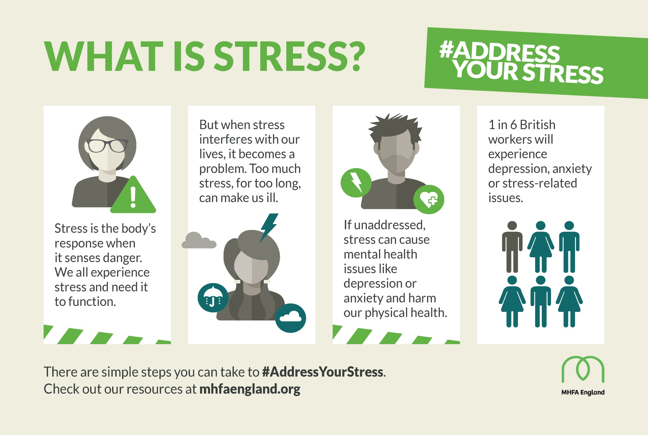

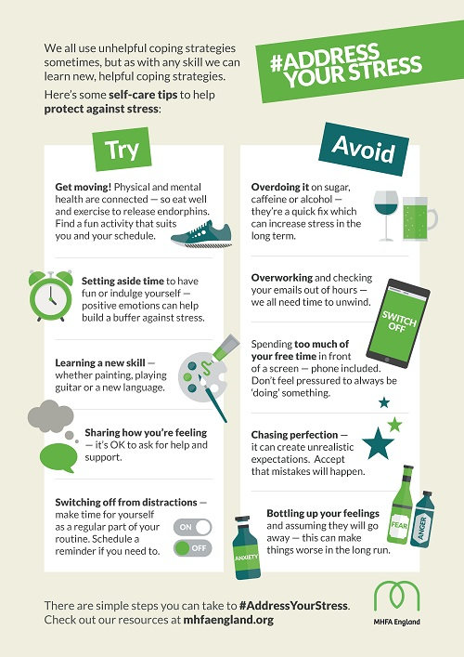

S1

First Aid Class for 1a7 – Wednesday 29 August 11.30am
Please collect guest from the reception prior to start of the lesson

Body Image

My first week in St.Ninian’s

Induction Slides

Pupil Council Nominations to be completed ASAP. Please forward names to year head.

S2

Sports Council – Nominate two pupils from each alpha to be a part of the St.Ninian’s Sports Council

Body Image

Study Skills for year ahead

Body Image

Induction Slides

Pupil Council Nominations to be completed ASAP. Please forward names to year head.

S3

My WoW Ambassador Programme

Sports Council – Nominate two pupils from each alpha to be a part of the St.Ninian’s Sports Council

Balanced Diet

Exercise Health and Fitness

Induction Slides

Pupil Council Nominations to be completed ASAP. Please forward names to year head.

S4

Sports Council – Nominate two pupils from each alpha to be a part of the St.Ninian’s Sports Council

Study Tips – Inside the mind of a Procrastinator

PSHE Booklet – Health and Wellbeing Pages 10, 11, 12 & 13.
Complete Term 1 Sections

Study Skills for S4 – Study Skills Video

Work Experience – Please go over with your respective classes

Induction Slides

Urdu Class for Nat 5 and Higher begins Friday 25th August. Please make those concerned aware of this.

Pupil Council Nominations to be completed ASAP. Please forward names to year head.

S5

Study Skills – in booklets, highlight the different types of approach to studying. Use ‘Notes’ page for this activity

Study Tips – Inside the mind of a Procrastinator

Induction Slides

Urdu Class for Nat 5 and Higher begins Friday 25th August. Please make those concerned aware of this.

Pupil Council Nominations to be completed ASAP. Please forward names to year head.

S6

Assembly for 6a1, 6a2, 6a3, 6a4 and 6a5. Register and send to the forum

Please register and send pupils who have signed up for the following S6 Service to the lecture theatre for 1.15pm
• Primaries
• Nursery
• Isobel Mair

Stuart Ivory "Money Talks" sessions 6a6 – Thursday 30th August 1.00pm
Please collect guest from the reception prior to the start of the lesson

First Aid Class for 6a7 – Thursday 30 August 1.00pm
Please collect guest from the reception prior to the start of the lesson

Study Tips – Inside the mind of a Procrastinator

Pupils are to leave class at 1.45pm to avoid corridor congestion

All about me – Complete with class

Induction Slides

S6 Service Slides

Heriot Watt University Open Days
Saturday 29 September
Friday 26 October

Those interested in Textiles and Design, there will be a separate open day at the Scottish Borders Campus in Galashiels Friday 12 October and Friday 16 November (10am to 4pm each day).

Pupil Council Nominations to be completed ASAP. Please forward names to year head.

My World of Work

S6 Service – encourage pupils to sign up to volunteering opportunities that are on offer throughout the year

T. Low

