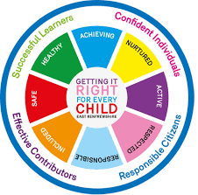
St Ninian’s High School
PSHE Newsletter
Week Beginning 26th August 2019

Focus:

Daily Prayers

- A Vision of Education for Our Young People

- C19: Permission for Pupils to be Out of Class

- Focus On Corridor Movement, Racism, Bullying

- Thursday 29th August Mass of Welcome at 7pm in the school Oratory for all families and the marking of the Ascensio Scholarum.

- Wellbeing

Lockers

All S2-S6 locker holders should ensure their locker is securely closed and padlocked.

If it has a tie or a School padlock on it a new 40mm padlock should be purchased asap and you must see Mrs Callan or Mrs Zochowska in School office. It may not be possible for it to be resolved immediately but you MUST return to office when asked to do so.

Extra-Curricular programme booklet

Saltire Awards

As you return to school after the summer break, please make sure that you are proactive in recording volunteering hours in order to gain a Saltire Award.

Please visit ‘Bridge the Gap’ at: http://bridgethegap.co/

This website provides updates and opportunities in East Renfrewshire for young people. It has been built by and for the young People of East Renfrewshire. You can find more information about Volunteering in East Renfrewshire, Volunteering Awards, Work & Training, and much more here. Please be aware that hours used towards other awards such as Duke of Edinburgh can be counted towards the Saltire award as well.

Please note that all Saltire submissions should be made directly to Mrs Miller to ensure hours are recorded.

Please see Mrs Miller for all information relating to Saltire Awards.

Mental Health Awareness
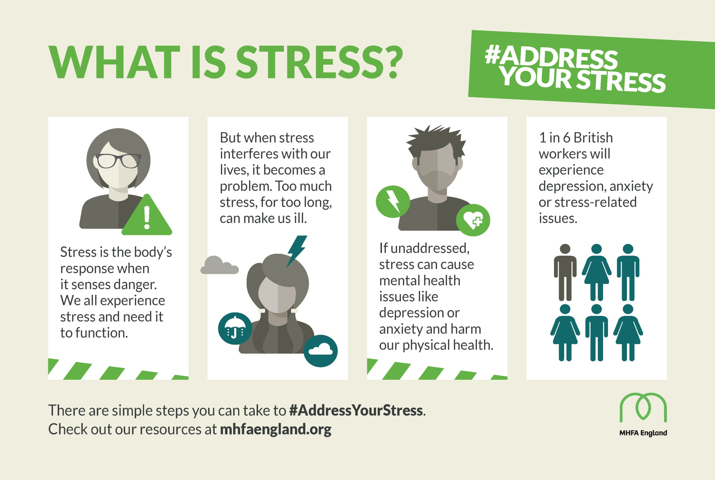

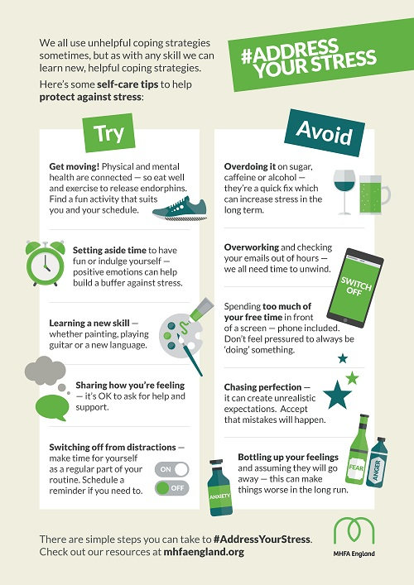

S1

Sports Council – Nominate two pupils from each Alpha class who wish to considered for the sports council and pass the names to T.Low.

PSHE First Aid Visits – Please collect visitor from the school office prior to lesson beginning:
1a6 – 28th August
1a1 – 30th August

Induction Slides

Body Image

My first week in St.Ninian’s

Pupil Council Nominations to be completed ASAP. Please forward names to year head.

S2

Body Image

Study Skills for year ahead

Body Image

Induction Slides

Pupil Council Nominations to be completed ASAP. Please forward names to year head.
S3

My WoW Ambassador Programme

Balanced Diet

Exercise Health and Fitness

Induction Slides

Pupil Council Nominations to be completed ASAP. Please forward names to year head.

S4

Study Tips – Inside the mind of a Procrastinator

PSHE Booklet – Health and Wellbeing Pages 10, 11, 12 & 13.
Complete Term 1 Sections

Study Skills for S4 – Study Skills Video

Work Experience – Please go over with your respective classes

Pupil Council Nominations to be completed ASAP. Please forward names to year head.

S5

Study Skills – in booklets, highlight the different types of approach to studying. Use ‘Notes’ page for this activity

Study Tips – Inside the mind of a Procrastinator

Induction Slides

Pupil Council Nominations to be completed ASAP. Please forward names to year head.

S6

Stuart Ivory "Money Talks" sessions 6a1 – Thursday 29th August 1.00pm
Please collect guest from the reception prior to the start of the lesson

Study Tips – Inside the mind of a Procrastinator

Pupils are to leave class at 1.45pm to avoid corridor congestion

All about me – Complete with class

S6 Service Slides

Heriot Watt University Open Days – Edinburgh Campus
Saturday 14 September
Saturday 26 October

Pupil Council Nominations to be completed ASAP. Please forward names to year head.

Diploma Completion for S6 pupils – See the below instructions

- Pupils go on to “Pupil Shared Area”
- Click on “PSHE”
- Pupils go on to “Diploma 2020”
- Pupils click on their own respective Alpha
- Click on the “S6 Diploma” and immediately save in the folder using their name.
- Pupils are to complete each section of the Diploma by writing in to the text box at the bottom of each section
- This will be a working document and pupils should save their work as they go
- It is important that when pupils are writing information in to the text box that they do not hit the return key as this will not work with the software when transferring on to the Diploma

Link to examples of previous diplomas

Link to Lesson for “Responsible Citizen”
Link to Lesson for “Confident Individual”
Link to Lesson for “Successful Learner”

My World of Work

S6 Service – encourage pupils to sign up to volunteering opportunities that are on offer throughout the year

T. Low

