St Ninian’s High School
PSHE Newsletter
Week Beginning 25th November 2019

Focus:

Daily Prayers

• Catholic Education Week - Article by Monsignor Monaghan on his experience of catholic education in our school

- November: Month of The Holy Souls

- Standards and Expectations – Please reiterate and cover with all classes

- Lost Property – Please highlight procedures to all pupils

- Emergency Evacuation Procedure

- Christmas Market Friday 29th November
Tickets: Children £1 and Adults £3

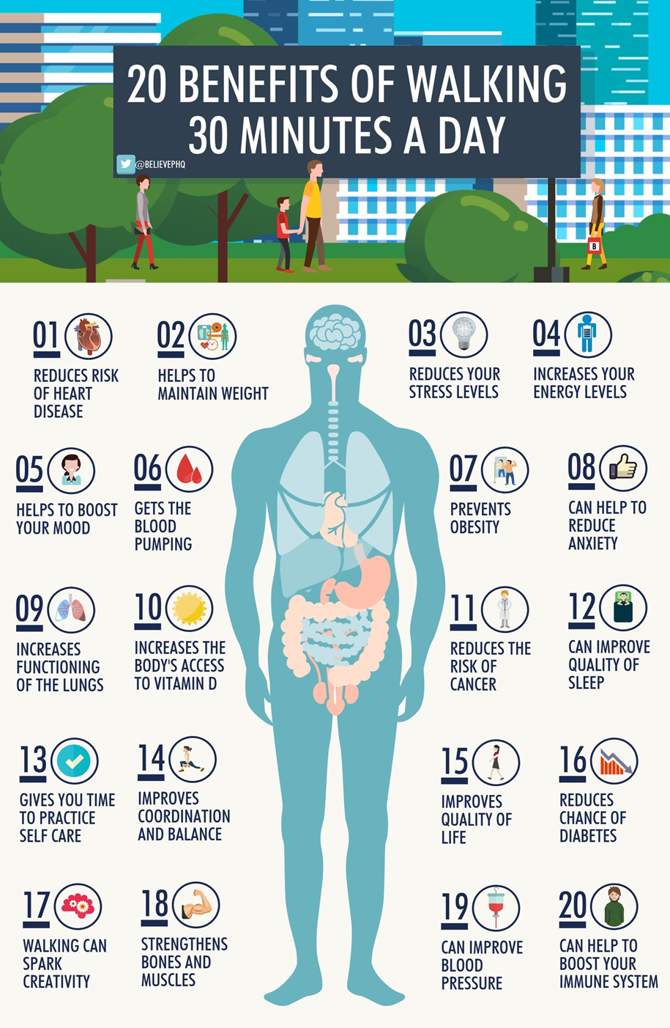
Mental Strength

S1

Eating for Success

S1 Road Safety Talks
1a9 – Wednesday 27th November
Please collect speaker from the school office

Talented Athletes – Please highlight to pupils and ask those that meet the criteria to speak with Miss Briggs in P.E.

Ski Trip – Pleaes promote to S1 pupils

S1 Pupil Council Minutest – Please cover with class

Road Safety Week 18th to 24th November

Anti – Bullying Week 11th to 15th November

S1 First aid visits
1a9 – Wednesday 4th December

S2

Food and Health

Anti – Bullying Week 11th to 15th November
Teachers Notes

Children Focussed video on rise of Nazis and how it affects a Jewish family – Please watch video with all classes

YPI Lessons for S2 PSHE – Please complete with class

Hunting the Cyber Bullies - Clickview -Panorama February 2012. Watch video and use Powerpoint with class

S3

Drugs Lesson 1

Anti Social Behaviour

S3 pupil forum minutes – please cover with all classes

Anti – Bullying Week 11th to 15th November
Teachers Notes

Strathclyde’s Engineering the Future for Girls – Please advertise to girls in S3 classes

Children Focussed video on rise of Nazis and how it affects a Jewish family – Please watch video with all classes

STUC Talks
Monday 2nd December at 1.50pm to 2.40pm – Classes 3a9 and 3a10
Tuesday 3rd December at 1.50pm to 2.40pm – Classes 3a4 and 3a5
Please register pupils and take them to the lecture theatre. The speaker will also need to be collected from the school office

Please regisgter classes and take to the lecture theatre. Please also collect
PC Waters from the school office.

S4

Drugs Lesson

Tracking Extercise to be completd in class

Road Safety Week 18 – 24 November

Prelim Study
All S4 pupils will receive study packs throughout this week. If you are absent when they are issued, please see Mrs Miller
Make the most of all the resources, along with accessing the helpful webpages to help you with studying for your prelims

RAMH Talks
Wednesday 4th December – 4a10
Friday 6th December – 4a5
Please collect speaker from school office

Children Focussed video on rise of Nazis and how it affects a Jewish family – Please watch video with all classes

Work Experience Recap lesson – Please cover the attached lesson via the hyperlink on pupils work experience placement and complete their booklets

Study Timetable Template – Please Highlight to pupils and print off if pupils would like a copy.

Focus group minutes for S4 – Please go over minutes with classes in PSHE

S5

Organ Donation

S5 Tutorials

Scholar workshops
Monday 25th November Period 5 5a1 - 5a5
Tuesday 26th November Period 7 5a6 - 5a10

RAMH Talks
5a4 – Tuesday 25th November – Please collect speaker from the school office

My WOW – Please ensure that pupils are registered

Anti – Bullying week – Slides and link to discussion – Please ensure that all classes provide a return on the Microsoft Forms using the QR Code reader or via the school website

Interim Report – Please complete Page 71 in PSHE Booklets – Pupils are to complete full page along with identifying Targets that they wish to achieve and how they will achieve this

Every Action has consequences Lessson 1

Study Timetable Template – Please Highlight to pupils and print off if pupils would like a copy.

Wider Involvemnent – complete pages 36 – 40 in PSHE booklets

Prepare a Study Plan – What do top students do?
Watch the video and look to see how you can create an effective study plan for yourself

S6

Road Safety Week 18 – 24 November

Healthy Eating on a budget for 6a8– Register classes and go to Home Economics

Stewart Ivory Money Talks visit Thursday 5th December – 6a6 – Pleaese collect speaker from the school office

Blood Collection Quiz – pupils should use their phones to complete the quiz on whether or not they are ellligble to give blood. The S6 Head team will be collecting names and providing slots of when pupils will be able to give blood on 9th January 2020 in the small gym. If there are any medical or travel enquiries pupils can call 0345 90 90 999. Only If pupils pass the quiz should they give their name to the S6 Head Team for the collection day.

S6 Tracking QR Code – Pleaes ask S6 pupils to complete in class

Anti – Bullying week – Slides and link to discussion – Please ensure that all classes provide a return on the Microsoft Forms using the QR Code reader or via the school website

Children Focussed video on rise of Nazis and how it affects a Jewish family – Please watch video with all classes

Please cover hyperlink slides from Mr McArthur with class:
UCAS – All pupils who are looking at applying through the UCAS process are to log on and fill in basic details including:

1. Personal Details
2. Additional information
3. Student Finance
4. Choices (If Pupils are aware of what Course they are applying for).
5. Education
6. Employment

Pupils should also be looking to complete drafts of Personal Statements for feedback from Pastoral Teacher. Highlight the links below which are on the school website.

6a9 Stewart Ivory Financial education talk. Please collect speaker from the school office

Healthy Eating on a budget for 6a6– Register classes and go to Home Economics

Application evening for S6 pupils

Pupils should log on to the school websit to see the advice available on how to complete their Personal Statement – See Below Hyperlinks

Link to school website and advice on completing Personal Statement

Link 1 – Advice on completing Personal Statement

Link 2 – How to structure Personal Statement

Caritas Award

GIRFEC Booklet – Work through SHANARRI Indicators and complete with class

All about me – Complete with class

T. Low

