St Ninian’s High School
PSHE Newsletter
Week Beginning 23rd September 2019

Focus:

Daily Prayers

- Discussion of Interim report for S2 and S4
Teachers should discuss the Negotiated Target and On Track to Achieve Grades with pupils explaining how the grades have been decided. Pastoral staff and Year Head will review the Reports and discuss the action required by pupils, support required from parents, & areas for action through support

- Pupils in S1-3 are not allowed to go to shops/toll. They should remain on the school grounds.

- S3 pupils are allowed to go to Eastwood Café during lunchtime only.

P.E. Reminder
Pupils are reminded that pupils are not allowed to use Aerosol/Spray deodorants in the changing rooms. If pupils are found to have these types of deodarants they will be confiscated by staff.

Extra-Curricular programme booklet

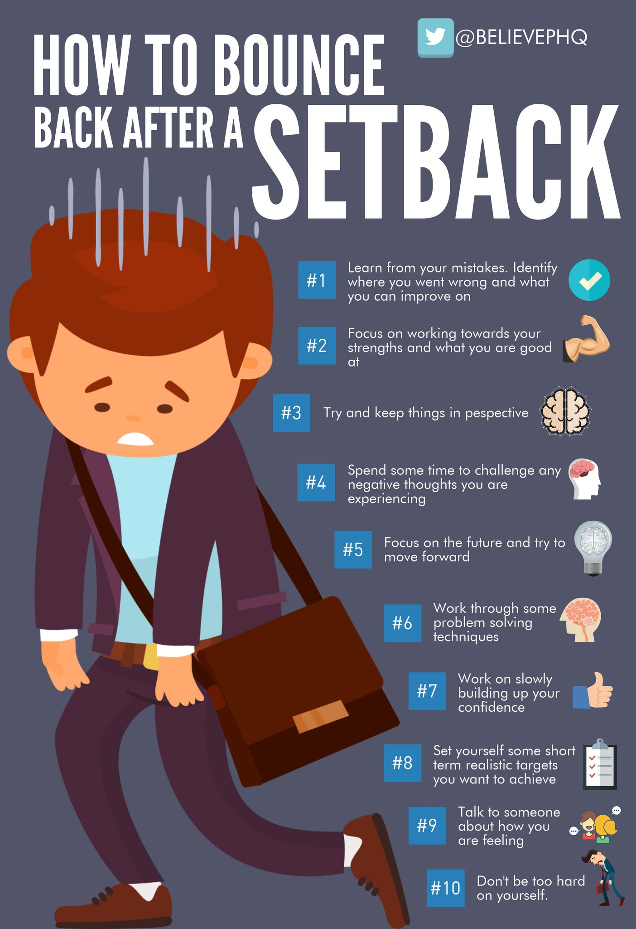
Mental Health Awareness

S1

Rugby Club will be on Wednesday’s after school on the grass pitch at the back of the Hockey pitch. Pupils must bring their P.E. Kit, boots and mouthguard. Pleaes see Mr Low for further information.

What is Bullying – Lesson 1

Internet Safety
Pupils must use their notes page to answer the questions on this document here

Watch the following clips:
- Chat Rooms
- Downloading files
- Instatnt Messaging
- Online Gaming
- Social Networking

Now answer the questions in your PSHE Booklet Notes section

Healthy Eating

GIRFEC Booklet – Work through SHANARRI Indicators and complete with class

Body Image

S2

The Impact of Bullying

Child Protection

Internet Safety

GIRFEC Booklet – Work through SHANARRI Indicators and complete with class

Study Skills for year ahead

Pupil Council Nominations to be completed ASAP. Please forward names to year head.

S3

My World of Work

S3 Tracking exercise to be completed

Body Image

Sound Sleep

Mental Health and Wellbeing
The attached slides cover how pupils, parents and staff can access support for a range of Mental Health issues. The information here can also be accessed on the main school website.

Study Skills

S4

RAMH Visit
4A7 Wednesday 25th Septbember.
Please collect speaker from the school office

CV Writing

Study Tips – Inside the mind of a Procrastinator

Study Skills for S4 – Study Skills Video

Mental Health and Wellbeing
The attached slides cover how pupils, parents and staff can access support for a range of Mental Health issues. The information here can also be accessed on the main school website.

PSHE Booklet – complete skills learned in each subject

GIRFEC Booklet – Work through SHANARRI Indicators and complete with class

PSHE Booklet – Health and Wellbeing Pages 10, 11, 12 & 13.
Complete Term 1 Sections

Work Experience – Please go over with your respective classes

Pupil Council Nominations to be completed ASAP. Please forward names to year head.

S5

Sound Sleep

Arnold Clark Apprenticeship experience – if any pupils are interested please pass their names to Mrs Kennedy

Prepare a Study Plan – What do top students do?
Watch the video and look to see how you can create an effective study plan for yourself

Complete S5 achievements profile on Pages 36, 37, 38 and 39. Also complete Academic transferable skills and Attributes Page 40.

Mental Health and Wellbeing
The attached slides cover how pupils, parents and staff can access support for a range of Mental Health issues. The information here can also be accessed on the main school website.

Importance of Sleep

GIRFEC Booklet – Work through SHANARRI Indicators and complete with class

Study Skills – in booklets, highlight the different types of approach to studying. Use ‘Notes’ page for this activity

Study Tips – Inside the mind of a Procrastinator

Induction Slides

Urdu Class for Nat 5 and Higher begins Friday 25th August. Please make those concerned aware of this.

Pupil Council Nominations to be completed ASAP. Please forward names to year head.

S6

Pupils completing the SCQF 5 Volunteering Award should register with their Pastoral Support Teacher and then meet Miss Goodenough in the lecture theatre. Please bring your Volunteering Booklets you received last week.

Caritas pupils – Mrs Ward will be having a meeting with all Caritas pupils in Geography room 2 on Friday 13th September at 12.30. Mrs Ward will be going through the programme and giving out dates for the gathering points

Morgan Stanley Glasgow High School Insight Week – Please promote to pupils

Job’s Fair:
Facilities Management are holding a Jobs Fair on Friday 13th September 2019 in Thorntree Hall, Thornliebank from 10am till 2pm. Please speak to your Pastoral Support Teacher if you are interested in attending

GIRFEC Booklet – Work through SHANARRI Indicators and complete with class

Stuart Ivory "Money Talks" sessions 6a3 – Thursday 19th September 1.00pm - Please collect guest from the reception prior to the start of the lesson

Study Tips – Inside the mind of a Procrastinator

Pupils are to leave class at 1.45pm to avoid corridor congestion

All about me – Complete with class

S6 Service Slides

Heriot Watt University Open Days – Edinburgh Campus
Saturday 14 September
Saturday 26 October

Pupil Council Nominations to be completed ASAP. Please forward names to year head.

Diploma Completion for S6 pupils – See the below instructions

- Pupils go on to “Pupil Shared Area”
- Click on “PSHE”
- Pupils go on to “Diploma 2020”
- Pupils click on their own respective Alpha
- Click on the “S6 Diploma” and immediately save in the folder using their name.
- Pupils are to complete each section of the Diploma by writing in to the text box at the bottom of each section
- This will be a working document and pupils should save their work as they go
- It is important that when pupils are writing information in to the text box that they do not hit the return key as this will not work with the software when transferring on to the Diploma

Link to examples of previous diplomas

Link to Lesson for “Responsible Citizen”
Link to Lesson for “Confident Individual”
Link to Lesson for “Successful Learner”

My World of Work

S6 Service – encourage pupils to sign up to volunteering opportunities that are on offer throughout the year

All about me – Complete with class

T. Low

