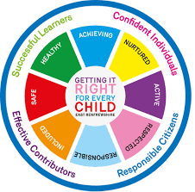
St. Ninian’s High School
PSHE Newsletter
Week beginning 23rd April 2019

Focus:

- 5 steps to wellbeing video – Please show all classes

- SQA Exams commence this week. Details issued to pupils and staff.

- Health and Wellbeing Committee Needs You!!!

Daily Prayers

Mental Strength HWB
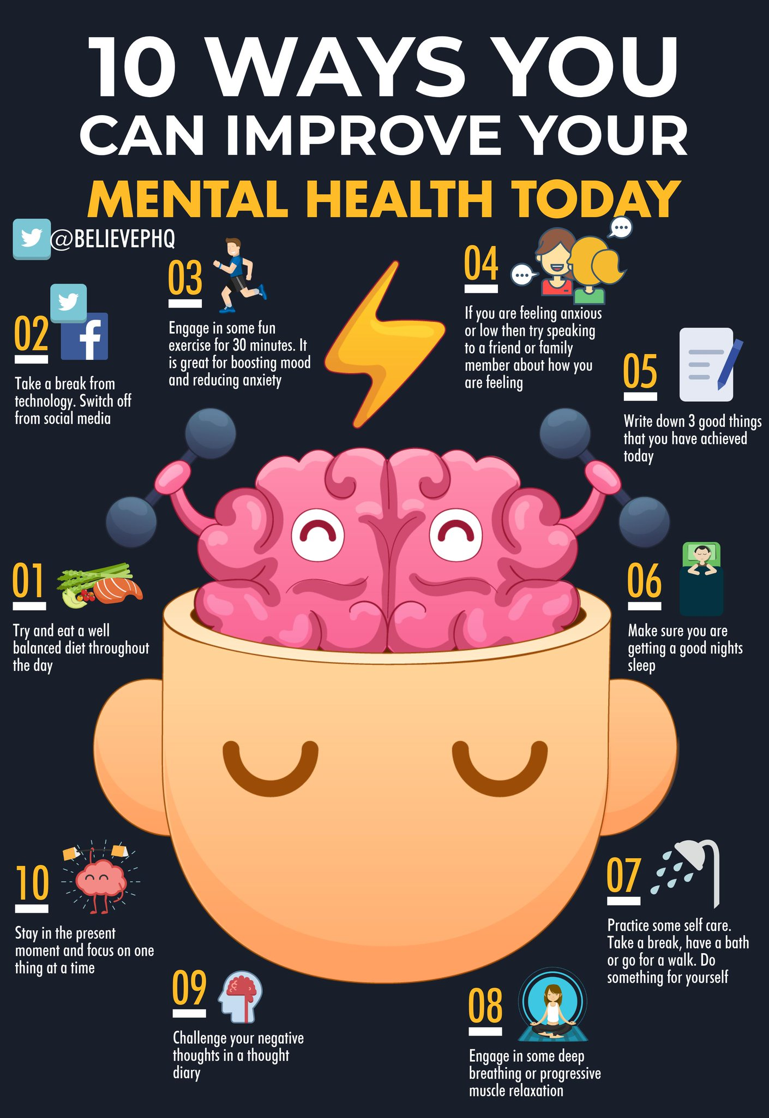

S1
Subject Choices – please complete with classes

Alcohol Part 1

Stressed Out

Friends and Friendship

PSHE Evaluation

S2
Stressed Out

Getting the Lowdown

Healthy Lifestyle

PSHE Evaluation

S3
SDS Workshops
- Tuesday 23rd April Period 6 3a2

Alcohol lessons Click view- ‘Kick it, Binge Drinking’

Alcohol lesson

PSHE Evaluation

T. Low

