St Ninian’s High School
PSHE Newsletter
Week Beginning 22nd October 2018

Focus:

Daily Prayers

- S6 Halloween Disco – Wednesday 24th October (7.30 – 9.30)
All staff welcome to attend and supervise this excellent event

- Healthy Living

Follow the 5 Ways to Better Wellbeing for the New Term:

- Connect
- Be Active
- Take Notice
- Learn
- Give

For more information follow the hyperlink

For S4, S5 & S6 – Please promote this Empoyabiltiy Event to pupils

Extra-Curricular programme booklet

HWB Mental Strength
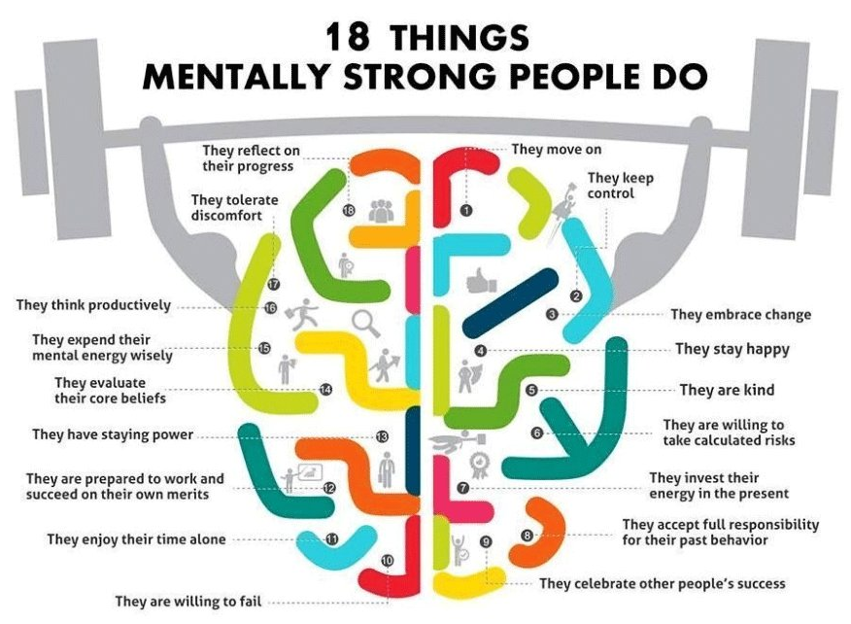

S1

S1 assembly Wednesday 31st October P4 – Firework Safety talk – Please register pupils and take them to the forum

S1 Road Safety Lesson for 1a6 Wednesday 24 October and 1a1 Friday 26 October – Please collect speaker from school office

S1 Tracking Exercise

Homework Diary Check – Pleaese check and sign pupils Diaries

Film Club

GIRFEC Booklet – Work through SHANARRI Indicators and complete with class

S2

YPI Lessons for S2 PSHE – Please complete with class

S4 My WOW Ambassadors will be visiting classes this week in PSHE

Discover Engineering for Girls – Please advertise to class

S2 Pupil Focus Group Minutes – Please go over with class.

Tracking for S2 – Please complete with class. Chromebooks are in R.E. corridor during P3 and P7. Candidate numbers can be found HERE

S3

STUC Presentation for 3a1, 3a2 and 3a3 – Please register classes and take them to the lecture – Click here for Presentation for STUC speaker

Tracking Process to be completed by all S3 pupils

Homework Diary Check – Pleaese check and sign pupils Diaries

PSHE Booklet Page 39 – CV Writing. Please complete Personal statement and Skills section with pupils. The hyperlink will also provide some usefule information for CV Writing.

S4

STUC Vists for 4a6, 4a7 and 4a8 Wednesday 24 October and 4a1, 4a2 and 4a3 Friday 26 October – Please register classes and take them to the Lecture theatre – Click here for STUC Presentation for Speaker

Work Experience Prep – Please distribute to class and cover the attached lesson via the hyperlink

Project Runway – Please advertise with pupils as this is a very exciting opportunity

Study Timetable Template – Please Highlight to pupils and print off if pupils would like a copy.

Focus group minutes for S4 – Please go over minutes with classes in PSHE

CV Writing

GIRFEC Booklet – Work through SHANARRI Indicators and complete with class PSHE Booklet – Health and Wellbeing Pages 10, 11, 12 & 13.
Complete Term 1 Sections

S5

Project Runway – Please advertise with pupils as this is a very exciting opportunity

Study Timetable Template – Please Highlight to pupils and print off if pupils would like a copy.

Wider Involvement – complete pages 36 – 40 in PSHE booklets

Complete S5 achievements profile on Pages 36, 37, 38 and 39. Also complete Academic transferable skills and Attributes Page 40.
GIRFEC Booklet – Work through SHANARRI Indicators and complete with class

Study Skills – in booklets, highlight the different types of approach to studying. Use ‘Notes’ page for this activity
S6

Healthy Eating on a budget for 6a1 and ½ 6a2 – Register classes and go to Home Economics

Stuart Ivory Money Talks Presentation for 6a5 Please collect speaker from School office and take to classroom for talk

S6 pupils who have signed up to Caritas the first Gathering point is on the 29th October in the Oratory

Project Runway – Please advertise with pupils as this is a very exciting opportunity

Study Timetable Template – Please Highlight to pupils and print off if pupils would like a copy.

Pupils should log on to the school website to see the advice available on how to complete their Personal Statement – See Below Hyperlinks

Link to school website and advice on completing Personal Statement

Link 1 – Advice on completing Personal Statement

Link 2 – How to structure Personal Statement

Caritas Award

GIRFEC Booklet – Work through SHANARRI Indicators and complete with class

T. Low

