St Ninian’s High School
PSHE Newsletter
Week Beginning 22nd October 2019

Focus:

Daily Prayers

- Family and Friends Quiz – Tickets are £3 or £15 per team (6 people per team). The quiz will be on Friday 25th October in school 7pm start

- Challenge Poverty – Wathc the animation and discuss with your class

- The Dangers of mobile phone/tablet use for young people – “Dear Student” film. Please show to all classes

- Optomistic October Calendar – Please promote to all pupils

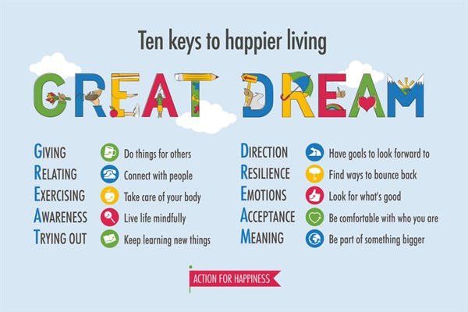
Mental Health

S1

S1 interim tracking report sheet – Please get pupils to complete in class

Marvel Movie Night – Please ask pupils to complete QR code questionnaire

S1 Road Safety Talks
1a1 – Friday 25th October
Please collect speaker from the school office

S1 First aid visits
1a9 – Wednesday 4th December

S1 Tracking Exercise

Homework Diary Check – Pleaese check and sign pupils Diaries

What is Bullying

Healthy Eating

Film Club

GIRFEC Booklet – Work through SHANARRI Indicators and complete with class

Body Image

S2

Tracking for S2 – Please complete with class today!

YPI Lessons for S2 PSHE – Please complete with class

Marvel Movie Night – Please ask pupils to complete QR code questionnaire

The Science of Character – please show video to all classes and discuss the questions in the powerpoint slide

Collate Pupil Council Names and send to year head

Homework Diary Check – Pleaese check and sign pupils Diaries

Hunting the Cyber Bullies - Clickview -Panorama February 2012. Watch video and use Powerpoint with class

The Impact of Bullying

Child Protection

Internet Safety

GIRFEC Booklet – Work through SHANARRI Indicators and complete with class

Study Skills for year ahead

S3

Marvel Movie Night – Please ask pupils to complete QR code questionnaire

Talk in Lecture theatre with PC J. Waters (Campus Police Officer) regarding:
• Teenage drinking
• Unacceptable use of social media
• Sexting and online bullying

Monday 18/11/19 – 3a9 and 3a10
Tuesday 19/11/19 – 3a4 and 3a5

Please regisgter classes and take to the lecture theatre. Please also collect
PC Waters from the school office.

Homework Diary Check – Pleaese check and sign pupils Diaries

PSHE Booklet Page 39 – CV Writing. Please complete Personal statement and Skills section with pupils. The hyperlink will also provide some usefule information for CV Writing.

Body Image

Sound Sleep

Mental Health and Wellbeing
The attached slides cover how pupils, parents and staff can access support for a range of Mental Health issues. The information here can also be accessed on the main school website.

Study Skills

GIRFEC Booklet – Work through SHANARRI Indicators and complete with class

Balanced Diet

S4

Work Experience Prep – Please distribute to class and cover the attached lesson via the hyperlink

Marvel Movie Night – Please ask pupils to complete QR code questionnaire

Collate Pupil Council Names and send to year head

RAMH Visit
4a3 Friday 25th October
4a4 Friday 22nd November
4a9 Wednesday 29th November

Please collect speaker from the school office

Study Timetable Template – Please Highlight to pupils and print off if pupils would like a copy.

Anti Smoking – Clickview - Introducing Tobacco

Focus group minutes for S4 – Please go over minutes with classes in PSHE

CV Writing

Mental Health and Wellbeing
The attached slides cover how pupils, parents and staff can access support for a range of Mental Health issues. The information here can also be accessed on the main school website.

PSHE Booklet – complete skills learned in each subject

GIRFEC Booklet – Work through SHANARRI Indicators and complete with class

PSHE Booklet – Health and Wellbeing Pages 10, 11, 12 & 13.
Complete Term 1 Sections

S5

Keeping myself safe at Parites and Nights out, Jo’s Story – Please use Glow details to log in and type in “Jo’s Story” in to the search bar at the top

Marvel Movie Night – Please ask pupils to complete QR code questionnaire

Collate Pupil Council Names and send to year head

RAMH Talks
5a2 – Monday 28th October
5a8 – Tuesday 22nd October

Homework Diary Check – Pleaese check and sign pupils Diaries

Study Timetable Template – Please Highlight to pupils and print off if pupils would like a copy.

Wider Involvemnent – complete pages 36 – 40 in PSHE booklets

Sound Sleep

Prepare a Study Plan – What do top students do?
Watch the video and look to see how you can create an effective study plan for yourself

Complete S5 achievements profile on Pages 36, 37, 38 and 39. Also complete Academic transferable skills and Attributes Page 40.

Mental Health and Wellbeing
The attached slides cover how pupils, parents and staff can access support for a range of Mental Health issues. The information here can also be accessed on the main school website.

Importance of Sleep

GIRFEC Booklet – Work through SHANARRI Indicators and complete with class

S6

6a8 Stewart Ivory Financial education talk. Please collect speaker from the school office

Homework Diary Check – Pleaese check and sign pupils Diaries

Study Timetable Template – Please Highlight to pupils and print off if pupils would like a copy.

Healthy Eating on a budget for 6a3– Register classes and go to Home Economics

Application evening for S6 pupils

Date | Event | Time
29th October | Application for early years and teaching | 7-9pm
5th November | Application for Business & Accounting | 7-9pm
5th November | Application for Engineering & Computing | 7-9pm
11th November | Application for Law and Social Sciences | 7-9pm
11th November | Interview evening for Medics/Dentists | 7-9pm

Pupil Focus Group meeting for S6

Volunteers required for S1 information evening. Please give your name to your Pastoral Teacher if you wish to help on the evening (4 October).

Arnold Clark Apprenticeship experience – if any pupils are interested please pass their names to Mrs Kennedy

Pupils should log on to the school websit to see the advice available on how to complete their Personal Statement – See Below Hyperlinks

Link to school website and advice on completing Personal Statement

Link 1 – Advice on completing Personal Statement

Link 2 – How to structure Personal Statement

Fast Track applicants should hand first draft of personal statement to teacher for feedback. Also, log on to UCAS using phones or computers to ensure all information is up to date.

Mental Health and Wellbeing
The attached slides cover how pupils, parents and staff can access support for a range of Mental Health issues. The information here can also be accessed on the main school website.

Caritas Award

GIRFEC Booklet – Work through SHANARRI Indicators and complete with class

Study Tips – Inside the mind of a Procrastinator

All about me – Complete with class

Induction Slides

Pupil Council Nominations to be completed ASAP. Please forward names to year head.

T. Low

