St Ninian’s High School
PSHE Newsletter
Week Beginning 20th August 2018

Focus:

Daily Prayers

Be the best that you can be: Values for Living & Learning

- Standards and Expectations
- Code of Conduct
- Corridor Movement
- Use of Electronic & Digital Technology

All of these documents can be accessed via the All Staff shared area Focus for The Week (Focus 18-19)

- Mobile Phones – please ensure the policy is applied in all classes. ‘Phones should not be used at the end of class and when moving between classes’.

Lockers

All S2-S6 locker holders should ensure their locker is securely closed and padlocked.

If it has a tie or a School padlock on it a new 40mm padlock should be purchased asap and you must see Mrs Callan or Mrs Zochowska in School office. It may not be possible for it to be resolved immediately but you MUST return to office when asked to do so.

All lockers must be secure by Friday 31st August. After this date, any insecure lockers will be reallocated and you will lose your locker.
If procedures are not followed, Pupils are at risk of losing their lockers
Extra-Curricular programme booklet

Saltire Awards

As you return to school after the summer break, please make sure that you are proactive in recording volunteering hours in order to gain a Saltire Award.

Please visit ‘Bridge the Gap’ at: http://bridgethegap.co/

This website provides updates and opportunities in East Renfrewshire for young people. It has been built by and for the young People of East Renfrewshire. You can find more information about Volunteering in East Renfrewshire, Volunteering Awards, Work & Training, and much more here. Please be aware that hours used towards other awards such as Duke of Edinburgh can be counted towards the Saltire award as well.

Please note that all Saltire submissions should be made directly to Mrs Miller to ensure hours are recorded.

Please see Mrs Howard for all information relating to Saltire Awards.

Mental Health Awareness
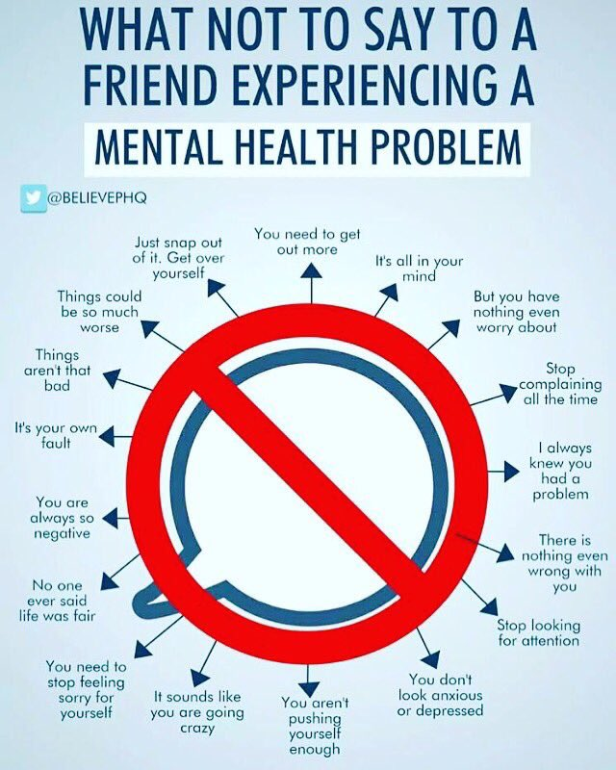

If you have a friend or a family member who is suffering from mental ill health, remember the above advice and try to get them to seek help from their GP or mental health professional. Remember that if you feel you are struggling with your own mental health, you can talk to your teachers, friends and parents.
S1

First Aid Class for 1a6 – Wednesday 22nd August 11.30am
Please collect guest from the reception prior to start of the lesson

Until the 24th August S1 pupils will receive their lunch from 12.10pm

My first week in St.Ninian’s

Induction Slides

Pupil Council Nominations to be completed ASAP. Please forward names to year head.

S2

Study Skills for year ahead

Body Image

Induction Slides

Pupil Council Nominations to be completed ASAP. Please forward names to year head.

S3

Exercise Health and Fitness

Induction Slides

Pupil Council Nominations to be completed ASAP. Please forward names to year head.

S4

Study Skills for S4

Work Experience – Please go over with your respective classes

Induction Slides

Urdu Class for Nat 5 and Higher begins Friday 25th August. Please make those concerned aware of this.

Pupil Council Nominations to be completed ASAP. Please forward names to year head.

S5

Induction Slides

Urdu Class for Nat 5 and Higher begins Friday 25th August. Please make those concerned aware of this.

Pupil Council Nominations to be completed ASAP. Please forward names to year head.

S6

First Aid Class for 6a1 – Thursday 23rd August 1.00pm
Please collect guest from the reception prior to start of the lesson

Induction Slides

S6 Service Slides

Heriot Watt University Open Days
Saturday 29 September
Friday 26 October

Those interested in Textiles and Design, there will be a separate open day at the Scottish Borders Campus in Galashiels Friday 12 October and Friday 16 November (10am to 4pm each day).

Pupil Council Nominations to be completed ASAP. Please forward names to year head.

My World of Work

S6 Service – encourage pupils to sign up to volunteering opportunities that are on offer throughout the year

T. Low

